1st Grade Igloo Project
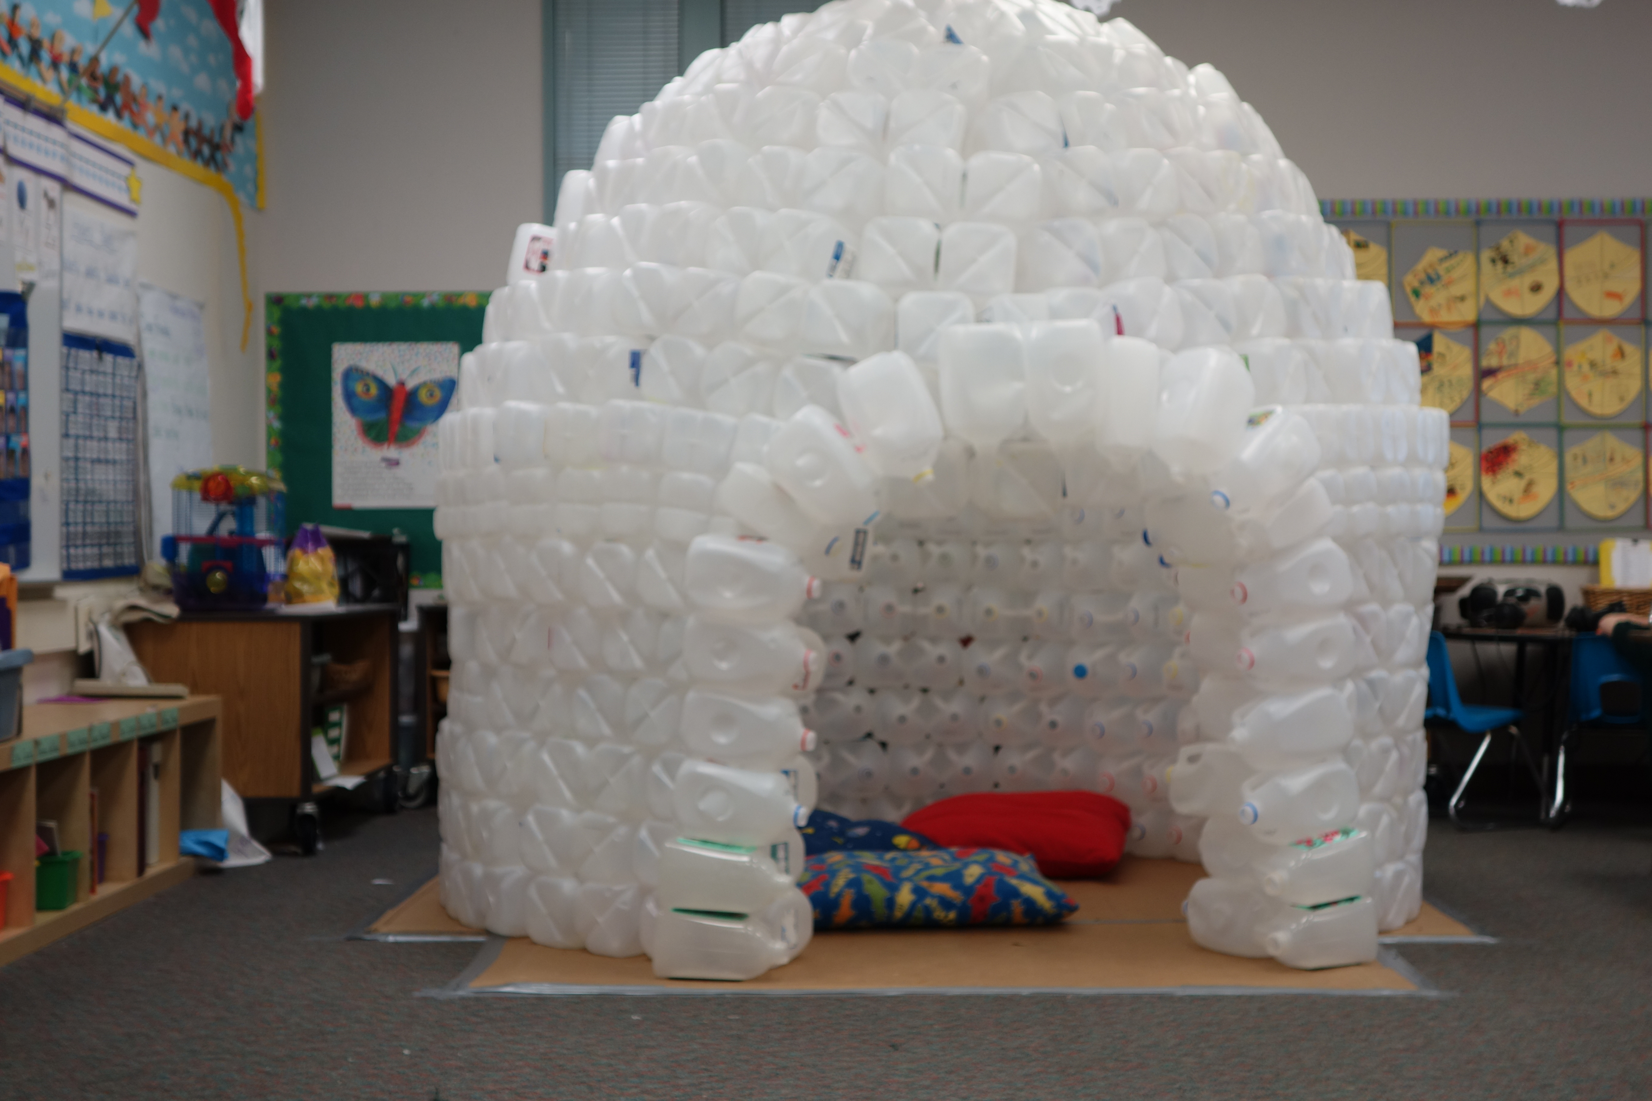

This project integrates science, math, language arts and social studies.

Students will collect recycled plastic milk jugs and figure out how to put them together to create an igloo inside the classroom. They will count their collection each day, recording their numbers using tally marks and a bar graph. They will bundle the milk jugs in groups of 10 and practice skip counting by 10s each day.
Science – recycling, seasons, weather, animals of the arctic
Social Studies – Traditional Igloos
Language Arts –
Math –
- 1 OA 1 Use addition and subtraction within 20 to solve word problems involving situations of adding to, taking from, putting together, taking apart, and comparing, with unknowns in all positions, e.g., by using objects, drawings, and equations with a symbol for the unknown number to represent the problem.

- 1 OA 3 Apply properties of operations as strategies to add and subtract. Examples: If 8 + 3 = 11 is known, then 3 + 8 = 11 is also known. (Commutative property of addition.) To add 2 + 6 + 4, the second two numbers can be added to make a ten, so 2 + 6 + 4 = 2 + 10 = 12. (Associative property of addition.)

- 1 OA 6 Add and subtract within 20, demonstrating fluency for addition and subtraction within 10. Use strategies such as counting on; making ten (e.g., 8 + 6 = 8 + 2 + 4 = 10 + 4 = 14); decomposing a number leading to a ten (e.g., 13 – 4 = 13 – 3 – 1 = 10 – 1 = 9); using the relationship between addition and subtraction (e.g., knowing that 8 + 4 = 12, one knows 12 – 8 = 4); and creating equivalent but easier or known sums (e.g., adding 6 + 7 by creating the known equivalent 6 + 6 + 1 = 12 + 1 = 13).

Day 1 – Introduce the idea of creating an igloo inside our classroom. Show pictures of other classroom igloos or videos of other class projects.
http://youtu.be/MdHBY2Axqdw
Day 2 – Decide on a classroom goal for how many milk jugs the class would like to collect. Create flyers/signs to post around the school to ask for recycled milk jugs. We also posted on our school yahoo group and encouraged families to collect bottles from their friends and neighbors. (I do this on a Friday to give people a weekend to start collecting)

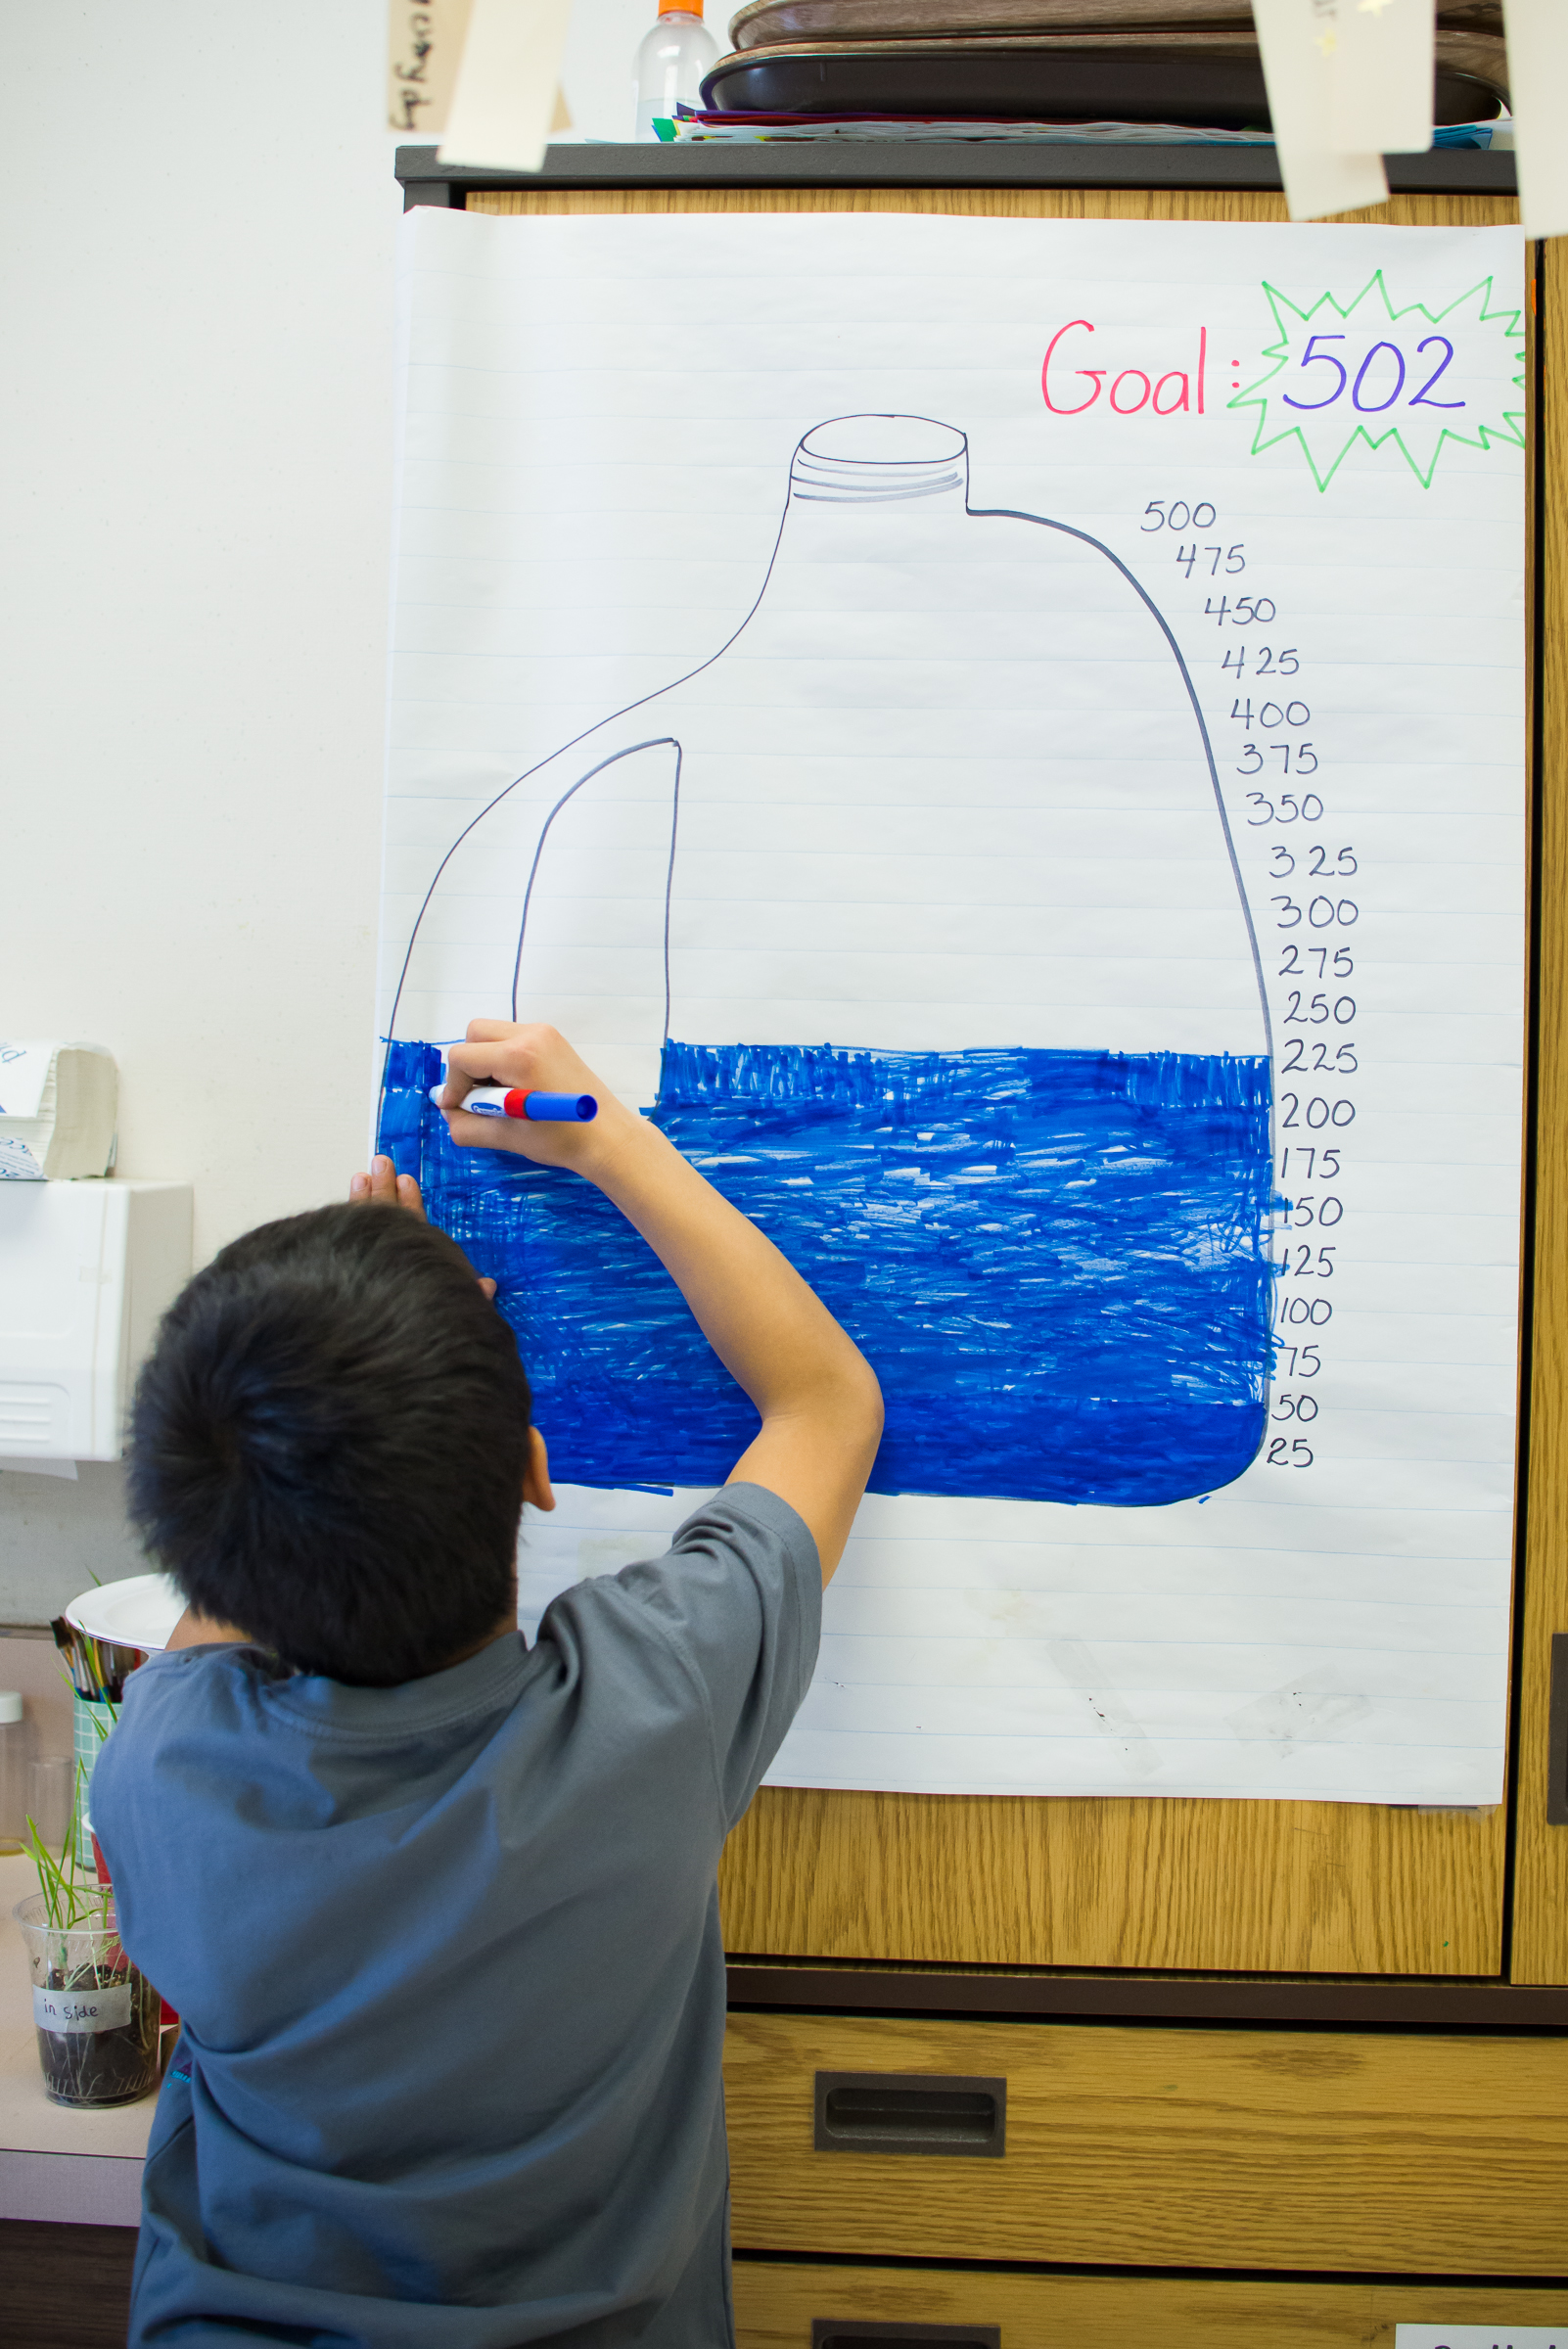

Day 3 – Start collecting jugs! Each day, 1 table group has the responsibility of collecting, cleaning, counting, recording and reporting. Students complete the Daily recording sheet as a table group, then record total numbers on class graphs and report to the class at the end of the morning meeting. The whole class counts the bundles of 10s and ones each day and records them on their own data collection sheet.
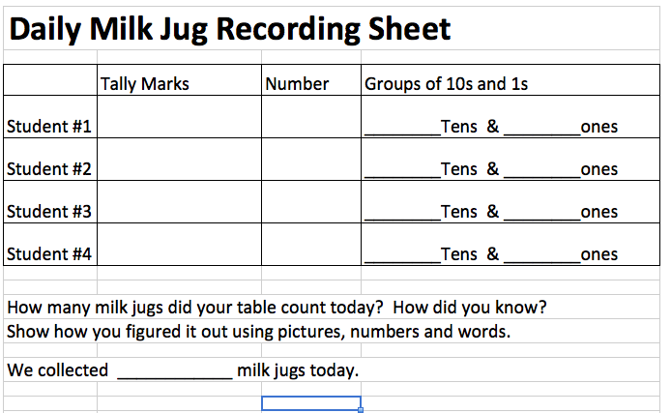

*Ask for bottles to be donated clean or your classroom will get really stinky really fast!!! We still rinsed them each day to be sure they were clean.
Day 4-14 – Continue collecting and counting. Each table group will have 2 turns counting, cleaning, recording and sharing data.

Planning for construction
Think about building a “real” igloo.
YouTube Video – How to build an igloo
http://youtu.be/hwuv9qzrVec
Watch the video of the other class creating their igloo, paying close attention to construction.
http://youtu.be/MdHBY2Axqdw

You will need the following materials –
A large refrigerator box (in good shape)
Duct Tape
High heat glue guns
LOTS of high heat glue sticks!!!

I schedule a workday on the weekend for any families who want to participate in beginning stages of construction. We worked for about 3 hours – laying out the refrigerator box, drawing our circle to guide our construction and building the 1st 2 layers of our igloo.

Assessments –
Presentation Assessment - Students prepare information and give “tours” to visiting classes. Information given during the tour would include the process of collecting and counting milk jugs, sharing our tally marks and graphs, planning and construction of the igloo, how we use the igloo, and our plan for recycling the igloo at the end of the project.
Performance Assessment -

