One Million Students’ Solar Lab Worksheet
As the impacts of global climate change and increased dependence on foreign fuels have become more prevalent issues, sustainable energy like limitless solar power has become an excellent alternative to traditional non-renewable resources. Solar panels not only prove useful in modern and more-developed communities, but also create a lasting impact in the developing world.
In this solar lab activity you will use the kit provided to study the amount of energy produced by solar photovoltaic cells in order to identify the optimal conditions under which to use solar panels.
Group Members:
____________________________________________________________________________
Part One: Measuring Current
a. Connect alligator clips to the solar panel
b. Connect red and black tester rods to the voltage meter
c. Connect alligator clips to the red and black tester rods
d. Turn on voltage meter to 20 V Setting
e. Use the compass for orientation
f. Use the protractor to measure the angle
g. Record all findings in the chart below:
 | 0$°$ | 30$°$ | 45$°$ | 60$°$ | 90$°$
Facing East In the Sun
Facing West in the Sun
Facing South in the Sun
Facing North in the Sun
Facing East in the Shade
Facing West in the Shade
Facing South in the Shade
Facing North in the Shade
Inside the Classroom

Part Two: Graphing your Results
a. Label the axes
b. Plot Findings for: 1. Intensity 2. Orientation 3. Angle
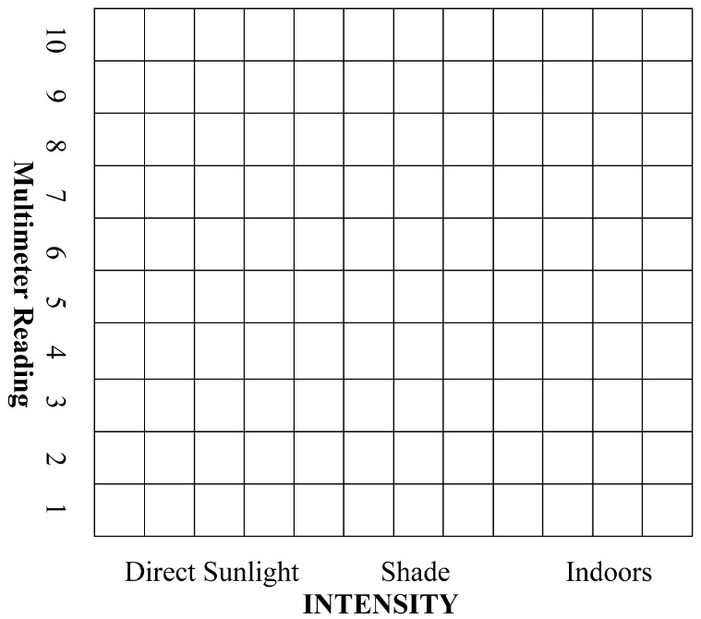
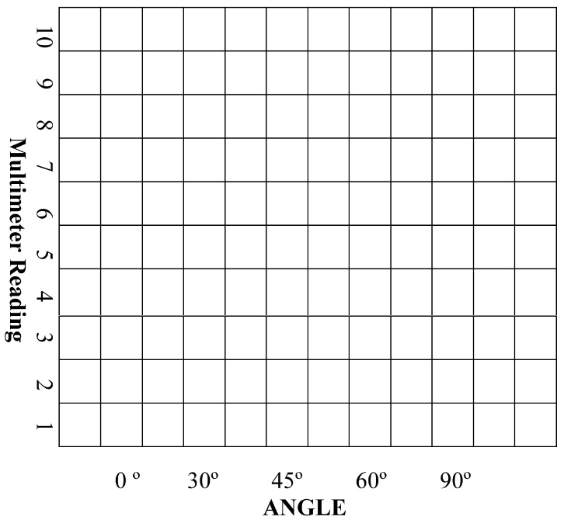
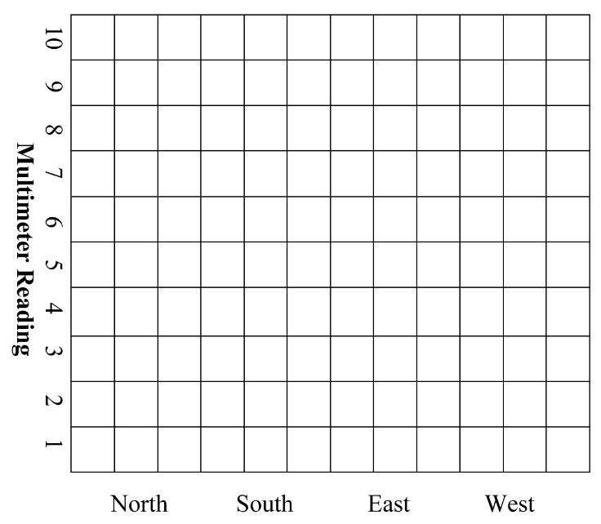
ANGLE Part Three: Analysis Questions
1. Which combination of Intensity, Orientation & Angle yielded the highest current? Why do you think so? How does the time of day and season impact your findings?
2. Where are the best places for solar panels worldwide? Which terrains are best for solar potential?
3. Based on your answer to #1, where on your school’s campus is the best place to install solar panels?

