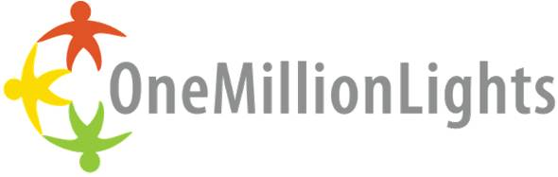

Solar Stories Worksheet
Directions for Students in groups of 2-4
1. At each station please select: a. One student to read the story out loud to the group b. One student to write down the groups answers
2. Discuss the Solar Story in your own group
3. Answer the following questions about your story, not all questions will be relevant to your story
4. Select one student to share your answers with the rest of the class

- Whose solar story do you have? Where do they live and what is it like there?

- What do they do? What does their family do?

- Do they have electricity at home? How dependable is their source of energy?

- How have solar lights helped this person’s life? How can solar impact their family and community in the future?

- How are their lives different from you and your family’s lives?

- Does anything unique about this person’s life stand out to your group?

- Who in your life can you share this person’s story with to increase awareness about solar power?

