**Mathematics**

C:\Users\Owner\AppData\Local\Microsoft\Windows\Temporary Internet Files\Content.IE5\5DBIPA0O\MC900237185[1].wmf

**Parent Handbook**

**Grade 6**

**Module 4 Topic B: Special Notations of Operations**

Grade 6: Module 4

The fourth module for 6th grade mathematics is on expressions and equations (algebra). The module is divided into 8 sections; Topics A- H.

Topic A:

In Topic A, students are introduced to important identities that will be useful in solving equations and developing proficiency with solving problems algebraically.  In Topic A, students understand the relationships of operations and use them to generate equivalent expressions. The module begins with the opportunity to clarify those relationships, providing students with the knowledge to build and evaluate identities that are important for solving equations.  In this topic, students discover and work with the following identities:

w - x + x = w w + x - x = w

a divided by b x b = a a x b divided by b = a (when b ≠ 0)

3x = x + x + x

Students will observe that dividing eight by two produces a quotient of four. They will experiment and find that if they subtract the divisor from the dividend four times (the quotient), they will find a remainder of zero. They continue to investigate with other examples and prove that if they continually subtract the divisor from the dividend, they will determine a difference, or remainder, of zero. Hence, $12÷x=4$ means $12-x-x-x-x=0$.

**Terminology**

New or Recently Introduced Terms

**Simple Expression :** a number, a letter which represents a number, a product whose factors are either numbers or letters involving whole number exponents, or sums and/or differences of such products.

Ex: 3 + x

**Term:** each product in a simple expression

Ex: 3 + x Terms are 3 and x.

**Coefficient:** the number that is multiplied by the variable.

Ex: 4x The coefficient is 4.

**Equation:** An *equation* is a statement of equality between two expressions…an equal sign is always present.

**Exponential Notation for Whole Number Exponents:** Let 𝑚 be a non-zero whole number. For any number 𝑎, we define 𝑎𝑚 to be the product of 𝑚 factors of 𝑎. The number 𝑎 is called the *base,* and 𝑚 is called the *exponent,* or *power* of 𝑎.



**Lesson 1: The Relationship Between Addition and Subtraction**

Objective:

* Students build and clarify the relationship of addition and subtraction by evaluating identities such as 𝑤- 𝑥 + 𝑥 = 𝑤 and 𝑤 + 𝑥 – 𝑥 = 𝑤.

Example 1: Use a tape diagram to represent the expression 3 + 2.

|  |  |  |  |  |
| --- | --- | --- | --- | --- |
|  |  |  |  |  |



3 + 2

Example 2:

If each of the squares represents 1 unit, represent the number 3 using the squares provided.

|  |  |  |
| --- | --- | --- |
|  |  |  |

Add two more squares to your tape diagram.

|  |  |  |  |  |
| --- | --- | --- | --- | --- |
|  |  |  |  |  |

Write an expression to represent how we created a tape diagram with 5 squares. 3 + 2

Remove two squares from the tape diagram.

|  |  |  |
| --- | --- | --- |
|  |  |  |

Alter the original expression 3 + 2 to create an expression that represents what we did with the tape diagram.

3 + 2 − 2

Evaluate the expression. What is 3 + 2 - 2?

Answer: 3

Example 3:

56 – 20 + 20 = 56.

**Lesson 2: The Relationship of Multiplication and Division**

Objective:

* Students build and clarify the relationship of multiplication and division by evaluating identities such as 𝑎 ÷ 𝑏 ∙ 𝑏 = and 𝑎 ∙ 𝑏 ÷ 𝑏 = 𝑎.

Example 1:

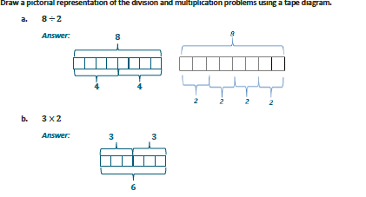

What students are encouraged to understand is that when they divide one number, then multiply by the same number, they end up with the original number. The same holds true when working with tape diagrams as well as a numerical equation.

Example 2:

12 ÷ 3 x 3 = 12

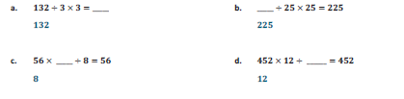

16

16

16

16

16

**Lesson 3: The Relationship of Multiplication and Addition**

Objective:

* Students build and clarify the relationship of multiplication and addition by evaluating identities such as 3 ∙ 𝑔 = + + 𝑔.

Students will be exposed to writing expressions using tape diagrams involving both addition and multiplication. Note: Although the tape diagram has two different expressions, the number of squares is equivalent because they represent the same value.

Example 1:

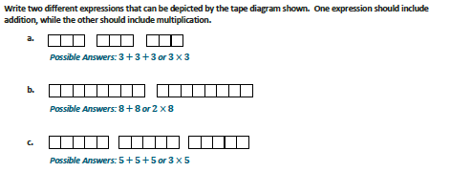

Example 2:

Looking further at the expression 3g = g + g + g.

3g is the same as writing 3 x g, but we no longer use the “x” for multiplication because it looks like a variable and can become confusing. When a number is next to a variable with no sign, multiplication is implied.

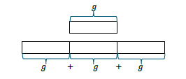

Equivalent Expressions:

1. 6 + 6 is the same as 2 x 6
2. 6y is the same as y + y + y + y + y + y
3. m + m + m + k + k + k + k + k = 3m + 5k
4. 3. 6 + 6 + 6 + 4 + 4 + 4 + 4 = 3 x 6 + 4 x 4

**Lesson 3: The Relationship of Multiplication and Addition (continued)**

Example 4: Nick wants to use a number like to show the relationship between multiplication and division. Here is an example to show that 3 x 2 is equivalent to 2 + 2 + 2.

The first number line shows that there are 𝟑 groups of 𝟐, resulting in 𝟔. The second number line shows the sum of 𝟐+𝟐+𝟐, resulting in 𝟔.

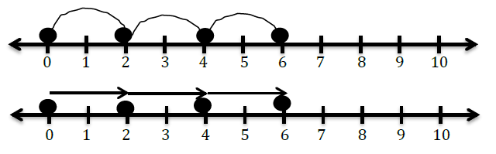

**Lesson 4: The Relationship of Division and Subtraction**

Objective:

* Students build and clarify the relationship of division and subtraction by determining that 12 ÷ 𝑥 = 4 means 12 – 𝑥 – 𝑥 – 𝑥 – 𝑥 = 0.

Example 1:

Build a tape diagram that has 20 squares.



Divide the tape diagram into 4 equal sections.



How many squares are in each of the 4 sections? 5

Write a number sentence to demonstrate what happened. 20 ÷ 4 = 5

Combine your squares again to have a tape diagram with 20 squares.



Now subtract 4 squares from your tape diagram.



Write an expression to demonstrate what happened. 20 − 4

Subtract 4 more squares and alter your expression to represent the new tape diagram.

 20 – 4 - 4

Subtract 4 more squares and alter your expression to represent the new tape diagram.

 20 – 4 – 4 – 4

Repeat this process one additional time and you will see that

20 – 4 – 4 – 4 – 4 – 4 = 0

**Lesson 4: The Relationship of Division and Subtraction (continued)**

Example 2: Using a tape diagram to represent division algebraically.

𝑥 is a number. What does 20 ÷ 𝑥 = 5 mean? *Exactly five* 𝑥*’s can be subtracted from twenty.*

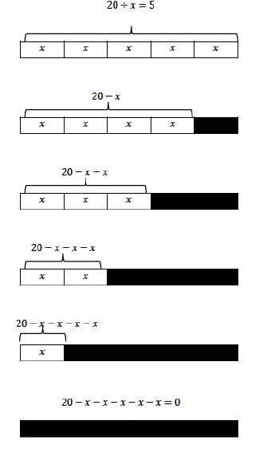

Determine the relationship between 20 ÷ 5 = 4 and 20 – 5 – 5 – 5 – 5 = 0.

20 ÷ 5 = 4 *is the same as* 20 – 5 – 5 – 5 – 5 = 0.

Example 3: Additional tape diagram models:

