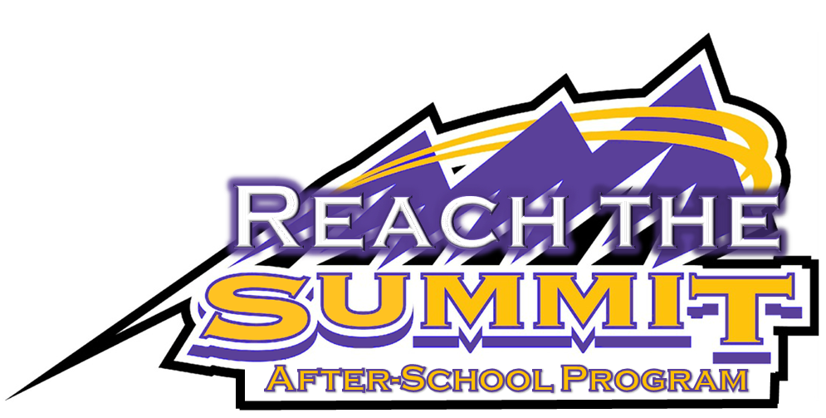

Assignment Communication Information

Johnston’s Google Domain will be utilized during Reach the Summit. Your student will have a folder on their Google Drive where teachers will have access to update it with missing assignments and class work that will be completed during Reach the Summit. We encourage parents to check their student’s Reach the Summit folder weekly to monitor progress on class work.

Google’s Gmail is the only e-mail that will work to share your student’s folder. If you already have a Gmail account, please send the Reach the Summit staff your Gmail address to michelle.jordan@johnston.k12.ia.us.

***If you do not have a Gmail account and would like to access your student’s folder, please follow the directions below.
To set up a Gmail account
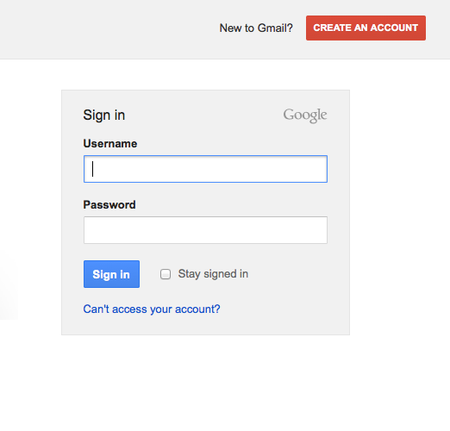
- Go to www.gmail.com
- Click Create an Account

- Fill out the requested information to set up your account
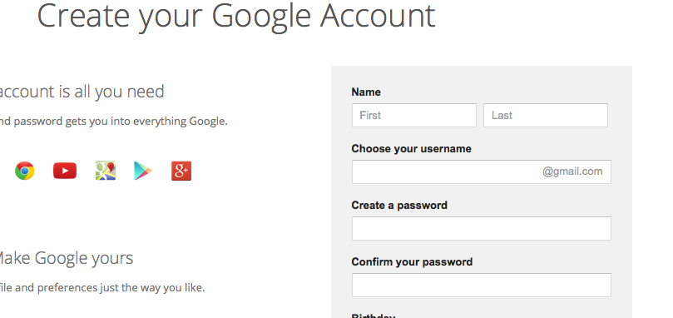

- Verify your account through text message or voice call
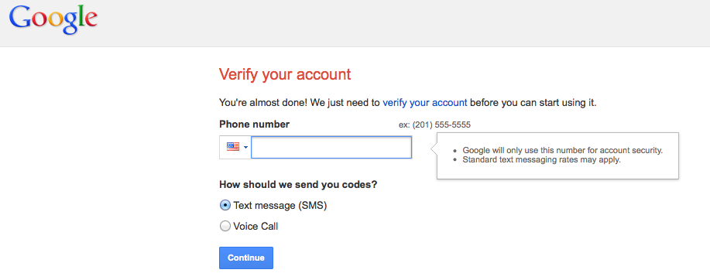

- Enter your verification code
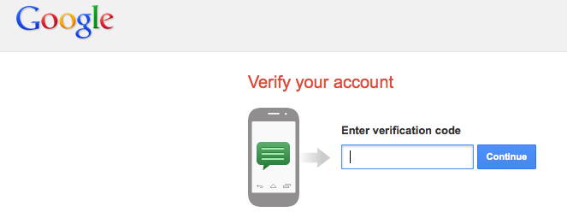

Access your student’s Reach the Summit Folder

- You must request access to your student’s Reach the Summit Folder by providing your Gmail address to michelle.jordan@johnston.k12.ia.us
- Once the Reach the Summit staff has given you access, you will be notified via e-mail.
- Log into your Gmail account
- Click on the Google Apps “Matrix”
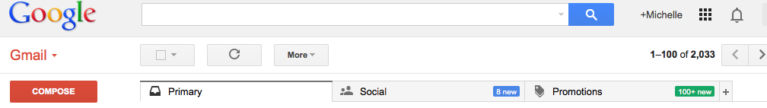

- Click on “Drive”
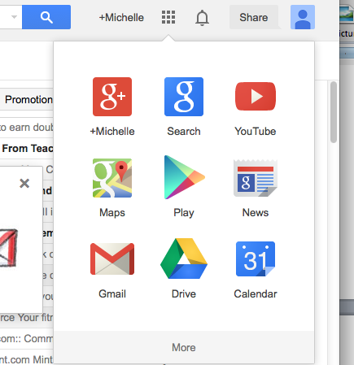

- Open your student’s “Reach the Summit Student Work Folder”
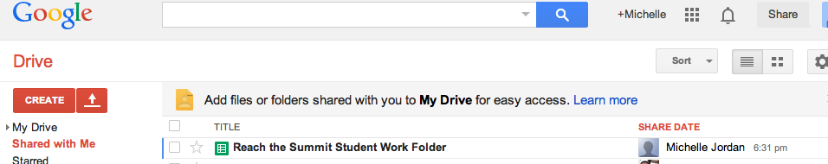

- Find missing assignments listed by course
