Page 27
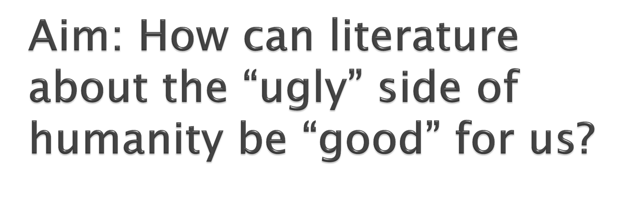

Do Now: Copy and explain the following:
“Hunger Games is part of a long grisly tradition.”
–Rebecca Keegan LA Times

Page 28
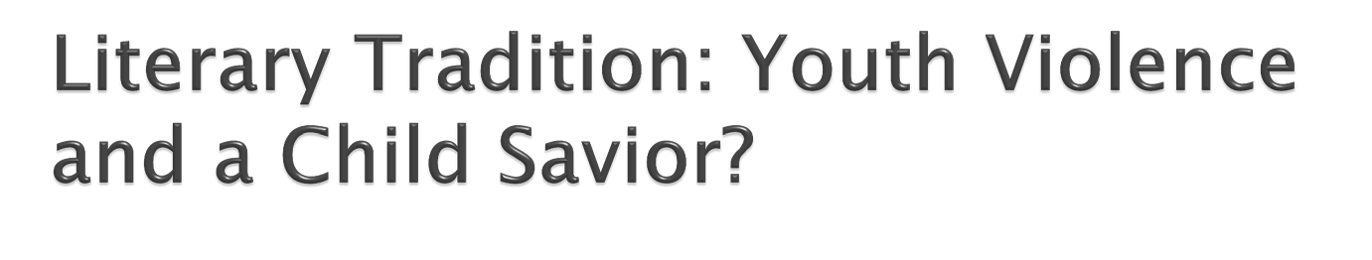

 http://www.youtube.com/watch?v=mfmrPu4
3DF8
 Define “Youth Violence” and “Child Savior”.
 How does this relate to Hunger Games?
 What can you tell me about: setting, characters and conflict?

Page 29
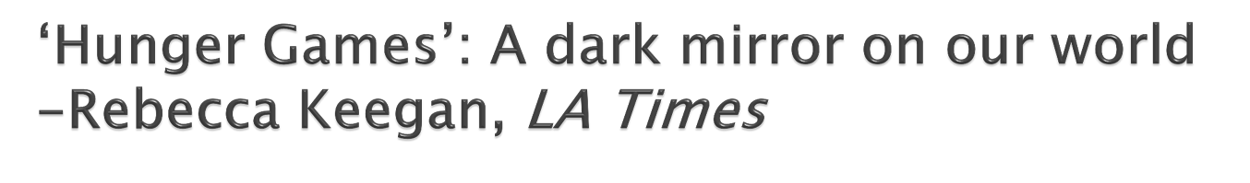

 In pairs, share your answer to today’s “do
now” then read the article:
- create a better answer to the “do now”, now that you have read the entire article….

What did Rebecca mean when she said, “Hunger Games is part of a long grisly tradition?” –Rebecca Keegan LA Times

Page 30
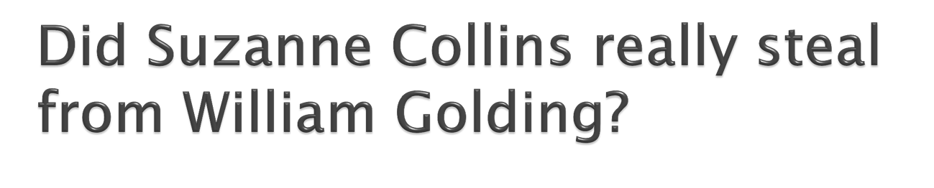

 What is similar in LOF and HG?

Page 31
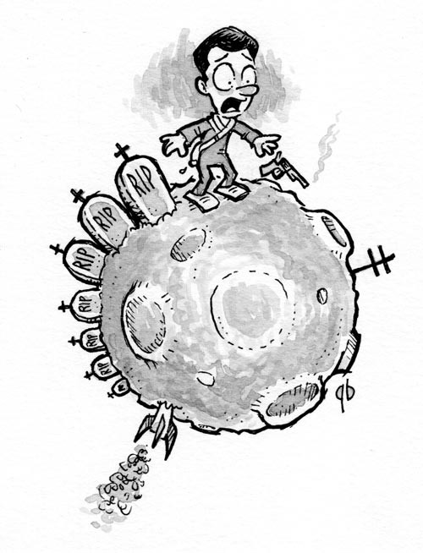
Aim: What is
society’s
“moral code”?

Do Now: How does
what you can do differ
from what you should
do?

Page 32
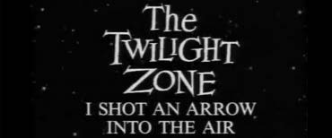

http://www.youtube.com/watch?v=xks8xcWyM

Page 33
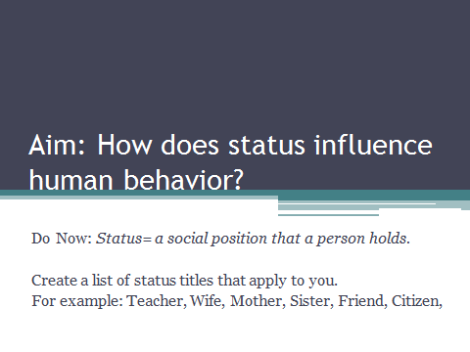

Page 34
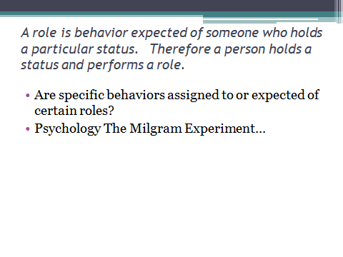

Page 35

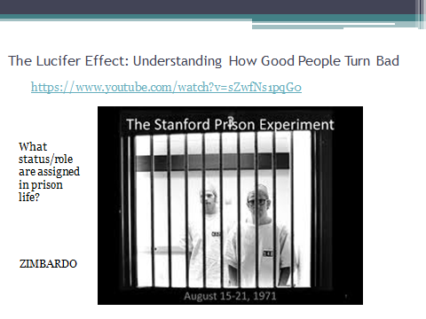

Page 36

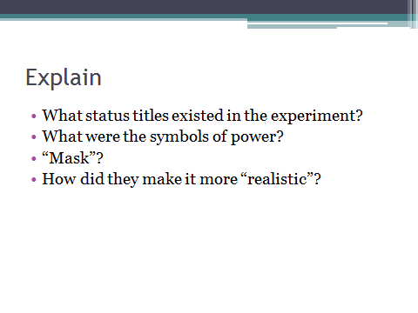

Page 37

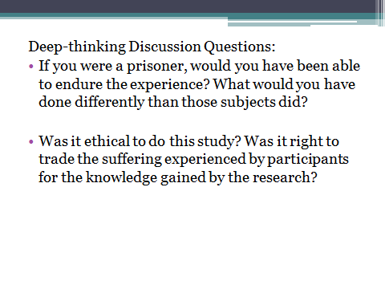

Page 38

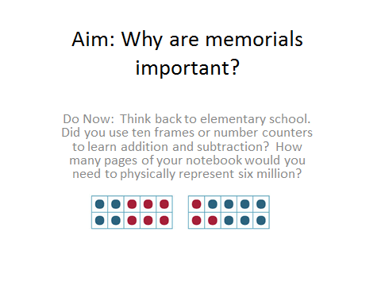

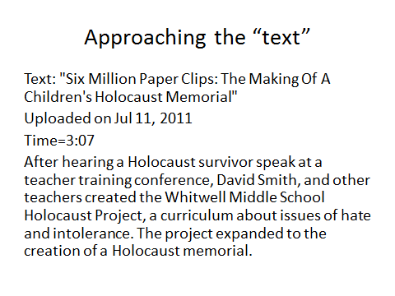
Page 39

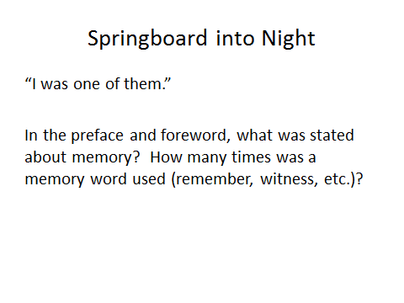
Page 40

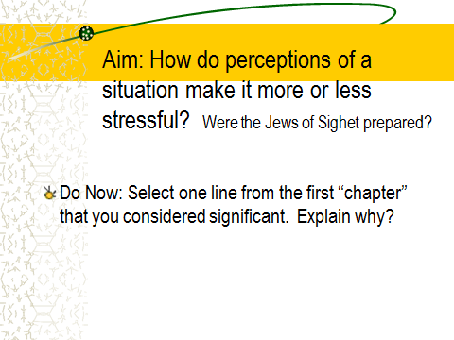
Page 41

Page 42
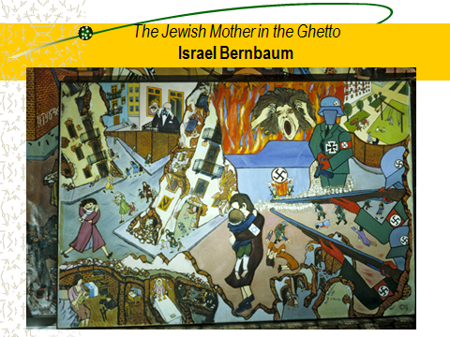

Page 43
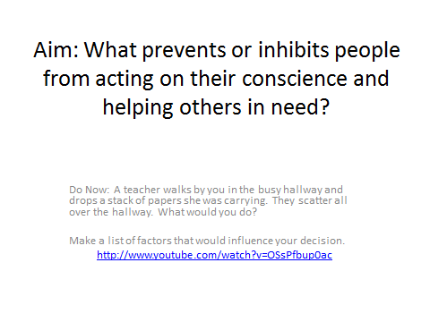

Page 44

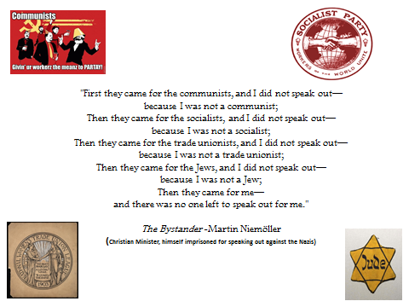

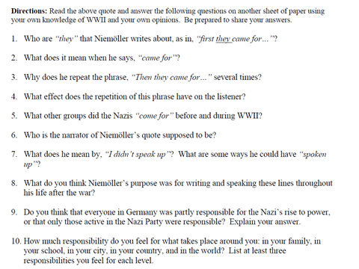
Page 45

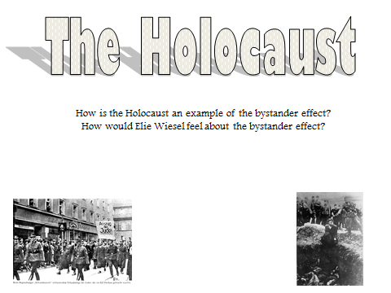
Page 46

