East Meadow School District

Curriculum Area Project

Grade 9-10

Living Environment Station Activities Part 1

Completed: October, 10th 2013

Authors:

Christy Sullivan

Barbara Lucia

Pam Freitag

Subject: Science/Biology/Living Environment

Abstract/Rationale

This CAP is titled the “Living Environment Station Activities Part 1” which is designed to be incorporated into the Living Environment classrooms, for mostly grades 9 and 10. The goal of this cap is to provide Living Environment teachers with activities and resources that help them reinforce the concepts taught in this course. Many of these activities are quick and easy to incorporate into any classroom routine. The stations included in this CAP foster learning by incorporating activities that allow students to use their many different learning styles during each lesson. The activities for each lesson include five different stations that students will rotate through during the duration of a Living Environment period (39 min). Timers should be used to monitor the movement of students and teachers will have the ability to interact with students as they work in cooperative groups. All activities are designed to meet the needs or our diverse student population and reinforce concepts learned in the Living Environment classroom. Lessons include fun ways for students to learn in cooperative groups. Hands-on activities, visuals, regents review, labs concepts, test review, reading comprehension, current events, etc are some of the many activities included within the station lessons developed for this CAP. The variety of activities created for this CAP can be utilized regularly to assess student performance and growth. These activities are meant to make the classroom a more active learning environment and include assignments that represent different learners and multiple intelligences. The activities developed are enjoyable for the students, connect to the curriculum and can be modified to meet the needs of our diverse student population. We incorporated a variety of activities that correspond with the different topics covered throughout the year. The activities focus on concepts tested in the NYS Living Environment regents by using the standards outlined by the state.. The CAP was developed using the Living Environment standards (Standards 1 and Standards 4.1.1, 4.2.1, 4.3.1, 4.4.1, 4.5.1, 4.6.1 and 4.6.2). We’re interested in completing successive CAPS to add to our educational resources. We look forward to collaborating with our colleagues to add to this CAP.

Hour Allotment

Each participant was allotted 30 hours to complete this CAP. Below you will find the breakdown of how the hours were spent.

|  |  |
| --- | --- |
| **Task** | **Hour(s) Spent per Participant** |
| Preparing Materials – CAP Procedures | 5 hours |
| Researching and preparing appropriate lessons/activities to be utilized by teachers and students | 5 hours |
| Researching and organizing activities to meet NYS standards | 5 hours |
| Typing, creating and formatting activities | 10 hours |
| Organizing Stations into 39 minute lessons | 5 hours |
| Total Hours | 30 Hours (per participant) |

**Classroom TIMERS LINK**

[**http://www.online-stopwatch.com/classroom-timers/**](http://www.online-stopwatch.com/classroom-timers/)

**Recommended 5 stations with 5 students in each group**

**Or 6 Stations with 4 students in each group**

**Students should have 5-6 minutes to work in each station**

**STATION**

**1**

**STATION**

**2**

**STATION**

**3**

**STATION**

**4**

**STATION**

**5**

**STATION**

**6**

|  |  |  |  |
| --- | --- | --- | --- |
| **Group Number** | **Member 1** | **Member 2** | **Member 3** |
| **1** |  |  |  |
| **2** |  |  |  |
| **3** |  |  |  |
| **4** |  |  |  |
| **5** |  |  |  |
| **6** |  |  |  |
| **7** |  |  |  |
| **8** |  |  |  |
| **9** |  |  |  |
| **10** |  |  |  |

|  |  |  |
| --- | --- | --- |
| **Student** | **Job** | **Date Started** |
|  |  |  |
|  |  |  |
|  |  |  |
|  |  |  |
|  |  |  |
|  |  |  |
|  |  |  |
|  |  |  |
|  |  |  |
|  |  |  |
|  |  |  |
|  |  |  |
|  |  |  |
|  |  |  |

**Works Cited**

|  |  |  |  |
| --- | --- | --- | --- |
| **Author** | **Website/Source** | **Right to use work** | **Date Retrieved** |
| **Christy Sullivan** | **Directly from Individual** | **Verbal** | **8/15/13** |
| **Pam Freitag** | **Directly from Individual** | **Verbal** | **8/15/13** |
| **Barbara Lucia** | **Directly from Individual** | **Verbal** | **8/15/13** |
| **Miller & Levine** | **Textbook (Biology Pearson Ed)** | **Textbook Permission**  **for educators** | **8/15/13** |
| **Colleen Fitzpatrick** | **Directly from Individual** | **Verbal** | **9/20/11** |
| **Ken Nyer** | **Directly from Individual** | **Verbal** | **9/15/13** |
| Biology Corner | http://www.biologycorner.com/worksheets/scientific_method_action.html#.Um6MVHjD9Fo | http://creativecommons.org/licenses/by-nc-sa/3.0/us/ | 9/15/13 |
| [**Monterey Bay Aquarium Web Site**](http://www.montereybayaquarium.org/) | 1. [www.seafoodwatch.org](http://www.seafoodwatch.org) | 1. [www.seafoodwatch.org](http://www.seafoodwatch.org) | 8/8/13 |
| Environmental Working Group | [www.ewg.org](http://www.ewg.org) | [www.ewg.org](http://www.ewg.org) | 8/8/13 |
| Department of Environment Conservation | http://www.dec.ny.gov/index.html | http://www.dec.ny.gov/index.html | 8/15/13 |
| Unknown | http://kisdwebs.katyisd.org/campuses/WMJH/teacherweb/tristani/Teacher%20Documents/Oraganic%20%20Inorganic%20Compounds.pdf | http://kisdwebs.katyisd.org/campuses/WMJH/teacherweb/tristani/Teacher%20Documents/Oraganic%20%20Inorganic%20Compounds.pdf | 8/15/13 |
| [www.nysed**regents**.org/](http://www.nysedregents.org/) | [www.nysed**regents**.org/](http://www.nysedregents.org/)  Living Environment Test Bank | www.nysed**regents**.org/ | 7/15/13 |
| Wizard Test maker | <http://www.wizardtm.com/Pages/SignedOutHome.aspx> | http://www.wizardtm.com/Pages/SignedOutHome.aspx | 8/15/13 |
| MED Weight Loss | http://www.mediweightlossclinics.com/patients/resources/articles/obesity-facts/ | http://www.mediweightlossclinics.com/patients/resources/articles/obesity-facts/ | 8/15/13 |
| H20 | http://www.all-water.org/Facts.html | http://www.all-water.org/Facts.html | 8/15/13 |

***Table of Contents***

**Station Topics Page #**

**Station Guidelines & Organizers**

**Station Set-up………………………………………………………… 3**

**Station Signs………………………………………………………….. 4 - 9**

**Station timers………………………………………………………… 3**

**Group Sheet………………………………………………………….. 10**

**Student Job…………………………………………………………... 11**

**Work cited……………………………………………………………. 12 -13**

**Reflections/Self-Assessment**

**Assignment Reflection……………………………………………17-18**

**Growth and Goals………………………………………………….19-20**

**All about You………………………………………………………122-124**

**Any Topic Station Activities**

**Article Outline…………………………………………………….25**

**Vocabulary Fill-in w/Index Cards………………………………27**

**Brainstorming Terms x1………………………………………….108**

**Brainstorming Terms x 2…………………………………………109**

**Scientific Method, Tools & Graphing**

**Microscope Diagram……………………………………………………..106**

**Graphing (Regents)………………………………………………………60-61**

**Graphing Bubbles vs. Depth…………………………………………….62-63**

**Graphing Blood Glucose…………………………………………………64-66**

**Graphing Water Depth vs. Temperature……………………………….67-69**

**Graphing Microorganisms………………………………………………70-71**

**Graphing Bacteria and pH………………………………………………72-73**

**Scientific Method…………………………………………………………104-105**

**Graphing Rules…………………………………………………………..74-76**

**Scientific Method Case of Beri Beri……………………………………..80-81**

**Lice Written Response………………………………………………….79**

**Diffusion Lab……………………………………………………………. 77-78**

**Biochemistry**

**Organic vs. Inorganic…………………………………………………….99**

**Life Elements Organizer…………………………………………………100-101**

**Life Elements Statistics……………………………………………………82-83**

**Carbon Statistics……………………………………………………………84**

**Ionic vs. Covalent………………………………………………………….85-86**

**All You Need to Know About H2O……………………………………….87-89**

**Cool Facts about H20………………………………………………………90-93**

**You Are What You Eat……………………………………………………102-103**

**pH Chart……………………………………………………………………94-95**

**Acid and Bases Are Everywhere………………………………………….96-98**

**Chemistry & Food…………………………………………………………58-59**

**Health Risk & Good Nutrition…………………………………………….52-57**

**Food Labels…………………………………………………………………110 - 111**

**The Fish You Eat……………………………………………………………113**

**Water You Drink……………………………………………………………114-115**

**Cells**

**Photosynthesis Word Association…………………………………………29**

**Phases of Meiosis………………………………………………………….30-31**

**Cells…………………………………………………………………………107**

**Genetics & Evolution**

**Blood Disorders…………………………………………………………...32**

**Dominant & Recessive…………………………………………………… 33-34**

**Selective Breeding………………………………………………………..35-36**

**DNA Vocabulary X1……………………………………………………..37**

**DNA Vocabulary X2……………………………………………………..38**

**DNA vs. RNA Chart……………………………………………………..39**

**DNA vs. RNA Questions………………………………………………..40-41**

**DNA and Chromosomes………………………………………………...21-24**

**Transcription & Translation…………………………………………….42-45**

**Horseshoe Crab Evolution……………………………………………….46-49**

**Evolution Matching……………………………………………………….50**

**Evolution Resistant Organisms…………………………………………..51**

**GMO’s …………………………………………………………………….112**

**Ecology**

**Adirondack Article Outline……………………………………………….26-27**

**Food Borne Illnesses………………………………………………………116-121**

**Crosswords and Wordsearches**

**Organic Compounds……………………………………………………125-126**

**Nutrition Crossword…………………………………………………….127**

**Genetics & Evolution…………………………………………………...128**

**Food Safety Wordsearch……………………………………………......129--130**

**Obesity Wordsearch……………………………………………….........131-132**

**Scientific Method Wordsearch………………………………………….133-134**

Station # ________

**Living Environment Student Self-Assessment, Reflection and Growth**

Student _____________________

Date________________

Assignment/Activity _______________

1. What was the one most useful thing you learned in this assignment/activity?

___________________________________________________________________

___________________________________________________________________

___________________________________________________________________

___________________________________________________________________

2. What suggestions would you give other students on ways to get the most out of

this assignment/activity?

___________________________________________________________________

___________________________________________________________________

___________________________________________________________________

3. How did this assignment/activity help you improve your grade?

___________________________________________________________________

___________________________________________________________________

___________________________________________________________________

4. List three ways you think you have developed or grown as a result of this

assignment/activity.

___________________________________________________________________

___________________________________________________________________

___________________________________________________________________

Flip

5. What problems did you encounter in this assignment/activity?

___________________________________________________________________

___________________________________________________________________

___________________________________________________________________

___________________________________________________________________

6. What did you learn about your weaknesses during this assignment/activity?

___________________________________________________________________

___________________________________________________________________

___________________________________________________________________

___________________________________________________________________

7. How can what you’ve learned from this assignment help you reach mastery on the Living Environment Regents?

___________________________________________________________________

___________________________________________________________________

___________________________________________________________________

___________________________________________________________________

8. Share number 2 with a classmate.

**Living Environment Student Self-Assessment, Reflection and Growth (Running Records)**

**Student _____________________**

**Assessment Growth**

|  |  |  |  |  |  |  |  |  |  |  |  |
| --- | --- | --- | --- | --- | --- | --- | --- | --- | --- | --- | --- |
| **Baseline** | **Target Score** | **1st Test** | **2nd Test** | **Midterm** | **4th Test** | **5th Test** | **6th Test** | **7th Test** | **8th Test** | **9th Test** | **Final** |
|  |  |  |  |  |  |  |  |  |  |  |  |

**Living Environment Goals 2013-2014**

**As a student it’s important to have short-term and long-term goals so you can gauge your progress throughout the year. Your goals should be specific, and you should be able to attain these goals. As you reflect on your goals throughout the year you can make necessary adjustments to your classroom and home performance to achieve your goals. This will help you have a successful school year**

**C:\Users\csulliva.INST\AppData\Local\Microsoft\Windows\Temporary Internet Files\Content.IE5\KFL9VNQH\MC900440432[1].wmf**

**Academic Goals**

1. **My 1st academic goal for Living Environment is to** ________________________________________________________________________________________________________________________________________________________________________________________________________________________________________________________________________________
2. **What can you do between now and the end of the school year to make those changes/improvements happen? Please be as specific as possible, and list at least three actions you can take:**

____________________________________________________________________________________________________________________________________________________________________________________________________________________________________________________________________________________________________________________________________________________

________________________________________________________________________________________________________________________________________

1. **My 2nd academic goal for Living Environment is to** ________________________________________________________________________________________________________________________________________________________________________________________________________________________________________________________________________________
2. **What can you do between now and the end of the school year to make those changes/improvements happen? Please be as specific as possible, and list at least three actions you can take:**

____________________________________________________________________________________________________________________________________________________________________________________________________________________________________________________________________________________________________________________________________________________

Name____________________ Date__________________________

Station # ________

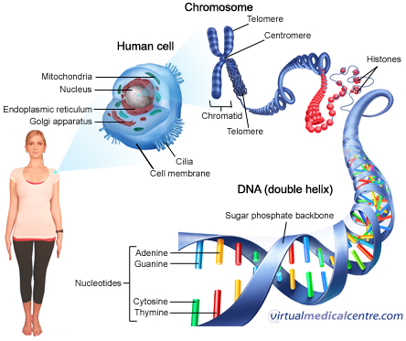

1. **Look at the picture above… Underline the words**

**Human cell – Chromosome – DNA (Double helix)**

1. **What are tiny structures inside cells with different jobs called?**
2. **Organs**
3. **Organelles**
4. **Tissues**
5. **Compounds**
6. **Which organelle is the control center of the cell?**
7. **Mitochondria**
8. **Golgi body**
9. **Nucleus**
10. **Ribosomes**
11. **Why is the ___________________ the control center of the cell?**

**____________________________________________________________________________________________________________________________________________________**

1. **What is inside the nucleus?**
2. **Cheeseburgers**
3. **Mitochondria**
4. **Chromosomes**
5. **Chloroplast**
6. **Which organic compound makes up chromosomes? _________________________**
7. **How many chromosomes do humans have in their body cells? _____________________**
8. **How many chromosomes do they have in their sex cells (gametes)? ________________**
9. **If you unwind (take apart chromosomes) what would you see?**

**__________________________________________________________________________**

1. **What is the backbone (strands) of DNA composed of?**
2. **Adenine**
3. **Sugar**
4. **Phosphate**
5. **Both b & c**
6. **What are the 4 nucleotides (molecular bases) that hold the strands together?**

**___________________________________**

**____________________________________**

**_____________________________________**

**_____________________________________**

1. **Where did you get your chromosomes from? ________________________________**
2. **Do all your trillions of body cells have identical chromosomes? Yes or No**
3. **How about your gametes? Yes or No**
4. **Do you have the same DNA sequence as your classmates? Yes or No**
5. **Do you have the same DNA sequence as anyone? Yes or No**
6. **Is your DNA sequence more similar to your best friend DNA or a family member.**
7. **What is your DNA sequence? _____________________________________________**

**Now draw DNA and Label the parts (Add color)**

**BONUS 🡪 What does DNA stand for? ___________________________________________**

Name____________________ Date__________________________

Station # ________

1. Title of the article. __________________________________________
2. When was this article published?

__________________________________________________________________________________________________________________________________

1. What is this article about? __________________________________________

_________________________________________________________________

____________________________________________________________________________________________________________________________________________________________________________________________________________________________________________________________________

_________________________________________________________________

1. Do you think this article is relevant? Explain. ___________________________________________________________________________________________________________________________________________________________________________________________________
2. List 2 facts you learned from this article.

___________________________________________________________________________________________________________________________________________________________________________________________________

**Name_________________________ Date______________**

Station # ________

1. Title of the article. __________________________________________
2. When was this article written? ____________________________
3. What is this article about? ________________________________________________________________________

____________________________________________________________________________________________________________________________________________________

1. Why does this Adirondack town want to use this herbicide? ________________________________________________________________________________________________________________________________________________
2. How has the town tried to kill the weeds naturally?

__________________________________________________________________________________________________________________________________________________________

1. Why is the Adirondack council against using the herbicide? _________________________

____________________________________________________________________________________________________________________________________________________

1. What happen in Lake Luzerne in 2011? __________________________________________

____________________________________________________________________________________________________________________________________________________

1. What is Eurasian watermilfoil? _______________________________________________
2. What did you learn? __________________________________________________________________________________________________________________________________

**Name_____________________**  **Date__________________________**

Station # ________

**Match the index cards (terms and definitions). Fill in your matches below.**

|  |  |
| --- | --- |
| **Word/Term** | **Meaning/Definition** |
|  |  |
|  |  |
|  |  |
|  |  |
|  |  |

**Which word/term (s) above do you still have trouble remembering? _________________________________________________________________________________________________________________________________________________________**

**Name_____________________**  **Date__________________________**

Station # ________

**Photosynthesis**

|  |  |  |  |  |
| --- | --- | --- | --- | --- |
| **Group 1** | **Group 2** | **Group 3** | **Group 4** | **Group 5** |
|  |  |  |  |  |
|  |  |  |  |  |
|  |  |  |  |  |
|  |  |  |  |  |
|  |  |  |  |  |

**Name_________________________ Date______________**

Station # ________

**Phases of Meiosis**

|  |  |
| --- | --- |
| **Name of Phase** | **Description** |
| 1. | Homologous chromosomes pair up and form tetrad |
| 2. | Spindle fibers move homologous chromosomes to opposite sides |
| 3. | Nuclear membrane reforms, cytoplasm divides, 4 daughter cells formed |
| 4. | Chromosomes line up along equator, not in homologous pairs |
| 5. | Crossing-over occurs |
| 6. | Chromatids separate |
| 7. | Homologs line up alone equator |
| 8. | Cytoplasm divides, 2 daughter cells are formed |

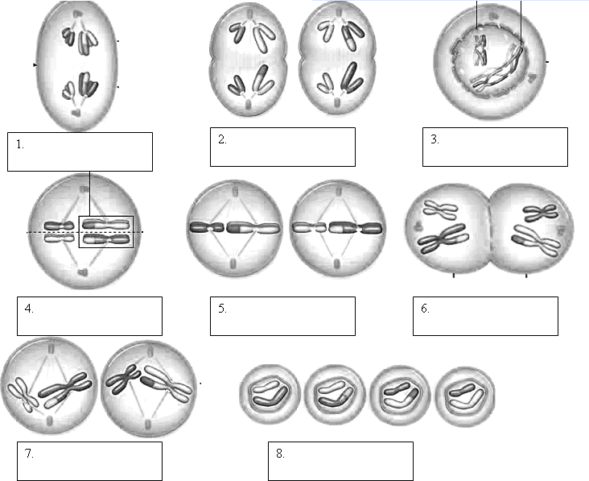

**Name______________________ Date__________________________**

Station # ________

**The Genetics of Blood Disorders**

1. If a female is a carrier for hemophilia X H X h and is married to a man with hemophilia X h Y , what is the probability that she will have a daughter with hemophilia?

2. A normal female marries a man who has hemophilia . (You’ll need to figure out the genotypes). What percentage of their sons will have hemophilia?   
  
  
  
  
  
3. If a female has hemophilia and is married to a normal man.   
What percentage of her sons will have hemophilia?   
  
  
  
What percentage of her daughters will have hemophilia?   
  
  
  
4. A woman with sickle cell anemia is married to a man who is a carrier for the trait.   
( a a x A a). What is the chance of their children having sickle cell anemia?

5. What is the chance that two people (both being carriers for sickle cell anemia) will have a child with the disease?

6. Von Willebrand Disease is an autosomal dominant disorder (not located on the sex chromosomes) where blood will not clot properly.   
  
What would be the two possible genotypes of a person who has the disorder?  
  
  
If a person is heterozygous for the trait (having the disease) is married to a normal spouse (dd), what is the chance that their children will have the disorder.

**Name____________________**  Date__________________________

Station # ________

**DOMINANT AND RECESSIVE CHARACTERISTICS**

Characteristics in the left-hand column dominate over those characteristics listed in the right-hand column.

|  |  |  |
| --- | --- | --- |
|  | **DOMINANT TRAITS** | **RECESSIVE TRAITS** |
| eye coloring | brown eyes | grey, green, hazel, blue eyes |
| vision | farsightedness normal vision normal vision normal vision | normal vision nearsightedness night blindness color blindness* |
| hair | dark hair non-red hair curly hair full head of hair widow's peak | blonde, light, red hair red hair straight hair baldness* normal hairline |
| facial features | dimples unattached earlobes freckles broad lips | no dimples attached earlobes no freckles thin lips |
| appendages | extra digits fused digits short digits fingers lack 1 joint limb dwarfing clubbed thumb double-jointedness | normal number normal digits normal digits normal joints normal proportion normal thumb normal joints |
| other | immunity to poison ivy normal pigmented skin normal blood clotting normal hearing normal hearing and speaking normal- no PKU | susceptibility to poison ivy albinism hemophilia* congenital deafness deaf mutism phenylketonuria (PKU) |

**Use the information from the chart and your prior knowledge to answer the following questions.**

1. What is a dominant trait? ______________________________________________________
2. What is a recessive trait? _______________________________________________________
3. What color hair do you have? ______________________Is it dominant or recessive? _______________
4. What color eyes do you have? ______________________ Is it dominant of recessive? _______________
5. Look at the facial features above and describe you characteristics. ____________________________________________________________________________________________________________________________________________________________________________________________________________________________________________________________________________________________________________________________________________________________
6. Where do you get your genes for your traits? ________________________________________________
7. Which organic molecule is responsible for the inheritance of traits? ______________________________
8. What is your favorite trait? ____________________________________________________
9. What is your least favorite trait? ________________________________________________

Name_____________________ Date__________________________

Station # ________

**Read the passage below and answer the following questions.**

**Selective Breeding**  
For thousands of years new varieties of cultivated plants and domestic animals have resulted from **selective breeding** for particular traits. Some selective breeding techniques include **artificial selection**, where individuals with desirable traits are mated to produce offspring with those traits. A variation of this process traditionally used in agriculture is **inbreeding**, where the offspring produced by artificial selection are mated with one another to reinforce those desirable traits. **Hybridization** is a special case of selective breeding. This involves crossing two individuals with different desirable traits to produce offspring with a combination of both desirable traits. An example of this are Santa Gertrudis cattle, which were developed by breeding English shorthorn cattle, which provided for good beef, but lacked heat resistance, with Brahman cattle from India which were highly resistant to heat and humidity. The Santa Gertrudis breed of cattle has excellent beef, and thrives in hot, humid environments.

|  |  |  |
| --- | --- | --- |
| **An Example of Selective Breeding** | | |
| http://regentsprep.org/regents/biology/units/heredity/brahman.jpg  Brahman cattle: Good resistance to heat but poor beef. | http://regentsprep.org/regents/biology/units/heredity/shorthorn.jpg  English shorthorn cattle: Good beef but poor heat resistance. | http://regentsprep.org/regents/biology/units/heredity/santagertrudis.jpg  Santa Gertrudis cattle: Formed by crossing Brahman and English shorthorns; has good heat resistance and beef. |

See Back for Questions ;)

1. Based on your prior knowledge, describe the difference between natural and artificial selection.

__________________________________________________________________________________________________________________________________________________________

_____________________________________________________________________________

1. What are the two types of artificial selection?

_____________________ & _______________________

1. Name the three different cattle describe on the chart.

_______________________ , __________________________ & ____________________

1. What does resistance to heat mean? ____________________________________________

__________________________________________________________________________

1. Which two types of cattle were crossed? ___________________ & ________________
2. Which type of cattle was produced as a result of this cross. __________________________
3. Which type of cattle is the most valuable to farmers? Why? __________________________

______________________________________________________________________________________________________________________________________________________________________________________________________________________________

Name_____________________ Date__________________________

Station # ________

|  |  |
| --- | --- |
| **Term** | **Definition** |
| 1) Deoxyribonucleic  Acid (DNA) |  |
| 2) Ribonucleic  Acid (RNA) |  |
| 3) Base Pairing |  |
| 4) Nucleotides |  |
| 5) Molecular Bases |  |
| 6) DNA Polymerase |  |
| 7) Chromosome |  |
| 8) Gene |  |
| 9) Genetics |  |
| 10) Heredity |  |

Name_____________________ Date__________________________

Station # ________

|  |  |
| --- | --- |
| 1) Adenine |  |
| 2) Thymine |  |
| 3) Cytosine |  |
| 4) Guanine |  |
| 5) Uracil |  |
| 6) Telomeres |  |
| 7) Replication |  |
| 8) Transcription |  |
| 9) Translation |  |
| 10) Codons |  |
| 11) Protein Synthesis |  |
| 12) Ribosomes |  |
| 13) Nucleus |  |

**Name_______________________ Date___________**

**(DNA & RNA Structure)**

Station # ________

**Use page _______________ in the text book to complete the chart below.**

|  |  |
| --- | --- |
| **DNA**  **( _______________________ )** | **RNA**  **( ______________________)** |
| 1) Organic molecule (polymere) = ___________________________  2) Subunits (monomers) = _______________  3) Bases = ____________________________  _____________________________________  _____________________________________  4) Sugar = ___________________________  5) Structure =  Single or Double Stranded | 1) Organic molecule (polymere) = ___________________________  2) Subunits (monomers) = _______________  3) Bases = ____________________________  _____________________________________  _____________________________________  4) Sugar = ___________________________  5) Structure =  Single or Double Stranded |

**Name__________________________ Date________________**

Station # ________

**1) What are the three differences between DNA and RNA?**

**______________________________________________________________________________________________________________________________________________________________________________________________________________________________________________________________________________________________________________________________________________________________________________________________________________________________________________________________________________**

**2) Where does the duplication of DNA occur? Where does the synthesis of protein occur?**

**_________________________________________________________________________________________________________________________________________________________________________________________________________________________________________________________________________________________________________________________________________________________________________________________________**

**3) What are the base pairs in DNA? What are the base pairs in RNA?**

**_________________________________________________________________________________________________________________________________________________________________________________________________________________________________________________________________________________________________________________________________________________________________________________________________**

1. **Describe how proteins are made using the instructions from DNA.**

**____________________________________________________________________________________________________________________________________________________________________________________________________________________________________________________________________________________________________________________**

1. **Describe what could happen if the molecular bases are changed (mutation) during replication?**

**________________________________________________________________________________________________________________________________________________________________________________________________________________________________________________________________________________________________________**

**Name__________________________ Date________________**

Station # ________

***Complete the questions below using your***

***knowledge of DNA transcription and translation.***

***Use the amino acid decoding chart to build your***

***Protein.***

1)DNA -- ATTCGATGGCGA

mRNA -- _____________________________________________

tRNA -- ______________________________________________

Amino Acid Sequence

______________________________________________________

2) DNA -- GGCGATTGACCGGAA

mRNA -- _____________________________________________

tRNA -- ______________________________________________

Amino Acid Sequence

______________________________________________________

3) DNA -- TTTGCGAATGCGCGGCGA

mRNA -- _____________________________________________

tRNA -- ______________________________________________

Amino Acid Sequence

______________________________________________________

4) DNA -- ATTGGCGCTGCC

mRNA -- _____________________________________________

tRNA -- ______________________________________________

Amino Acid Sequence

______________________________________________________

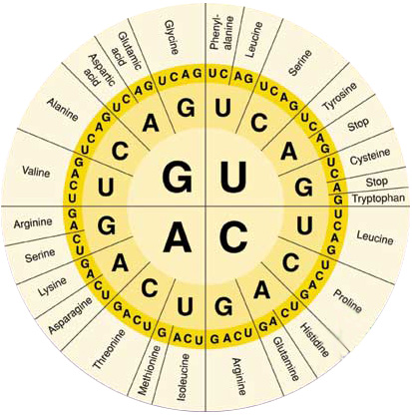

**Name___________ Date______________**

Station # ________

**Horseshoe Crab**

**A Prehistoric Creature!**

*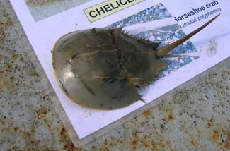  
Although sharp, the tail of the horseshoe crab  
is not poisonous*

**Interesting Facts**

* The horseshoe crab (*Limulus polyphemus*) is often referred to as a living fossil, and is thought to have evolved more than 200 million years ago!
* Although the word "crab" is part of its name, the horseshoe crab is more closely related to spiders and scorpions than to true crabs.
* Their blood is blue (caused by the presence of hemocyanin - human blood is red because of the presence of hemoglobin), and it has unique bacteria fighting ability which is used by pharmaceutical and biomedical industries for important medical research and testing.
* Horseshoe crabs feed on a variety of marine worms, mollusks, and other small marine animals.
* These prehistoric creatures can grow to about 20 inches (51cm) in width, that's almost 2 feet wide!
* Their eggs are an essential food source for many migrating shorebirds, including red knots, semipalmated sandpipers, sanderlings and dowithers, and their eggs and larvae are consumed by many fish such as American eel, killifish, weakfish, silversides, summer flounder and winter flounder.

**Where Are They Found?**

Horseshoe crabs are found from Nova Scotia in Canada to the Yucatan Peninsula in Mexico. In New York they are found year-round in Long Island Sound, Great South Bay, and in other areas along the coast of New York.

**When Can They be Spotted?**

In the spring horseshoe crabs come to the shore to spawn. Thousands can be seen along the shorelines of Long Island making the shore quite a sight to see. The spawning season is usually in May and June, and tends to peak at night around the new and full moons.

**Volunteer for Horseshoe Crab Research**

Come out and help us track spawning horseshoe crabs! The horseshoe crab spawning survey is conducted annually during the spawning season (May-June) to monitor the relative abundance of horseshoe crabs in New York's coastal waters. NYSDEC and Cornell University Cooperative Extension's Marine Program work together to develop and organize this project, which helps in the management and conservation of this significant species. For more information on the survey and to find out how you can become a volunteer, visit ***www.nyhorseshoecrab.org*** (*a direct link to this website can be found in the right hand column under Links Leaving DEC's Website*).

**Harvest Information**

Horseshoe crabs are used as bait in fisheries, but are not typically eaten for a meal. Before harvesting horseshoe crabs be sure to contact the DEC Bureau of Marine Resources (*contact information can be found in the right hand column*) for current information on open seasons, permits and harvest regulations. Details of the regulations can be found in [6 NYCRR Part 44](http://www.dec.ny.gov/regs/4011.html). A recreational limit of 5 horseshoe crabs per day may be taken but the crabs may not be offered for sale and must be for the harvester's own personal use.

Name________________________________ Date__________________________

Station # ________

1. Look at the horseshoe crabs. Names 3 adaptations you notice.

_________________________________

_________________________________

_________________________________

1. How do these adaptations help them survive?

__________________________________________________________________________________________________________________________________________________________________________________________________________________________________________________________________________________________________

1. What do the horseshoe crabs do in late spring, May and June?
2. Die
3. Come together to breed/reproduce
4. Hibernate
5. Party
6. List 3 different animals that feed on horseshoe crab eggs.

_______________________________________

_______________________________________

_______________________________________

1. Are horseshoe crabs a keystone species? Yes or No
2. What do horseshoe crabs use their telson (tail) for? __________________________________________________________
3. Where does the horseshoe crab name come from? ____________________________________________________________________________________________________________________
4. Is the male or female horseshoe crab larger? ____________________
5. What is the lifespan for horseshoe crabs? ________________________
6. What are pheromones? ____________________________________

___________________________________________________________

1. How long have horseshoe crabs been around for? ____________________________________________________________________________________________________________________
2. What do they eat? ________________________________________

Name_________________________ Date__________________________

Station # ________

**Match the terms with the definitions below**

1. Evolution _________ A. Organelle found in autotrophs/producers.

Organelle where photosynthesis occurs.

2. Mitochondria _________ B. Compound composed of carbon and

hydrogen atoms.

3. Chloroplast __________ C. Speeds up the rate of chemical reactions.

Functions based on shape.

4. Adaptation __________ D. Process that creates the biodiversity

you see in the world today.

5. Enzyme ____________ E. Organelle that synthesizes ATP

6. Organic _____________ F. A trait (physical or behavioral) that

gives the organism an advantage

in their environment

7. Genetic Engineering ____________ G. Change in inherited characteristics

of biological populations over many

generations

8. Biodiversity _______________ H. Directly manipulating the genes of an

organisms Ex, Goats that produce spider

silk

9. Natural Selection _______________ I. Humans controlling plant and animal

reproduction to get desired traits

in the next generation

10. Artificial Selection _____________ J. The differences/variations in life

Name_________________________ Date__________________________

Station # ________

**What causes variations within populations?**

1. **Mutations**
2. **Asexual reproduction**
3. **Sexual reproduction**
4. **Both a and c**
5. **What does the term resistant mean? _________________________________________**

**________________________________________________________________________**

1. **How do populations become resistant? _______________________________________**

**________________________________________________________________________**

**________________________________________________________________________**

1. **How can the development of resistant insects or bacteria create a danger to humans and other organisms?**

**________________________________________________________________________________________________________________________________________________________________________________________________________________________________________________________________________________________________**

1. **How can we try to prevent the creation of pesticide and antibiotic resistant organisms?**

**________________________________________________________________________________________________________________________________________________________________________________________________________________________________________________________________________________________________**

Name________________________________ Date__________________________

Station # ________

**Discover the health risks.**



More than 65 million adults and 10 million children suffer from obesity, considered one of the leading causes of life-threatening diseases. Being morbidly obese can compromise your health, shorten your life, and even cause death. If you are overweight, the probabilities of developing heart disease, diabetes, and high blood pressure increase significantly. Here are the top 10 obesity-related diseases.

**1. High Blood Pressure —** [High blood pressure](http://www.webmd.com/hypertension-high-blood-pressure/guide/understanding-high-blood-pressure-basics) is the primary cause of death among Americans older than 25. About 75 million people suffer from high blood pressure or hypertension, which is a major risk factor for heart disease. Blood pressure tends to increase with weight gain and age. It is not known why obesity is a major cause of high blood pressure. However, research has shown that obese patients displayed an increase in blood volume and arterial resistance. For people who are overweight and have high blood pressure, losing as little as 8 pounds can help reduce blood pressure to a safe level.

**2. Diabetes —** Obesity is considered one of the most significant factors in the development of insulin resistance, and insulin resistance can lead to type 2 diabetes. According to the World Health Organization, more than 90 percent of diabetes patients worldwide have type 2 diabetes. Being overweight or obese contributes to the development of diabetes by making cells more resistant to the effects of insulin. A weight loss of 15-20 pounds can help you decrease your risk of developing type 2 diabetes. Read: [Exercising with Diabetes](https://www.mediweightlossclinics.com/patients/resources/articles/Exercising-with-Diabetes/).

**3. Heart Disease —** According to the [American Heart Association](http://www.heart.org/), obesity is a major risk factor for developing coronary heart disease, which can lead to a heart attack or stroke. People who are overweight are at a greater risk of suffering a heart attack before the age of 45. Obese adolescents have a greater chance of having a heart attack before the age of 35 than non-obese adolescents. If you are overweight, losing 10-15 pounds can reduce your risk of developing heart disease. If you exercise regularly, the risk of developing heart disease falls even more. Read: [Benefits of Cardiovascular Exercise](http://www.mediweightlossclinics.com/patients/resources/articles/benefits-of-cardio/).

**4. High Cholesterol levels —** High cholesterol is one of the leading causes of heart attacks. Cholesterol is transported through your blood in two ways: the low –density lipoprotein (LDL), which transports cholesterol to the cells that need it, and the high-density lipoprotein (HDL), which is the healthy cholesterol that reduces your risk for heart attack. Having high LDL levels raises your risk of having heart disease by 20 percent. Losing 11-20 pounds can help you significantly reduce your cholesterol level.

**5. Cancer —** A study by the [American Heart Association](http://www.heart.org/) found that being overweight increases your chances for developing cancer by 50 percent. Women have a higher risk of developing cancer if they are more than 20 pounds overweight. Regular exercise and a weight loss of as little as 12 pounds can significantly decrease the risk.

**6. Infertility —** Being obese can cause changes in the hormonal levels of women, which can result in ovarian failure. Women who are 15-25 pounds overweight are at a higher risk of suffering from infertility and ovarian cancer. Our bodies need to be at an appropriate weight to produce the right amount of hormones and regulate ovulation and menstruation. Don’t think men are immune to infertility. Overweight men have a greater chance of developing motility and a lower sperm count. Shedding 12-14 pounds can help you lower the risks.

**7. Back Pain —** Obesity is one the contributing factors of back and joint pain. Excessive weight can cause injury to the most vulnerable parts of the spine, which carries the body’s weight. When it has to carry excess weight, the odds of suffering from a spinal injury or structural damage increase. Being overweight also raises the risk of developing osteoporosis, lower back pain, arthritis, and osteoarthritis. Losing 10-15 pounds can help you decrease the risk of developing these problems.

**8. Skin Infections —** Obese and overweight individuals may have skin that folds over on itself. These creased areas can become irritated from the rubbing and sweating, which can lead to skin infections.

**9. Ulcers —**According to a study by the [National Institutes of Health (NIH)](http://www.nih.gov/), obesity can be a contributing factor to the development of gastric ulcers. Gastric ulcers occur when there is an imbalance between the amount of hydrochloric acid that is secreted and the enzyme pepsin. Overweight men are at a greater risk of developing gastric ulcers than women. A weight loss of as little as 7 pounds can help reduce the risk.

**10. Gallstones —**Being severely overweight increases the risk of developing gallstones, especially in women. Gallstones are caused when the liver releases excessive amounts of bile, which is stored in the gallbladder. Gallstones are more common in older women and those with a family history of gallstones. Losing 4-9 pounds reduces the risk of developing gallstones. Moderate exercise also can help lower your risk.

**It's not just about a smaller waistline.**

Most Americans want to lose weight, but for [diabetics](http://diabetes.webmd.com/guide/understanding-diabetes-basics), maintaining a healthy [BMI](http://www.mediweightlossclinics.com/patients/resources/bmi-calculator/) is vital. Diabetics who are overweight often experience high blood pressure and are at an elevated risk for diabetes complications.

[WebMD.com](http://www.webmd.com/) spoke with Cathy Nonas, MS, RD, a spokeswoman for the [American Dietetic Association](http://www.diabetes.org/) and a professor at Mount Sinai School of Medicine, who explained that dropping a few pounds can be extremely beneficial for an individual's overall well-being.

"We know it's true that if someone with [diabetes](http://diabetes.webmd.com/guide/understanding-diabetes-basics) loses 5 to 10 percent of their weight, they will significantly reduce their blood sugar," she said.

Of course, beginning a diet is never a simple task, and people often need help from different outlets. Because of this, diabetics may want to consider looking into a weight loss program that will take their overall health into consideration.

Medi-Weightloss Clinics® will provide an in-depth medical consultation and devise a custom diet and exercise plan for individuals looking to become slimmer, healthier and ultimately happier.

**The benefits of participating in a regular exercise routine go far above and beyond weight management.**

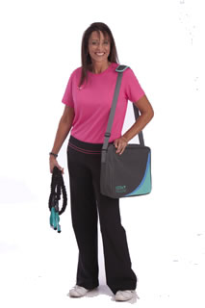

The benefits of participating in a regular exercise routine go far above and beyond weight management. Research has proven that exercise can help decrease your risk of developing a number of diseases and improve your overall quality of life. Here are just a few benefits of [incorporating exercise](http://www.mediweightlossclinics.com/patients/resources/articles/fitness-lifestyle/) into your life.

**Improves bone health:**Regular weight-bearing exercise, such as walking, running, or resistance exercise, helps promote healthy bone growth, delays bone loss, and may protect against osteoporosis, a form of bone loss associated with aging.

**Prevents and controls diabetes:**The Finnish Diabetes Prevention Study (DPS) is the first individually randomized controlled clinical trial to test the effects of lifestyle modification in individuals with a high-risk of developing diabetes. The DPS study results showed that type 2 [diabetes can be prevented](https://www.mediweightlossclinics.com/patients/resources/articles/Exercising-with-Diabetes/) by making changes in lifestyle, including improving diet and exercising.

**Improves mood:**A recent study showed the antidepressant effect of regular physical exercise to be as effective at boosting mood as antidepressant medication. Individuals in the study exercising at least 30 minutes a day three times a week showed decreased symptoms of depression and elevated mood.

**Helps lower cholesterol:**Exercise has been shown to improve cholesterol levels by decreasing LDL (bad) cholesterol, triglycerides and total cholesterol and increasing HDL (good) cholesterol.

**Lowers blood pressure:**A recent study analyzed the effects of exercise on individuals suffering from [hypertension (high blood pressure)](http://www.webmd.com/hypertension-high-blood-pressure/guide/understanding-high-blood-pressure-basics). Results concluded that exercise can help decrease blood pressure and recommends exercise be used in the management of hypertension both in untreated hypertensive patients and for individuals at high-risk for developing hypertension.

**Enhanced cardiovascular health:**One of the primary risk factors for [cardiovascular disease](http://www.webmd.com/heart-disease/guide/diseases-cardiovascular) is lack of physical activity. A number of studies have shown that individuals who exercise decrease their risk of having a heart attack or stroke. [Regular physical exercise](http://www.mediweightlossclinics.com/patients/resources/articles/benefits-of-cardio/) increases the strength of your heart, and a strong heart can pump more blood with less effort.

With the countless benefits of exercise, it is critical each and every Medi-Weightloss Clinics® patient incorporate physical activity into his/her life.

**Questions**

1. How many adults suffer from obesity? _________________________
2. How many children? _____________________________
3. What increases significantly if you’re overweight? _____________________________________________________

______________________________________________________________________________________________

1. What is the primary cause of death of individuals over the age of 25? ____________________________
2. High blood pressure/Hypertension is a major risk factor for _________________ ____________________.
3. If you’re overweight, losing weight can help you reduce your blood pressure. (True or False)
4. What percent of diabetes patients worldwide have diabetes? __________________________

Which type of diabetes? __________________________

1. How does being overweight contribute to the development of diabetes?____________________________________

_______________________________________________________________________________________________

1. What can coronary heart disease lead to? ____________________________________________________________
2. Who has a greater chance of having a heart attack before age 35? ________________________________________
3. List two ways to reduce your risk of heart disease. _____________________________________________________

______________________________________________________________________________________________

1. What is the leading cause of heart attacks? _______________________________________________________
2. What are the 2 ways that cholesterol is transported through your blood? __________________________________

______________________________________________________________________________________________

1. Which cholesterol is good? __________________________________________
2. Being overweight increases your risk for getting cancer by ____________________ percent.
3. What is infertility? __________________________________________________________________
4. What do our bodies need to produce the right amount of hormones? ______________________________________

______________________________________________________________________________________________

1. How is back and joint pain connected to excess weight? _________________________________________________

______________________________________________________________________________________________

1. List 3 other health problems that are associated with being overweight. _____________________________________________________________________________________________________________________________________________________________________________________________________________________________________________________________________________________________

Describe how a regular exercise routine can help you more than just managing your weight. ______________________________________________________________________________________________________________________________________________________________________________________________________________________________________________________________________________________________________

Name________________________________ Date__________________________

Station # ________

1. Which elements do carbohydrates contain?

1) carbon, nitrogen and potassium

2) carbon, hydrogen and oxygen

3) nitrogen, carbon and hydrogen

4) nitrogen, carbon, phosphorus and nitrogen

2) Which choice best defines nutrition?

a) working out to maintain an attractive physique

b) ingesting food and changing it into a usable form

c) eating large amounts of complex carbohydrates and lipids

d) drinking at least 64 ounces of soda each day

3) Which one is not a nutrient that your body needs to function?

a) water

b) tomato sauce

c) vitamins

d) carbohydrates

4) The primary solvent in the body, which is essential for most chemical reactions to

occur is __________.

1. water
2. sugar
3. fat
4. vitamins

5) What are trace elements?

a) elements that the body needs in very small amounts

b) another name for vitamin C

c) a vitamin that is not needed by the body

d) disorders caused by lack of water

6) How does matter move through the environment and living things?

a) it decreases as it passes through the environment

b) it decreases as it passes through organisms

c) it is cycled through

b) no one knows for sure

7) Which choice includes **only** minerals?

a) calcium, carbohydrates and iron

b) proteins, iron, potassium and carbohydrates

c) calcium, potassium, zinc and iron

d) B-12, potassium, calcium, lipids and iron TURN OVER

8) Which choice best defines anorexia nervosa?

a) an eating disorder characterized by an intense fear of being fat

b) an eating disorder characterized by overeating and then vomiting

c) an eating disorder characterized by working out three times a week

d) an eating disorder characterized by being lazy and never exercising

9) A balanced diet is best described as…

a) a diet that contains a variety of the basic food groups

b) a diet that contains lots of carbohydrates and no fats/oils

c) a diet that contains lots of fruits and vegetables

d) a diet composed of lots of water and exercise

10) What happens to food during the process of digestion?

a) it is broken down and then removed from the body

b) it is set to the circulatory system

c) it is broken down into a form that can be absorbed and used for energy

d) it is set to glands

11) Which choice best defines synthesis?

a) process by which complex molecules are broken down to form simple molecules

b) process by which simple molecules chemically combine to form more complex

molecules

c) maintaining a stable external environment

d) using the brain to regulate all of the life processes

12) How can you prepare for a hurricane or another natural disaster to keep your family safe.

Outline 5 things you should do to prepare.

______________________________________________________________________________________________________________________________________________________________________________________________________________________________________________________________________________________________________

Name________________________________ Date__________________________

Station # ________

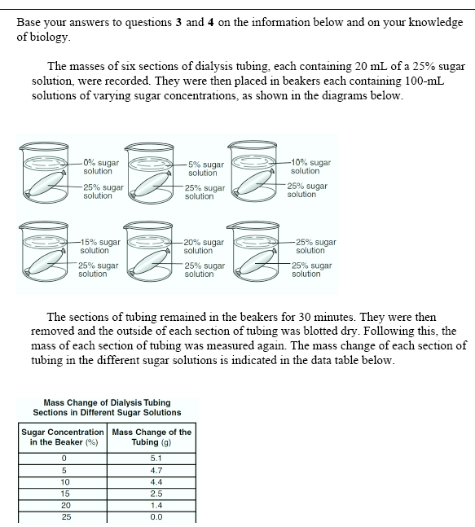

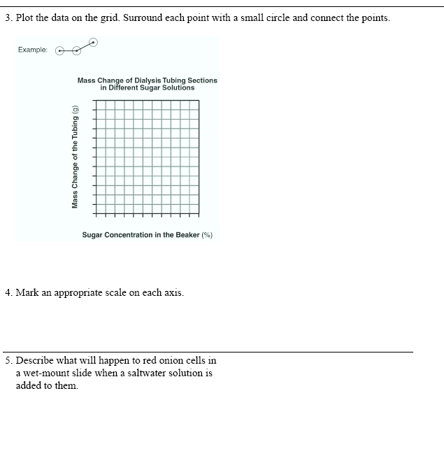

**_______________________________________**

**6. Draw a picture of a red onion cell after is was placed in a salt solution.**

Name________________________________ Date__________________________

Station # ________

**Graphing Activity**

1.    Use the data in the table below to complete the graph provided.  Remember to title your  
       graph, label the axes properly when setting up your scale, make a key, and to write a legend   
       for your graph when completed.

|  |  |  |
| --- | --- | --- |
| **Depth in meters** | **Number of bubbles/min Plant A** | **Number of Bubbles/min Plant B** |
| 2 | 29 | 21 |
| 5 | 36 | 27 |
| 10 | 45 | 40 |
| 16 | 32 | 50 |
| 25 | 20 | 34 |
| 30 | 10 | 20 |



Legend: __________________________________________________________________________

Answer the following questions based on the graph above you just completed.

2.   What is the independent variable?  __________________________________________________

3.   Why is this the independent variable? ________________________________________________

       ____________________________________________________________________________

4.   What is the dependent variable?  ___________________________________________________

5.   Why is this the dependent variable?  _________________________________________________

       ____________________________________________________________________________

6.    Use one or more complete sentences to state a conclusion about the data in graph # 1.

        ____________________________________________________________________________

Name________________________________ Date__________________________

Station # ________

**Graphing Activity**

Diabetes is a disease affecting the insulin producing glands of the pancreas.   If there is not enough insulin being produced by the cells, the amount of glucose in the blood will remain high.   A blood glucose level above 140 for an extended period of time is not considered normal.    This disease, if not brought under control, will lead to severe complications and even death.

1.    Use the data in the table below to complete the graph provided.  Remember to title your  
       graph, label the axes properly when setting up your scale, make a key, and to write a legend   
       for your graph when completed.

|  |  |  |
| --- | --- | --- |
| **Time After Eating (hrs.)** | **Glucose Level in ml/liter of blood in person A** | **Glucose Level in ml/liter of blood in person B** |
| 0.5 | 170 | 180 |
| 1 | 155 | 195 |
| 1.5 | 140 | 230 |
| 2 | 135 | 245 |
| 2.5 | 140 | 235 |
| 3 | 135 | 225 |
| 4 | 130 | 200 |



Legend: ________________________________________________________________________

Answer the following questions based on the graph above you just completed.

2.   What is the independent variable?  __________________________________________________

3.   Why is this the independent variable? ________________________________________________

       ____________________________________________________________________________

4.   What is the dependent variable?  ___________________________________________________

5.   Why is this the dependent variable?  _________________________________________________

       ____________________________________________________________________________

6.   Which, if any of the above individuals has diabetes?    Be sure to justify your answer!

      _____________________________________________________________________________

     ______________________________________________________________________________

7.  If the time period were extended to 6 hours, what would be the expected blood sugar level for   
     Person B?    __________

8.  What would be a probable blood sugar level for person B at 3.5 hours?    ________

9.   Use one or more complete sentences to state a conclusion about graph # 2.

      _____________________________________________________________________________

      _____________________________________________________________________________

Name________________________________ Date__________________________

Station # ________

The data table shows water temperatures at various depths in an ocean.

**Water Temperatures at Various Depths**

|  |  |
| --- | --- |
| **Water Depth  (meters)** | **Temperature** (°C) |
| 50 | 18 |
| 75 | 15 |
| 100 | 12 |
| 150 | 5 |
| 200 | 4 |

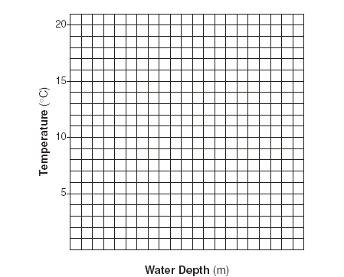  
  
  
Using the information in the data table, construct a line graph on the grid, following the directions   
below:

-- Mark an appropriate scale on the axis labeled "Water Depth (m).

-- Plot the data on the grid. Surround each point with a small circle and connect the points  
  
Example:    http://www.ekcsk12.org/faculty/jbuckley/lelab/graphi4.gif  
  
**Problems Based on Graphing Set One**  
  
.1. Using a complete sentence, state the general relationship between temperature and water depth.

2.  The approximate water temperature at a depth of 125 meters would be closest to   (1) 15°C   
     (2) 8°C   (3) 13°C  (4) 3°C

A student counted the total number of leaves in a group of duckweed plants   
(*Lemna gibba*) over a 5-day period. The data collected are shown in the table below.  
  
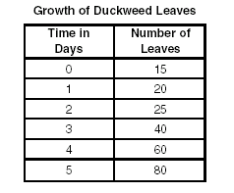

Using the information in the data table, construct a line graph on the grid provided following the directions below.  
  
  
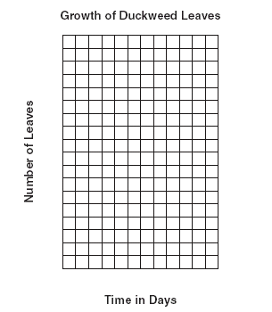

-- Mark an appropriate scale on each labeled axis.

-- Plot the data from the data table. Surround each point with a small circle and connect the points.

Example:    http://www.ekcsk12.org/faculty/jbuckley/lelab/graphi4.gif  
  
**Problems Based on Graphing Set Two**   
  
1.   The time it takes for the number of leaves to increase from 15 to 30 is approximately  
      (1.) 2.0 days   (2.) 2.3 days   (3.) 2.9 days  (4.) 3.2 days

2.  Using a complete sentence, state what would most likely happen to the production of oxygen   
     by duckweed plants if the intensity and duration of exposure to light were increased.

Name________________________________ Date__________________________

Station # ________

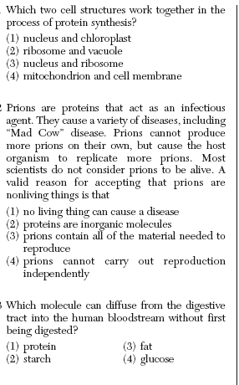

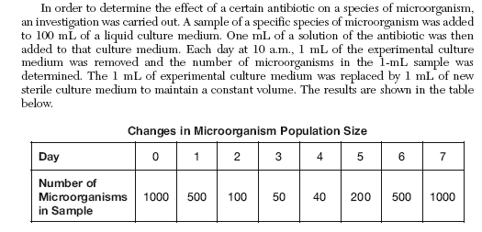

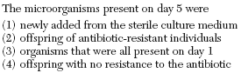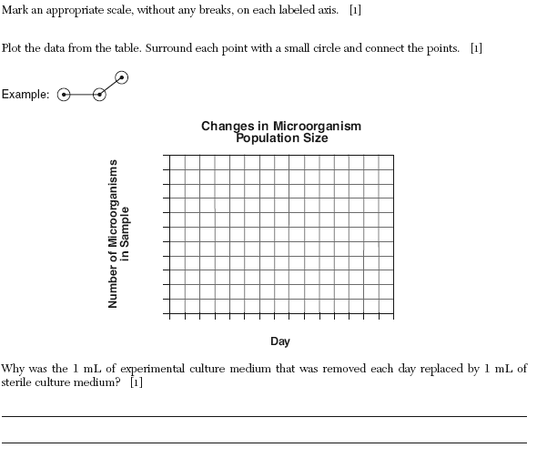

Name________________________________ Date__________________________

Station # ________

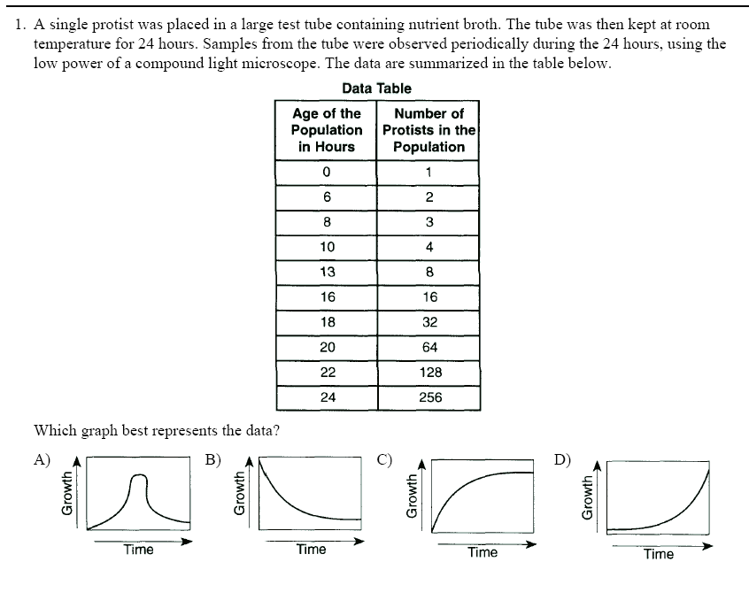

Turn OVER

Base your answers to questions **2** through **4** on the information and data table below.

One milliliter of a solution containing an even distribution of a species of bacterium was spread on the

surface of a nutrient medium in each of five culture dishes. The nutrient medium in each dish was the

same, except for pH. The dishes were then incubated at 37ºC for 24 hours. The number of bacterial

colonies in each dish was then counted, and the results are represented in the data table below.

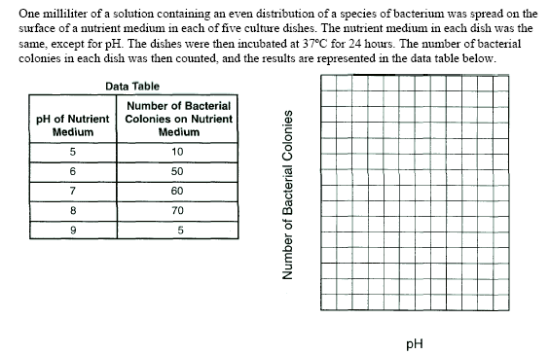

2. Plot the data for the number of bacterial colonies on the grid. Surround each point with a small circle and

3. Using one or more complete sentences, state a conclusion that relates the number of colonies of the species of bacterium to pH.

________________________________________________________________________________________________________________________________________________________________

________________________________________________________________________________

4. The limiting factor in this investigation is the

A) pH of the nutrient medium

B) species of bacterium in each culture dish

C) color of the colonies of bacteria

D) amount of nutrient medium in each culture dish

**Name_________________ Date_________**

**Graphing Rules**

Station # ________

1. **List graphing procedures/rules.**

**GRAPHING RULES**

* **______________________________________________**
* **______________________________________________**
* **______________________________________________**
* **______________________________________________**
* **______________________________________________**
* **______________________________________________**
* **______________________________________________**
* **______________________________________________**
* **______________________________________________**
* **______________________________________________**
* **______________________________________________**
* **______________________________________________**
* **______________________________________________**

1. **Why is it important to follow all graphing rules? ____________________________________________________________________________________________________________________________________________________________________________________________________________________________________________________________________**
2. **Use the data below to make a line graph. Make sure you follow all the graphing procedures/rules.**

**Independent Variable ____________________________________________**

**Dependent Variable_____________________________________________**

|  |  |
| --- | --- |
| **Percent of CO2 in Exhaled air** | **Number of Mosquitoes attracted to site** |
| **2** | **2** |
| **3** | **2** |
| **4** | **3** |
| **5** | **4** |
| **6** | **5** |
| **7** | **5** |
| **8** | **7** |
| **9** | **9** |
| **10** | **12** |



**Using the data above describe the relationship between the level of CO2 in exhaled air and mosquito attraction.**

**____________________________________________________________**

**____________________________________________________________**

**Name________________________ Date_________________**

Station # ________

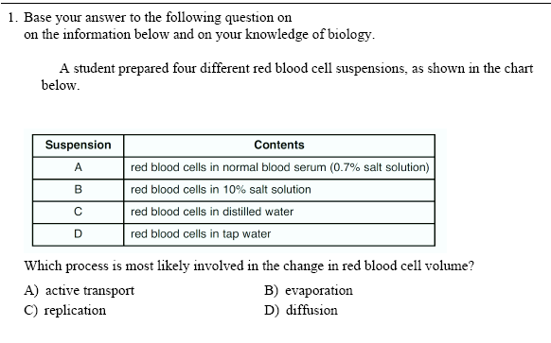

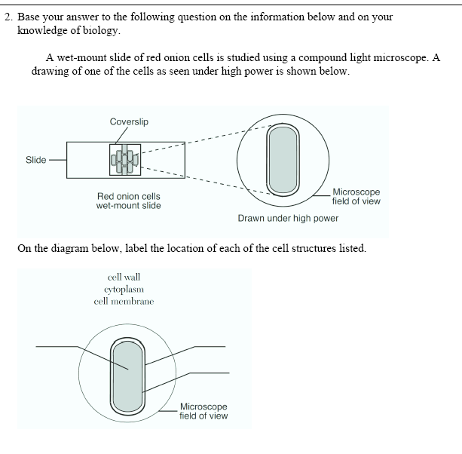

3) Draw the beaker and cell you set up in class. Fill in the before and after using

the compounds we added to the cells.

S = Starch

G = Glucose

H2O = Water

I = Iodine (Starch Indicator)

4) Which Molecules diffused? ____________________________

Name________________________________ Date__________________________

Station # ________

Base your answer to the next 4 questions on the passage below and on your knowledge of biology.

Blown Away **Head Lice Meet Hair Dryer of Death**

Head lice are becoming indestructible. A study found that as many as 80 percent of the bugs are [resistant] to insecticides in over-the-counter shampoos, and resistance will only increase. Evolutionary biologist Dale Clayton may have a new line of attack.

Clayton, who usually studies lice on bird feathers, stumbled onto his solution after a major research setback. When he moved his laboratory from England to the University of Utah a decade ago, his entire louse collection perished in the dry desert air. Soon after, his 8-year-old came home from school with head lice. He wondered if human head lice could also be killed by drying them out. "It was sort of a forehead slapper," Clayton says. After conventional hair dryers failed, Clayton came up with the LouseBuster, a 10-pound device resembling a vacuum cleaner that desiccates [dries out] the bugs with a jet of 140-degree air [140°F]. "It's a pretty brutal assault," he says. Tests show the invention is both safe and effective, eradicating 80 percent of live lice and 98 percent of eggs, leaving survivors unable to breed. And, Clayton says, "it will be awfully hard for lice to develop resistance."

Source: Emily Saarman, "Blown Away—Head Lice Meet Hair Dryer of Death,"

*Discover Magazine*, February 2007

|  |  |
| --- | --- |
|  |  |

Design a controlled experiment to determine the effect of hot, dry air on head lice. You experiment should include.

* State the hypothesis being tested
* Identify the independent variable
* Identify the dependent variable
* State one way the control group will differ from the experimental group
* State *one* result of the experiment that would support the hypothesis
* State how Clayton first learned the desiccating (drying out) lice kills them

________________________________________________________________________________________________________________________________________________________________________________________________________________________________________________________________________________________________________________________________________________________________________________________________________________________________________________________________________________________________________________________________________________________________________________________________________________________________________________________________________________________________________________________________________________________________________________________________________________________________________________________________________________________________________

Name________________________________ Date__________________________

Station # ________

**Scientific Method In Action**

**The Strange Case of BeriBeri**

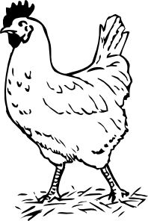*In 1887 a strange nerve disease attacked the people in the Dutch East Indies. The disease was beriberi. Symptoms of the disease included weakness and loss of appetite, victims often died of heart failure. Scientists thought the disease might be caused by bacteria. They injected chickens with bacteria from the blood of patients with beriberi. The injected chickens became sick. However, so did a group of chickens that were not injected with bacteria.*

*One of the scientists, Dr. Eijkman, noticed something. Before the experiment, all the chickens had eaten whole-grain rice, but during the experiment, the chickens were fed polished rice. Dr. Eijkman researched this interesting case and found that polished rice lacked thiamine, a vitamin necessary for good health.*

1. State the Problem

2. What was the hypothesis?

3. How was the hypothesis tested?

4. Should the hypothesis be supported or rejected based on the experiment?

5. What should be the new hypothesis and how would you test it?

**How Penicillin Was Discovered**

*In 1928, Sir Alexander Fleming was studying Staphylococcus bacteria growing in culture dishes. He noticed that a mold called Penicillium was also growing in some of the dishes. A clear area existed around the mold because all the bacteria that had grown in this area had died. In the culture dishes without the mold, no clear areas were present.*

*Fleming hypothesized that the mold must be producing a chemical that killed the bacteria. He decided to isolate this substance and test it to see if it would kill bacteria. Fleming transferred the mold to a nutrient broth solution. This solution contained all the materials the mold needed to grow. After the mold grew, he removed it from the nutrient broth. Fleming then added the nutrient broth in which the mold had grown to a culture of bacteria. He observed that the bacteria died which was later used to develop antibiotics used to treat a variety of diseases.*

6. Identify the problem.

7. What was Fleming's hypothesis?

8. How was the hypothesis tested?

9. Should the hypothesis be supported or rejected based on the experiment?

10. This experiment lead to the development of what major medical advancement?

**Name___________________________ Date___________**

Station # ________

**Life Elements (Carbon, Hydrogen, Oxygen, Nitrogen and Phosphorus)**

**Use your Periodic Table to fill in the information for each element listed below.**

1. **Element Name________________________**

**Symbol ___________________________**

**Atomic Number ____________________**

**Atomic Mass/Weight_________________**

**Number of Protons __________________**

**Number of Electrons__________________**

**Number of Neutrons__________________**

1. **Element Name________________________**

**Symbol ___________________________**

**Atomic Number ____________________**

**Atomic Mass/Weight_________________**

**Number of Protons __________________**

**Number of Electrons__________________**

**Number of Neutrons__________________**

1. **Element Name________________________**

**Symbol ___________________________**

**Atomic Number ____________________**

**Atomic Mass/Weight_________________**

**Number of Protons __________________**

**Number of Electrons__________________**

**Number of Neutrons__________________**

1. **Element Name________________________**

**Symbol ___________________________**

**Atomic Number ____________________**

**Atomic Mass/Weight_________________**

**Number of Protons __________________**

**Number of Electrons__________________**

**Number of Neutrons__________________**

1. **What is a compound? _____________________________________________**

**________________________________________________________________**

1. **Describe a chemical reaction that is important for living things.**

**________________________________________________________________________________________________________________________________________________________________________________________________**

**Name___________________ Date________________**

Station # ________

1. **What is the symbol for carbon?**
2. **What is the atomic # for carbon?**
3. **How many protons does carbon have?**
4. **What does the atomic # of an element represent?**
5. **What is the atomic mass for carbon?**
6. **How many neutrons does carbon have**
7. **What does the atomic mass of an element represent?**
8. **How many electrons does carbon have?**

**Name______________________ Date_________________**

Station # ________

**Use the textbook page__________________ to fill in the two columns. Please provide examples of compounds that fit into each category.**

**Ionic Bond Covalent Bond**

|  |  |
| --- | --- |
|  |  |

**1) What are valence electrons? ___________________________________________**

**______________________________________________________________________**

**2) Why are valence electrons important to understand when learning about different types of chemical bonds? _________________________________________**

**____________________________________________________________________________________________________________________________________________**

**3) How many electrons fit in the first shell/orbital? __________ Second? _________ Third? ______________ Fourth? ______________**

Name_____________ Date__________

Station # ________

All You Need To Know About H2O

Brainstorm 🡪 List 10 important functions or properties of water

________________________________________________________________________________________________________________________________________________________________________________________________________________________________________________________________________________________________________________________________________________________________________________________________________________________________________________________________________________________

Properties of H2O Check List

1. Each water molecule is composed of ____ Hydrogen and ____ Oxygen
2. A water molecule is formed using covalent bonds

( _______________________________________________________)

1. How many electrons in hydrogen? _______________

How many electrons in oxygen? _________________

Use your periodic tables if you forgot.

1. Drawing a water molecule activity.

|  |
| --- |
|  |

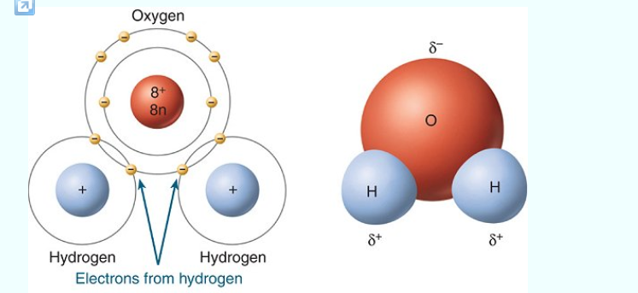

1. How does one water molecule attach to another water molecule?

_____________________________________________________________________________________________________________________________________________________________________________________________________________________________________________________________________________________________

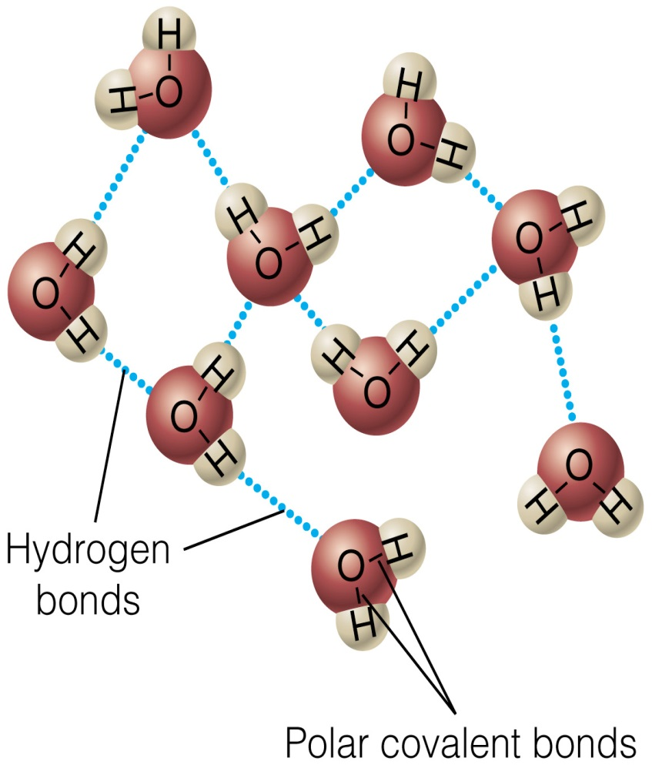

|  |
| --- |
|  |

Name_____________ Date__________

Station # ________

Highlight 5 facts you find interesting and complete the demonstration for cohesion and adhesion.

Cool Facts about H2O

|  |
| --- |
| * **Water is made up of two elements,** [**hydrogen**](http://www.sciencekids.co.nz/sciencefacts/chemistry/hydrogen.html) **and** [**oxygen**](http://www.sciencekids.co.nz/sciencefacts/chemistry/oxygen.html)**. Its chemical formula is H2O.** * **Each molecule of water is made up of two hydrogen atoms bonded to a single oxygen atom.** * **Your trillions of cells are filled with a watery substance called cytoplasm** * **The existence of water is essential for life on Earth.** * **Water has three different states, liquid, solid and gas.** * **The word water usually refers to water in its liquid state. The solid state of water is known as ice while the gas state of water is known as steam or water vapor.** * **Water covers around 70% of the Earth’s surface.** * **The three largest oceans on Earth are the Pacific Ocean (largest), the Atlantic Ocean (second largest) and the Indian Ocean (third largest).** * **Found in the Pacific Ocean, the Mariana Trench is the deepest known point in the world’s oceans.** * **Ocean tides are caused by the rotation of the Earth and the** [**gravitational**](http://www.sciencekids.co.nz/sciencefacts/gravity.html) **pull of the Moon and Sun acting on ocean water.** * **Water from a sea or ocean is known as seawater. On average, every kilogram (2.2lb) of seawater contains around 35 grams (1.2 oz) of dissolved salt.** * **The freezing point of water lowers as the amount of salt dissolved in at increases. With average levels of salt, seawater freezes at -2 °C (28.4 °F).** * **The longest river in the world is the** [**Nile River**](http://www.sciencekids.co.nz/sciencefacts/earth/nileriver.html)**, it reaches 6650 kilometers in length (4132 miles).** * **The second longest river in the world is the** [**Amazon River**](http://www.sciencekids.co.nz/sciencefacts/earth/amazonriver.html)**, it reaches 6400 kilometres (4000 miles) in length.** * **The longest river in the USA is the Missouri River. At around 2,340 miles (3,770 km) in length it is slightly longer than the** [**Mississippi River**](http://www.sciencekids.co.nz/sciencefacts/earth/mississippiriver.html) **(2,320 miles). The two combine to form the longest river system in North America.** * **Water makes a good solvent with many sugar, salts and acids easily dissolving in it. On the other hand oils and fats don’t mix well with water.** * **The water cycle involves water evaporating (turning into a gas), rising to the sky, cooling and condensing into tiny drops of water or ice crystals that we see as clouds, falling back to** [**Earth**](http://www.sciencekids.co.nz/sciencefacts/earth.html) **as rain, snow or hail before evaporating again and continuing the cycle. Learn more about** [**the water cycle**](http://www.sciencekids.co.nz/sciencefacts/weather/thewatercycle.html)**.** * **Water in the form of ice is found at the polar ice caps of the planet** [**Mars**](http://www.sciencekids.co.nz/sciencefacts/planets/mars.html)**, some scientists have also suggested the possibility of liquid water on the red planet.** * **Pure water has no smell and no taste, it also has a pH level around 7.** * **While most people know that water boils at 100 °C (212 °F), this is at the normal conditions of sea level. The boiling point of water actually changes relative to the barometric pressure. For example, water boils at just 68 °C (154 °F) on the top of Mount Everest while water deep in the ocean near geothermal vents can remain in liquid form at temperatures much higher than 100 °C (212 °F).** * **Water expands as it cools from 4 °C to 0 °C (above 4 °C it does the opposite). In freezing conditions, water has been known to burst water pipes as it freezes to ice.** * **Water can move up narrow tubes against the force of gravity in what is known as capillary action. Check out this** [**capillary action experiment**](http://www.sciencekids.co.nz/experiments/escapingwater.html) **for more.** * **Most people around the world have access to clean drinking water but it is a major problem in poorer areas of the world. Water pollution and low quality water can lead to dangerous bacteria, disease and viruses such as E coli and Cryptosporidium.** * **Drinking water is needed for** [**humans**](http://www.sciencekids.co.nz/sciencefacts/humanbody.html) **to avoid dehydration, the amount you need each day depends on the temperature, how much activity you are involved in and other factors.** * **An important use for water is in agricultural irrigation, this is when water is artificially added to soil in order to assist the growth of crops.** * **Water is used frequently by firefighters to extinguish fires. Helicopters sometimes drop large amount of water on wildfires and bushfires to stop fires spreading and limit the damage they can cause.** * **The water industry helps deliver water to homes in various cities and countries around the world. This can involve services such as purification, sewage treatment, filtering, distillation and plumbing.** * [**Electricity**](http://www.sciencekids.co.nz/sciencefacts/electricity.html) **can be created from hydropower, a process that uses water to drive water turbines connected to generators. There are many hydroelectric power stations around the world.** * **Water also plays a role in cooking. Steaming and boiling food are well known cooking methods. You may have noticed this last time you made pasta or noodles.** * **Water is also used for fun. Water sports are a very popular recreational activity and include things like swimming, surfing and waterskiing. Ice and snow is also used in ice skating, ice hockey, skiing and snowboarding.** |

**How many drops of water can you get onto the surface of a penny?**

**Trial 1 -- ____________**

**Trial 2 -- ____________**

**Trial 3 -- ____________**

**Average - ___________**

* 1. **Which process is responsible for the attraction between the same molecules (ex; water to water)? __________________________**
  2. **Which process is responsible for the attraction between different types of molecules (Ex; water clinging to glass)? ______________________________________**
  3. **Describe how cohesion and adhesion were involved during the penny activity.**

**____________________________________________________________________________________________________________________________________________________________________________________________________________________________________________**

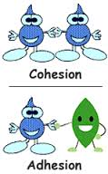

* 1. **Explain why the existence of water is necessary for life on Earth.**

**_____________________________________________________________________________________________________________________________________________________________________________________________________________________________________________________________________________________________**

**BONUS: Look it up for HW 🡪 How many water molecules are bonded together in an 8 ounce glass or water?**

Name_____________ Date__________

Station # ________

**pH Scale (Potential Hydrogen)**

**Use the textbook page__________________ to fill in the two columns. Please provide examples of compounds that fit into each category.**

**Write out Chemical equation**

**_______________ 🡪 ______________ + ______________**

**_______________ 🡪 ______________ + _______________**

|  |  |  |  |
| --- | --- | --- | --- |
| **Solution** | **Acid** | **Neutral** | **Base** |
| **pH range** |  |  |  |
| **# of Hydrogen ions (H+)** |  |  |  |
| **Examples** |  |  |  |

1. **What does pH measure? ______________________________**

**_____________________________________________________**

1. **Do all organisms live in environments with the same pH level?**

**__________________________________________________**

1. **How does the pH of an environment impact an organisms’ ability to live there?**

**____________________________________________________________________________________________________________________________________________________________**

1. **What do you think is the most acidic part of your body?**

**__________________________________________**

Name_____________ Date__________

Station # ________

**ACIDS AND BASES ARE EVERYWHERE**

Every liquid you see will probably have either acidic or basic traits. One exception might be distilled water. Distilled water is just water. That's it. The positive and negative ions in distilled water are in equal amounts and cancel each other out. Most water you drink has ions in it. Those ions in solution make something acidic or basic. In your body there are small compounds called amino acids. Those are acids. In fruits there is something called citric acid. That's an acid, too. But what about baking soda? When you put that in water, it creates a basic solution. Vinegar? Acid.   
  
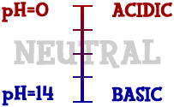Scientists use something called the **pH scale** to measure how acidic or basic a liquid is. Although there may be many types of ions in a solution, pH focuses on concentrations of hydrogen ions (H+) and hydroxide ions (OH-). The scale goes from values very close to 0 through 14. Distilled water is 7 (right in the middle). Acids are found between a number very close to 0 and 7. Bases are from 7 to 14. Most of the liquids you find every day have a pH near 7. They are either a little below or a little above that mark. When you start looking at the pH of chemicals, the numbers go to the extremes. If you ever go into a chemistry lab, you could find solutions with a pH of 1 and others with a pH of 14. There are also very stong acids with pH values below one such as battery acid. Bases with pH values near 14 include drain cleaner and sodium hydroxide (NaOH). Those chemicals are very dangerous.

**NAMES TO KNOW**

Here are a couple of definitions you should know:  
**Acid:** A solution that has an excess of H+ ions. It comes from the Latin word acidus that means "sharp" or "sour".   
**Base:** A solution that has an excess of OH- ions. Another word for base is alkali.  
**Aqueous:** A solution that is mainly water. Think about the word aquarium. AQUA means water.   
**Strong Acid:** An acid that has a very low pH (0-4).  
**Strong Base:** A base that has a very high pH (10-14).   
**Weak Acid:** An acid that only partially ionizes in an aqueous solution. That means not every molecule breaks apart. They usually have a pH close to 7 (3-6).   
**Weak Base:** A base that only partially ionizes in an aqueous solution. That means not every molecule breaks apart. They usually have a pH close to 7 (8-10).   
**Neutral:** A solution that has a pH of 7. It is neither acidic nor basic.

**WHAT REALLY HAPPENS**

What really happens in those solutions? It gets a little tricky here. We'll give you the straight answer. Acids are compounds that break into hydrogen (H+) ions and another compound when placed in an aqueous solution. Bases are compounds that break up into hydroxide (OH-) ions and another compound when placed in an aqueous solution.   
  
Let's change the wording a bit. If you have an ionic compound and you put it in water, it will break apart into two ions. If one of those ions is H+, the solution is acidic. If one of the ions is OH-, the solution is basic. There are other ions that make acidic and basic solutions, but we won't be talking about them here.

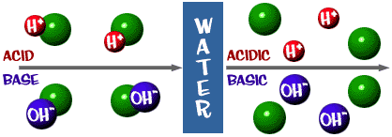

That pH scale we talked about is actually a measure of the number of H+ ions in a solution. If there are a lot of H+ ions, the pH is very low. If there are a lot of OH- ions, that means the number of H+ ions is very low, so the pH is high.   
  
Think about it for a second. Why would a liquid with high levels of NaOH be dangerous and very basic? The Na-OH bond breaks in solution and you have sodium ions (+) and hydroxide ions (-). The sodium ions don't really pose a danger in solution, but there are a huge number of hydroxide ions in solution compared to the hydrogen ions. All of those excess OH- ions make the pH super-high and the solution will readily react with many compounds. The same thing happens on a less dangerous scale when you add baking soda to water. OH- ions are released in the solution. The numbers of OH- are greater than the H+ and the pH decreases.

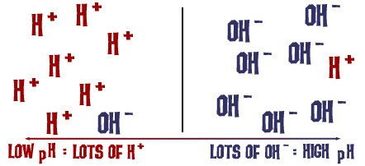

**Complete Questions using the article about pH.**

1. **Does every liquid have a pH?**
2. **What do ions in a solution do?**
3. **What does the pH scale measure?**
4. **Which two ions does the pH scale focus on?**
5. **The scale goes from 0 - __________.**
6. **Acids pH scale # range =**
7. **Bases pH scale # range =**
8. **Underline an example of something acid and basic in the article.**
9. **What is a neutral?**
10. **A solution with a low pH has a lot of _________________ ions.**

**Name_____________________ Date______________**

**Comparing Organic and Inorganic compounds.**

Station # ________

1. **How do living things get the elements & compounds they need to carry out their life processes?**

**______________________________________________________________________________________________________________________________________**

**Use the textbook page__________________ to fill in the two columns. Please provide examples of compounds that fit into each category.**

|  |  |
| --- | --- |
| **Organic Compounds** | **Inorganic Compounds** |
|  |  |

Name________________________________ Date__________________________

Station # ________

**Use the information from this chart and reading passage to fill in the chart below.**

|  |  |  |  |  |
| --- | --- | --- | --- | --- |
|  | **Carbohydrates** | **Lipids** | **Proteins** | **Nucleic Acids** |
| Elements | Carbon,hydrogen and oxygen | Carbon, oxygen, hydrogen and phosphorus | Carbon, oxygen,  hydrogen, nitrogen and sulfur | Carbon, oxygen, hydrogen, nitrogen and phosphorus |
| Examples | Sugars, starch, cellulose | Fats, oils, waxes,  phospholipids and  cholesterol | Enzymes, skin and hair | DNA and RNA |
| Function | Supply energy for  cell processes; form plant structures; short-term energy storage | Store large  amounts of energy long term; form boundaries around cells | Regulate cell processes and build cell structures | Carry hereditary information; used to make proteins |

**Organic Compounds**

You and all living things are made up of compounds that are classified as organic or inorganic. Rocks and other nonliving things contain inorganic compounds, but most do not contain large amounts of organic compounds. Organic compounds always contain carbon and hydrogen and usually are associated with living things. One exception would be nonliving things that are products of living things. For example, coal contains organic compounds because it was formed from dead and decaying plants. Organic molecules can contain hundreds or even thousands of atoms that can be arranged in many ways. The table above compares the four groups of organic compounds that make up all living things – carbohydrates, lipids, proteins, and nucleic acids.

**Carbohydrates** Carbohydrates are organic molecules that supply energy for cell processes. Sugars and starches are carbohydrates that cells use for energy. Some carbohydrates also are important parts of cell structures. For example, a carbohydrate called cellulose is an important part of plant cells.

**Lipids** Another type of organic compound found in living things is a lipid. Lipids do not mix with water. Lipids such as fats and oils store and release even larger amounts of energy than carbohydrates do. One type of lipid, the phospholipid, is a major part of cell membranes.

**Proteins** Organic compounds called proteins have many important functions in living organisms. They are made of smaller molecules called amino acids. Proteins are the building blocks of many structures in organisms. Your muscles contain large amount of protein. Proteins are scattered throughout cell membranes. Certain proteins called enzymes regulate nearly all chemical reactions in cells.

**Nucleic Acids** Large organic molecules that store important coded information in cells are called nucleic acids. One nucleic acid, deoxyribonucleic acid, or DNA – genetic material – is found in all cells. It carries information that directs each cell’s activities. Another nucleic acid, ribonucleic acid, or RNA is needed to make enzymes and other proteins.

|  |  |  |  |  |
| --- | --- | --- | --- | --- |
| **Elements** | **Monomer (Building Blocks)** | **Polymer** | **Functions in Living Things** | **Examples** |
|  |  |  |  |  |
|  |  |  |  |  |
|  |  |  |  |  |
|  |  |  |  |  |

Name________________________________ Date__________________________

Station # ________

1. Describe how diet is related to the compounds we are composed of. ______________________________________________________________________________________________________________________________________________________________________________________________________________________________
2. How do you know that the 4 categories of compounds outlined above are organic?

____________________________________________________________________________________________________________________________________________________

1. List 5 compounds that are inorganic.

_____________________________________

_____________________________________

_____________________________________

_____________________________________

_____________________________________

1. What happens to the compounds that an organism is composed of when they die?

__________________________________________________________________________________________________________________________________________________________________________________________________________________________________________________________________________________________________________________________________________________________________________________

1. Try to life the 8 life process without using your notes.

____________________________________________

____________________________________________

____________________________________________

____________________________________________

____________________________________________

_____________________________________________

_____________________________________________

_____________________________________________

Name________________________________ Date__________________________

Station # ________

1. **In an experiment to measure how temperature affects the number of times**

**a cricket chirps, the independent variable would be?**

1. **Temperature**
2. **Number of times the cricket chirps**
3. **The number of crickets in the control group**
4. **The number of crickets in the experimental group**

**2) In an experiment to measure how temperature affects the number of times**

**a cricket chirps, the independent variable would be?**

1. **Temperature**
2. **Number of times the cricket chirps**
3. **The number of crickets in the control group**
4. **The number of crickets in the experimental group**

**3) Which choice best defines a controlled experiment?**

**A) When all the variables are purposely changed**

**B) When only one variable is changed at a time and all other factors are**

**kept constant**

**C) When you only have a control group**

**D) When you only have an experimental group**

**4) What is the purpose of the control group?**

**A) It receives the experiment**

**B) Used to create more work for the scientist**

**C) Used for comparison (placebo is given to humans)**

**D) No one knows for sure**

**5) Define Hypothesis - _____________________________________________________________________**

**_____________________________________________________________________**

**6) Which is the last test of the scientific method?**

**A) Developing a hypothesis**

**B) Making a conclusion**

**C) Retesting**

**D) Experiment**

**7) What does a graduated cylinder measure?**

**A) Mass**

**B) Weight**

**C) Volume**

**D) Height**

**8) What is your favorite subject?**

**A) Math**

**B) English**

**C) SCIENCE**

**D) Social Studies**

**9) 2.8cm = __________________ mm**

1. **How is a theory different than a hypothesis? ________________________________________________________________________________________________________________________________________________________________________________________________________________________________________________________________________________________________________**

Name________________________________ Date__________________________

Station # _______

**Name the parts of the microscope using the word bank below**

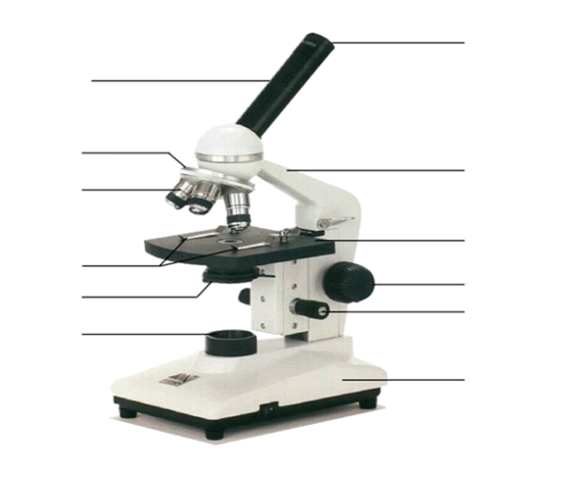

1. Base 6) Eyepiece
2. Objective Lens 7) Stage Clips
3. Light Source 8) Diaphragm
4. Fine Adjustment knob 9) Stage
5. Revolving Nose Piece 10) Arm

**Select 2 parts of the microscope and describe their function.**

1. _________________ -- __________________________________________

__________________________________________

1. _________________ -- __________________________________________

Name________________________________ Date__________________________

Station # ________

**Label as many parts as you can. Use arrows**

**and lines to point to the structure you’re labeling.**

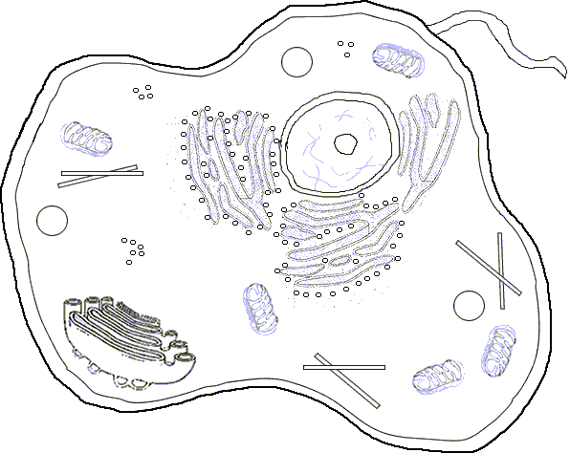

Select 2 structures you identified above and describe their function.

1) __________________ -- ______________________________________________________

2) _________________ -- ________________________________________________________

Name________________________________ Date__________________________

Station # ________

**Brainstorm with your partners and for each term write vocabulary you associate with each column heading**

|  |  |  |
| --- | --- | --- |
| **Photosynthesis** | **Cellular Respiration** | **Metabolism** |
|  |  |  |
|  |  |  |
|  |  |  |
|  |  |  |
|  |  |  |

**Pick one of the terms above and draw a picture representing the process.**

Name________________________________ Date__________________________

Station # ________

**Brainstorm with your partners and for each term write vocabulary you associate with each column heading**

|  |  |  |
| --- | --- | --- |
| **Sexual Reproduction** | **Asexual Reproduction** | **Survival of the Fittest** |
|  |  |  |
|  |  |  |
|  |  |  |
|  |  |  |
|  |  |  |

**Compare and contrast sexual and asexual reproduction in a few words.**

**_______________________________________________________________**

Name____________________________ Date__________________________

Station # ________

**Use the label below to fill in the following information.**

**Answer the questions on the next sheet.**

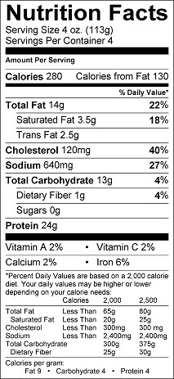

1. **Total calories -- _________________**
2. **Calories from Fat - ______________**
3. **Percent Calories from Fat - __________ (divide calories from fat by total calories)**
4. **How many mg of sodium? ______________**
5. **How many grams of saturated fat? ______________**
6. **How many grams of trans fat? ____________________**
7. **What is the serving size for this food? ____________________**
8. **How many servings are in this box? _______________________**
9. **How many grams of protein? ___________________________**

**10) Which vitamins are present in this food? _______________________________**

**11) How much dietary fiber? __________________________**

**12) How much of your percent daily value does sodium account for? ________________**

**13) How much of your percent daily value does the dietary fiber account for? __________**

**14) Do you think this food is a healthy choice? Explain? _________________________________________________________________________________________________________________________________________________________________________________________________________________________________________________________________________________________________**

**Name_____________________________ Date______________**

Station # ________

**GMO’s (___________________ ___________________ __________________)**

*Thinking Critically*

***The following educational activity is intended for middle school and high school students studying GM foods. It is designed to stimulate critical thinking about the many issues involved in the production of GM foods:* Ask students to pick one side of each argument below. Once students have chosen sides, they should makea list of all the reasons they believe their position to be true with the information they’ve learned about GM foods.**

**Argument A: Labeling of GM Foods**

**I believe all foods that have been genetically modified should be labeled.**

**I do not believe it is necessary to label GM foods as long as they are equivalent to a current food on**

**the market.**

**Argument B: The Risk of GM Foods**

**Genetically modified foods likely are unsafe for human consumption. By adding genes to foods, it**

**is unclear how the food is affected. I worry about developing an allergy or causing harm to another**

**area of my body.**

**GM foods are perfectly safe for me to eat. I don’t worry about consuming them. The U.S.**

**government does a good job of protecting our food for consumption.**

Name________________________________ Date__________________________

Station # ________

Which fish should I eat? [www.seafoodwatch.org](http://www.seafoodwatch.org)

**Scroll down and on the bottom right hand side there is a box to type in the type of fish you eat.**

Type in 3 -4 different fish and see what it says.

Which fish did you select?

____________________ ____________________ _________________ ______________________

What did they say about each fish you selected?



**On the right hand side, underneath seafood recommendations, and past top searches**

**Click on browse super green list**

These are fish that are not only ecologically healthy but healthy for humans as well.

In order for a fish to be on this list they must fit the following 3 criteria:







Which fish are on this list?



**Click on sustainable seafood recipes**

Select a recipe that looks good and then make it for class! ☺ Just kidding. Really, pick a recipe a try it at home

Which recipe did you like?

Name________________________________ Date__________________________

Station # ________

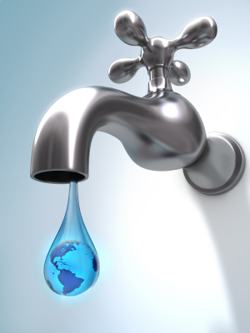What are You Drinking?

[www.ewg.org](http://www.ewg.org)

1. In the middle of the webpage click on water
2. click on our national drinking water guide
3. Read Over 300 pollutants found in US tap water

**How do you feel about this statement?**

More than half of the chemicals detected are not subject to health or safety regulations and

can legally be present in any amount. The federal government does have health guidelines

for others, but 49 of these contaminants have been found in one place or another at levels

above those guidelines, polluting the tap water for 53.6 million Americans. The

government has not set a single new drinking water standard since 2001

It’s scary that our government is not doing anything to keep us safe. New standards and guidelines need to be continuously developed to help keep the public safe as the contaminants in water are continuously changing.

EWG launched a 3-year project to create the largest drinking water quality database in existence. This user-friendly, interactive resource covers 48,000 communities in 45 states and the District of Columbia.

Scroll up to the top of webpage and click on *Find your water*

On the right hand side, type in your zip code and the name of your water company

1. How many people does your water company serve?
2. What violations does your water company have? How many?

Scroll up to the top

Click on Full Report

Click on water pollution sources

1. What are the four main water contaminants?
2. What do you think about the water you drink now?

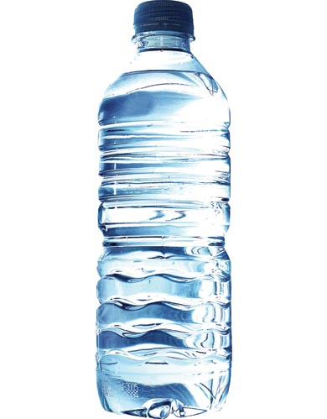

Bottled Water!

[www.ewg.org](http://www.ewg.org)

1. Go back to ewg.org
2. Scroll down to middle of page and click on water
3. click on bottled water

**Click on is your bottled water worth it.**

**Click on top right hand corner – go to report**

How do you feel about the best-selling brands, nine — Pepsi's Aquafina,

Coca-Cola's Dasani, Crystal Geyser and six of seven Nestlé brands — don't answer at

least one of the following questions

* Where does the water come from?
* Is it purified? How?
* Have tests found any contaminants?

_______________________________________________________________________________________________________________________________________________________________________________________________________________________________________________________________________________________

__________________________________________________________________________________________________________________________________________________________________________________________

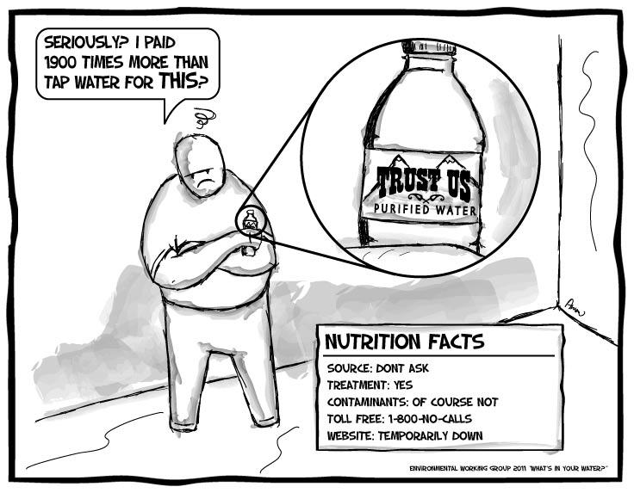**On the right hand side look for**

***Check out your bottled water***

Type in the name of the water you

Most often drink

What is the letter grade?

Name of water ______________

Grade _____________________

Name of water______________

Grade ____________________

Your thoughts: _______________  
___________________________  
___________________________  
____________________________

____________________________

Name___________________________ Date____________________

Station # ________

Foodborne Illness, Foodborne Disease, (sometimes called “Food Poisoning”)

**Go to🡪** [**http://www.cdc.gov/foodsafety/facts.html**](http://www.cdc.gov/foodsafety/facts.html)

***Answer the following questions.***

***General questions***

1) [What is foodborne illness (disease, infection)?](http://www.cdc.gov/foodsafety/facts.html#what)

______________________________________________________________________________________________________________________________________________________________________________________________________________________________________________________________________________________________________________________________________________________

1. [What are the most common foodborne diseases?](http://www.cdc.gov/foodsafety/facts.html#mostcommon)

______________________________________________________________________________________________________________________________________________________________________________________________________________________________________________________________________________________________________________________________________________________

1. [How many cases of foodborne disease are there in the United States?](http://www.cdc.gov/foodsafety/facts.html#howmanycases)

______________________________________________________________________________________________________________________________________________________________________________________________________________________________________________________________________________________________________________________________________________________

1. [Are the types of foodborne diseases changing?](http://www.cdc.gov/foodsafety/facts.html#changing)

___________________________________________________________________________________________________________________________________________________________________________________________________________________________________________________________________________________________

1. [What are some critical unsolved problems in foodborne disease?](http://www.cdc.gov/foodsafety/facts.html#criticalproblems)

______________________________________________________________________________________________________________________________________________________________________________________________________________________________________________________________________________________________________________________________________________________

***Outbreaks and surveillance (tracking)***

6)[How do public health departments track foodborne diseases?](http://www.cdc.gov/foodsafety/facts.html" \l "tracking)

______________________________________________________________________________________________________________________________________________________________________________________________________________________________________________________________________________________________________________________________________________________

1. [What is a foodborne disease outbreak and why do they occur?](http://www.cdc.gov/foodsafety/facts.html#whatisanoutbreak)

______________________________________________________________________________________________________________________________________________________________________________________________________________________________________________________________________________________________________________________________________________________

1. [Why do public health officials investigate outbreaks?](http://www.cdc.gov/foodsafety/facts.html#investigate)

______________________________________________________________________________________________________________________________________________________________________________________________________________________________________________________________________________________________________________________________________________________

1. [How are outbreaks of foodborne disease detected?](http://www.cdc.gov/foodsafety/facts.html#detection)

______________________________________________________________________________________________________________________________________________________________________________________________________________________________________________________________________________________________________________________________________________________

1. [How is a foodborne disease outbreak investigated?](http://www.cdc.gov/foodsafety/facts.html#howinvestigate)

______________________________________________________________________________________________________________________________________________________________________________________________________________________________________________________________________________________________________________________________________________________

1. [What foods are most associated with foodborne illness?](http://www.cdc.gov/foodsafety/facts.html#whatfoods)

______________________________________________________________________________________________________________________________________________________________________________________________________________________________________________________________________________________________________________________________________________________

***Food safety***

12) [How does food become contaminated?](http://www.cdc.gov/foodsafety/facts.html#howcontamination)

______________________________________________________________________________________________________________________________________________________________________________________________________________________________________________________________________________________________________________________________________________________

13) [There is only so much the consumer can do. How can food be made safer in the first](http://www.cdc.gov/foodsafety/facts.html#howsafer) place?

______________________________________________________________________________________________________________________________________________________________________________________________________________________________________________________________________________________________________________________________________________________

1. [What is CDC doing to control and prevent foodborne disease?](http://www.cdc.gov/foodsafety/facts.html#whatiscdcdoing)

______________________________________________________________________________________________________________________________________________________________________________________________________________________________________________________________________________________________________________________________________________________

***Diagnosing and treating foodborne illness***

1. [What happens in the body after the microbes that produce illness are swallowed?](http://www.cdc.gov/foodsafety/facts.html#whathappenswhenswallowed)

______________________________________________________________________________________________________________________________________________________________________________________________________________________________________________________________________________________________________________________________________________________

1. [How are foodborne diseases diagnosed?](http://www.cdc.gov/foodsafety/facts.html#howdiagnosed)

______________________________________________________________________________________________________________________________________________________________________________________________________________________________________________________________________________________________________________________________________________________

1. [How are foodborne diseases treated?](http://www.cdc.gov/foodsafety/facts.html#howtreated)

______________________________________________________________________________________________________________________________________________________________________________________________________________________________________________________________________________________________________________________________________________________

1. [When should I consult my doctor about a diarrheal illness?](http://www.cdc.gov/foodsafety/facts.html#whenconsultdr)

______________________________________________________________________________________________________________________________________________________________________________________________________________________________________________________________________________________________________________________________________________________

***Protecting yourself from foodborne illness***

1. [What can consumers do to protect themselves from foodborne illness?](http://www.cdc.gov/foodsafety/facts.html#whatprotect)

______________________________________________________________________________________________________________________________________________________________________________________________________________________________________________________________________________________________________________________________________________________

1. [Are some people more likely to contract a foodborne illness? If so, are there special precautions they should take?](http://www.cdc.gov/foodsafety/facts.html#aresomepeoplemorelikely)

______________________________________________________________________________________________________________________________________________________________________________________________________________________________________________________________________________________________________________________________________________________

1. [What can consumers do when they eat in restaurants?](http://www.cdc.gov/foodsafety/facts.html#whattodoinrestaurants)

______________________________________________________________________________________________________________________________________________________________________________________________________________________________________________________________________________________________________________________________________________________

1. [Where can I learn more about food safety and foodborne illnesses?](http://www.cdc.gov/foodsafety/facts.html#wherelearn)

___________________________________________________________________________________________________________________________________________________________________________

**Name________________________ Date______________**

Station # ________

All about you….

1. What are you taking after this class ends? _______________________________________________________________

________________________________________________________________

________________________________________________________________

1. How did you do in your classes last quarter? Circle one

Excellent, Good, Fair, Not So Good, Horrible

1. If you didn’t do excellent what kind of changes can you make to improve?

___________________________________________________________________________________________________________________________________________________________________________________________________

1. If you did excellent how did you achieve this? __________________________________________________________________________________________________________________________________
2. What’s your favorite **activity**, not sleeping, to do when you have free time? Why?

_____________________________________________________________

_____________________________________________________________

**Name________________________ Date______________**

Station # ________

]All about you….

1) The thing I like best about myself is? Because? ________________________________________________________________

________________________________________________________________

________________________________________________________________

2) The thing I would change about myself is…. Why?

__________________________________________________________________________________________________________________________________

_________________________________________________________________

3) My favorite meal is….

__________________________________________________________________________________________________________________________________

4) When I get a car I want to buy a….

_____________________________________________________________

_____________________________________________________________

5) What is something that you did that you’re proud of. __________________________________________________________________________________________________________________________________

**Name___________________ Date__________________**

Station # ________

All about you….

1. The thing I like best about myself is… Because? ________________________________________________________________

________________________________________________________________

________________________________________________________________

1. The thing I would change about myself is… Why?

__________________________________________________________________________________________________________________________________

1. Did you consider the time off from school a break or not? Explain.

____________________________________________________________________________________________________________________________________________________________________________________________________________________________________________________________________

1. What is the craziest thing that ever happened to you or someone you know. (Please keep it clean)

_____________________________________________________________

_____________________________________________________________

_____________________________________________________________

**Name___________________ Date__________________**

Station # ________

**ORGANIC COMPOUND**

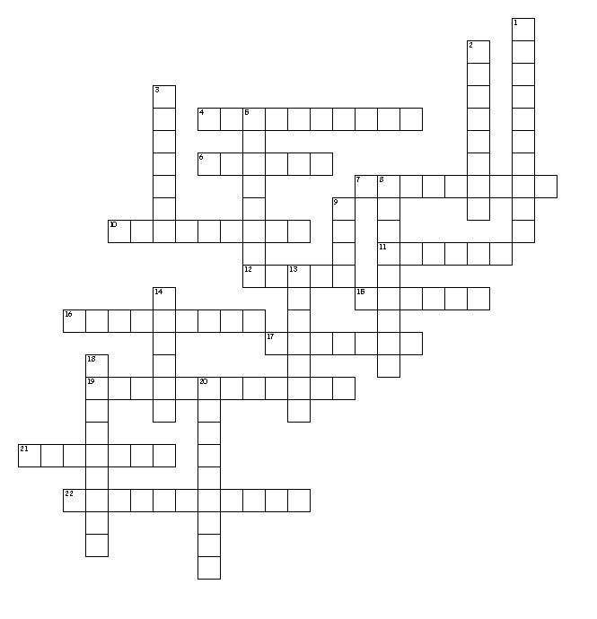

**Across**

4. An educated guess that can be tested through experimentation

6. Living factors in an ecosystem

7. ______________ compounds that do not contain

10. The life process that gets rid of metabolic waste

11. To make the results of an experiment more accurate a scientist should __________

12. The ________________ of a protein determines its function/job

15. A type of complex (big) sugar

16. The building of compounds

17. In an experiment the ____________ group does not get what's being tested

19. The life process that makes new organisms

21. When you put cells together you get ________________.

22. Maintaining a stable internal environment

**Down**

1. All the chemical reactions that keep organisms alive

2. The second coolest science teacher

3. _________________ compounds contain carbon and hydrogen

5. ______________ are formed when you put amino acids together

8. Eating healthy food

9. The coolest science teacher

13. Nonliving factors in an ecosystem

14. A well supported set of observations

18. The life process that includes absorption and distribution

20. The breaking down of compounds

*22 of 22 words were placed into the puzzle.*

Name________________________________ Date__________________________

Station # ________

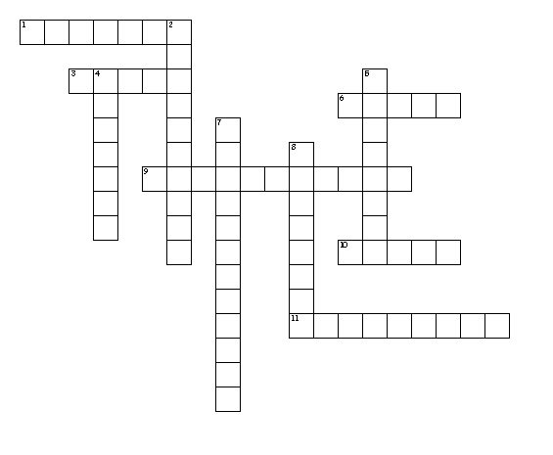

**Across**

1. The new food ___________ is more personalized

3. Digestion begins in the mouth

6. Type of carb that the body can't digest. It helps move food through body

9. Digestive organ that stores bile

10. Important nutrient that keeps you hydrated

11. The name of this class

**Down**

2. If you don't drink enough water you might become __________________

4. When food is grown without chemicals we call it ____________

5. The bacteria that killed over 30 people through cantaloupe contamination

7. Is the condition that occurs when your body does not get enough nutrients

8. Organism that makes you sick

Name____________________ Date__________________________

Station # ________

**Genetics, Evolution and Cell Division**

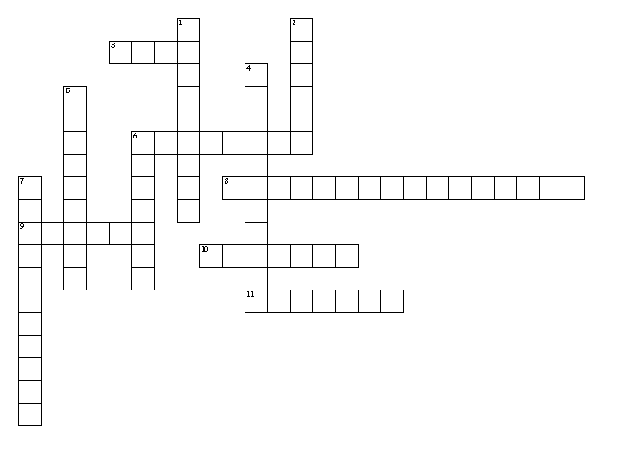**Across**

3. _________ pairing is when the A goes with the T and C goes with the G in DNA

6. A change in DNA.

8. __________________ acid is the compound that DNA represents.

9. We can use DNA evidence to solve _____________.

10. Type of cell division that produces genetically different gametes

11. Another name for sex cells

**Down**

1. We create pesticide _____________ insects by over using pesticides.

2. Charles _____________ came up with the theory of evolution.

4. Genetic _________ is a technique that directly manipulates the DNA.

5. The change in species over time.

6. Type of cell division that produces genetically identical body cells.

7. DNA is composed of smaller subunits called __________________.

Name______________ Date__________

Station # ________

**FOOD Safety**

I R R K O I R O C W B T P M E R A L L E N O M L A S E W W K A O G Z S

M E G I W M Z T V C X B J S R B P N A T N B U Q I G N J S Z B G M E S

M F A A G I J L V K C W F R K V S X N C J Z O O K Y U E U C S A P S Y

U R U I J U H Z B P D U Y G P J K M E Y D K L G D Y L U G G S A D G S

N I B D F A N V E E F P Q Y U G O Q N Y F W N A Y V K L O O R M D G P

E G R M A E E V D Y X A V H Z Q O P V V Z R S D I R P X Y A H M O I C

F E C O A J Z M P N I Q Z X P T G U C S D F Z Y W S N M T D Q T T A F

N R E R T K P C P W W S A K C R N C W F E O I D T H C E I T K L A J X

Q A E W W I D C Q N N B J S Y B B I W F D E R J G J V J F U V R O P K

H T Q E W Z N D N D I R I K J O U N R V V N K C R Y K U C P B H I Y X

Y E Y T Z B G O E Y C B K J J Y B A V X P P H P I J Z S U W E M S Y Z

E N E O Y E Z R M J H E O J J R W G F R E P V I O I P H H S B L M K L

E X R G B M I J C I R M A H R D G R L S E K T F I O Q X O H O B L U S

T C X N H P O I S O N I N G A Z H O T R C Z D L Z B Z C P N S V E F Y

N G N N X I F U P Y N M Y H W K K I L M G Z I Z R K R Q Y C F G K U G

C H F E U F D N W L D T L H N B C K M G F A O G R R W Q U U N F A N F

S Y T P L M K L B J P J A S B I S V J P S B A F Z H M T Q P S S F T X

K N U G J X G H B Q V N B M D W T H J K A O Y Y E O H O P L C Y N Y B

X B E A F Y N F D A Z Y S E I B X P Z R E T A L U G E R V Q Q E S X A

U R F X A M K N V P V F S B D N P Z X N B A U P E O P V M J C J L E U

N A W V M D Q Q A U E S B C A W A N A E L C J A E Y B Y L O S E B P U

N L N C O N Z G E C K L Z J N T K T R X M D U E E A A M L A X F D T Y

R G D A A L R U G V D Z B N S X I O I P L P Z K Z R C I E A C H Q O G

F V L M E K I S C K M E O P E S M E O O J T S T G M T Q Y B A S D E K

S A F E T Y H S V R G R Y X T H Y L Y C N W L L M R E S V Y N A Y G P

F D B I Z F F V T I Z K C J I W C Z V C S Q Q X Y I R U A C J W N M X

T V I N O D R G S E P C D W S U Q K P M K Z O R O K I A J Q A S T H C

U B A A A R O L M D R J R R A G C K U Z X F Z Y T T A M J T D E X T O

Y T A T V X A G C A W I X T R I I S E T G K T L K S T S R R R R B F M

O R Q L X C D B C N B J A I A W Z S Z W K O L P B L R N N I J Y E B K

M B G N I C I F K F W G T D P C Y E S K O Z T G M A K F B E Q T X I F

Y A I M K D E S Z K K E S L S V B I P W D A D J K V A K T W X F E M A

W D E V F S K M W H O U T K V P V P H M R V M O T C K S W G T R M F T

K H D Q I B D Z K U N L J C G L A K R G P U G W F X K E F J A P E W J

C E G B L Z U V I C L H W C E F C P X H G J J Z G L B J C Z L L F W R

BACTERIA CHEMICALS CLEAN

CONTAMINATION COOK ECOLI

EPA EXPIRED FDA

FEMA FREEZE IMMUNE

LISTERIA MONITOR ORGANIC

PARASITES PATHOGENS PESTICIDES

POISONING RAW REFRIGERATE

REGULATE SAFETY SALMONELLA

SEPARATE SOAP USDA

WASH

Name______________ Date__________

Station # ________

**Obesity**

G G H C V R G U A Q A I R R Z A C Z Q O G E E W X X F J W P

G Y Z T X L M L L H T N E L H M H R L T M E T K C C Z Z A W

M B L N L J T J A K L F C I K X E F C B I E X Q S B N H I O

H E A R T A T T A C K E N B M E S J V R C Q W G J B E W S E

X Y T M T R E B D E O R A C Y B B B K W Y I Q I L P Y U T J

C A I R Q A I H U I A T C M B M Z S J S N S T O M A C H L D

C E Z P A Q B E X D D I M X Z Q D S H F L M F G J K R P I P

H P F S M W S E T U W L Y T I Y T F E P L K A X L E U S N C

A X H A L T U G B Z H I N X R U L C F Y T S M C M A A C E Y

C N F S N W V N L P P T L D G L T P H T G N I T A E D H H G

B H F I E A U I W X A Y M G I I D T G H E G P Y Z H A A A Y

I S O D Z N H W W J K Z M P O B L B Y G A H X W B A O C J M

I J O L X T I J N K B X I N W A T J J I X U Y Q D D W I C K

B Y Q Z E D R T F G Q D S D E E D A L E G H R F G U Y I E F

I N X N E S H A S K S F X H K H A E U W Y Z Y S O D P N G Y

C A R A N B T Z I E J D N Q M V E G L R O B S E S S I O N T

O K T O T F V E J N T U K E L J Z A M E U H O Q M L X W N I

C H W X U S A T R S E N O T S L L A G V Y E O U U V Y O S S

X C R B O E L V D O Q R I Y Q Y F J L O S N I A P P J R V E

W J Y M T H Y I Z U L H E K T S R I L A N U S E R L P K F B

A L S X Y A F U K N N H Z X O I V K E S T R E S S C D O K O

G M Z S V P G F P U U R D E C B V S B W V T A W M I F U N W

E M G K O K J M A A Q T N R D E I I O N T A Y P A S G T Q R

O X A U C H O O Q A E H R E U D S E T T Q W Q B N U D L B Y

W A B Z X Z O Q N M C F N I Q J L S E C Y Z E C T G V U S G

O X O K M N Z R G O W Y Q Y T M D G S J A T C X U A S V R P

U B Y L U T X N V G A R C I E I F P S M E Y S V C R N G R H

Z W B A S I Z J I N N R D I O J O S X S F P Q F B W S V A S

D X F D D L F S X U L M N L Y P K N D H T T E S I C R E X E

X T H N T X Z K L C Y F J P R J Z T O W E J L G C M O Z G H

ACTIVITY BMI CANCER

CHOLESTEROL DEATH DIABETES

DISEASE EATING EXCESS

EXERCISE GALLSTONES HEALTH

HEARTATTACK INFECTIONS INFERTILITY

INTESTINES JOINTS LIPIDS

NUTRITION OBESITY OBSESSION

OVERWEIGHT PAIN STOMACH

STRESS SUGAR TRAINER

UNHEALTHY WAISTLINE WORKOUT

Name______________ Date__________

Station # ________

[Print this page](http://puzzlemaker.discoveryeducation.com/code/BuildWordSearch.asp)

**Scientific Method**

I S U G P K A F A S I C C C P P F V N E J C U L N T R C I C

T N E D N E P E D N I I O H D E L L O R T N O C E N X Z H A

I P D O O I C N R C F X O N G U X K O P M W Y K G E Q Y E O

V S A R T A T T K I Y S A D C V X H V B U M D S O M H T G U

W V T I R I T U T E P D C U E L P R O B L E M D R N Q S R T

M M B B X J U N H H V A D I G E U Q H E J O L G T O R T K T

Z M O Y O V E Q O C T C L B O K R S I B F M H L I R U N U I

R N H D G I B R S M A T E R I A L S I H F V H H N I T E Q Y

A E I K C X U P O O S R C A U E U T P O D A B N P V J D X V

N O T S O S E Q T T M T A U R M E V X X N R C S J N N N N X

P P E E N J R A N X T H B P L N A C W Q R I F N E E Z E X Z

H D A C S S Z A S T N E M E L E R Z B F H A L Z W H P P Q Z

E Q A W N T T N U J J P C G V D X R K O P B V H Z K E E N J

N N G C T S T M E O A I I B N A B Y T V J L Z A D I N D S F

R T P P N U S B G G T L I H K J X R E M E E S F A V C I R Y

H Y P O T H E S I S O K O F R G E G K T X U G C E K I Y S P

E R C V Z W U Z H A M R U R V G F L P X P J P I K E L W Y R

E Q S Z B Y Y G U I B B D T J M O L C I E F G U C P B K E S

Y J U T A E I Y G N R E A Y S P Y E I E R N V O B E D V U R

C A F I R O J E W P L Q A D H J O G Q M I N E G Y X O Q X H

Z X F K P Y Q O U O Q Y S W R K A F C B M J K Y D G V D Z Y

R D H E Q M I W H Z O R T H Z T S D P T E P G N Y N A Y E F

Y L H J Z W E R M D I V O P F L D A U O N N U S Z F G H O L

D U P A S H I N D L D E U E D Y N C H W T O U R W R P M W J

V X U G P S H J T N F D D T C B R I E P P D Z J A P O X H F

U W N L R S Q J M Y F Z Q P F J R K M M S J F P Q B J N B W

S M L E V B A V W G T Y Z Y C T A Q O R N S H R K Y Q O V N

U U T L E J W N X K E N J E Y O O C V P B I X J F P G T B G

Y G K B G C N X I K F I X H D B N G V G N E W T M T P N Q E

Y P E P Y B R S S Q S Q H D P S X A Z G U H D B S J U O W C

**AXIS CARBON COMPOUND**

**CONCLUSION CONSTANTS CONTROLLED**

**DEPENDENT ELEMENTS ENVIRONMENT**

**EQUIPMENT EXPERIMENT GRAPHING**

**HYDROGEN HYPOTHESIS INDEPENDENT**

**MATERIALS MOSQUITOES NITROGEN**

**OXYGEN PARACHUTING PENCIL**

**PHOSPHORUS PROBLEM RETEST**

**SCIENTIFIC VARIABLE**