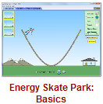
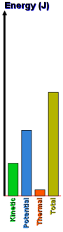
The Skate Basic Park – Intro to Energy Potential and Kinetic PhET Lab
Introduction:
When Tony Hawk wants to launch himself as high as possible off the half-pipe, how does he achieve this? The skate park is an excellent example of the conservation of energy. The law of conservation of energy tells us that we can never create or destroy energy, but we can change its form. In this lab, we will look at the conversion of energy between gravitational-potential energy, work, and kinetic (or moving) energy.

Use the internet, your textbook, or notes to define the following key terms:
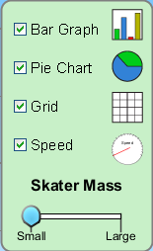
Kinetic Energy ________________________________________________________________________
Potential Energy _______________________________________________________________________
Mechanical Energy ____________________________________________________________________
Joule ________________________________________________________________________________

State, in your own words, the Law of the Conversation of Energy. _____________________________
____________________________________________________________________________________

Procedure: PheT Simulations → Play With Sims → Physics → Energy Skate Park: Basics 

Take some time and play with the skater. Turn on the Bar Graph, Pie Chart, and Speed options.

How does increasing skater's mass change the skater’s….
Kinetic Energy? ____________________Potential Energy? ____________________Total Energy? _____________________

How does the skater’s kinetic energy change as he moves down the ramp? _________________________________________

How does the skater’s kinetic energy change as he moves up the ramp? ___________________________________________

How does the skater’s potential energy change as he moves down the ramp? _______________________________________

How does the skater’s potential energy change as he moves up the ramp? __________________________________________

How does the skater’s total energy change as he moves down the ramp? ___________________________________________

How does the skater’s total energy change as he moves up the ramp? _____________________________________________

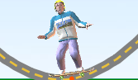
Describe the skater’s kinetic energy at the bottom of the ramp. _____________________________________

Describe the skater’s potential energy at the bottom of the ramp. ___________________________________

What happens when the skater is dropped onto the ramp from above the ramp? ______________________________________

Observe the following situations. Draw the possible bar graphs for the situation shown. Compare your results with a nearby lab group, AFTER you have completed this section.

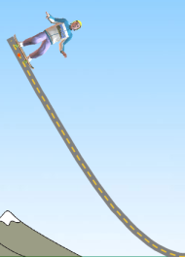 Top of the ramp, stopped for just an instance. | 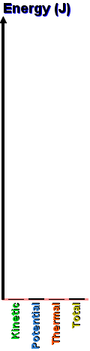 | 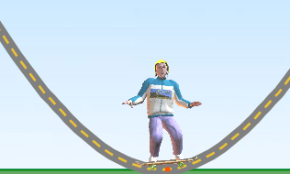 Bottom of the ramp, zooming past the middle.
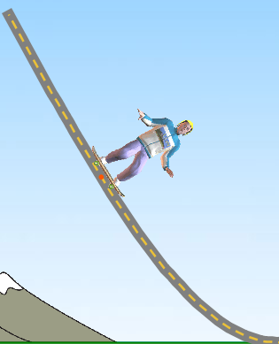 Mid-way down the ramp, moving about mid-speed. |  | 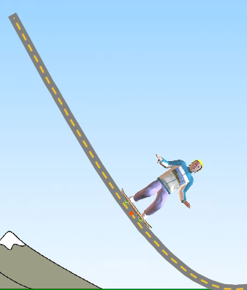 3/4 of the way down the ramp, moving pretty fast.

Draw where the skater might be based on the bar graphs shown. Compare your results with a nearby lab group, AFTER you have completed this section.
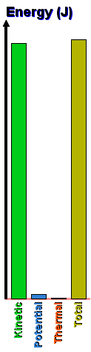 | 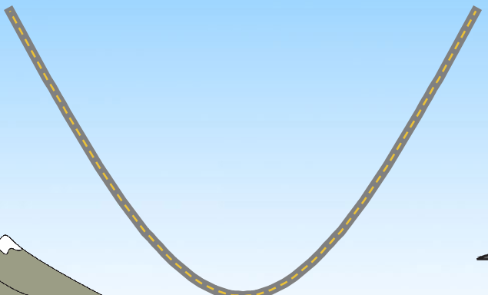 | 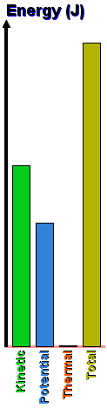
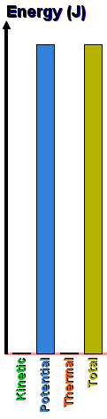 |  | 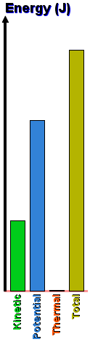
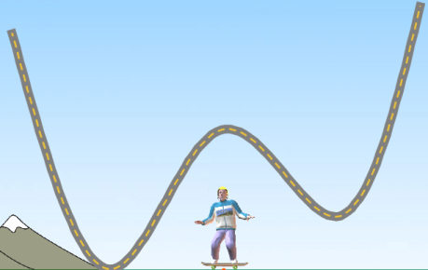
A
← Consider this zany track. What point or points on this track would the skater have ...
The most kinetic energy? The most potential energy?
D
E
The same kinetic energy (two points) and
B
C

Conclusion Questions: (circle the correct answers)
- At the highest point kinetic energy is zero / maximum while the potential energy is zero / maximum.
- At the lowest point kinetic energy is zero / maximum while potential energy is zero / maximum.
- Mass affects / does not affect the amount of energy.
- As an object falls in gravity, kinetic energy increases / decreases / remains the same.
- As an object falls in gravity, potential energy increases / decreases / remains the same.
- As an object falls in gravity, total energy increases / decreases / remains the same.
- An object travelling faster and faster has a kinetic energy that increases / decreases / remains the same.
- An object travelling faster and faster has a potential energy that increases / decreases / remains the same.
- As an object speeds up, the total energy increases / decreases / remains the same.
- As an object slows down, the total energy increases / decreases / remains the same.

