SIDE 1 Parallel Lines and Transversals
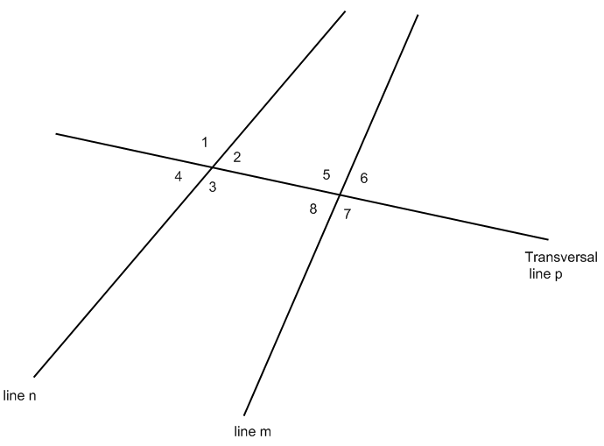
!. What are the names of the 2 main lines?
2. Are the 2 main lines parallel?
3. What is the name of the transversal?
4. How would you define a transversal?
5. Fill in the chart by naming angle pairs:
Corresponding Angles | Alternate Interior Angles | Alternate Exterior Angles | Consecutive Interior Angles
$∠$ _____ and $∠$______ | $∠$ _____ and $∠$______ | $∠$ _____ and $∠$______ | $∠$ _____ and $∠$______
$∠$ _____ and $∠$______ | $∠$ _____ and $∠$______ | $∠$ _____ and $∠$______ | $∠$ _____ and $∠$______
$∠$ _____ and $∠$______
$∠$ _____ and $∠$______

SIDE 2 Parallel Lines and Transversals
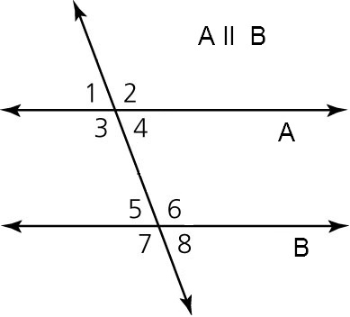 | 6. Directions: Measure all of the angles. Ask for help if you don’t know how to use a protractor.  Hint: use a ruler to extend the lines if they aren’t long enough!  - $m∠1=$____________  - $m∠2=$____________  - $m∠3=$____________  - $m∠4=$____________  - $m∠5=$____________  - $m∠6=$____________  - $m∠7=$____________  - $m∠8=$ ____________

7. Fill in the chart by naming angle pairs:
Corresponding Angles | Alternate Interior Angles | Alternate Exterior Angles | Consecutive Interior Angles
$∠$ _____ and $∠$______ | $∠$ _____ and $∠$______ | $∠$ _____ and $∠$______ | $∠$ _____ and $∠$______
$∠$ _____ and $∠$______ | $∠$ _____ and $∠$______ | $∠$ _____ and $∠$______ | $∠$ _____ and $∠$______
$∠$ _____ and $∠$______
$∠$ _____ and $∠$______
Answer the following questions:
8. Compare the measures of the pairs of corresponding angles. Guess at the missing word.
“Corresponding Angles are_______________
9. Compare the measures of the pairs of alternate interior angles. Guess at the missing word.
“Alternate Interior Angles are _____________”
10. Compare the measures of the pairs of alternate exterior angles. Guess at the missing word.
“Alternate Exterior Angles are _____________”
11. Compare the measures of the pairs of consecutive interior angles. Guess at the missing word.
“Consecutive Interior Angles add up to _____________”
12. Do you think it matters if the two main lines are parallel? (Compare to the lines on the other side)

