How do you make a Peanut Butter and Jelly Sandwich? Name:____________________________

Instructions:  Write down in order the steps you would use in making a Peanut Butter and Jelly Sandwich.  You do not have to use every line on this page, but write as many steps as you think the task should take.  You may continue on back if you need more than 12 steps. | 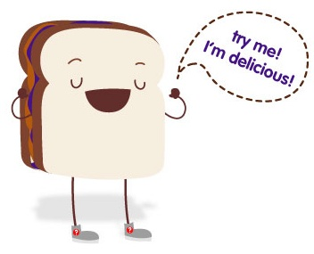

Step in the process of making a PB&J sandwich | Don’t use this side yet
1. | 1.
2. | 2.
3. | 3.
4. | 4.
5. | 5.
6. | 6.
7. | 7.
8. | 8.
9. | 9.
10. | 10.
11. | 11.
12. | 12.

Teacher Notes:
The goal of this activity is as a demonstration of why precision and specifics matter in proofs. Students write their plans for how to make a sandwich. As a demonstration, the teacher can follow the instructions exactly to construct the sandwich. If the student doesn’t specify a step, such as ‘open the jar’, the teacher doesn’t do that and demonstrates how it won’t work.

