East Meadow School District

Curriculum Area Project

ELA Literature Circles in Memoir Unit

Grade 6

Completed February 2013

Grade 6 Language Arts

Clarke Middle School/Woodland Middle School

Participants:

Patricia Hartman Clarke Middle School

Marge Sweeny Clarke Middle School

Roberta Herman Woodland Middle School

Brenda Marino Woodland Middle School

Susan Mele Woodland Middle School

Tonianne Smith Woodland Middle School

Table of Contents

|  |  |
| --- | --- |
| 1 | Cover page |
| 2 | Table of Contents |
| 3 | Abstract |
| 4 | Rationale |
| 5 | Bibliography |
| 6 | Readers and Writers Choice Worksheet |
| 7 | Speaker and Listeners Worksheet |
| 8-9 | Lesson: Genre of Memoir |
| 10 | Text: *Junior* |
| 11 | Lesson: Sharing Writer’s Notebook entry |
| 12 | Handout: Your Life is a Story |
| 13-14 | Lesson: Using Written Dialogue for Book Circle Conversations |
| 15-17 | Lesson: Paying Attention to Detail |
| 18 | Handout: Going Deeper Into Conversation |
| 19-20 | Lesson: Writing Successful Questions for Deeper Conversation |
| 21 | Handout: Question Characteristics |
| 22-23 | Lesson: Relating to a Specific Place in a Memoir |
| 24-25 | Lesson: Inferences |
| 26-27 | Lesson: Going Even Deeper into Book Circle Conversations |
| 28 | Lesson: Students Dealing with Unprepared Group Members |
| 29-30 | Lesson: Graphic Representations |
| 31-33 | Lesson: Developing Effective Questions for Deeper Conversation |

ELA Literature Circles in Memoir Unit

Grade 6

ABSTRACT

Through this Literature Circles in Memoir Unit, we promote literacy and expand our students’ exposure to the genre of non-fiction, through the sub-genre of memoir. Lessons and handouts are included which will direct the sixth grade teacher to successfully facilitate the Literature Circles in Memoir Unit. In order to differentiate instruction, and to challenge all of our readers, students will read full-length memoir novels in addition to smaller memoir texts.

Assessments are provided that follow this unit. Students will go through the writing process to produce a published memoir.

ELA Literature Circles in Memoir Unit

Grade 6

RATIONALE

In aligning with the Common Core Standards, this Literature Circles in Memoir Unit provides students with an array of opportunities to read memoirs in order to expand their understanding of non-fiction as a genre. The unit includes related activities to help students reflect on what they have read.

The Common Core Standards are fully addressed in this CAP. Students will be analyzing text, citing textual evidence, identifying literary elements, determining central themes, analyzing point of view, speaking across texts, analyzing texts deeply and writing objective summaries.

ELA Literature Circles in Memoir Unit

Grade 6

BIBLIOGRAPHY

Cohen, Marina. Dear Bully: Seventy Authors Tell Their Stories. “My Apology”. New York, NY:

Harper Collins Publishers. 2011.

Daniels, Harvey & Steineke, Nancy. Mini-Lessons For Literature Circles. Portsmouth, NH:

Heinemann, 2004.

Fletcher, Ralph. Marshfield Dreams. New York, NY: Henry Holt

& Company, 2005.

Paulsen, Gary. My Life In Dog Years. New York, NY: Yearling, a

Division of Random House, 1998.

Rylant, Cynthia. “My Grandmother’s Hair”. 1981.

Rylant, Cynthia. When I Was Young In The Mountains. New York, NY: Dutton’s Children’s

Books, a division of Penguin Young Readers Group, 1981.

Readers and Writers

Choice Worksheet

Book Circle members will choose a different square to work on during

Book Circle discussion days. The center square requires you to *cite textual evidence* for all of the boxes you choose.

|  |  |  |
| --- | --- | --- |
| Making Inferences |  | Write an objective summary |
| Determine central (main) idea | **CITE**  **TEXTUAL**  **EVIDENCE** | Analyze how memoirist’s life experiences effect his point of view |
| Analyze how the memoirist helps the reader to get to know individual in memoir |  | Identify the universal in the specific |

Speakers and Listeners

Book: ____________________

Group Members:

_____________________

_____________________

_____________________

_____________________

_____________________

Absent:

______________________

Worksheet

Date:__________________ LA per:___

Today’s **Discussion Facilitator**:____________________

Today’s **Note Taker**:____________________________

Discussion Notes:

|  |  |  |
| --- | --- | --- |
| ☺☺☺☺☺☺☺ | Chat Focus: | Chat Focus: |
|  | Play Your Best  Post-It | (write which item from R/W Choice Worksheet  you focused on:) |
| Write  notes  about your chat on the lines | _____________________  _____________________  _____________________  _____________________  _____________________ | _____________________  _____________________  _____________________  _____________________  _____________________ |

Process:

Write some notes about any of the following questions:

* Who spoke?_________________________________________________
* Who was a leader?____________________________________________
* Who felt left out?____________________________________________
* Who took over?______________________________________________
* Who was unprepared?__________________________________________
* Great questions asked?_________________________________________

__________________________________________________________

* What was the best thing we did today?_____________________________

__________________________________________________________

* What do we want to discuss next time?_____________________________

__________________________________________________________

* How did you change as communicators?______________________________

___________________________________________________________

“If you aren’t making each other smarter, you could have done it alone.”

~your LA teacher ☺

The next two lessons will be added to Biography when the Jackie Robinson excerpts are utilized.

**Aim:** What is the genre of memoir?

**Objective:** Students will identify the genre of memoir and after generating a list of memoir topics, will write a “moment” in their lives.

Do Now: Each teacher will follow his/her classroom routine

1. Add “Junior” to Table of Contents

2. Copy Homework (Complete writing from class)

**Materials:** “Junior” from *Marshfield Dreams,* by Ralph Fletcher

Hard copy and overhead

**Standards:**

SL.6.1. Engage effectively in a range of collaborative discussions (one-on-one, in groups, and teacher-led) with diverse partners on grade 6 topics, texts, and issues, building on others’ ideas and expressing their own clearly

RI.6.1. Cite textual evidence to support analysis of what the text says explicitly as well as inferences drawn from the text.

RI.6.3. Analyze in detail how a key individual, event, or idea is introduced, illustrated, and elaborated in a text (e.g., through examples or anecdotes).

W.6.3. Write narratives to develop real or imagined experiences or events using effective technique, relevant descriptive details, and well-structured event sequences.

**Lesson/Procedure:**

1. “We have been studying non-fiction by reading excerpts about Jackie Robinson through a biography, his autobiography, his daughter’s autobiography and a picture book. Today I am going to introduce another sub-genre of non-fiction called “memoir”. Writers of memoirs, “memoirists”, don’t write about their entire life; they choose **moments** in their lives in which they have changed significantly. But, they don’t simply tell a story about a memory, they go much deeper and share a moment in their lives in which they were changed. They may be hoping to change us through their own experience. This relates to our Big Picture Idea, that writers write to change people and readers read to become different.

One of my favorite authors is Ralph Fletcher. Some of you may be familiar with him as an author because he has written several books. Has anyone read *Spider Boy* or *Flying Solo*?

Throughout the year, I am going to share with you memoirs from Ralph Fletcher’s book, *Marshfield Dreams*. I am going to refer to this book as our “context text,” because we will all be reading the pieces and talking about them.

Today I am going to share with you one of the first pieces in *Marshfield Dreams* titled “Junior.” As I read it, think about what you can infer about Ralph and how you know.”

2. Read aloud of “Junior.” Then, share on overhead and distribute copies of “Junior.” Students will identify what they know about Ralph and mark up the copy.

3. From this piece, students will create a class list of topics that could be generated from this piece.

* how you were named
* what confuses you
* what annoys you
* what makes you proud

4. Students will write a “moment” in their lives as their first memoir entry. Students will complete writing for homework.

**Assessment:** Teacher will informally assess and confer as students are writing. Students will share their writing in the following day’s class.

**Follow Up:** Follow up tomorrow with lesson on page 11

N

***Junior***

As the oldest of nine, I was named after my father and my grandfather. Some kids on Acorn Street teased me, calling: “Hey, Juuuu-nioooor!” not that I minded. I liked having the same name as my father, but it did cause confusion in the house.

Whenever Mom called out, “Ralph!” Dad and I would both answer, “Yeah?”

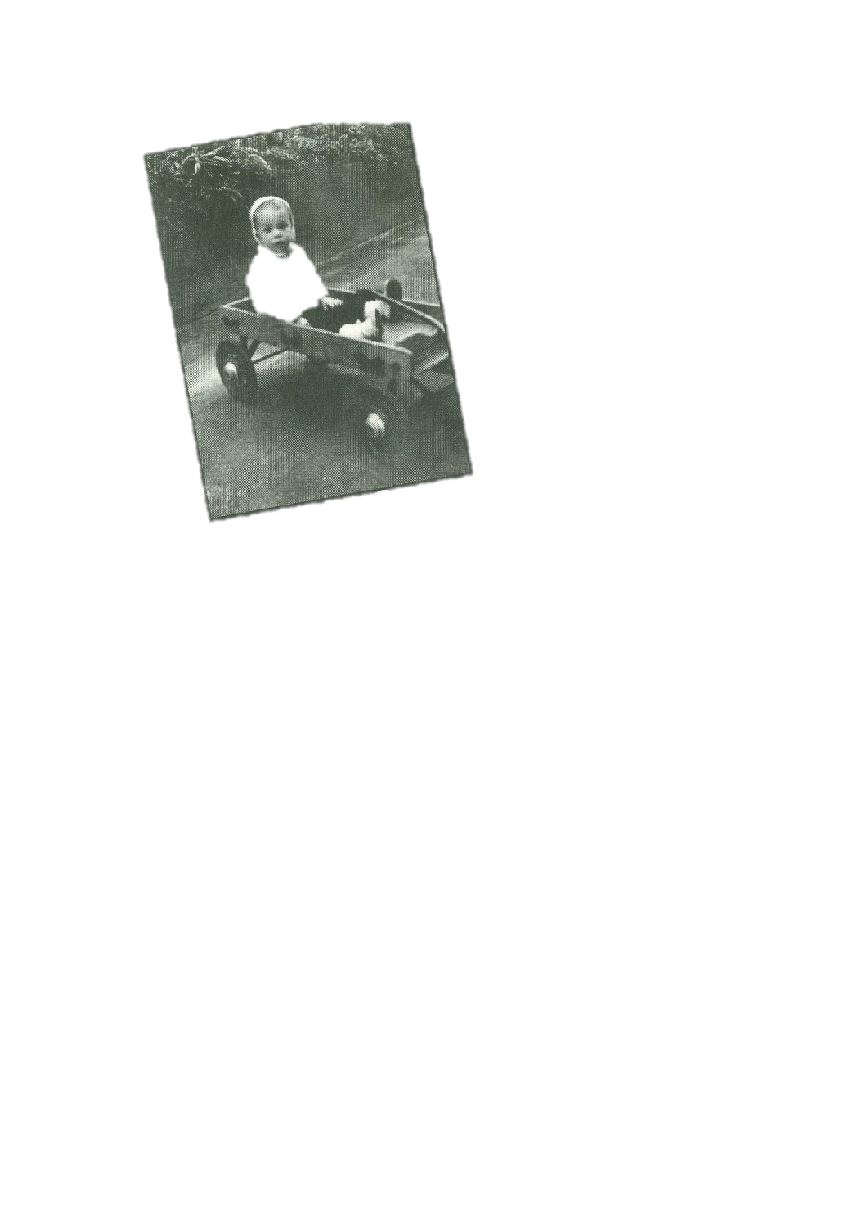 “No, Big Ralph!” or, “Little Ralph!” she yelled back, to clarify things. I guess that would have annoyed some people, but it didn’t really bother me. Dad was tall and handsome. I bragged to my friends that my father was so cool he had three jobs: teacher, milkman, bartender. I was proud of him. I loved knowing that *Ralph* could fit us both in one snug syllable.

**Me, age two, in a wagon.**

**Aim:** Students will share their first entry in their Memoir Writer’s Notebook.

**Objective:** Students will reflect on the genre of memoir and set up their Memoir Notebook for the year.

**Materials:** class set of “Your Life Is a Story”

**Time:**  half a period

**Standards:**

SL.6.1. Engage effectively in a range of collaborative discussions (one-on-one, in groups, and teacher-led) with diverse partners on grade 6 topics, texts, and issues, building on others’ ideas and expressing their own clearly

**Lesson Procedure:**

1. Students will share their memoir writing topic from last night with a partner. Teacher walks around listening to reading and conversations.
2. Afterwards, teacher will say, “I loved walking around and listening to your memoir writing. Your topics were wonderful. We are going to be writing a memoir later in the school year. What memoirists (writers of memoirs) do is start writing down memoires so that when they are ready to publish, they have lots of rich ideas. We are going to do that. Yesterday you came up with a list of possible writing ideas. I took all of your ideas and compiled them into one chart. We are going to glue this into the inside cover of our Memoir Notebook.”
3. Say, “This is our Memoir Notebook and I want it to be special and unique to you. Your homework is to decorate the cover with pictures and words that reflect YOU!” Show some samples. Remind students not to cover the box on front with name and to adhere the cut-outs down well so it lasts all year. Due in one week.
4. HW: Complete one from the chart

**Your Life is a Story!!**

**The best memoir writing ideas are living inside you!**  Your challenge is to dig them out. Do the writing only YOU can do. Remember that every writer gets stuck from time to time, so below are some topics to get you started. Complete in any order. Check off topics as you complete them. Skip topics that don’t make sense to your life. Add your own topics. ☺

|  |  |
| --- | --- |
| C:\Users\bremarin\AppData\Local\Microsoft\Windows\Temporary Internet Files\Content.IE5\VBPRJQKV\MC900441310[1].png | **Ideas:** |
|  | How you were named |
|  | What confuses you |
|  | What annoys you |
|  | What makes you proud |
|  | A family story |
|  | A time you shared a tradition with your family |
|  | How an artifact has importance in your life |
|  | A special place to you (attic, basement, scary closet, tree house…) |
|  | An experience you had with a special person in your life |
|  | Your place in your family (only child, oldest, youngest, middle, adopted…) |
|  | A memorable time with a best friend |
|  | When you moved |
|  | A disastrous time you had at camp or a family vacation |
|  | Horrible haircut |
|  | An injury |
|  | An important first (losing a tooth, school, riding a bike, jumping off a diving board…) |
|  | When your family changed (sibling off to college, grandma lived with you, new sibling born…) |
|  | What you are/used to be afraid of |
|  | **C:\Users\bremarin\AppData\Local\Microsoft\Windows\Temporary Internet Files\Content.IE5\VUHMKRH3\MP900402910[1].jpg**A time you got into trouble |
|  | A great lesson you learned the hard way |
|  | A challenge you faced |
|  |  |
|  |  |
|  |  |
|  | DIg up those great writing ideas! |

**Aim:** Using written dialogue as book circle conversations

**Objective:** The students will be able to have a deeper conversation with their book circle members by writing their conversation down on chart paper. Using written dialogue in book circles allows the group members to think before they speak. It also provides an opportunity for the “quiet” students to have a voice.

**Materials:**

Chart Paper

Multiple packages of Markers

**Standards:**

SL.6.1. Engage effectively in a range of collaborative discussions (one-on-one, in groups, and teacher-led) with diverse partners on grade 6 topics, texts, and issues, building on others’ ideas and expressing their own clearly.

SL.6.4. Present claims and findings, sequencing ideas logically and using pertinent descriptions, facts, and details to accentuate main ideas or themes; use appropriate eye contact, adequate volume, and clear pronunciation.

W.6.1. Write arguments to support claims with clear reasons and relevant evidence.

W.6.5. With some guidance and support from peers and adults, develop and strengthen writing as needed by planning, revising, editing, rewriting, or trying a new approach.

**Lesson/ Procedure:**

1. The students have been working on the Memoir Unit. Each student has been placed in a memoir book circle.
2. Today is a “Chat Day. ”Instead of “chatting” together verbally, the students will be writing down their conversation on chart paper. The teacher says, “Think of it as writing a note back and forth with each other! This method of talking allows the group to stay on task and piggy back off the other group members that spoke before. Too often, students get distracted and forget what other people have said during regular *oral* conversation.”
3. Each group will receive a piece of chart paper and colored markers. (Every member in the groups receives a different colored marker.)
4. Once all materials have been given out, the students will “play” their best post-it. When discussing the post-its, the students do not have to write the conversation on chart paper.
5. After the students play their best post-it, they will decide collectively on a question/topic to discuss and write it on top of the chart paper. The question/topic can be from the list of “DEEPER” ideas on the board, an idea from the post-its or one the group comes up with on their own.
6. The students are now ready to have a conversation. The teacher will say to the students, “Even though each member has a different colored marker, make sure to put your initials down before you comment.” For example, TS:
7. As the students are “chatting on paper,” the teacher will walk around and confer with the students through written dialogue. The teacher will place her initials on the chart paper and make a comment to the group or ask a question to keep the conversation deep.
8. After about 15-20 minutes, the teacher will stop the groups and call them back to a whole group. The teacher will ask each group to briefly share their written conversation with the class.
9. At the end of class, after the students have shared, they will fold the chart paper and place it in their book circle folders. The book circle members will then have the opportunity to look back at the conversation in the future and possibly use it to guide other conversations.

**Assessment:** The students will be assessed informally on their written responses when the teacher confers with the book circle groups. In the future, the students will be able to go back to the written dialogue and self-assess their progress.

**Aim:** How can we pay close attention to detail in our book circle chats?

**Objective**: Students will recognize that as readers, they must pay attention to the smallest detail and in doing so, they can think deeper about their reading.

**Do Now**: Each teacher will follow his/her classroom routine

1. Add “My Grandmother’s Hair” to Table of Contents
2. Copy Homework

**Materials**: “My Grandmother’s Hair” by Cynthia Rylant

Hard copy and overhead

**Standards:**

RI.6.1. Cite textual evidence to support analysis of what the text says explicitly as well as inferences drawn from the text

RI.6.2. Determine a central idea of a text and how it is conveyed through particular details; provide a summary of the text distinct from personal opinions or judgments.

RI.6.4. Determine the meaning of words and phrases as they are used in a text, including figurative, connotative, and technical meanings.

RI.6.5. Analyze how a particular sentence, paragraph, chapter, or section fits into the overall structure of a text and contributes to the development of the ideas.

RI.6.6. Determine an author’s point of view or purpose in a text and explain how it is conveyed in the text.

RI.6.10. By the end of the year, read and comprehend literary nonfiction in the grades 6–8 text complexity band proficiently, with scaffolding as needed at the high end of the range

**Lesson/Procedure:**

Motivation script: (Teacher should personalize the script)

1. “I know that every successful person knows how to pay attention to the smallest detail. If you go to art school, you may be given an egg to study. You look at the size, the shape, the texture, the color. All kinds of things. Artists have to slow down their brain to study all of the details.

I’ve noticed that in sports, athletes can talk for hours about one thing. Take basketball – basketball players can talk about dribbling: how they dribble with the right hand, with the left hand, behind their back, between their legs…they can talk and talk and talk just about dribbling the ball.

I know that scientists can study one germ for years. Or, can study one form of DNA for years. On a personal note, I’m really glad about that, because I hope that by studying one strand of DNA, they can find a cure for Alzheimer’s.

Every smart successful person slows down their brain and can talk about one topic and notice everything. And, if you don’t get smarter from talking about a topic, you might as well stay home.”

2. Ask a student to come up to help. Have someone time you for 3 minutes.

Using the overhead, share the title of the text. Highlight the title and say, “The memoirist must have created this title for a reason. I wonder why? (Personalize) I know that I can make a connection to this title because it reminds me of my grandmother and her hair. If I close my eyes, I can see her purple hair, although it wasn’t always purple. It was just purple when she colored it with the dye from the box. And if I close my eyes again, I can almost smell the terrible smells that came from the goop that she put on her head.”

Ask the student if he/she has anything to say.

3. Circle the first word: “When” and read the first sentence. Say, “I know that the memoirist starts so many of her books or stories with the word When –*When I was Young in the Mountains,* *When the Relatives Came*. She’s letting us know right from the start “When” this was happening. I also know that she likes to focus on the setting in her stories.” Ask the student if he/she has anything to add.

4. Ask the students, “What did we do?” Record answers on the board.

Possible responses should include: (Personalize)

* Observed words
* Took author’s memories and put them into your memories (text/self connections)
* Eye contact
* Went deeper into wondering
* Made connections to other books
* Took turns
* Showed respect

Hopefully, **“turned a word into a conversation”** will surface as an answer.

5. Now, it’s the students’ turn:

Have students read the 2nd sentence; give them 3 minutes to talk.

Ask: “What surprised you?”

Record answers on the board:

* noticed the grammar – there’s a really long sentence.
* it made a visual detailed image in my head
* it’s like a movie
* maybe other people could relate to the character

6. Students are then to talk in their book circle group. Tell them they are to think deeper about their reading.

Choose one sentence, one paragraph, one post-it, or one question…

At the end of the class, ask the groups to share one way they thought more deeply. Create a class chart.

When we got deeper…

* We asked a question that no one had considered before
* We didn’t know what a word meant, so we used context clues. That didn’t help, so we looked up the word and then had to use the definition of a work within the word
* We asked why the memoirist did something and we found a “trigger”
* We compared to our lives
* We asked “Why did the memoirist write about something?”

7. Teacher will create a handout entitled “Going Deeper into Conversation” based on the class responses. (Personalize)

Note: This may take more than one period.

**Assessment:** Teacher will informally assess and confer as students are in their discussion groups.

**Going Deeper Into Conversation:**

C:\Users\bremarin.EM-INSTRUCT\AppData\Local\Microsoft\Windows\Temporary Internet Files\Content.IE5\SFAWF3QR\MC900441417[1].wmf

Universal emotion

Recently read chapters

Inferences

Cover design

Plot events

Characters & their feelings

Characteristics of main characters

Relationship between all of the chapters

Setting

Favorite parts

Confusing parts

Text/text, text /world connections

Personal connections (text/self)

Back/forth conversation, responded to each other

Why did memoirist include this part in the book?

Sucked a lot out of one sentence

Predictions

Questions

Stayed on topic

Waited/took turns

Agreed/disagreed

Branched off from one comment into something deeper

***Slow Down!***

Follow-up lesson to “How can we go deeper in our book circle chats?”

**Aim:** How can I write a successful question that will lead to deeper conversation in my book circle group?

**Objective:** Students will notice the qualities of successful. They will then generate successful questions for their future chats.

**Do Now:** Each teacher will follow his/her classroom routine.

1. Add “Going Deeper into Conversation” (from previous lesson) to Table of Contents
2. Add “Successful/Dead-End Questions” to Table of Contents
3. Add “Question Characteristics” handout to Table of Contents
4. Copy Homework – Complete reading and 3 post-its

**Materials:** “Going Deeper into Conversation” handout

“Question Characteristics” handout

**Standards:**

RI.6.1. Cite textual evidence to support analysis of what the text says explicitly as well as inferences drawn from the text.

RI.6.3. Analyze in detail how a key individual, event, or idea is introduced, illustrated, and elaborated in a text (e.g., through examples or anecdotes).

RI.6.6. Determine an author’s point of view or purpose in a text and explain how it is conveyed in the text.

RI.6.8. Trace and evaluate the argument and specific claims in a text, distinguishing claims that are supported by reasons and evidence from claims that are not

W.6.1. Write arguments to support claims with clear reasons and relevant evidence.

SL.6.1. Engage effectively in a range of collaborative discussions (one-on-one, in groups, and teacher-led) with diverse partners on grade 6 topics, texts, and issues, building on others’ ideas and expressing their own clearly.

**Lesson/Procedure:**

Motivation script: (Teacher should personalize the script)

1. “Yesterday, you did some really good work in talking about just one line of a memoir. Some of you were able to get into your book circle groups and start to “chat” about your books.

In fact, one group (point it out on the chart) noticed that someone had asked a question that no one had considered before. I’d consider that a really *successful* question.”

Teacher will start a two-column chart on the board. Students will make two columns in their notebook.

Successful Questions: Dead-end Questions:

* makes you notice something you didn’t before

“There can also be dead-end questions; for example, think back to when we were interviewing one another for our biographies. Does anyone remember what a dead-end question was because it didn’t generate any information?”

Hopefully, someone will say a “yes” or “no” question.

Add that to the chart under bad questions.

2. “Take 3 minutes to look at the questions in your folder that you have chosen to talk about when you played your best post it.

Were any of these a successful question? Why was it a successful question? What did it make you, as a reader and a group do?

Were any of these a dead-end question? Why was it a dead-end question? Why did it not lend itself to discussion?

I will come around as you think about these and you can add them to your chart in your notebook.”

3. Have a whole-class share and create a group chart.

4. Script: “Today when you are reading, think about writing questions that make you think deeply about your reading. Your 3 post-its for tomorrow’s chat should be those kinds of questions.”

5. Prior to the end of class, distribute “Question Characteristics” handout; students are to attach to notebook page and use to assist them in creating their post-its.

**Assessment**: Teacher will informally assess and confer with students as they are reading.

**Question Characteristics**

**Successful Questions**  **Dead-end Questions**

* make you notice something you didn’t before
* are not easily answered-make you think
* have more than one possible answer
* lead to different opinions/viewpoints
* make people infer why something happens or why a character does something
* make you predict a problem
* pose comparisons
* get you to connect to the universal emotion
* make you see something in a different way
* help you to understand something
* pull different parts of the book together
* make you put yourself in the character’s (memoirist’s) shoes
* lead to more follow-up questions
* focus on important parts of the story or the memoirist’s life
* have a yes or no answer
* you can easily find the answer
* ask for one specific detail-not much to talk about
* nothing to disagree or argue about
* only one opinion is possible
* ask about something that is not important to the story or the memoirist’s life
* don’t help people understand the memoir better
* make it hard to think of follow-up questions
* don’t make you go back to the book
* have obvious answers-don’t take much thinking
* don’t connect with other parts of the story
* have nothing to do with the story
* are too general

Follow-up lesson to “How can we go deeper in our book circle chats?”

**Aim:** How does the memoirist relate to a significant place?

**Objective:** The students will understand the characteristics of a memoir that focuses upon the relationship of the memoirist and a place.

**Materials:**

Chart Paper

Writer’s Notebook

*When I Was Young in the Mountains* by Cynthia Rylant

**Standards:**

RI.6.1. Cite textual evidence to support analysis of what the text says explicitly as well as inferences drawn from the text.

RI.6.3. Analyze in detail how a key individual, event, or idea is introduced, illustrated, and elaborated in a text (e.g., through examples or anecdotes).

W.6.3. Write narratives to develop real or imagined experiences or events using effective technique, relevant descriptive details, and well-structured event sequences.

**Lesson/Procedure:**

1. The teacher will explain to the students that good readers visualize or create pictures in their minds and that is one reason good readers are engaged.
2. The teacher will read aloud to the students *When I Was Young in the Mountains* by Cynthia Rylant. As she reads, the teacher will encourage the students to visualize the place in the story.
3. After the teacher finishes the reading, point out to the students that the picture book is a memoir because it focuses on a writer and a memorable, important place that is significant to the writer.
4. The students and teacher will discuss the story briefly as a whole group. The teacher will ask the students if any of them can make text/self-connections.
5. Together, the teacher and students will brainstorm questions from the reading and record on chart paper. (These are some suggestions of questions discussed. Personalize the questions to your class!)

* Where is this place?
* What was the memoirist’s purpose for telling you about this place? What does the memoirist want you to think about this place?
* How does the memoirist show you the importance of the place? Through his/her feelings or thoughts?
* What descriptive words does the memoirist use to tell you about the place?
* What memories does the memoirist share with you when telling you about the place?

1. Have the students go back to their Memoir Notebooks and jot down some places that came to mind while the teacher was talking. Then, have the students share their ideas with the class. Allow the students to keep their notebooks handy. Encourage the students to listen to their peers with a “writer’s ear.” As new ideas come to mind, jot them down in their Memoir Notebook.
2. Finally, with the time left in the period, have the students get into their book circles. The book circle chat will focus on the memoirist’s relationship to a place. The students will choose a passage from their book where the memoirist tells about a special, important place. The chat will focus on how place is relevant to each individual. Also, they will chat and discuss questions they identified for *When I Was Young*.

**Homework:** In your Writer’s Notebook, write a personal memory where you have a relationship to a significant place.

**Assessment:** The students will be assessed informally on their written and oral responses in class.

**Aim:** How does a reader make inferences about a memoirist both implicitly and explicitly?

**Objective:** After this scaffolded mini-lesson, the struggling students will be able to independently make connections about the character traits of a particular memoirist within their “Book Circle Group” book using both implicit (inferred) and explicit (directly stated) ideas.

**Do Now:** Each teacher will follow his/her classroom routine.

**Materials:**

Overhead projector

Overhead copy of pages 26-27 from *My Life in Dog Years* by Gary Paulsen

overhead markers

**Standards:**

RI.6.1. Cite textual evidence to support analysis of what the text says explicitly as well as inferences drawn from the text.

RI.6.4. Determine the meaning of words and phrases as they are used in a text, including figurative, connotative, and technical meanings.

RI.6.5. Analyze how a particular sentence, paragraph, chapter, or section fits into the overall structure of a text and contributes to the development of the ideas.

RI.6.6. Determine an author’s point of view or purpose in a text and explain how it is conveyed in the text.

**Lesson/Procedure:**

1. The students have been previously introduced to the concept of implicit (implied or inferred in the text) details and explicit (directly stated in the text) details.
2. Today is a “Chat Day.” Before sending groups off to chat together, the students will take part in a mini-lesson which will take about 10 minutes. The teacher will say to the students, ”Today, I am going to model how a successful detective will search for implicit and explicit traits about a character, within a text. This will allow you to see how you can search for these traits as you are reading.”
3. The teacher will use the text pages below to model explicit and implicit details:

**furious-** (explicit trait)

It states directly in the passage that Gary Paulsen was not furious at the dog; he was furious at the hunters. See underlined passage.

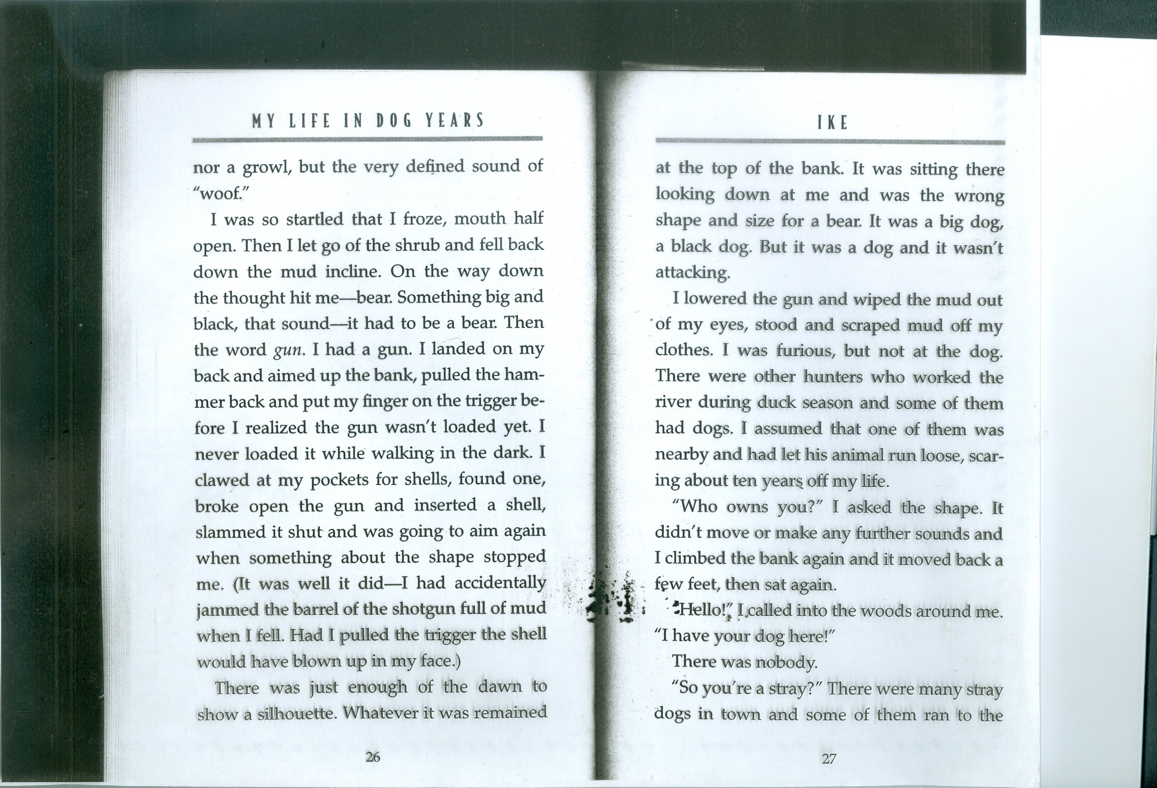

**nervous-**

(implicit trait)

We infer that Gary Paulsen is nervous based on the idea that he saw a “big and black” bear (the use of hyphens; bears are scary), he never loaded a gun in the dark, he “clawed” at his pocket for the shells, and he “slammed” the gun shut

1. In groups, students will discuss additional implicit/explicit details
2. Students will take part in their daily chat. They will be reminded to go deeper within the text using the same procedure as above if they are to discuss implicit/explicit details. The teacher will then rotate around the room in order to facilitate discussion and ensure understanding.
3. Students may be asked to chart an implicit/explicit detail on their post-it during their next independent reading. This will be used during a future chat day.

Assessment: The students will be assessed informally on their written responses as the teacher confers with the individual book circle groups. As the unit progresses, student will have the chance to self-reflect on their progress. This scaffolded lesson allows the teacher to provide additional support for the struggling readers.

**Aim:** How can effective speakers hold an even deeper conversation in their book circles?

**Objective:** Students will observe and analyze how members of a book group have a successful discussion based on a video clip.

**Materials:**

* Chart Paper
* Group Notebook/Group Folders
* Video Clip

**Standards:**

SL.6.1. Engage effectively in a range of collaborative discussions (one-on-one, in groups, and teacher-led) with diverse partners on grade 6 topics, texts, and issues, building on others’ ideas and expressing their own clearly.

SL.6.4. Present claims and findings, sequencing ideas logically and using pertinent descriptions, facts, and details to accentuate main ideas or themes; use appropriate eye contact, adequate volume, and clear pronunciation.

SL.6.5. Include multimedia components (e.g., graphics, images, music, sound) and visual displays in presentations to clarify information.

W.6.1. Write arguments to support claims with clear reasons and relevant evidence.

W.6.5. With some guidance and support from peers and adults, develop and strengthen writing as needed by planning, revising, editing, rewriting, or trying a new approach.

**Lesson/Procedure:**

1. Today is a “Chat Day.” The teacher will begin by telling the students that they will be watching a video clip of fifth grade students partaking in a book discussion. “As you engage in your book circle discussions, you might see that your skills are not perfect. Some groups will click, while one or two groups will argue or ignore each other. To prevent this problem from happening, I am going to show you a video clip of a book discussion in action.” As you observe the book circle, I want you to pay close attention to their physical behaviors and verbal behaviors. What is it that you like about their discussion and what are some things that didn’t work well?”
2. Students will watch the video clip on the SMART board or TV. They will write down their observations on post-it notes.
3. After the students finish watching the video clip, a member from each book circle group will open to either a clean page in their group notebook.
4. Students will write at the top of the page “Friendliness and Support.” Then they will fold the paper in half lengthwise to create two columns. On the left side, they should write “Looks Like” and title the right side “Sounds Like.” The teacher will create their own T-chart along with the class.
5. The teacher will invite the students to share what observations they noticed during the book discussion. Students will be given two examples that the teacher noticed during the discussion to show as an example. The teacher will say “giving eye contact” and “That’s a good idea.” Then ask the students what column they would go under. The teacher should emphasize that “Looks Like” refers to the body language, while “Sounds Like” should be phrases that people would say. All examples should be about the positive behaviors seen in the video clip.
6. As the students give their examples, stress that the item in one column does not need to directly correspond with the idea across from it in the other column.
7. After giving their observations from the video clip, have the students work in their book circle groups constructing their own rules on how their book discussion should “Look Like” and “Sound Like.”

**Assessment:** Students will be assessed by the teacher walking around and monitoring their progress and assisting when needed.

**Aim:** How can effective group members deal with members who are unprepared during discussions?

**Objective:** Students will work together and create rules for members who come to the discussion unprepared.

**Materials:**

* Chart Paper
* Markers
* Group Notebook/Group Folders

**Standards:**

SL.6.1. Engage effectively in a range of collaborative discussions (one-on-one, in groups, and teacher-led) with diverse partners on grade 6 topics, texts, and issues, building on others’ ideas and expressing their own clearly.

SL.6.4. Present claims and findings, sequencing ideas logically and using pertinent descriptions, facts, and details to accentuate main ideas or themes; use appropriate eye contact, adequate volume, and clear pronunciation.

W.6.1. Write arguments to support claims with clear reasons and relevant evidence.

W.6.5. With some guidance and support from peers and adults, develop and strengthen writing as needed by planning, revising, editing, rewriting, or trying a new approach.

Lesson/Procedure:

1. The teacher will tell the students that today they are going to discuss the issue of having some members of their book groups who come to the discussion unprepared. It is extremely important that all group members complete their tasks of reading and creating post-its.
2. Students will be asked to brainstorm ways to productively deal with members who come unprepared. Each group will work together for 5 minutes and then regroup to create a whole-class master list. This list will then get recorded into their marble notebook.
3. It is important to tell the students that the responsibility should rest on them and not on the teacher. All the solutions require that each group owns the problem.
4. Once the groups have a variety of choices, they will choose the rules that best fit for their group and commit to those rules.

**Assessment:** Students will be informally assessed by the teacher walking around and monitoring their progress and assisting when needed.

**Aim**: How can students use graphic representations to support book circle discussions?

**Objective**: Students will read teacher selected text and demonstrate comprehension through a graphic representation. They will demonstrate comprehension through their drawings. Drawings can be annotated and/or colored. This is an excellent opportunity for the student(s) who have difficulty articulating their responses.

**Do Now:** Present students with an image; have them annotate or provide a caption for that image. Discuss with them, *"What story can be told from the picture?*

**Materials:** image, "My Apology" by Marina Cohen, index cards

**Standards**

RI.6.2. Determine a central idea of a text and how it is conveyed through particular details; provide a summary of the text distinct from personal opinions or judgments

SL.6.2. Interpret information presented in diverse media and formats (e.g., visually, quantitatively, orally) and explain how it contributes to a topic, text, or issue under study.

SL.6.4. Present claims and findings, sequencing ideas logically and using pertinent descriptions, facts, and details to accentuate main ideas or themes; use appropriate eye contact, adequate volume, and clear pronunciation.

SL.6.5.. Include multimedia components (e.g., graphics, images, music, sound) and visual displays in presentations to clarify information.

**Lesson/Procedure/Mini-lesson**

1. This activity is an alternative to having students record their thoughts, interpretation and/or comprehension of a text in written response. It allows students to practice and strengthen their ability to visualize what they have read. In addition, it addresses alternative learning styles. Tell students they are going to explore a new method for capturing their thoughts and ideas about a text. Explain to students that they will be drawing their thoughts. Emphasize that this not about drawing a pretty picture, it is about using the author's words to capture the meaning of what is written.
2. Draw Aloud: Read a short piece of text aloud and then draw your own graphic response on the overhead. Vocalize as you draw:

When I read the introduction to "My Apology" I was so startled by the author's words. The author is clearly frustrated and furious with the situation. So I can draw vultures as the students circling the bully and the victim. They are squawking "fight, fight, fight!" and the bully is going to be drawn big, with glowing green eyes. I'm going to add a speech bubble because I get the sense that maybe, just maybe she really would rather be walking home instead of fighting with the author. "I'm not going to start this. (I really just want to go home.)" I'm going to draw the author as if she is a bomb about to explode with only 3 seconds on the clock. Her arm extending from the black ball, which is her body, hitting the green eyed bully across her face.

* Tell the students that it is now their turn to draw a response to what they read. Tell students that the types of drawings they do may include:

* scene, character, moment, or event from the story

* An image or picture that came to mind while you were reading; it could be a memory or scene from your life

* A diagram, flow chart, or map of the story

* An abstract form that represents a thought or feeling you got from the reading---an explosion, a thunderbolt, a pattern, etc.

* Annotate or create a caption for your drawing

* Give students time to read and draw. Explain to them that this should be a quick rendering of their thoughts and that they should not spend time perfecting their drawing. The purpose is to capture what strikes you when you read. The teacher will circulate the room assisting struggling students. Teacher could select one line from the text for the student to draw.
* In their book circles have students show their pictures to their partners. Students should not explain their picture but rather have their partners guess at what they are representing. When everyone has had a chance to comment, the picture can be explained and discussed.
* After students are done discussing their drawings ask for volunteers to tell about a picture that started some really good conversation in the group. An alternative to this would be to conduct a gallery walk and have students point out a picture that sparked good conversation. Have students explain why the picture sparked a good conversation.

**Assessment**

Students will be informally assessed as the teacher circulates from group to group. Drawings should be dated and placed in the group's memoir notebook/folder.

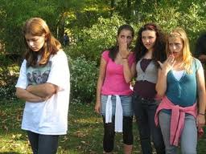

*adapted from "Mini-Lessons For Literature Circles" by Harvey Daniels & Nancy Steineke

**Aim**: Teaching students to develop "good" questions for book circle discussion.

**Objective**: Students will know what types of questions will elicit an extended response resulting in good conversation.

Too often students make comments or ask questions that bring about a one word or short response. Many students need to be taught to ask questions that require a more thoughtful and extended response. This lesson should be used after students have participated in two or more book circle discussions.

**Do Now**: In groups of two, have students discuss the following questions: In the vignette, "First Pen" by Ralph Fletcher 1. What kind of pen did Ralph's father buy him? 2. Why do think the pen is significant to Ralph? Ask for volunteers to answer the questions. Which question resulted in a lengthy answer? a thoughtful answer? multiple answers? A one word answer? only one answer?

**Materials**

Memoir notebooks

Lined paper

**Standards**

**Comprehension and Collaboration**

* SL.6.1. Engage effectively in a range of collaborative discussions (one-on-one, in groups, and teacher-led) with diverse partners on grade 6 topics, texts, and issues, building on others’ ideas and expressing their own clearly.
* Come to discussions prepared, having read or studied required material; explicitly draw on that preparation by referring to evidence on the topic, text, or issue to probe and reflect on ideas under discussion.

**Presentation of Knowledge and Ideas**

* SL.6.4. Present claims and findings, sequencing ideas logically and using pertinent descriptions, facts, and details to accentuate main ideas or themes; use appropriate eye contact, adequate volume, and clear pronunciation

**Craft and Structure**

* RI.6.4. Determine the meaning of words and phrases as they are used in a text, including figurative, connotative, and technical meanings.
* RI.6.5. Analyze how a particular sentence, paragraph, chapter, or section fits into the overall structure of a text and contributes to the development of the ideas.

RI.6.6. Determine an author’s point of view or purpose in a text and explain how it is conveyed in the text.

**Lesson/Procedure**

**\*Have students sit with their book circle groups. They will need their group notebooks and several sheets of paper. Post-its will serve the purpose.**

**\*Create a classroom chart of "good" questions and "bad" questions. See attachment.**

* Whole class instruction: *Ask students if any of their discussions have ever fallen flat or if they have struggled to have lengthy, deeper conversation*. *Why do you think this has happened?*  Chart their responses.
* Explain to students that we will be examining "Good" questions and "Bad" questions. Have each group create a page in their notebooks titled "Questions for Deeper Conversation." They should mimic the chart on display. One student in the group should be assigned to record information into the notebook.
* Students are then asked to use their notes from past book circle discussions and jot down six questions: three that created an interesting and extended conversation and -- under the label "Bad Questions" -- three that didn't work very well.
* Next, students should examine their questions with the group and try to figure out why some worked and others did not. Have students share their lists of good questions and bad questions. Chart on overhead.
* After creating a master list, have groups revisit their questions and decide what characteristics their questions reflected. Have them set and record 3 question goals for their next book circle discussion. Whole class share.

**Assessment:** Students can be assessed informally based on the goals they have shared or an exit card can be used. The exit card should list the groups 3 goals. This can be placed on a chart for the students to refer to for their next discussion.

*adapted from "Mini-Lessons For Literature Circles" by Harvey Daniels & Nancy Steineke

Sample Chart

**Good Questions Characteristics**

*Why did Rutherford leave *More than one answer may

Southern Illinois? be right.

*Why did he take the log book? *Leads to theories and what you think will happen.

*Why did Falcon crumple up *Makes you talk about other

Rutherford's papers? things that happened in the book.

**Bad Questions Characteristics**

*Why would she force *Some those questions get

Rutherford to marry her? answered in like the next

paragraph.

*Why would Rutherford need *Questions just require short

a pistol? answers, not much to discuss

*Why does Falcon have all *Require no opinions or details.

his stuff rigged? There's only one right answer

Characteristics of Good and Bad questions

**Good Questions**

* Are not easily answered- makes you think.
* Have more than one possible answer.
* Lead to different opinions/viewpoints.
* Make people interpret why something happens or a character does something.
* Make you predict the ending or future problems.
* Pose comparisons
* Get you emotionally involved
* Make you fill details from your imagination
* Bring up controversial ideas
* Make you notice something you didn't before
* Make you see something in a different way
* Help you understand the book better
* Pull different parts of the book together
* Make you put yourself in the character's shoes.
* Lead to more follow-up questions
* Connect the book with personal experiences
* Focus on important parts of the story.
* Are interesting and get attention

**Bad Questions**

* **Have a yes or no answer**
* **You can easily find the answer**
* **Ask for one specific detail-not much to talk about**
* **Nothing to disagree or argue about.**
* **Only one opinion is possible**
* **Ask about something that isn't important to the story**
* **Don't help people understand the book better**
* **Make it hard to think of follow-up questions**
* **Don't make you go back to the book.**
* **Have obvious answers; don't take much thinking**
* **Don't connect with other parts of the story**
* **Don't make members solve a problem or use imagination**
* **Have nothing to do with the book**
* **Are too vague, too general**