4th Grade
Science, Technology, Art, & Writing Connection

The following activities can be used to connect an Earth Science Unit with Technology, Art, and Writing.

Teacher Lesson Plans
Earth Science

Grade level:4th
Next Generation Science Standards:
4-ESS1-1. Identify evidence from patterns in rock formations and fossils in rock layers to support an explanation for changes in a landscape over time.
4-ESS2-1. Make observations and/or measurements to provide evidence of the effects of weathering or the rate of erosion by water, ice, wind, or vegetation.
Reading and Writing Standards:
RI.4.1 Refer to details and examples in a text when explaining what the text says explicitly and when drawing inferences from the text. (4-PS3-1)
RI.4.3 Explain events, procedures, ideas, or concepts in a historical, scientific, or technical text, including what happened and why, based on specific information in the text. (4-PS3-1)
RI.4.9 Integrate information from two texts on the same topic in order to write or speak about the subject knowledgeably. (4-PS3-1)
W.4.2 Write informative/explanatory texts to examine a topic and convey ideas and information clearly. (4-PS3-1)
W.4.7 Conduct short research projects that build knowledge through investigation of different aspects of a topic. (4-ESS1-1),(4-ESS2-1)
W.4.8 Recall relevant information from experiences or gather relevant information from print and digital sources; take notes and categorize information, and provide a list of sources. (4-ESS1-1),(4-ESS2-1)
W.4.9 Draw evidence from literary or informational texts to support analysis, reflection, and research. (4-ESS1-1)

Lesson: Rock Cycle, Erosion & Weathering
Lesson Objective: Students will understand and describe the Rock Cycle. Students will describe changes that take place in our landscape over time.

Procedure:
Students should read Science textbook sections on Earth Science including Rock Cycle, Weathering, Erosion, and Minerals. In groups or pairs, the students should discuss the key points and take notes. (For more information, California Academy of Sciences offers excellent resources at: http://www.calacademy.org/teachers/resources/ After the discussion time, Students should use their notes to create a Foldable display of the main idea and details of each section. The Foldable should include illustrations to show what they’ve learned.

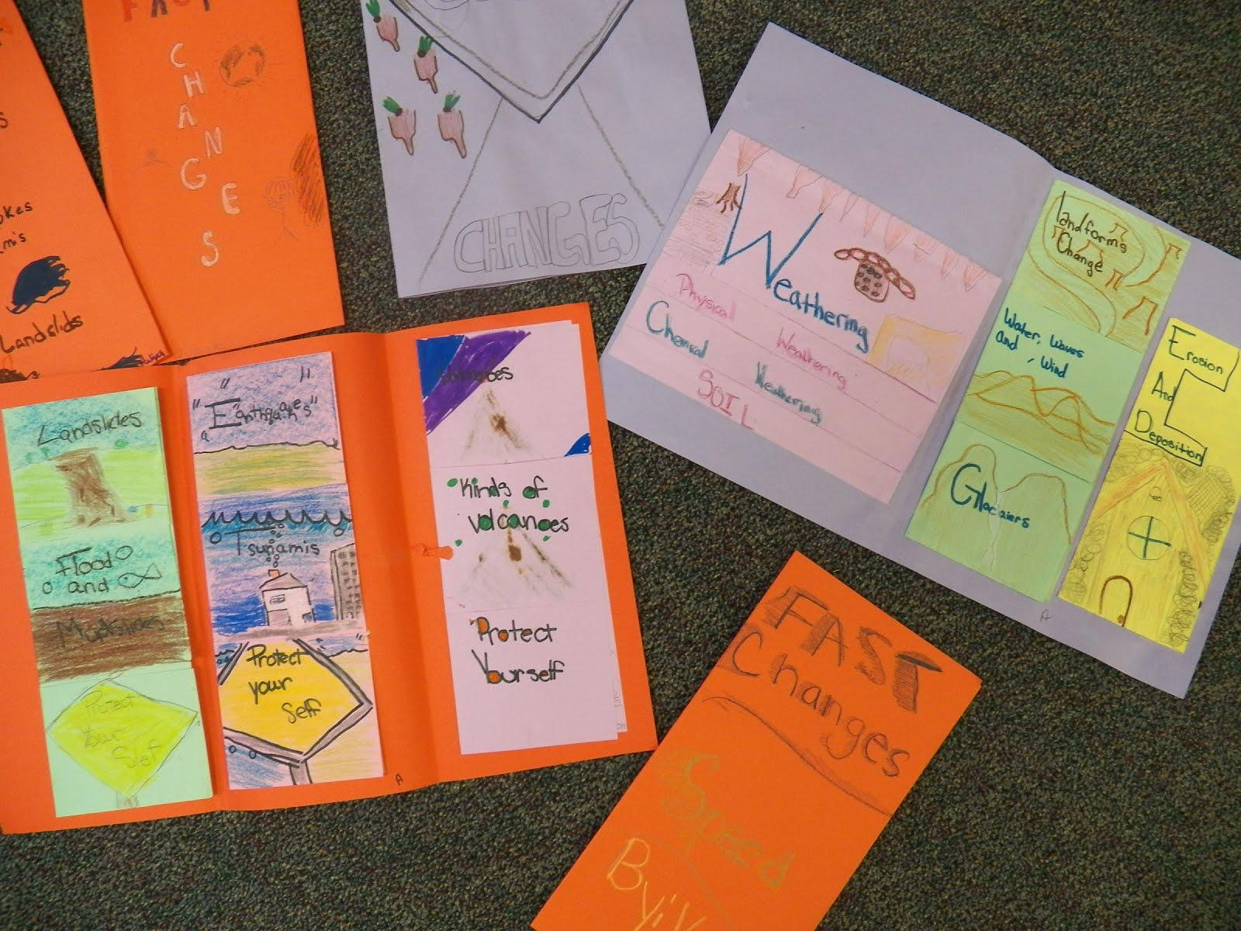
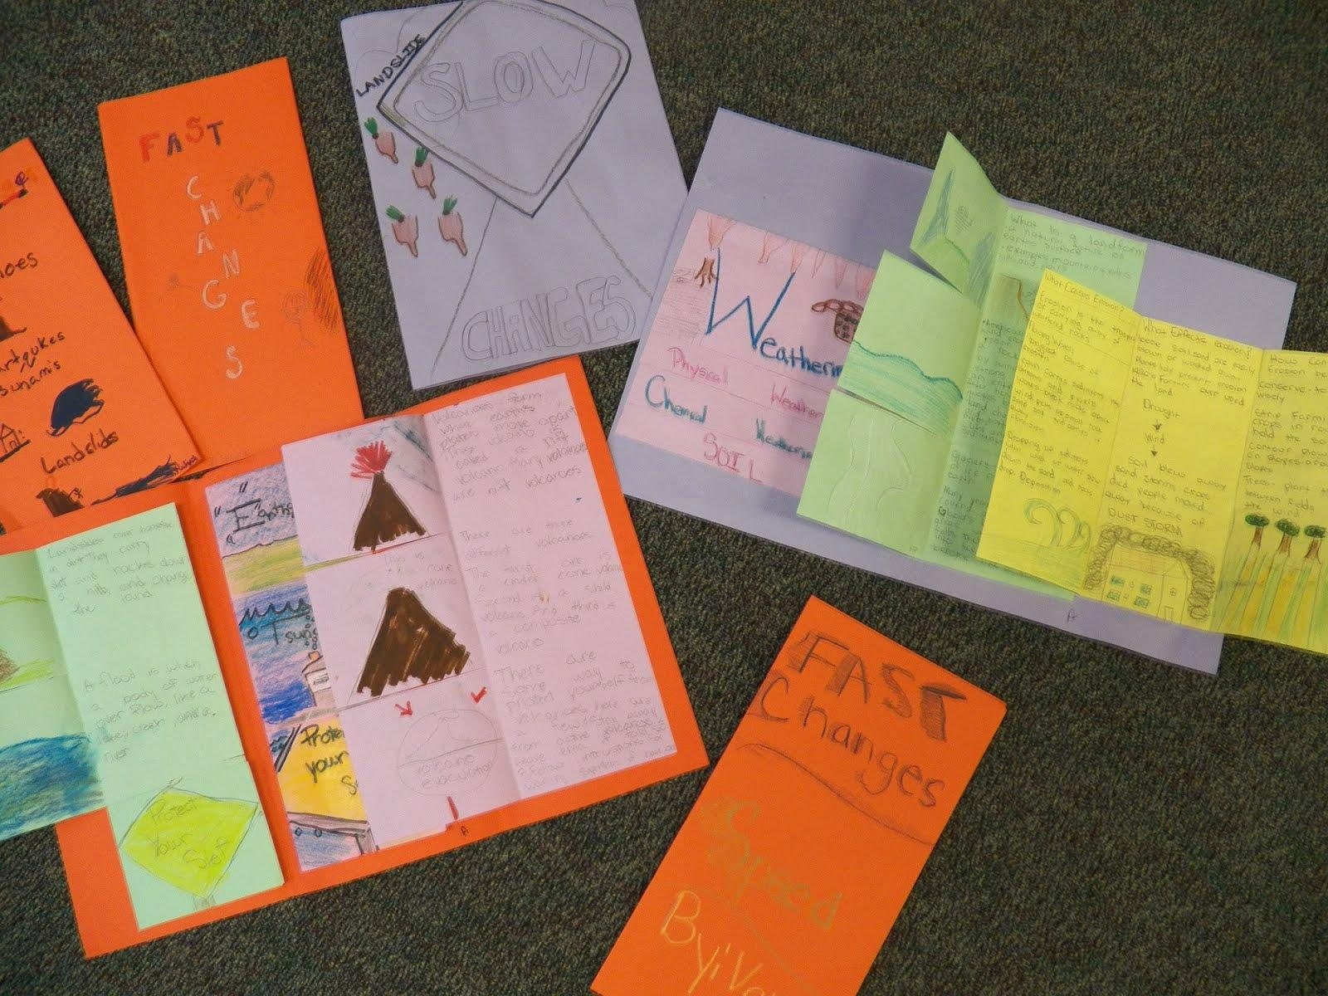

Report Writing with Watercolor Art Display
Lesson Objective: Rocks and Minerals- students will research a mineral and develop a presentation based on identification, classification, utilization, and location.
- Assign each student a rock or mineral. Each student researches his or her own mineral using iPads or Computer and takes notes. Notes should include formation, hardness level, description, where it is found, and uses.
- Introduce “Mask” poems to the class. These are types of poems that describe their subject similar to a “Who Am I” poem. “Colorado River” by Marybeth Wargo is one example.
- Ask students to imagine that they are their mineral or rock, then fill out the Mask Poem brainstorm page. The students will then use this page to help them write their own “Who Am I/Mask” poem. The poem should contain the important information about their rock or mineral and be fun and creative too! I recommend writing one together as an example.
- Poem should be typed google docs and shared with the teacher.
- Art display: each child will need 9 x 12 watercolor paper, 4 x 4 watercolor paper, 4 ½ x 4 ½ black construction paper, and plastic wrap. (I like to use watercolor paper because it really brings out the colors, but regular white construction paper can also be used.)
- Use a spray bottle to get the 9x12 paper slightly wet.
- Dab watercolors on the wet paper that “go with” the rock or mineral. I encourage the students to use only 2 or 3 colors. They should not paint with brush strokes, only blot spots until the entire paper is covered, no white left.
- As soon as they finish, while the paper is still wet, place a piece of plastic wrap that is larger than the paper on top of the watercolor paper. It will look crinkled up. Leave it on until the paper is completely dry. When the plastic wrap is removed, the paper will look like stained glass.
- Students should use the 4x4 white paper to draw their mineral as a character. Color drawing with crayons and paint over it with watercolors to create a crayon resist.
- Glue the printed mineral report poem, the 4x4 picture, and a title to the 9x12 watercolored paper.
- Students also create a Power Point type of presentation to present to the class.
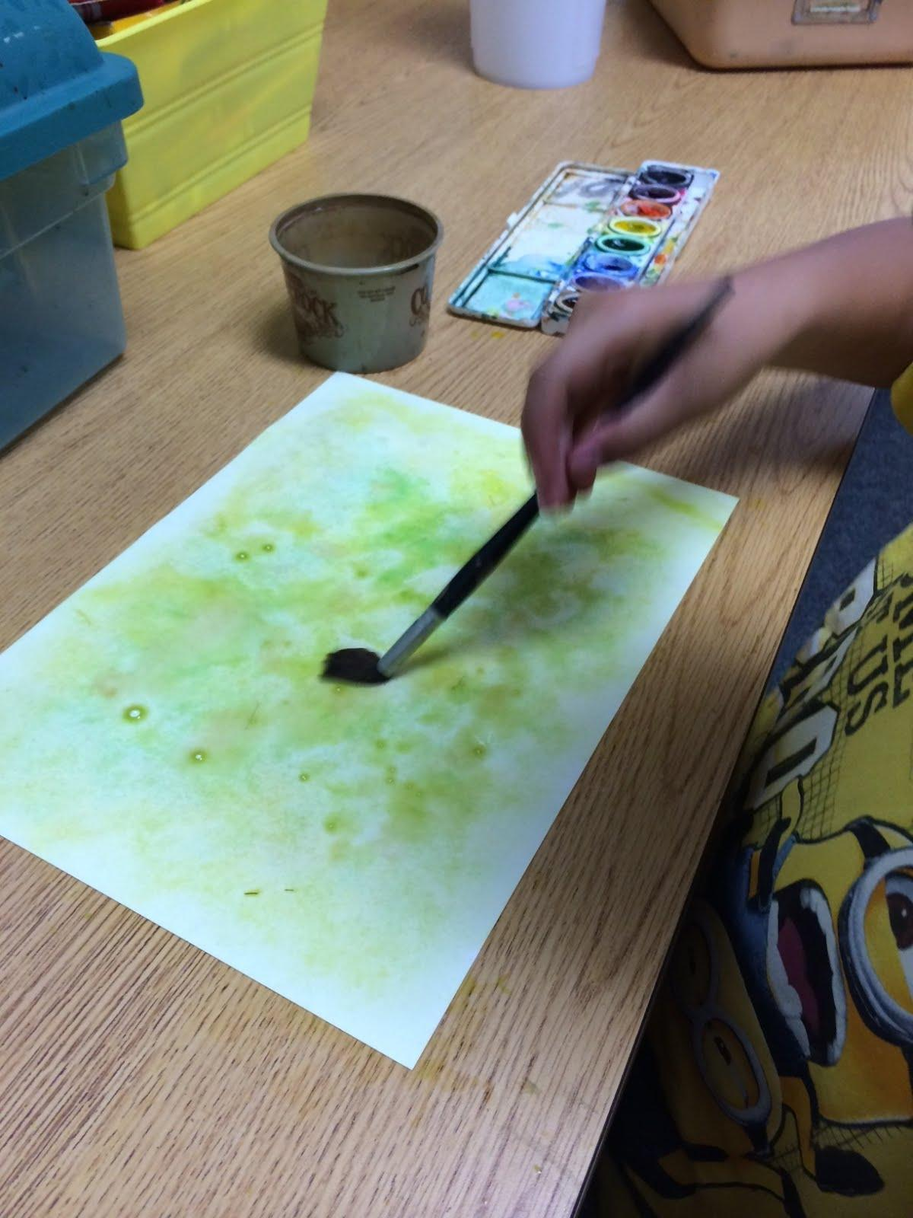
Blot paint on damp watercolor paper.

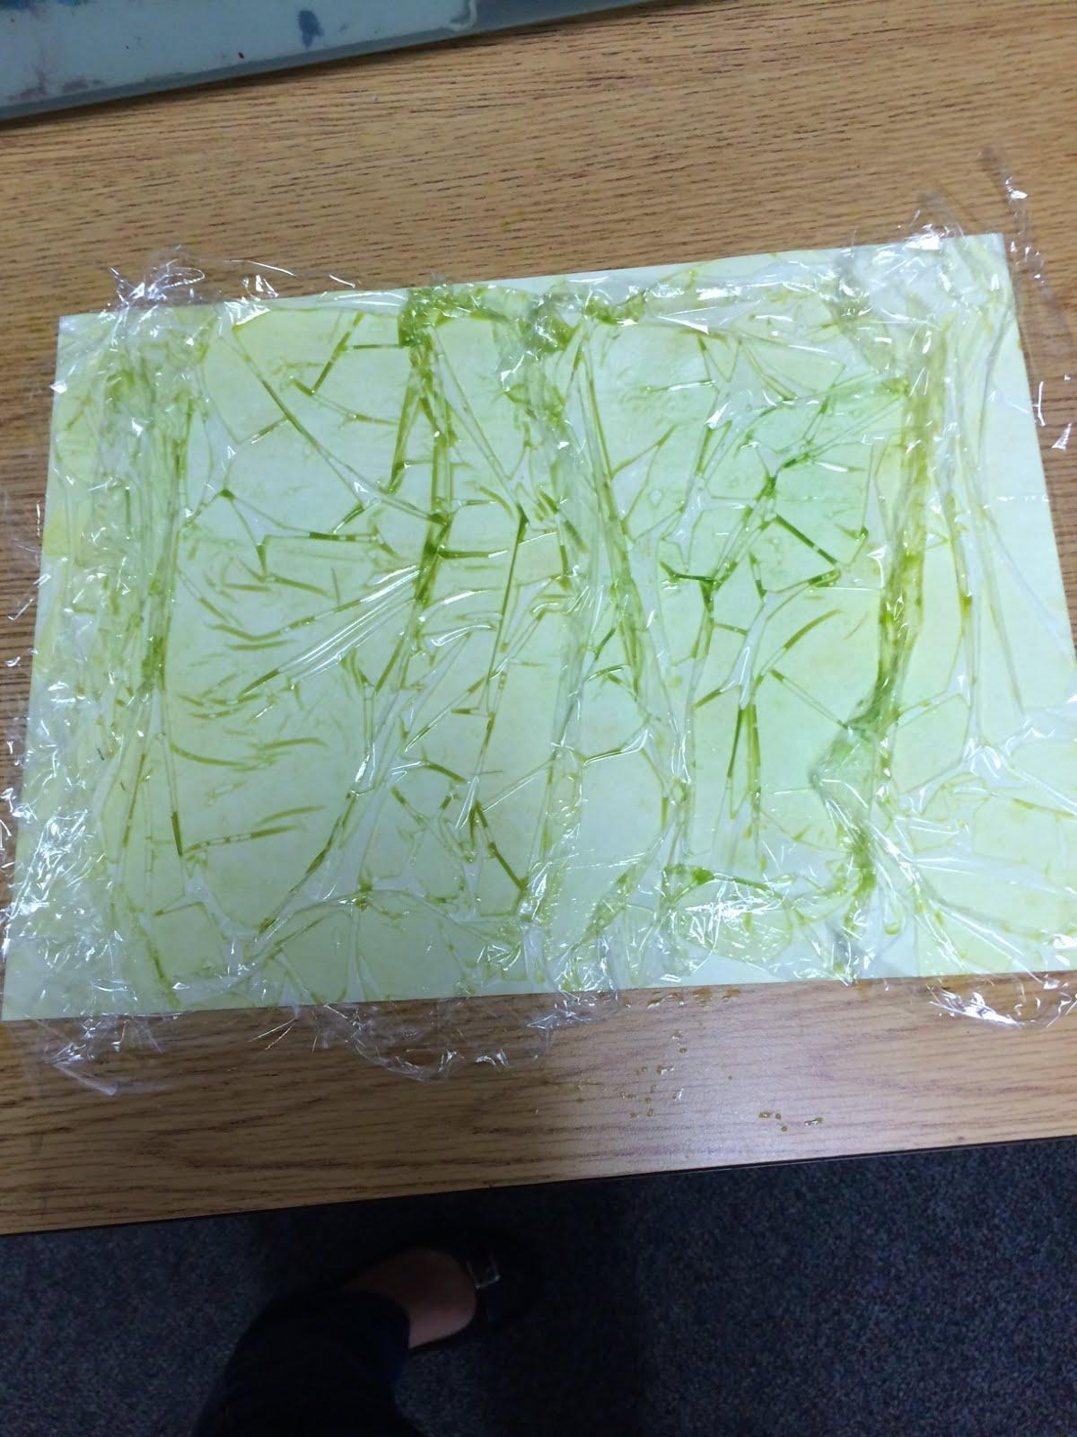
Cover the wet paper with plastic wrap in a crinkled fashion. Allow to dry completely.

Finished Watercolor backgrounds:
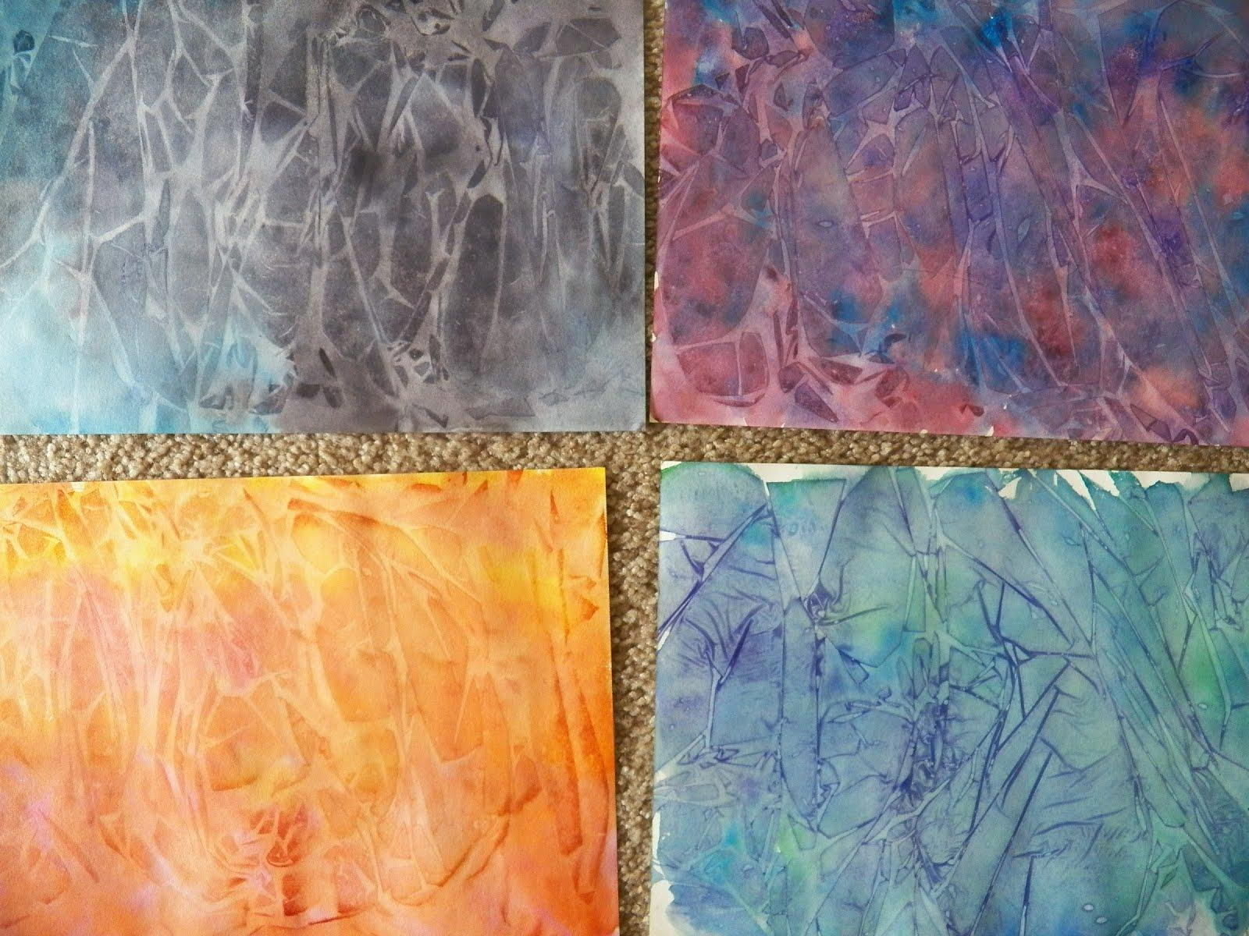
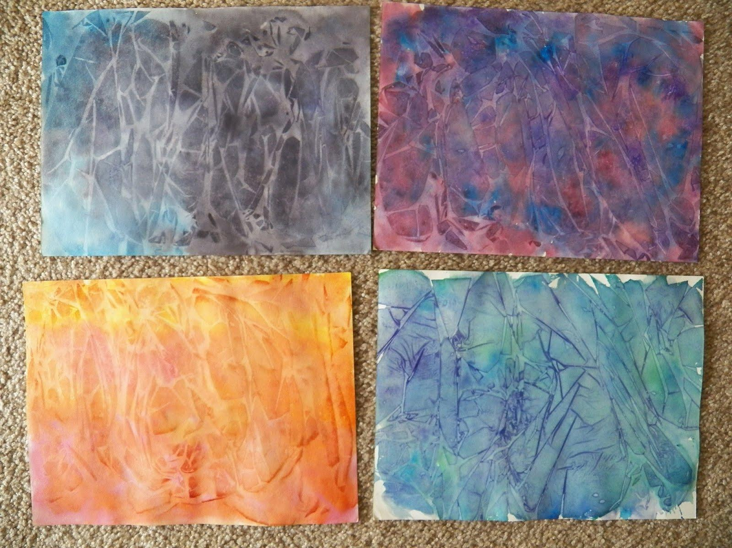

Finished Mineral Report Poems:
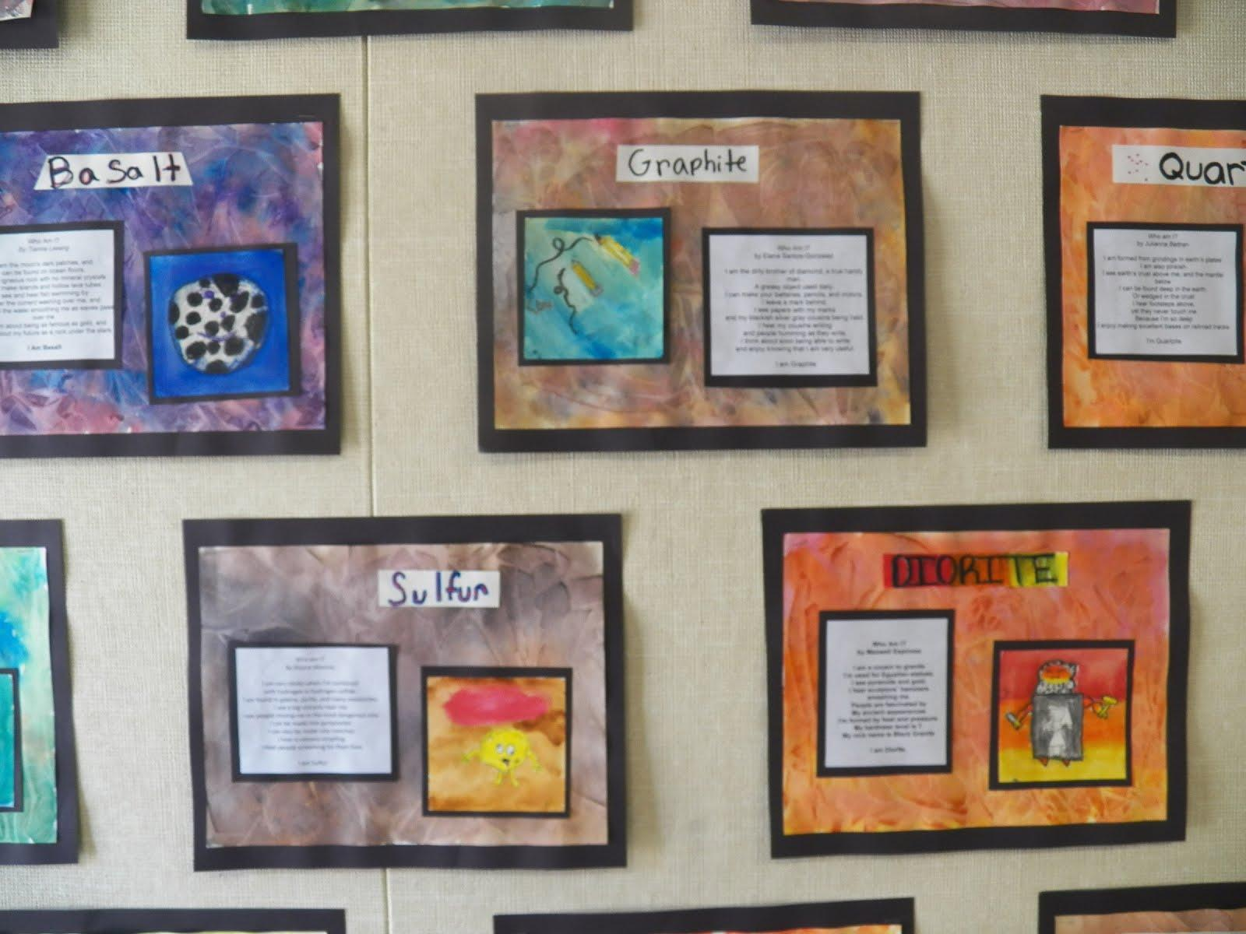
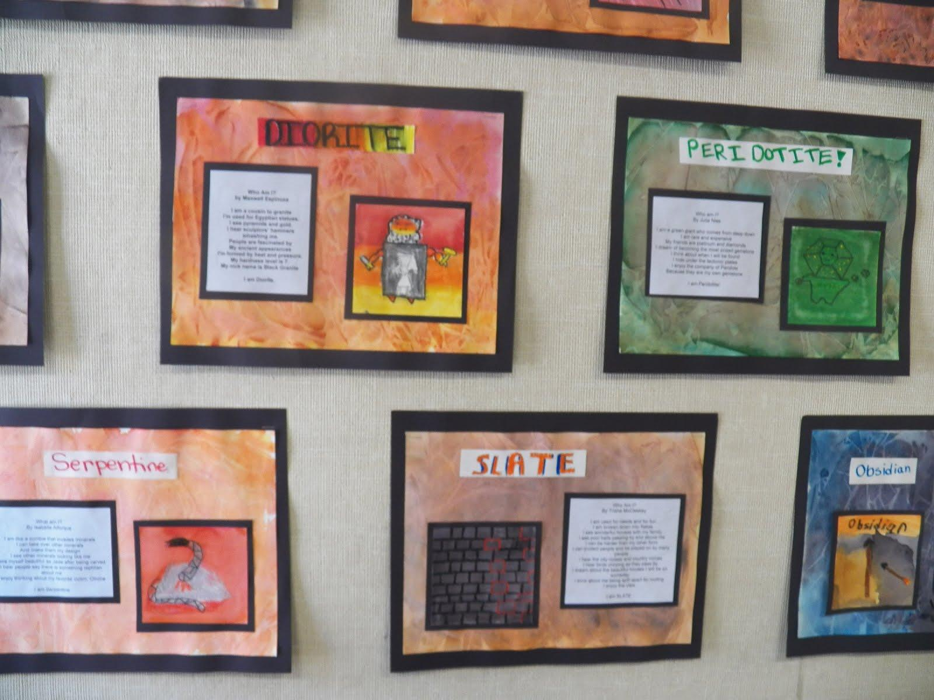

Mask Poem Brainstorm

Name: ______________________________

Mineral or Rock: ____________________________

Imagine that you have become your assigned mineral or rock. What would you be like? What would you see, hear, or be able to do? Write your ideas here and then use them to write your poem. Use your research notes to help you.

I see…

I am…

I can…

I hear…

I dream about…

I think about…

I enjoy...

Composer Connection:
Frede Grofe and “The Grand Canyon Suite”

Lesson Objective: Students will read a short biography on Frede Grofe and listen to “The Grand Canyon Suite.” Students will draw and paint a picture of the Grand Canyon.

Grofe was inspired to compose music after visiting various places including the Grand Canyon. Disney put his composition, “Grand Canyon Suite,” to motion picture years ago and it was included in the bonus material of the DVD, “Sleeping Beauty.” Disney’s “Grand Canyon Suite,” has beautiful scenes that bring the music come to life. The Grand Canyon is a wonderful example of weathering, erosion, and the formation of rocks. The section of this composition entitled, “On the Trail,” also shows various animals of the canyon including the bobcat that will be used in a direct draw lesson later.

After discussing Frede Grofe and listening to (and watching) “The Grand Canyon Suite,” we drew and painted the Grand Canyon using a Grand Canyon painting lesson found on www.deepspacesparkle.com I used white paper and watercolor paints instead of yellow paper and tempera paints. I started by doing the direct draw lesson of the canyon. Then the student used watercolors to paint. After the pictures dried, they outlined their drawings with a fine point black pen.

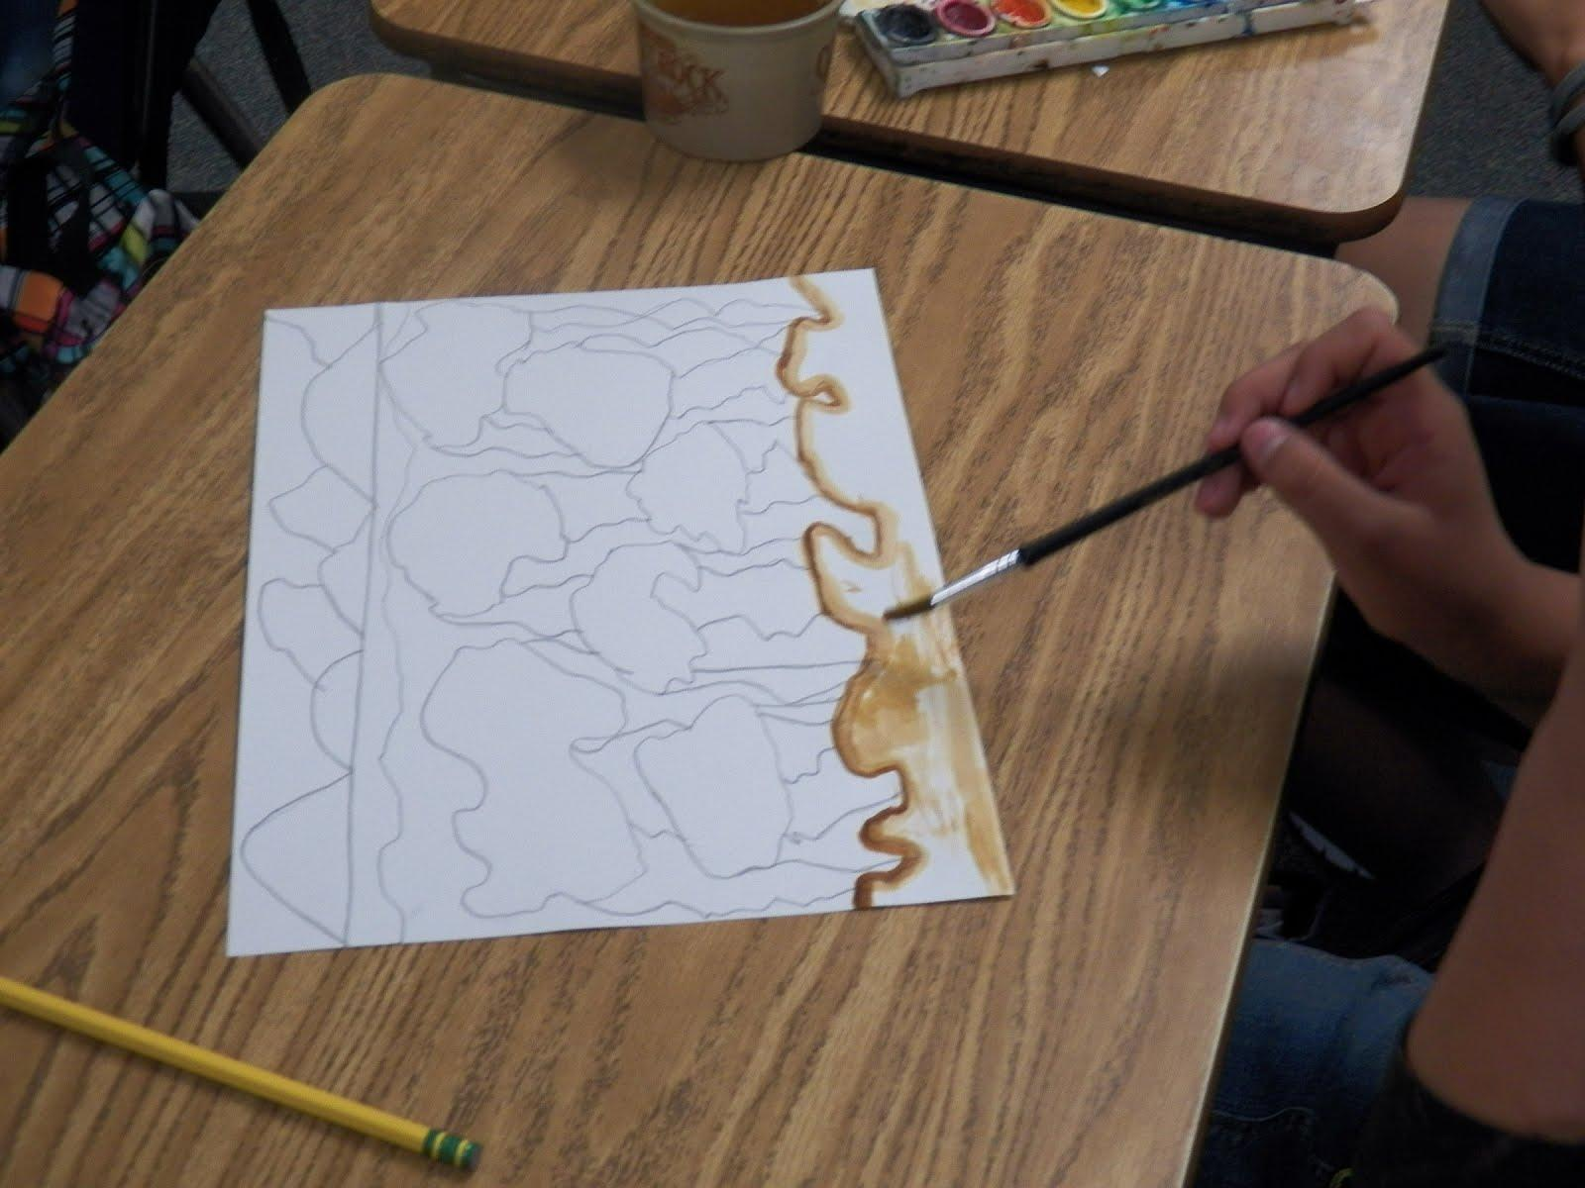
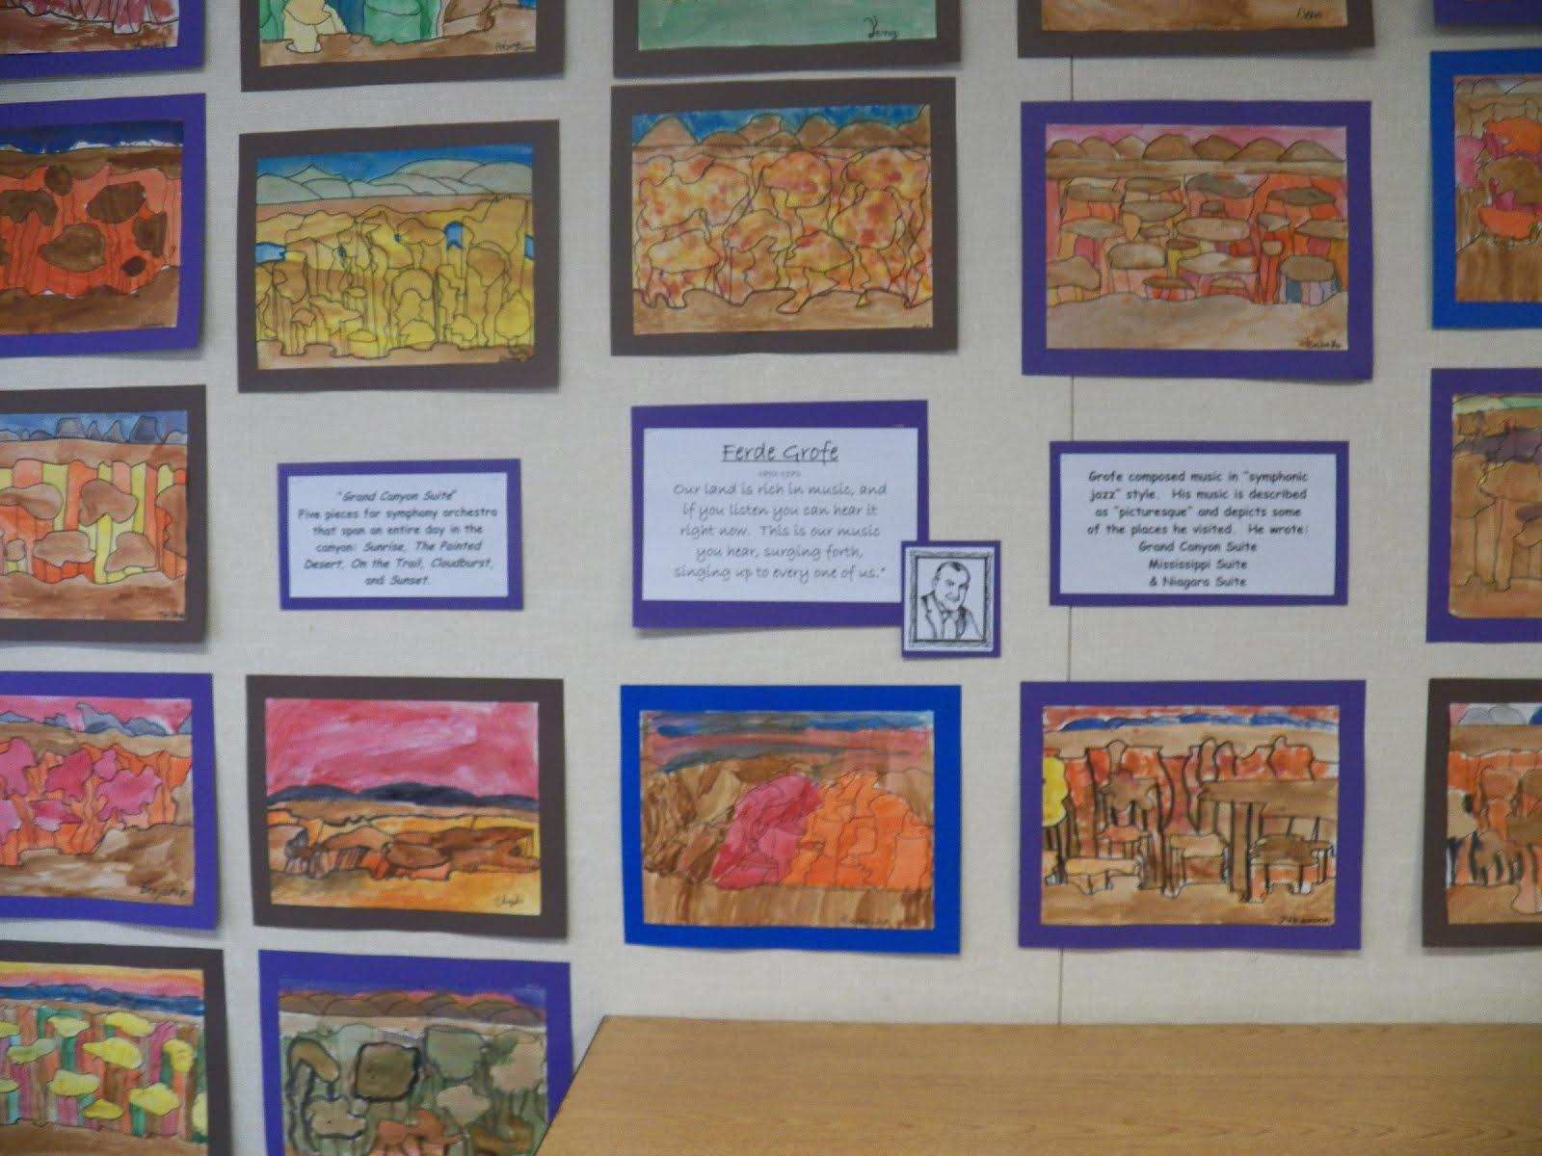
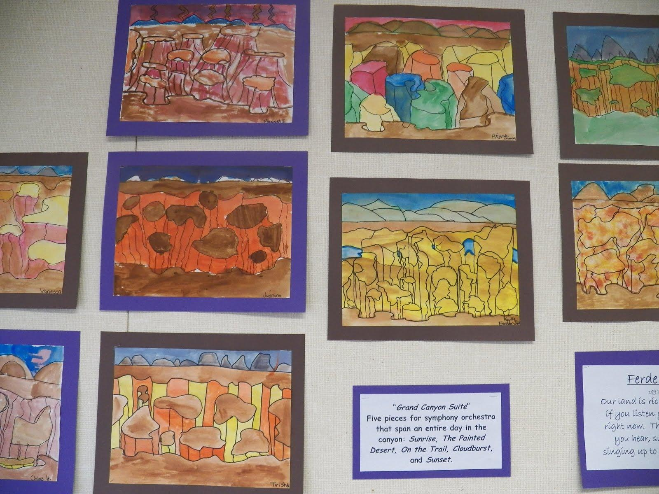

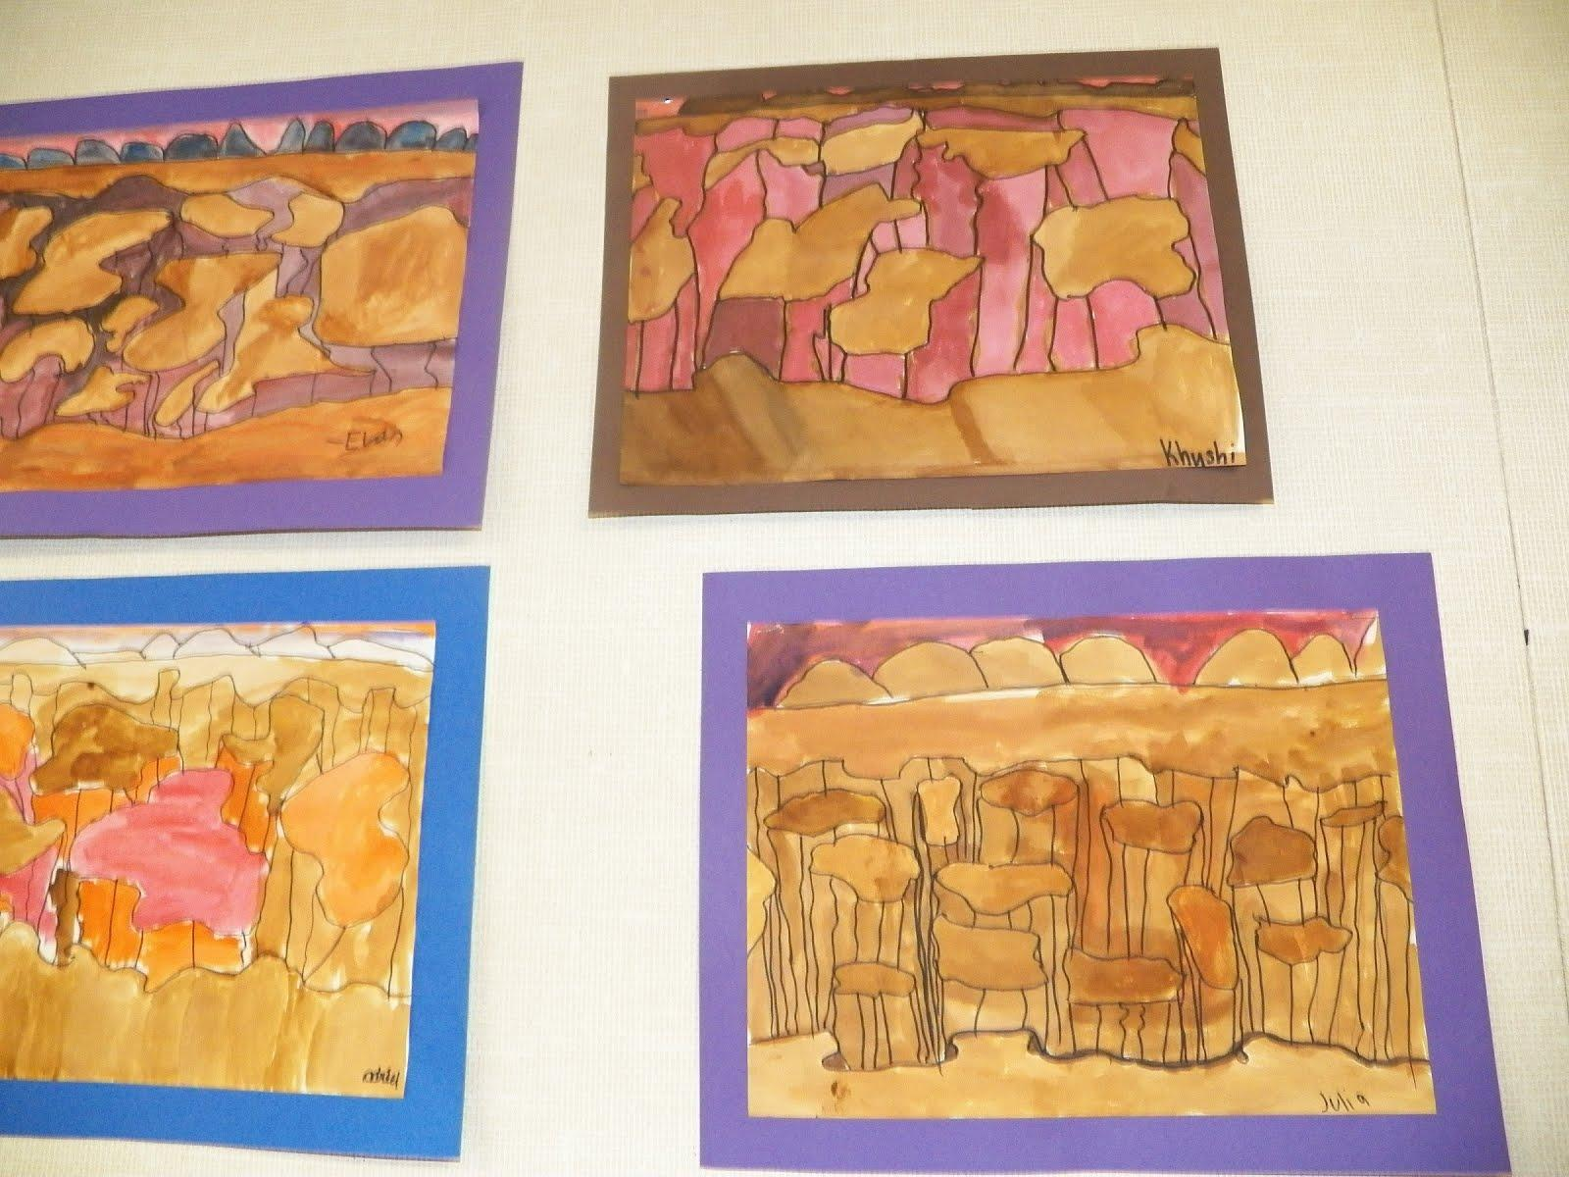

Direct Draw California Animals
Lesson Objective: Students will complete four drawing reflecting the four regions of California.

California has four distinct regions: Mountains, Coast, Desert, and Central Valley. We study the characteristics of these and the animals that live in them. This unit ties in with our Life Science Unit as well as Social Studies. Direct Draw lessons are easy to find on-line. We start with pencil and then go back over our drawings with fine point black markers.
