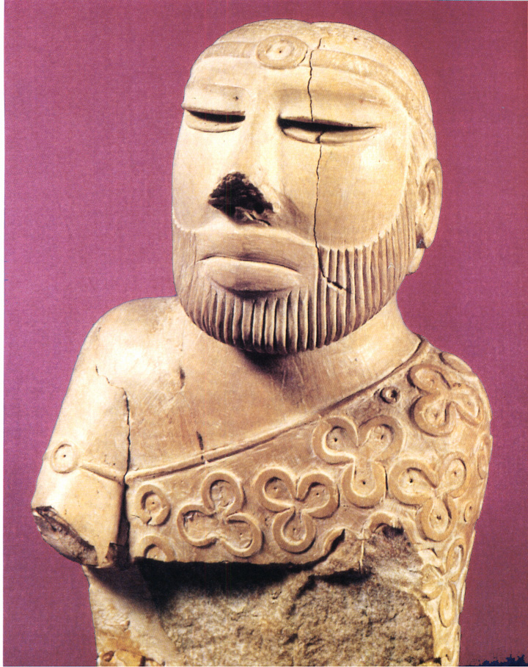
What Caused the Decline of the Indus River Valley Civilization?

An Inquiry Lesson Developed by
Christina Tillery
World History

Overview
The students will learn the three main theories why the Indus River Valley civilization declined through using the inquiry model. The three main reasons are: Invasion by the Aryans, effects of Plate Tectonics, and Natural Disasters, such as flooding, and monsoons. The lesson will begin with a demonstration the three main causes. The students will work in pairs and as a class to formulate hypotheses of why the Indus River Valley declined. Students will work similar to historians by reviewing secondary sources to support their hypotheses.
The students will have read Chapter 8: India’s Great Civilization in their world History Textbooks. The reading will provide the students with great background knowledge on the culture, lifestyle, religion, and the geography of the Indus River Valley civilization. Also the students would have already studied other ancient civilizations which will supply the students with information about other declination of civilizations, such as Mesopotamia, and Ancient Egypt. The students will know the unique geography of the Indus River Valley which will help them create their initial hypotheses.
Grade/Class 9th Grade/ World History I
Length 8:45 am to 10:15 am; an hour and thirty minutes session
Background Information
The Indus River valley civilization was a prominent society that reached across the Indian subcontinent. The region was highly arable, the people set up a substantial agricultural system from the cultivation of wheat, rye, and numerous vegetables. The society was also rich in culture and religion. The Harappans (inhabitants of the Indus River valley) were polytheistic. In the discovery of the ancient civilization, there were remains of religious statues and altars. In addition to the civilization’s great attributes, it also had a stable government ran by priests that ruled from the citadels of each city. The declination of the Indus River valley civilization happened over a period time between 1500 BC and 1000 B.C. The class will be investigating the reasons behind its demise.
Rationale
I am using the Historical Inquiry Model for this lesson plan. The key component of the inquiry is for students to “inquiry lessons introduce to students to the ‘doing’ of history”. (Stanford History Education Group) The usage of the inquiry model is essential because it promotes analysis of primary and secondary sources to test hypotheses. The declination of the Indus River valley civilization is great topic for an inquiry lesson because there is not a definite explanation to why the civilization ended. Currently, archaeologists and historians are working together to gather more information, and knowledge about the society.
In addition to the ongoing research, these experts also debate which factors really caused the declination of the civilization. This lesson allows students to analyze the information presented to them and along with their own background knowledge to investigate the demise of the Indus River valley civilization.
Objectives
The Virginia Standard of Learning WHI.3: The student will demonstrate knowledge of ancient river valley civilizations, including those of Mesopotamia, Egypt, the Indus River Valley, and China and the civilizations of the Hebrews, Phoenicians, and Nubians. This inquiry lesson will also cover the NCSS theme of People, Places, & Environment. This theme wants students to use “appropriate experiences [that] will encourage increasingly abstract thought as students use data and supply skills in analyzing human behavior in relation to its physical and cultural environment.”(NCSS Themes Blackboard) In addition to covering those standards, this lesson will have specific objectives for the students to achieve and these objectives will be assessed.

The students will be able to:
- Create hypotheses based on previous knowledge
- Support hypotheses using primary and secondary sources
- Analyze the primary and secondary sources
- Formulate a substantial conclusion using the knowledge from the sources
Assessment
The students will write a short paragraph of which factor they believe is responsible for the fall of the Indus River valley. The paragraph should state clearly which factor, and then have strong supporting evidence. This paragraph is a quick check to make sure the students understand the information from the data sets.
Content and Instructional Strategies
Introduction:
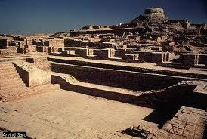
When the students are settled in their seats, introduce to them the topic for the lesson. Explain to the students the purpose and functionality of a Historical Inquiry lesson plan. For the purpose of this lesson the hook will be perform at the end. This will help not to sway students’ answers while they elicit their hypotheses for the fall of the Indus River valley. In order to engage the students in the lesson present to them this photo on the overhead projector:
This photo shows the remains of an intricate societal dwelling. Speak about the photo with the students: talk about the detailing of the architecture, what was the purpose of this structure, and what does this photo say about the Indus River valley?
- Elicit Hypotheses
  - I will clearly pose the questions to the students. Why did the Indus River valley civilization declined? The question will produce multiple and competing answers. The students will have already experienced the three main theories from the previous activity; the activity will elicit quick response since it was a visual experience. I will write the students’ responses on the whiteboard. (10 mins)
- Data Gathering and Processing
Since there is little recovered from the ancient civilization of the Indus River Valley civilization, there are four data sets of secondary sources that I have reviewed and created for the students. Students will remain in the same groups that they were in for the “hook”.
  - Data Set 1: A video source from AllHistories’ youtube account. The link is http://www.youtube.com/watch?v=cRNgJJjTh8I&NR=1. Start viewing the video at a minute and thirty seconds and end the video at four minutes and forty-three seconds. The video will discuss the natural disasters theory by showing students how historians and archaeologists work together to conclude the why the Indus River Valley declined. (3 mins)
  - Data Set 2: A composition of maps to show the propose invasion/migration of Aryans into the Indus River Valley. (4 mins)
  - Data Set 3: A photo of physical evidence of defense walls surrounding the Harappan towns. (4 mins)
  - Data Set 4: An excerpt from a source I reviewed that explains the plate tectonics theory very explicitly and clearly for the students. (3 mins)
- Revising Hypotheses
After viewing and analyzing the data sets, the students will reconvene as a class to review the initial hypotheses on the board. As a class and with my aid, the students will choose the major theories/reasons why the Indus River Valley civilization declined. (10 mins)
- Conclusions
The students will conclude that there is not one, sole explanation to why the Indus River Valley civilization declined, but understand that it was a combination of factors to explain the declination.
- The Hook
  - To emphasize the three main theories of the declination of the Indus river Valley:
Aryan Invasion, Plate Tectonics, and Natural Disasters I will demonstrate the theories with a visual activity. The activity will allow students to recognize the difficulties that the inhabitants of the Indus River Valley faced. In front of the classroom I will have already set up a miniature replica of the Indus River valley created out of sugar cubes placed on a towel.
  - Demonstrate the invasion theory. I will take one of the sugar cube buildings.
  - Demonstrate the plate tectonics theory. I will move the towel on the table to create the fall of the town.
  - Demonstrate the Natural Disasters (consistent flooding, climate changes,
and monsoons) theory. Approach the villagewith an adjusted spray
bottle, spray each town so that the sugar dissolves a little. (total of 9 mins)
Resources
- White board/ Dry erase markers and eraser
- One towel
- Desks
- About 50
- An adjustable spray bottle
- Printer for copies
- A computer and a projector to view the video
- Trashcan

Data Set 2:

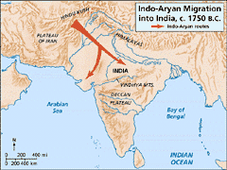

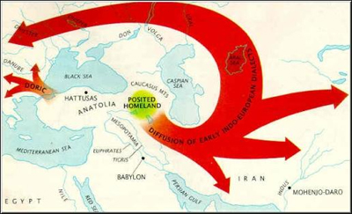

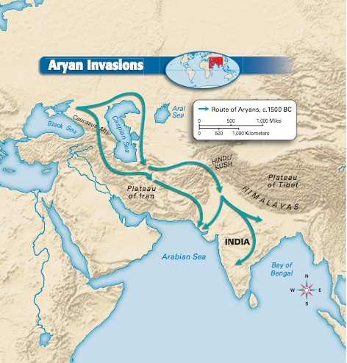

Data Set 3:

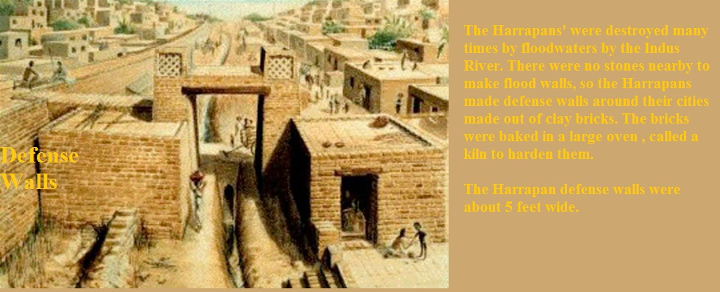

Data Set 4:

“The earthquakes associated with such an uplift would have been tremendous and the disruption of sea and land trade networks would have been devastating. The proximity to Arabian sea trade routes was, after all, the raison d'etre for sites such as Sutkagen Dor and Sutkha Koh. This tectonic uplift, then, would explain the demise of several Harappan coastal sites, as well as imply a hardship for many other Harappan sites which were dependent on these coastal sites for trade and/or marine resources.”

http://www.adventurecorps.com/archaeo/collapse.html

Differentiation:
This lesson provides on hands-on learning, visual aid, and group/class work. These aspects of the lesson will allow students to work together to solve problems, and also individual analysis of sources. Students will be able to come together a class and discuss ideas, and perspectives, which will allow them to produce a conclusion. This lesson represents differentiation in the overall curriculum by showing how I want to be able to reach out to all types of student learners. I want to be able to have activities that will assist every student in learning the material.
Adaptations:
In this particular class, there are not any recorded IEPs or 504 plans but there are still students with certain learning issues that can hinder them any class. In a case where they are students with special accommodations, the lesson can be modified into the students reviewing the data with another person rather than in a large group. I tend to notice that students with special needs can get lost in a group or classroom activity, so working in a pair will allow the student to participate more and I can easily walk over and discus with the students the significance of the source.
Pre-Reflections:
The biggest issue with this lesson will be time management. I want to maximize the actual learning/investigative time of the lesson, so it will require a lot of strict classroom management from me. The lesson is fun and unique which can cause students to become too excited and therefore at times it may be hard for them to settle down. Also, this lesson may require the usage of personal funds for the sugar cubes. The “hook” is very essential to providing a great sympathy for the inhabitants of the Indus River Valley civilization, but it is be cost effective for me to just do the activity once in front of the whole class. The students will not be able to witness firsthand the difficulties the civilization had which led to their declination. The plate tectonic theory may be hard for some students to grasp if they do not have firm understanding of earth science and continental plate drift. I will have to do Data Set 4 as a class which will be fine, because then as class we can review the initial hypotheses again for smooth transition. The lesson should go over very well if I keep the students interest.
Post-teaching:
After the lesson is completed, I will ask students how they enjoyed the overall class for that day. Was the information helpful? Was my method clear and understandable? Was the lesson and sources too easy or too hard (not grade-level appropriate)? I believe this lesson will score high under the Standard 1: Higher Order Thinking. In this lesson students will “manipulate information and ideas through these processes allows students to solve problems and discover new (for them) meanings and understandings.” (PASS Module, p.7) A historical inquiry lesson gives students the chance to interpret history for themselves, and work as historians.
Technology Product:
The main technology that will be used in this lesson is the overhead projector. The overhead projector creates a low-cost interactive environment in the classroom. The overhead projector can be connected to a laptop or simply use to display images placed on the surface under the LCD projector. In order to show the video from AllHisotries.com, the teacher should connect their laptop to the projector using the USB cord.
Here is a photo of modern overhead projector:

In a strange case that the overhead projector is not working, for a backup plan the teacher can have another projector just in case of problems, or the students can view the video on their own laptops provided by the school.

Technology Reflection:
Technology is a great resource in the classroom. This lesson does not require vast amounts of technology, but for presenting the first data set it is extremely helpful. The video on AllHistories.com allows me to give the students additional information to the students by presenting it in a different media which is the UDL’s first principle. The second principle suggests using multiple strategies to engage students. This lesson supports this principle because I used images, and physical demonstration of the declination of the Indus River Valley.
The students will demonstrate what they learned through using the multiple medias and strategies by completing their assessment paragraph. In this particular lesson, the technology used helps with maximizing instructional/learning time. The usage of technology connects with my pedagogical approach in the classroom by allowing me to reach all students by presenting the information in different ways. I want to be able to accommodate every student’s strengths and work with their weaknesses. Content, pedagogy, and technology should work together for the benefit of the students. The students should feel that the lessons are adequate, necessary, and practical. The combination of those three factors will aid in the advancement of students.

References
AllHistories Youtube Channel http://www.youtube.com/user/AllHistories
Kostman, Chris. The Demise of Utopia: Contexts of Civilization Collapse in the Bronze Age Indus Valley.
Stanford History Education Group. What is an Inquiry Lesson? Teachinghistory.org http://teachinghistory.org/teaching-materials/teaching-guides/24123
Richardson, Hazel. Life in the Ancient Indus River Valley. Crabtree Publishing Company. 2005
KidsPast.com http://www.kidspast.com/world-history/0103-aryans.php
Mr. Hendricks’ Exploratorium http://eslsocialstudiesexploratorium.blogspot.com/2010_11_17_archive.html

