Who Do Voodoo?

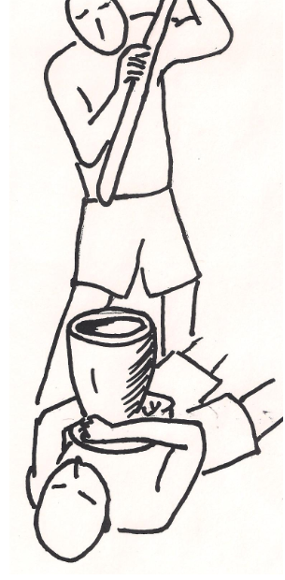

Some witch doctors claim to have special powers that allow them to do things ordinary people cannot do. The people who perform these feats of "magic" may demand large fees from their uneducated followers. The picture shows a voodoo witch doctor laying on a sandy beach with a wood mortar held tightly to his chest. Another man slams a pestle into the container. Other people take turns using the pestle, yet the witch doctor remains unharmed. Once again he has convinced his followers that he has magical powers.
Identify as many variables you can that might allow the witch doctor do this "magic."
Design a safe experiment to test one of the variables you have identified.

To the teacher
This demonstrates some basic physics
Inertia. The heavy mass does not move much.
Pressure. The force is distributed over a fairly large area.

Students will probably consider variables such as the sandy beach, the size of the pestle, the diameter of the base of the mortar.

