**CASTLE LEARNING ASSIGNMENT 18A**

1.  Which number is equivalent to?

1. 0.5
2. 
3. 1.2
4. 

2.  Salma rolls a standard 6-sided number cube once, and then she rolls it a second time. What is the probability that Salma rolls a six both times? Express your answer as a fraction in simplest form.

Answer: _______

3.  Solve.

-5 + 5 = _______

Answer: _______

4.  The first whole number is _______.

Answer: _______

5.  Which equation is an illustration of the additive identity property?

1. *x*  1 = *x*
2. *x* + 0 = *x*
3. *x* - *x* = 0
4. *x*  1/*x* = 1

6.  The following is a set of scores on a math test:

68, 77, 93, 61, 84, 88, 76, 91, 80, 100, 89

What is the median of the scores?

Answer: _______

7.  Mr. Hughes tallied up the scores of his students on a recent French quiz. He summarized the data in the table.

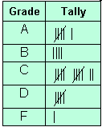

How many students received a grade below *C*?

Answer:  _______ students

8.  Find (-3)(5).

Answer:  _______

9.  Which of the following will *not* give you the same result as the others?

1. (-5)(-8)
2. (-5)(8)
3. (-8)(-5)
4. (5)(8)

10.  What is the value of -42 ÷ 6?

Answer:  _______

11.  The number "460,060,000" can be written as:

1. four hundred sixty billion, sixty thousand
2. four hundred sixty million, sixty thousand
3. four hundred six thousand, sixty
4. four hundred sixty million, six thousand

12.  If the length of the box is 7 centimeters, the width is 5 centimeters, and the height is 8 centimeters, what is its volume?

1. 225 cm3
2. 255 cm3
3. 275 cm3
4. 280 cm3

13.  Solve for *m*: 6 + 3*m* = 24.

Answer: *m* = _______

14.  Sharon was offered 80 + 40 ÷ 2 as a grade on her next math quiz. Should she choose to take this grade or not?

1. Yes
2. No

15.  The triple bar graph below shows the different types of businesses that were started in 1975, 1980 and 1985.

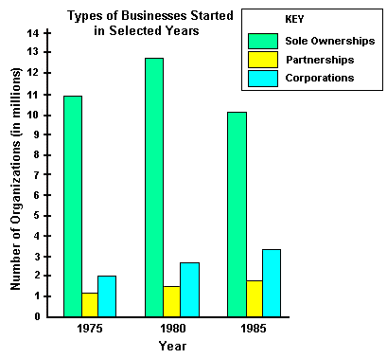

What can you conclude from the bar graph?

1. Most of the business organizations were corporations
2. Sole Ownerships were started more than both Partnerships and Corporations combined.
3. Sole Ownerships increased in 1990.
4. Six million Corporations were started in 1980.

16.  The data table show the daily high temperatures recorded over the period of one week.

|  |  |  |  |  |  |  |
| --- | --- | --- | --- | --- | --- | --- |
| Mon. | Tues. | Wed. | Thurs. | Fri. | Sat. | Sun. |
| 72° | 75° | 80° | 76° | 89° | 84° | 82° |

Which graph best displays this data?

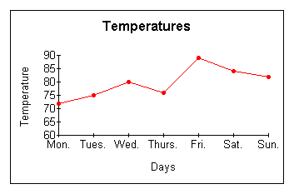

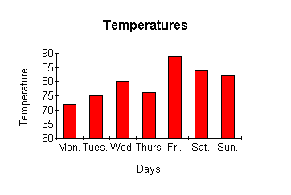

3.

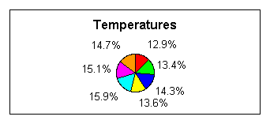

4.

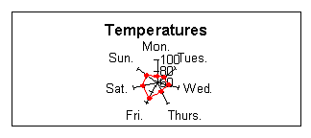

17.  Simplify the expression: 12 × 6 ÷ 2 = _______

Answer: _______

18.  The cost of your hotel bill increases as the number of days you stay increases. What would this relationship look like on a line graph?

1. The line would be horizontal.
2. The line would be vertical.
3. The line would go down from left to right.
4. The line would go up from left to right.

19.  For lunch, each student at Holland Middle School has a choice of one main course, one beverage, and one dessert from the menu.

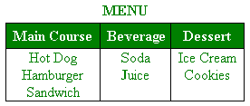

How many different combinations of lunches consisting of one main course, one beverage, and one dessert can be chosen?

Answer:  _______

20.  Based on the line graph above, in what year did unemployment in the United States show the greatest peak?

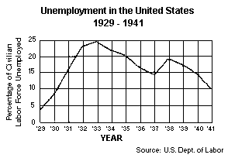

Answer:  _______