**CASTLE LEARNING ASSIGNMENT 15A**

1.  Mr. Hughes tallied up the scores of his students on a recent French quiz. He summarized the data in the table.

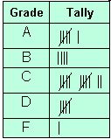

Which statement about the data is *false*?

1. More students earned a grade of *C* than any other grade.
2. At least half of the students passed the quiz.
3. More students earned a *D* than earned an *A*.
4. 28 students took the quiz.

2.  Name a radius of the circle.

1. 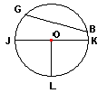
2. 
3. 
4. 

3.  Jody and Liam were driving upstate to a cabin on Long Lake. It is 360 miles from their house to Long Lake. If Jody drove two-fifths of the trip, how many miles did she actually drive?

Answer: _______ miles

4.  Nadia collected and recorded measurements of the amount of carbon monoxide in the air at the same location each day for one week. Nadia’s data are shown in the table.

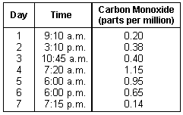

What is the range of the data?

Answer: _______ parts per million

5.  If three-fourths of the marbles in a bag are blue and there are 20 marbles in the bag, how many marbles are *not* blue?

1. 15
2. 16
3. 10
4. 5

6.  The histogram shows the grade distribution for a mathematics test given to Ms. Keith's class. How many students are in the class?

1. 12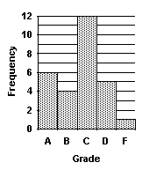
2. 23
3. 28
4. 33

7.  Which of the following correctly lists the integers in order from *least* to *greatest?*

1. -5, -2, -4, 2, 3, 6
2. -5, -4, -2, 2, 3, 6
3. 6, 3, 2, -2, -4, -5
4. 6, 3, 2, -5, -4, -2

8.  A parallelogram is shown below on a coordinate plane.

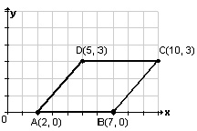

What is the *x*-coordinate of point *D*?

Answer: (_______, _______)

9.  Simplify: (12 - 2)(4 + 6) = _______

Answer: _______

10.  How can you express the area of the circle in terms of π?

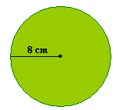

1. 8π
2. 16π
3. 64π
4. 80π

11.  Kyle drove his car 250 miles on 20 gallons of gas. How many miles per gallon did Kyle average?

Answer:  _______ miles per gallon

12.  Miguel is making a chart of factors. Help Miguel to complete the chart by filling in the missing factors, in order of *least to greatest*.

|  |  |
| --- | --- |
| **Number** | **Factors** |
| 4 | _______, 2, _______ |
| 10 | 1, 2, _______, _______ |

13.  Which of the following is a prime number?

1. 15
2. 16
3. 17
4. 18

14.  The greatest common factor of 48 and 16 is _______.

Answer: _______

15.  Which fraction is *not* in simplest form?

1. 
2. 
3. 
4. 