**CASTLE LEARNING ASSIGNMENT 9A**

1. Simplify the fraction.

1. 
2. 
3. 
4. 

2.  What would be the denominator for representing a fraction of the circle?

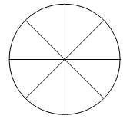

1. 7
2. 8
3. 9
4. 10

3.  Which of these numbers is a factor of 26?

1. 10
2. 7
3. 3
4. 13

4.  Which group is made up *only* of composite numbers?

1. 2, 4, 6
2. 7, 9, 15
3. 5, 10, 15
4. 4, 9, 12

5.  Josh went to the sporting goods store to buy tennis balls. The tennis balls *only* come in packages of 3. Which of the following numbers *could* represent the total number of balls that Josh bought?

1. 15
2. 13
3. 8
4. 22

6.  Which fraction is equivalent to ?

1. 
2. 
3. 
4. 

7.  Which fraction is greater than ?

1. 
2. 
3. 
4. 

8. The least common multiple of 3 and 8 is _______.

1. 24
2. 8
3. 3
4. 0

9.  Ms. Barnard is a math teacher. She says to the class, "Subtract one half from three fourths." What would this question look like?

1.  - 
2.  - 
3.  - 
4.  - 

10.  What is the area of the rectangle?



1. 4 square units
2. 12 square units
3. 48 square units
4. 32 square units

11.  Which unit label would ***not*** be used for the answer to an area problem?

1. ft2
2. m2
3. yd2
4. cm

12.  The table below shows the total number of points scored by each member of a girls basketball team:

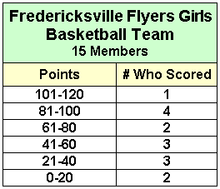

How many girls scored 40 points *or less* all season?

Answer: _______ girls

13.  The line graph shows the total number of miles traveled by the Samkowitz Family on vacation each year.

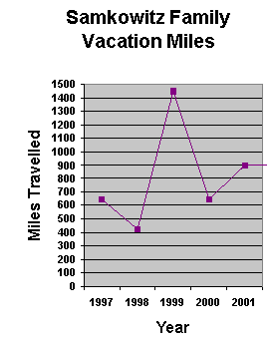

In which two years did they travel the same number of miles?

1. 1997 and 1999
2. 1998 and 2000
3. 1999 and 2001
4. 1997 and 2000

14. What is the ratio of blue to red sectors shown in this circle?

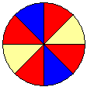

1. 2:2
2. 2:4
3. 2:6
4. 2:8

15. Which is *not* a way to write a ratio?

1. 6 to 7
2. 6:7
3. 
4. 6-7