Mike Archibald
INST 6730
Lesson Plan Week #10
July 18th, 2010

Audience:
The class that this will be taught this lesson consists of 7th grade students fresh out of 6th grade. This is their first real taste of science at the middle school level. Students generally fall into the age range of 11 to 12 years old and the vast majority of them are enthusiastic and very attentive at the beginning of a new school year.

Instructional Goals:
This lesson will key in on and hopefully teach aspects of the different Utah state science standards for 7th grade. The standards and objectives are listed below:
- Standard 5 Objective 1-Students will be able to defend the importance of observation in scientific classification and demonstrate that there are many ways to classify things.
- Standard 5 Objective 2-Students will be able to use a provided classification scheme to classify things whilst generalizing basic rules for classification.
- Standard 5 Objective 3-Students will be able to identify types of organisms that are not classified as either plant or animal and be able to arrange organisms according to kingdom whilst using a classification key.

Timeline:
Students will be taught this unit over a two week period. This lesson will be one lesson that will be part of the entire unit. It is not necessarily intended to be used to begin or conclude the unit but to build upon intermediate knowledge throughout the unit.

Procedure:

Setting
Students will be given internet access and an individual computer to complete this assignment over two different class periods.

Introduction
Students will be given the following websites with an accompanying worksheet that will walk them through each of the sites to ensure that they seek out and learn the appropriate information on each site. Each site will build upon the previous instructional site and help students gain an understanding of how and why scientists classify various organisms.

As a review at the start of class students will be asked general knowledge questions about classification including some of the possible questions below:

What is classification?
Why do scientists classify living organisms?
What is the basis for most classification systems?
What does a classification key generally look like?
What are the 7 levels of classification?

Primary Assignment
Upon conclusion of the above mentioned discussion students will be given access to their computers and the accompanying worksheet that will guide their studies as they use various OER type websites across the face of the internet.

Animal Classification Review
http://www.quia.com/cm/1130.html?AP_rand=575988743

Silly Taxonomic Key
http://www.biologycorner.com/worksheets/pamishan.html

Interpreting Taxonomic Keys
http://www.biologycorner.com/worksheets/taxonomy_interpret.html

Evolutionary Information
http://www.pbs.org/wgbh/evolution/change/family/

The 6 Kingdoms of Life
http://www.ric.edu/faculty/ptiskus/Six_Kingdoms/Index.htm

Binomial Nomenclature
http://www.palaeos.com/Systematics/Linnean/Linnean.htm

Dichotomous Plant Keys
http://www.biologyjunction.com/dichotomous_keying.htm

During the course of this activity students will be working steadily on this project and the teacher will act as a mediator between the material and the students. This means the teacher should be going around and answering questions and assisting student learning during the duration of the lesson.
The following screenshots were taken at a few of the various websites listed above to give you a taste of what the students will be learning as they go through the lesson plan.

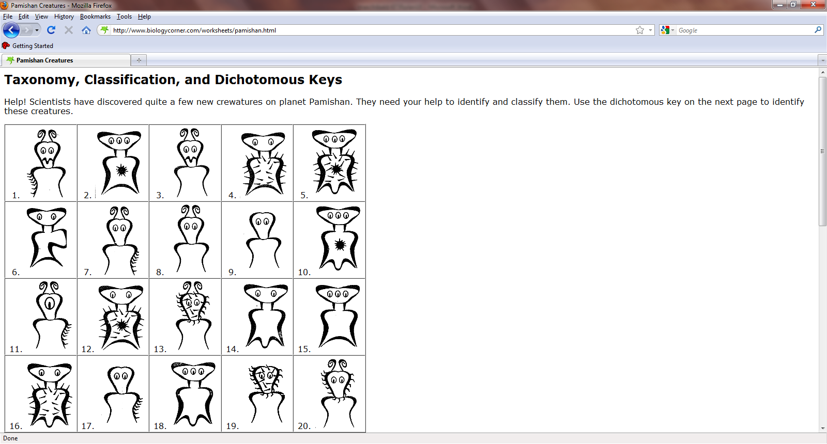

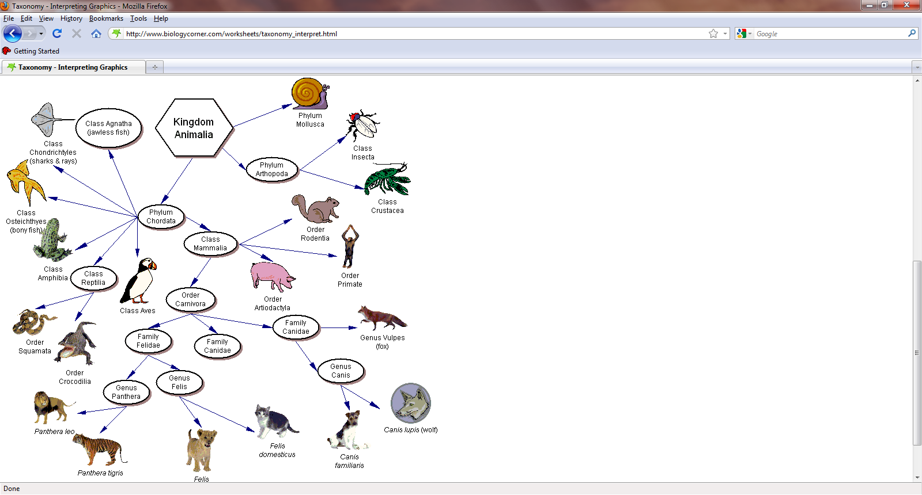

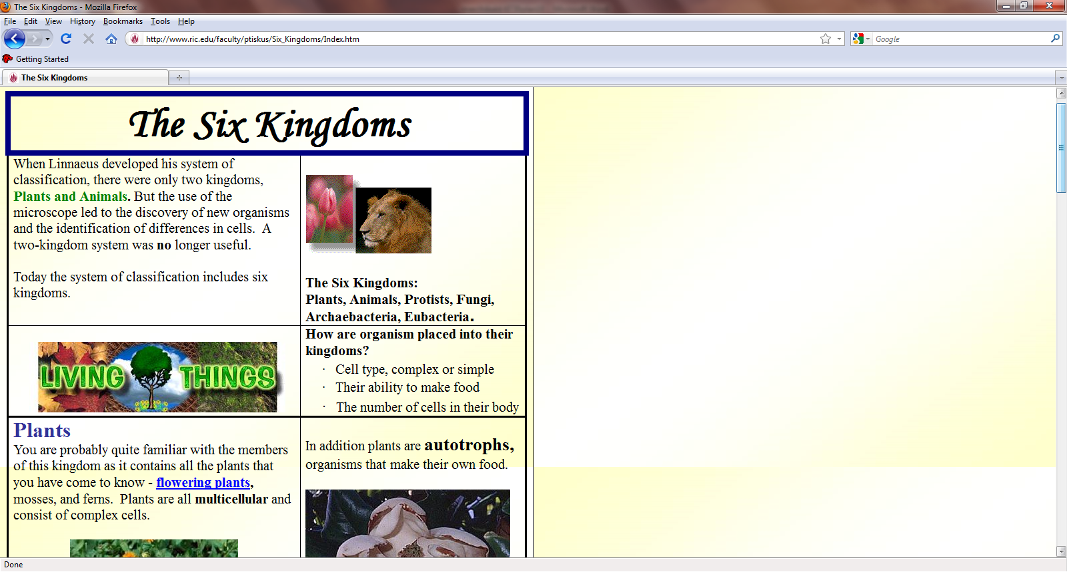

Facets of Technology Used
Technology is at the core of this lesson as students use various internet websites and programs developed by other teachers online to learn the course material. It’s funny as a teacher you can sometimes repeat vocabulary terms or important concepts again and again and again but until students go online and get an opportunity to apply that knowledge and seek out their own answers it doesn’t seem to really stick.
Another great aspect of using this branch of technology is that as a teacher you can instantly pick up on which students understand the covered material and which students are not. With various technological modules doing the reviewing and teaching of new concepts the teacher is free to walk about the classroom and monitor students for appropriate understanding of curriculum. In a traditional classroom this opportunity to monitor student comprehension is not always readily available.

