Census 2010-Creating a Chart in Excel

Open up the template I have created for you called “Unfinished Census Sibling Birth Month.”
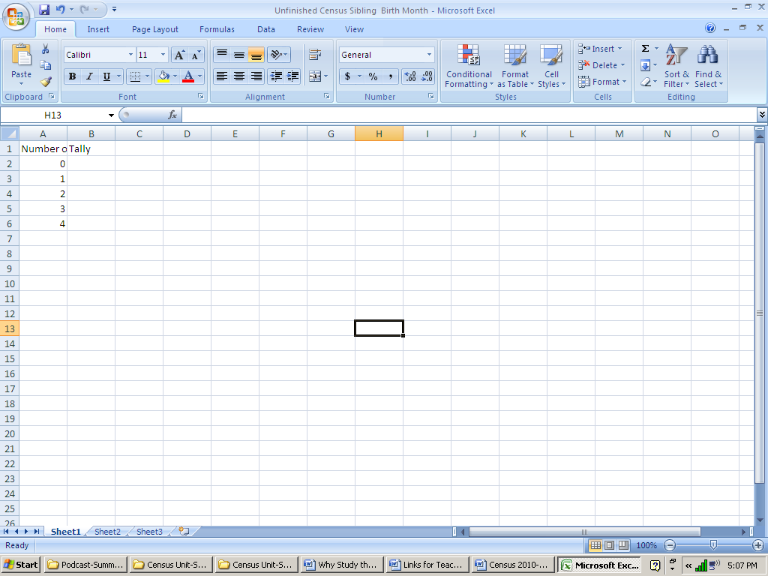
Double-click on the line between the A and B columns to make column A larger

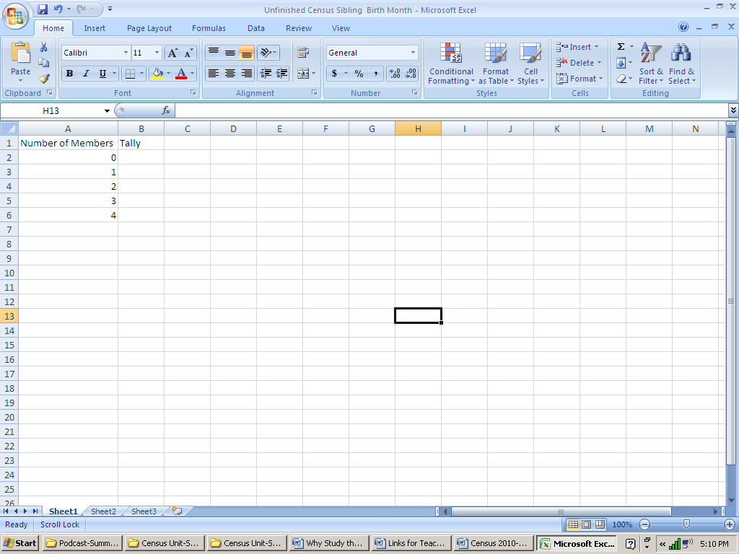

Put in the data you have.
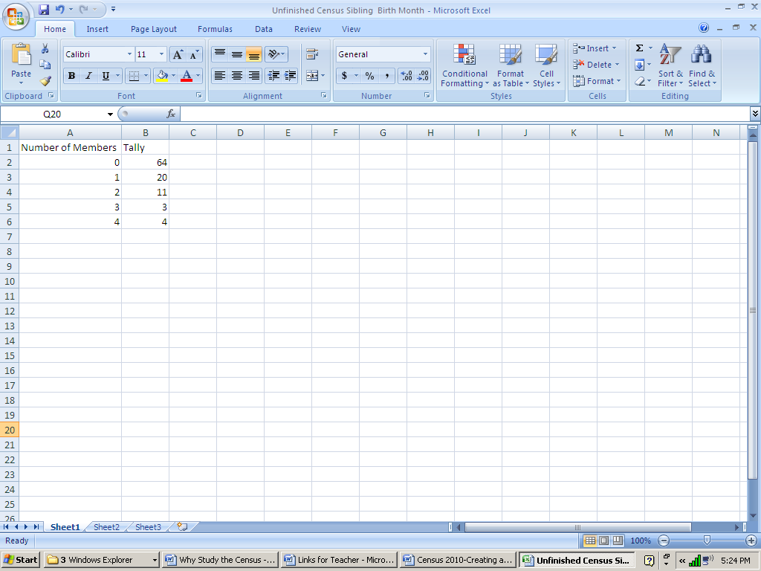

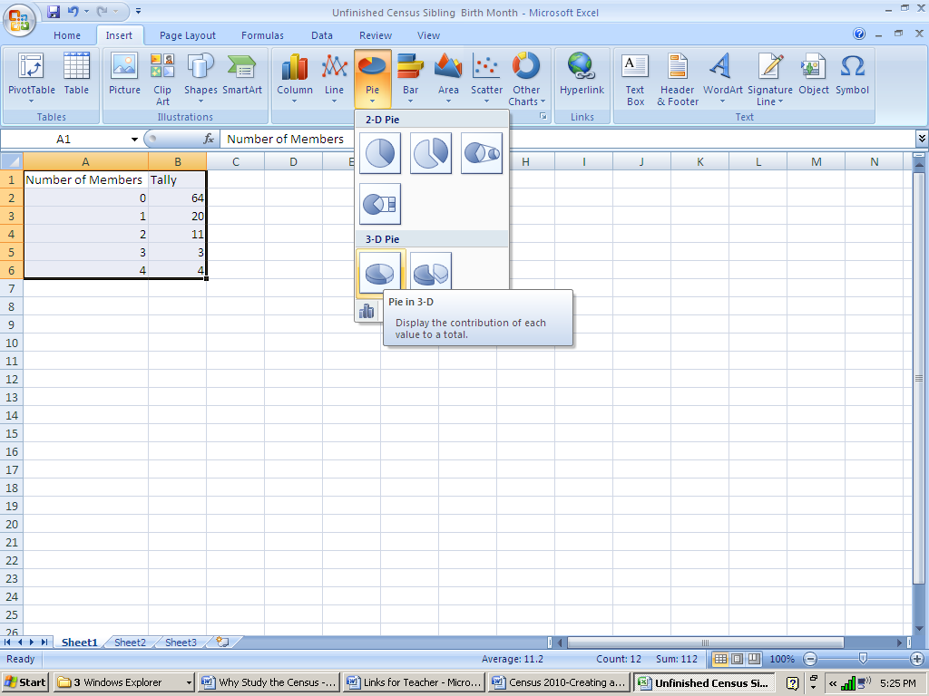
Select all the cells with information, go to the Insert tab, and select the first 3-D pie chart.

Make sure you are on the Design tab, and select the Move Chart icon
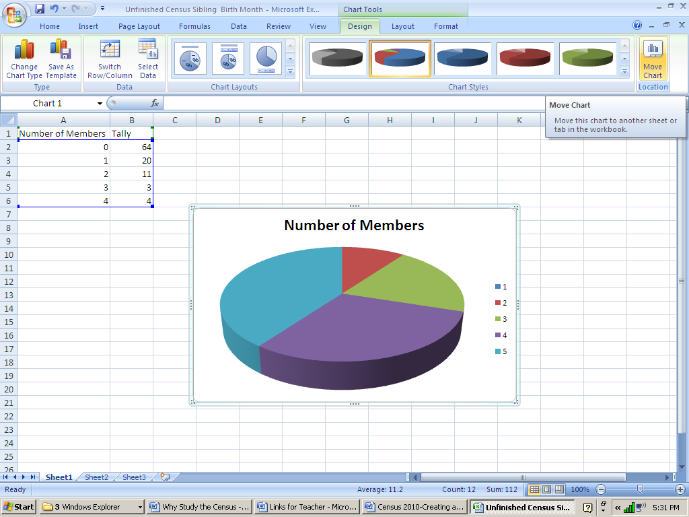

Select New Sheet and rename it Pie Chart. Click OK.
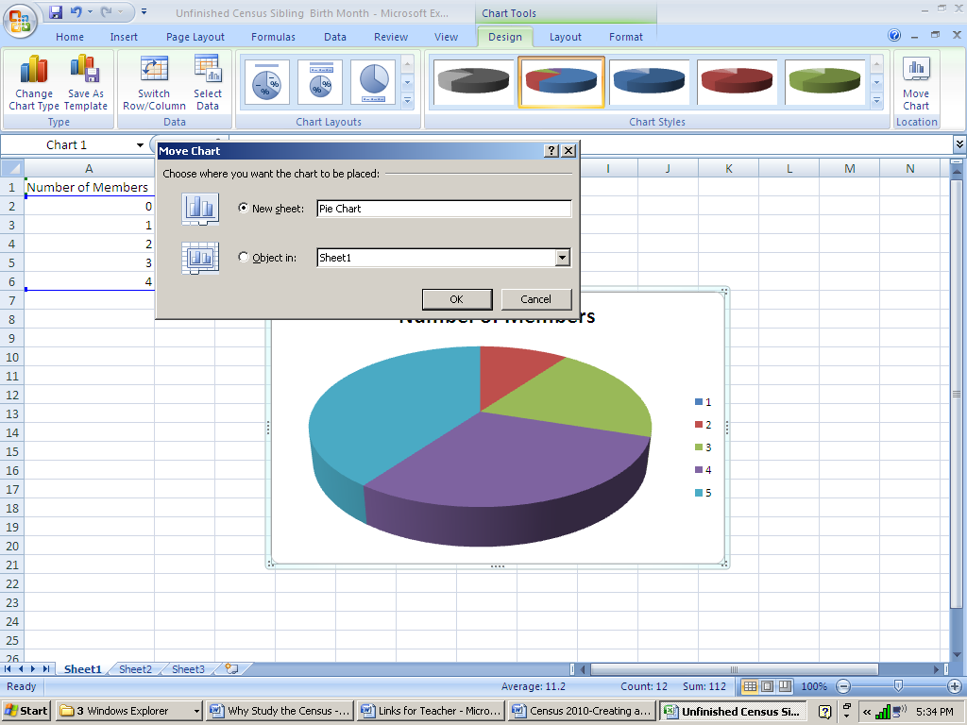

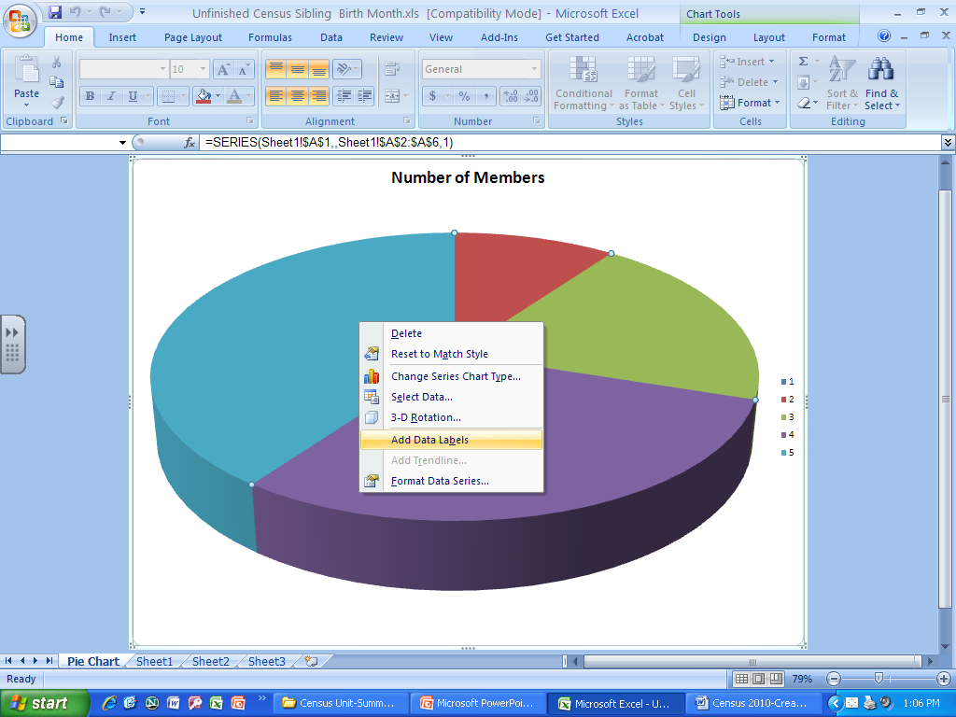
Right-click on the pie. Select add data labels.

Right-click again. Choose Format Data Labels…
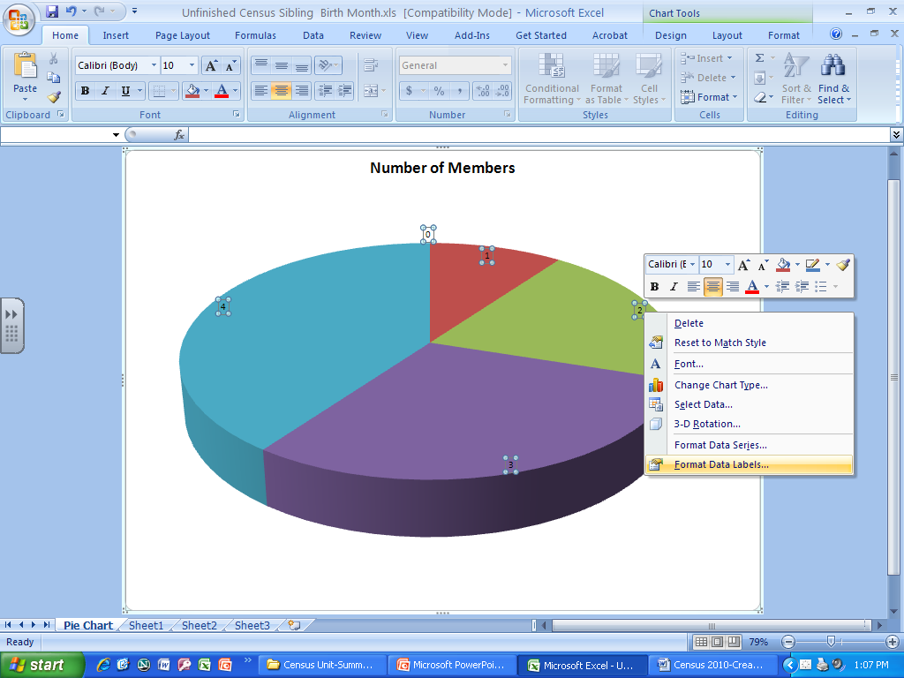

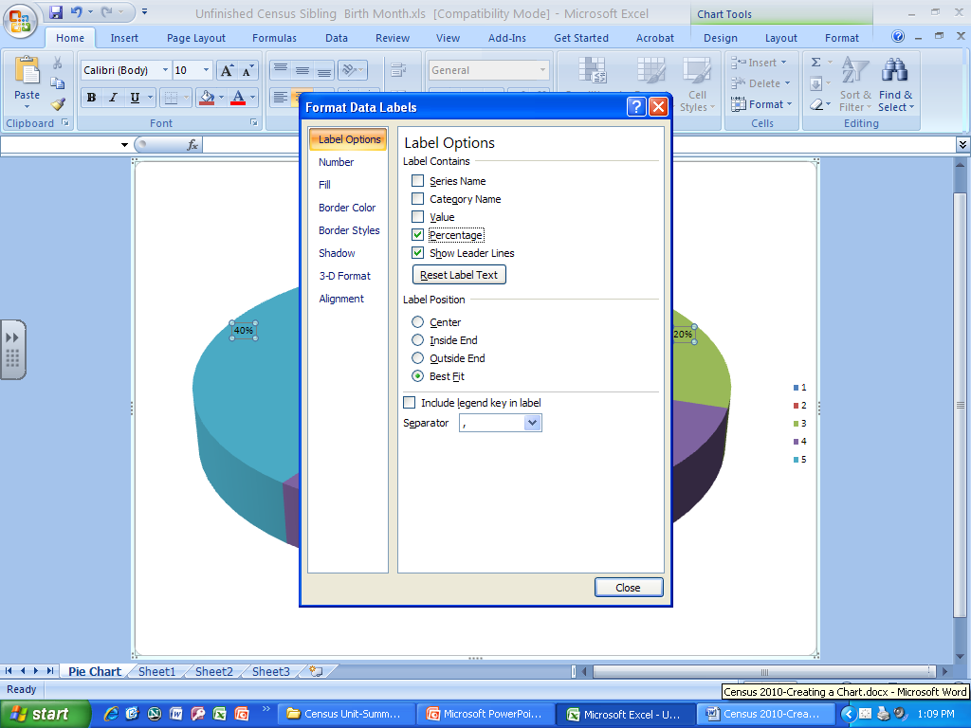
Deselect value and add percentage.

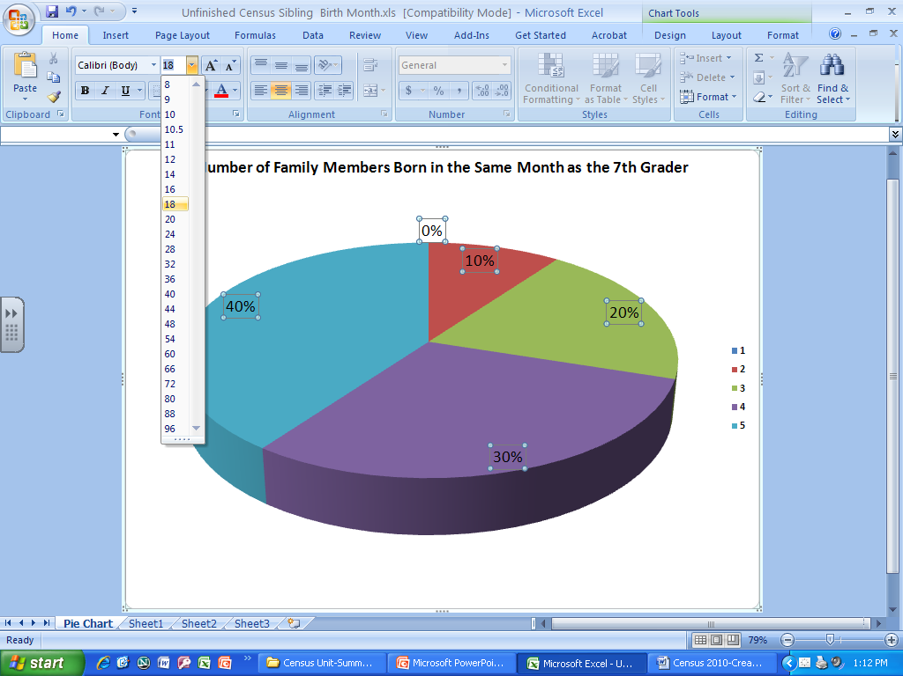
Enlarge fonts and give the chart a meaningful title.

If you want to change the color of a slice, click on the slice twice, right-click and choose Format Data Point…
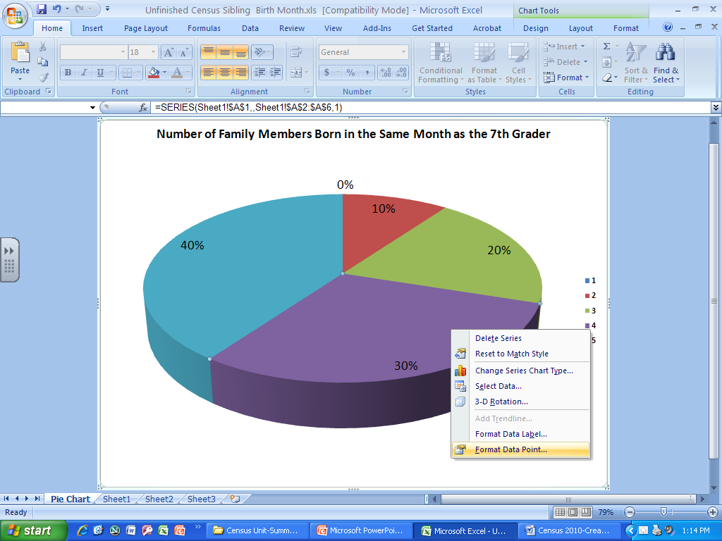

Choose Fill, Solid fill, and choose a color.
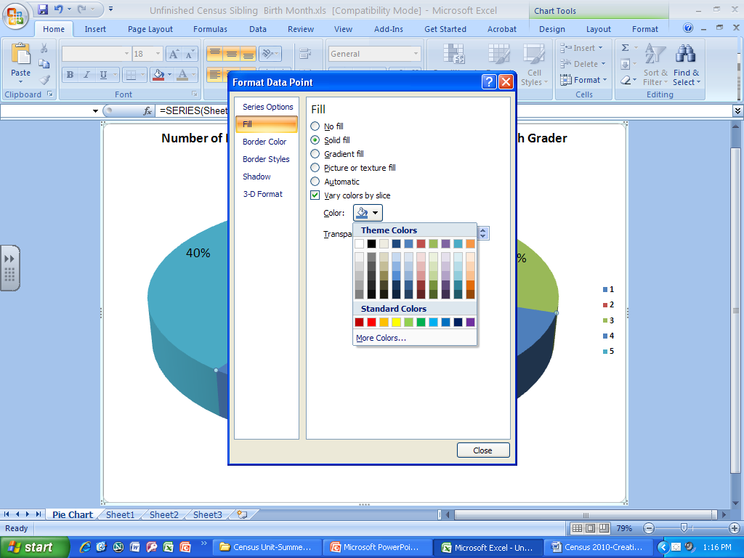

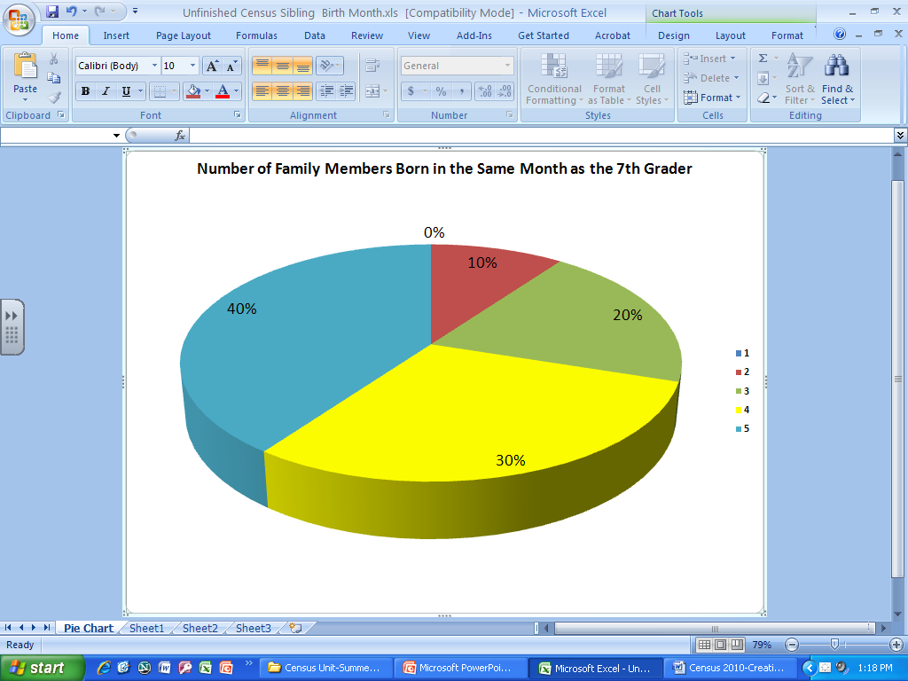
Both the color in the slice and the legend will change.

To tilt and rotate the chart, select the entire chart, right-click, and choose 3-D Rotation...
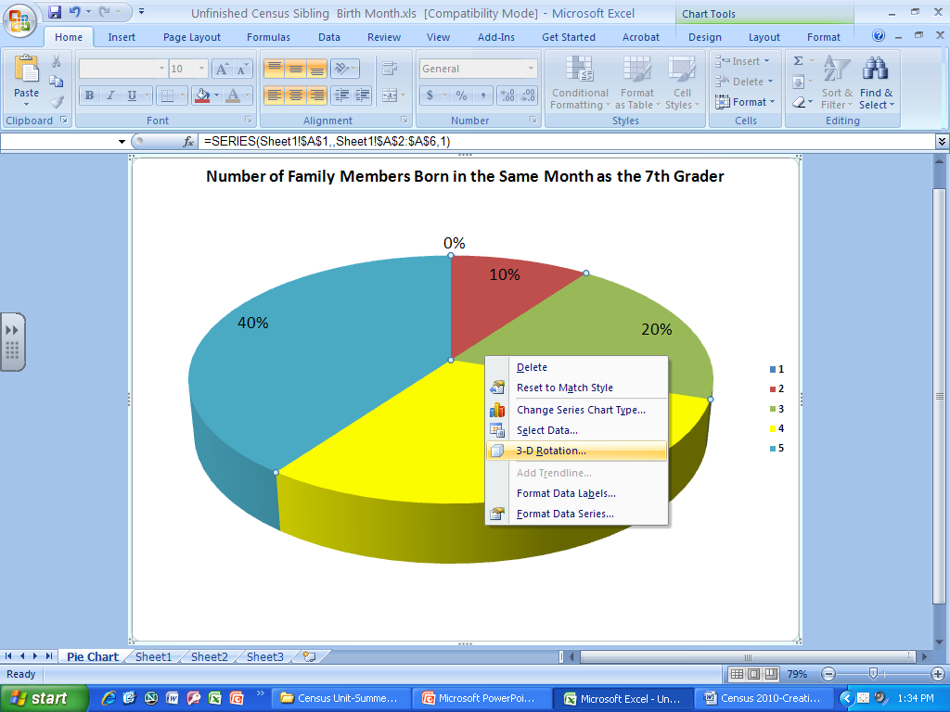

Changing the number in the X axis will rotate the chart
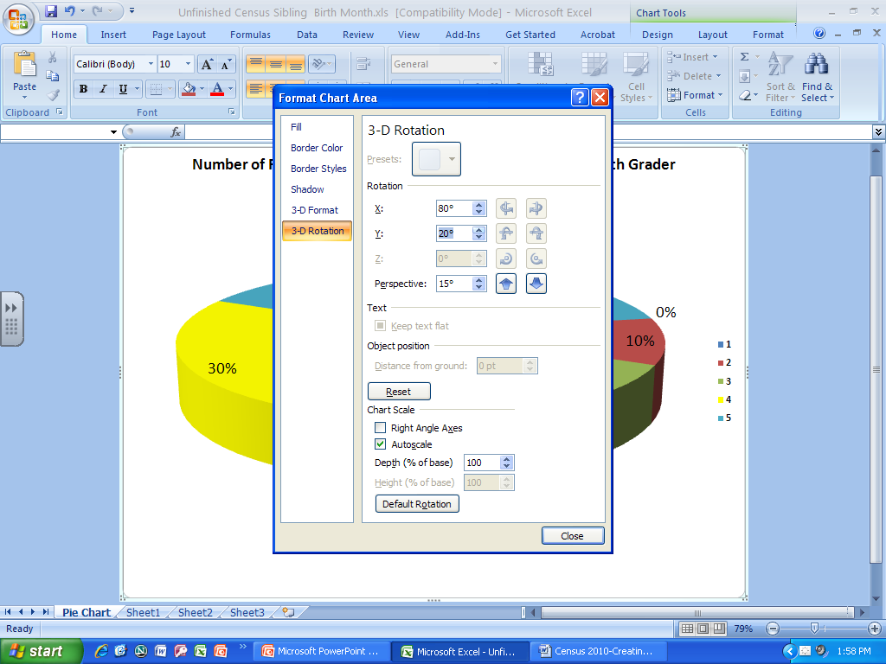

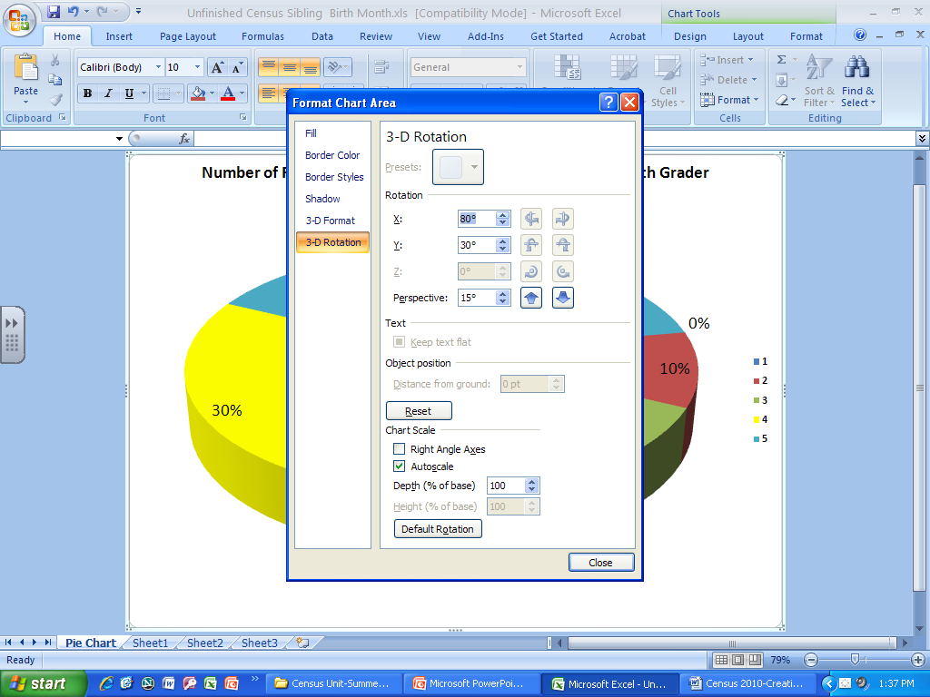
Changing the number in the Y axis will tilt the chart

