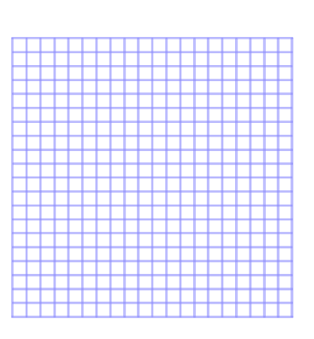Division Template

Manipulatives for Division Problems

Decimal Points and Bars