Melinda Westall
Warm it up with Franklin Unit
ECMT 6030
Summer 2009
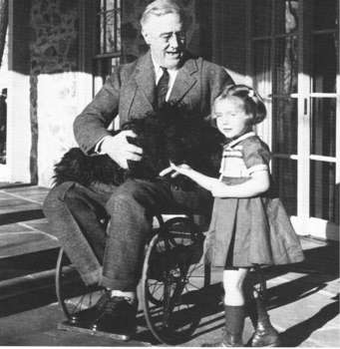
Table of Contents
Unit Overview

Schematic Map

Calendar

Lesson One: Pre-Assessment/Heroism

Lesson Two: Early Years

Lesson Three: Warm Springs

Lesson Four: The New Deal

Lesson Five: World War II

Lesson Six: His Legacy

Bibliography: Resources for teacher and students
Unit Overview
Unit Title: Warm it up with Franklin
Content Area: Social Studies and Science
Targeted Grade Level: 3rd Grade
Unit Length: Six days instructional unit of six lessons (time of lessons will vary from 65-165 minutes) pre-assessment and post-assessment included

Warm It up with Franklin is an integrated, thematic, third grade, Social Studies and Science unit. This unit will be taught through the concept development of heroism by learning the life of Franklin D. Roosevelt and the characteristic traits he possessed to have the title of “hero.” Students will be involved in a variety of activities contributing to the events in FDR’s life and will combine these into a booklet titled Warm It up with Franklin. Students will use inquiry-based learning when conducting a science experiment to understand what the springs felt like that Franklin D. Roosevelt used for therapy.

Georgia Performance Standards Addressed:
Historical Understandings
SS3H2 The student will discuss the lives of Americans who expanded people’s rights and freedoms in a democracy.
a. Franklin D. Roosevelt (New Deal and World War II)
b. Explain social barriers, restrictions, and obstacles that these historical figures had to overcome and describe how they overcame them

SS3G2 The student will describe the cultural and geographic systems associated with the historical figures in SS3H2a.
a. Identify on a political map specific locations significant to the life and times of these historical figures.
b. Describe how place (physical and human characteristics) had an impact on the lives of these historical figures.
c. Describe how each of these historical figures adapted to and was influenced by his/her environment.
d. Trace examples of travel and movement of these historical figures and their ideas across time.

SS3CG2 The student will discuss the character of different historical figures in SS3H2a.
a. Describe how the different historical figures in SS3H2a display positive character traits of cooperation, diligence, courage, and leadership.
b. Explain how the historical figures in SS3H2a used positive character traits to support their beliefs in liberty, justice, tolerance, and freedom of conscience and expression.
c. Explain how the historical figures in SS3H2a chose when to respect and accept authority.

Physical Science

S3P1. Students will investigate how heat is produced and the effects of heating and cooling, and will understand a change in temperature indicates a change in heat.
c. Investigate the transfer of heat energy from the sun to various materials.
d. Use thermometers to measure the changes in temperatures of water samples (hot, warm, cold) over time.

Unit Goals:
The student will:
- Recognize and appreciate when a person demonstrates heroism
- Understand the effect Franklin D. Roosevelt had on Americans during his presidency
- Understand the effect Warm Springs, GA had on Franklin D. Roosevelt
- Know the characteristic traits Franklin D. Roosevelt demonstrated that made him a hero
- Understand how the heat from the springs helped Franklin D. Roosevelt overcome his challenge with polio

Unit Objectives

The student will:
- Students will define the word heroism as a class.
- Describe the characteristic traits FDR possessed, including cooperation, diligence, courage, and leadership.
- Compare the characteristic traits FDR possessed, including diligence and courage to a time the student showed the same traits.
- Compare a time the student did an act of public service with an act of public service President Roosevelt did.
- Describe how the New Deal helped Americans.
- Explain how World War II created jobs for Americans.
- Analyze why President Roosevelt believed it was important to stop the leader of Germany from taking over other countries
- Locate on a map and explain how Warm Springs, Georgia; Washington, D.C.; and Hyde Park, NY were important places in FDR’s life.
- Create a timeline of important events in Franklin Roosevelt’s life.
- Create a flow map to show the transfer of heat energy from the sun to the water to FDR and tell how it helped him strengthen his legs.

Enduring Understandings

The student will understand that:
- Individuals have an effect on society whether intentional or not by learning about the contribution to the rights and freedoms in a democracy provided to us by President Franklin Delano Roosevelt.
- Specific character traits a person carries can affect the world.
- Positive outcomes can result from difficult times.
- Heat energy is transferred between two objects.

Essential Questions:
What does heroism mean?
What would be the positives and negatives if you helped a person in need?
What character traits did President Roosevelt possess in order to help so many Americans during a hard time?
How did Franklin Delano Roosevelt help Americans when many people lost most of their money and their jobs during The Great Depression?
How did WWII help provide jobs to Americans?
Why did President Roosevelt think it was important to stop the leader of Germany from trying to take over other countries?
How do various materials affect the transfer of heat energy from the sun?
What is the difference between heat and temperature? How is heat transferred?
Essential Vocabulary:
- Heroism- students will determine this definition
- *Public Service- work for the good of others, often through a job in government
- *Liberty- freedom from being controlled by someone else
- *Diligently- with hard work and effort over a long time
- *Cooperate- work together with someone
- *Campaign- time before an election when people running for office try to convince voters to vote for them
- *The New Deal- the government started programs that gave people jobs and hope
- *Fireside Chats- radio speeches given by Franklin D. Roosevelt
- *World War II- Germany, Italy, and Japan were trying to take over Europe. Great Britain, France, United States, and the Soviet Union were trying to stop them and fight for democracy. Many jobs were created and filled in the United States due to the war.
- *Democracy-a government in which the people have the power to make political decisions
- **Polio- contagious virus disease that damages the central nervous system, causing paralysis, loss of muscle tissue, and often death
- **Politics- the art or science of governing
- **Tutor-a private teacher
- ***Radiation- the movement of energy by waves
- ***Conduction- the movement of heat within a solid or from one solid to another
- ***Conductor- any material that allows heat to move through it easily
- ***Heat- the flow of thermal energy from warmer objects to cooler objects
- ***Temperature: the measure of how hot or cold something is
- ***Disabled- having a condition that makes it difficult to do something
- ***Solar energy- energy from the sun
- ***Thermal energy-the energy of moving particles in matter
- ****Characteristics- Being a feature that helps to distinguish a person or thing
- ****Therapy- Treatment of illness or disability
- ****Courage- The state or quality of mind or spirit that enables one to face danger or fear
- ****Leadership- Guidance; direction

Source for vocabulary words:
*Katzin, N.A. (2006). American heroes: Franklin Delano Roosevelt. Boston,
Massachusetts: Houghton Mifflin Company.
**Potts, S. (1996). Franklin D. Roosevelt. Mankato, Minnesota: Capstone Press.
*** Georgia Science. (2008). Heat. Georgia Science. Boston, Massachusetts: Houghton
Mifflin.
****Houghton Mifflin. (2009). The American Heritage: Dictionary of the English
language. Retrieved July 15, 2009, from http://familyinternet.about.com/gi/dynamic/offsite.htm?zi=1/XJ&sdn=familyinternet&cdn=parenting&tm=8&gps=105_10_1259_778&f=21&su=p284.9.336.ip_&tt=3&bt=0&bts=0&zu=http%3A//kids.yahoo.com/reference/dictionary/english.

Pre-Assessment/Post-Assessment:
The pre-assessment for this unit will be done using a K-W-L chart (What I know, What I want to know, and What I want to learn). Using a piece of chart paper, the teacher will divide it into the three sections. Students will tell the teacher what they know about Franklin D. Roosevelt, and then they will tell the teacher what they would like to learn. The teacher will fill in the chart with lists students give. After each lesson, the teacher will fill in the “L” section. This will be done by the students telling the teacher what they have learned about Franklin D. Roosevelt. If necessary, use a piece of chart paper for each section. Make sure you use a marker to write on the chart paper so all students can see. At the end of the unit, the “L” section will be filled completely with everything the students have learned on FDR, and this will be part of the post-assessment. The “Warm it up with Franklin” booklet will also be the other part of the post-assessment.

Example of a K-W-L Chart

K | W | L

Who are your heroes?
Hero Board
(Ongoing)
-Pre-Assessment
-Examples
-Non-examples
-Definition
Content Title
Map Key
Focus Points

-Begin “Warm It Up With Franklin” Booklet
Day 2
-Hyde Park, NY
-Family
-Public Service
-Background Information
Activities

Complete “Warm It Up With Franklin” Booklet
(Post-Assessment)
-Roosevelt Rap
-Finish Timeline
-Death of FDR
-Effects on U.S. Still Today
-leadership
Day 1
Heroism
Early Years
Skit of Roosevelt’s Life
Franklin D. Roosevelt
-Treatment
-Effects of Heat Therapy
-Diligence, courage
-Roosevelt Warm Springs Institute for Rehabilitation

Day 6
His Legacy
Warm Springs
Day 3
-Women in the Workforce Photos (analyze photos)
New Deal
Day 5
Create scrapbook picture
Speaker with Disability (diagonosed with polio preferred)
-Alphabet President
-New Jobs
-Programs/Agencies
-The Great Depression
-Fireside Chats
-Cooperation, diligence, courage

WWII

Experiment with Water and Temperature
-Pearl Harbor
-Changed Way of life
-Jobs Created for All
-Won the War

Day 4
Draw Flow Map of Heat from Sun to Water to FDR
FDR’s ABC poem
Create Ad for a New Job

Calendar

Instructional Day | Date | Instructional Topic | Instructional Time
1 | November 2, 2009 | Pre-Assessment/  Heroism | 65 minutes
2 | November 3, 2009 | Early Years | 115 minutes
3 | November 4, 2009 | Warm Springs | 115 minutes
4 | November 5, 2009 | New Deal | 145 minutes
5 | November 6, 2009 | World War II | 140 minutes
6 | November 9, 2009 | His Legacy | 165 minutes

Lesson One: Heroism

Time: 65 minutes

Academic Standards:

Historical Understandings
SS3H2 The student will discuss the lives of Americans who expanded people’s rights and freedoms in a democracy.
- Franklin D. Roosevelt (New Deal and World War II)

SS3CG2 The student will discuss the character of different historical figures in SS3H2a.
a. Describe how the different historical figures in SS3H2a display positive character traits of cooperation, diligence, courage, and leadership.
b. Explain how the historical figures in SS3H2a used positive character traits to support their beliefs in liberty, justice, tolerance, and freedom of conscience and expression.
c. Explain how the historical figures in SS3H2a chose when to respect and accept authority.

Objective:
The student will:
- Define the word heroism as a class using the concept of heroism chart.

Essential Vocabulary
- Heroism- students will determine this definition
- Characteristics- Being a feature that helps to distinguish a person or thing

Materials and Resources
- Appendix A: Education World. (2000). What makes a hero? Retrieved July 12, 2009, from http://www.education-world.com/a_lesson/TM/WS_lp218_2282.shtml.
- 20 copies of Appendix A
- Appendix B: Education World. (2000). Who is your hero? Retrieved July 12, 2009, from http://www.educationworld.com/a_lesson/TM/WS_lp218_2283.shtml.
- 20 copies of Appendix B
- Cable News Network. (2009). CNN Heroes: Ordinary people extraordinary impact. Retrieved July 2, 2009, from http://www.cnn.com/SPECIALS/cnn.heroes/.
- Appendix C: Heroism chart
- Expo Marker, black
- White Board
- 20 Pencils
- Computer
- Access to the internet
- Construction paper, 20 sheets of 8 ½ x 11, green
- Construction paper, 20 sheets of 8 ½ x 11, yellow
- 3-ring hole puncher
- Staples or ribbon for binding
- Scissors
- Markers, 20 sets of 8 colors
- LCD Projector
- Bulletin Board
- ½” Capital letters, yellow, 1 H, 1 E, 2 R’s, 2 O’s, 1 B, 1 A, 1 D
- Green bulletin board paper, length will depend on bulletin board available
- 1 box of clear thumb tacks
- 20 black folders, letter-size, 2 folders
- 1 packet of sticky notes, orange
- 20 sheets of wide-ruled paper
- 1 piece of chart paper

Note to Teacher:
Materials are based on 20 students. If you have more or less than 20 students, adjust materials as needed. Students will make a booklet out of 8 ½ x 11” green or yellow construction paper. The construction paper will serve as the front and back cover. Creating the booklet will be an ongoing process throughout the unit. On the last day of the unit, students will bind their booklet with ribbon. The black folder will be used to store all information to be placed in their booklets until the last day when the booklets are finalized. All construction paper and final documents to be placed in the booklet need to be hole punched. The hero bulletin board will be an ongoing event throughout the unit as well. Teacher will title bulletin board with the letters “HERO BOARD.” Students will write on the sticky note describing how they were a ‘hero’ to someone else or how someone showed heroism. Students will then use a thumb tack to attach to the bulletin board. Students will be allowed to submit their hero online through CNN as ongoing project, http://www.cnn.com/SPECIALS/cnn.heroes/. (Click on the tab nominate and fill in information and then hit submit. Students may need teacher assistance.)

Procedures

Introduction (10 minutes)
- Ask students what they think of when they hear the word hero. Note to teacher: Students may give examples from one spectrum to the other. The point of this question is to have the students’ minds wonder.

- Extend the discussion: “Why do you connect these thoughts with this word? Imagine what the world would be like if there were no heroes.”

- Next, explain the lesson. The teacher will say, “As a class, we will decide on a definition of heroism to go along with our next unit. First, we are going to do a few activities before we decide on the definition.”

Instructional Activities (45 minutes)
- Students fill out What makes a hero? (see Appendix A). Note teacher: This will be placed in the “Warm it up with Franklin” booklet.

- Discuss the meaning of characteristics.

- “Now that we have filled out what makes a hero and understand what characteristics means, we will begin to fill in our heroism chart together.” (See Appendix C) Note to teacher: This chart should be projected on the board for all students to see through the LCD projector. Have the expo marker ready to fill in chart. First, fill in the characteristics column. Students will decide on these traits. Teacher may have to get students started. Next, have students fill in the example column. This is where the students will give examples of heroism. Afterwards, fill in the non-examples column. Once all three columns are filled in and all students agree, discuss a final definition of heroism. Teacher may have to guide students in this section.

- On the white board the teacher will write the final definition of heroism. Students will write this on a sheet of paper. Note to teacher: This will be included in the “Warm it up with Franklin” booklets.

- “Using the definition we decided for heroism, fill out the who are your heroes worksheet.” (See Appendix B) Note to teacher: This will be placed in their “Warm it up with Franklin” booklets.

- “How many of you have heard of Franklin D. Roosevelt? Great, now we going to fill in this chart to see what we do know about him, and then we will add what we want to learn about him.” Note to teacher: Begin filling out K-W-L chart. K-W-L stands for Know, Want to know, Learned. Teacher will fill out what the students know about FDR, and then what they want to learn about FDR. The learned section can be filled out as students learn something about FDR in the unit. This will be the pre-assessment for this unit.

Closing Activities (10 minutes)
- Ask students what they believe would be the positives and negatives if you helped a person in need? Answers will vary. However, positives could be: putting a smile on someone’s face, giving someone hope, helping someone in a time of need, etc. The negatives would be nothing.

- What does heroism mean? Answer should be the definition the class came up with.

- Teacher will review the K & W section of the K-W-L chart with students.

- Inform students they will be making a “Warm it up with Franklin” booklet. Note to teacher: Inform students this is the title of the unit we will be focusing on for the next week. The work they will be doing during this time will go into this booklet.

- Students will share with the class who is there hero is based off of the worksheet “Who are your heroes?” Students will discuss why this person is their hero.

- Teacher will review with students the directions of the hero board.

- Teacher will discuss directions of submitting their hero to CNN online.

- Teacher will remind students of their definition of heroism. Challenge students to show acts of heroism throughout the day.

Student Assessment:
Consider their reasons for choosing their person as their hero and does it relate to the definition of heroism.

Accommodation Activities
Teacher will walk around from student to student assisting as needed. Teacher will guide students throughout the process.

Enrichment Activities:
Students may draw a picture of their hero to go along with “Who are your heroes?” Students can begin decorating their front and back cover of their “Warm it up with Franklin” booklets.
Appendices:
Appendix A: What makes a hero?
Appendix B: Who are your heroes?
Appendix C: Heroism Chart

Appendix A:

WHAT MAKES A HERO?
DIRECTIONS: Directions: Read the statements below. Circle the word agree next to each statement that matches your opinion of what makes a hero. Circle the word disagree if the statement does not fit your opinion of what makes a hero.
1. A hero is brave and strong. | Agree | Disagree
2. A hero is caring and thoughtful. | Agree | Disagree
3. A hero is selfish. | Agree | Disagree
4. A hero is never frightened. | Agree | Disagree
5. A hero wants to be rewarded for his or her actions. | Agree | Disagree
6. A hero makes mistakes. | Agree | Disagree
7. A hero is never silly. | Agree | Disagree
8. A hero is dishonest. | Agree | Disagree
9. A hero puts others before himself or herself. | Agree | Disagree
10. A hero stands up for himself or herself. | Agree | Disagree
11. A hero never gets angry. | Agree | Disagree
12. A hero is always a popular person. | Agree | Disagree

Use your own words to finish the sentence below.
In my opinion, a hero is someone who:

© 2000 by Education World®. Education World grants users permission to reproduce this page for educational purposes
Adapted from: Education World. (2000). What makes a hero? Retrieved July 12, 2009, from http://www.education-world.com/a_lesson/TM/WS_lp218_2282.shtml

Appendix B:

Who Are Your Heroes?
DIRECTIONS: Directions: Write a few words to complete each statement below.
- A person who is my hero is

- This person is my hero because

- Two words that describe this person are

and

- One thing the person does that I admire is

- One way I can be more like my hero is by

Are you a hero? Write a few sentences telling about something that you did that you think was heroic.

Adapted from: Education World. (2000). Who is your hero? Retrieved July 12, 2009, from http://www.educationworld.com/a_lesson/TM/WS_lp218_2283.shtml.

Appendix C

Defining Heroism Chart
Definition  Heroism | Characteristics  (What describes a hero)
Examples | Non-Examples

Lesson Two: The Early Years
Time: 115 minutes
Academic Standards:
Historical Understandings
SS3H2 The student will discuss the lives of Americans who expanded people’s rights and freedoms in a democracy.
a. Franklin D. Roosevelt (New Deal and World War II)
SS3G2 The student will describe the cultural and geographic systems associated with the historical figures in SS3H2a.
a. Identify on a political map specific locations significant to the life and times of these historical figures.
b. Describe how place (physical and human characteristics) had an impact on the lives of these historical figures.
c. Describe how each of these historical figures adapted to and was influenced by his/her environment.
SS3CG2 The student will discuss the character of different historical figures in SS3H2a.
b. Explain how the historical figures in SS3H2a used positive character traits to support their beliefs in liberty, justice, tolerance, and freedom of conscience and expression.

Objective
The student will:
- Compare a time the student did an act of public service with an act of public service President Roosevelt did.
- Locate on a map and explain how Hyde Park, NY was important places in FDR’s life.
- Create a timeline of important events in Franklin Roosevelt’s life.

Essential Vocabulary
- Public Service- work for the good of others, often through a job in government
- Politics- the art or science of governing
- Tutor-a private teacher

Materials and Resources
- Katzin, Nathan Asher. (2006). American heroes: Franklin Delano Roosevelt. Boston,
Massachusetts: Houghton Mifflin Company.
- 21 sets, American heroes: Franklin Delano Roosevelt
- You Tube. (2008). Roosevelt Rap. Retrieved July 5, 2009, from
http://www.youtube.com/watch?v=2sfftlJx9Vk.
- Appendix A: Roosevelt Rap Lyrics, 20 copies
- 40 sheets of 8 ½ x 11, white
- 20 pencils
- Markers, 20 sets of 8
- LCD projector
- Internet Access
- Computer
- Microsoft Paint
- Color printer
- K-W-L chart, made in lesson one
- Savannah Chatham County Public School System. (2007). Jazz and World War
II: A Rally to Resistance, A Catalyst for Victory. Teaching American History.
Savannah, Georgia: Author.
- Cable News Network. (2009). CNN Heroes: Ordinary people extraordinary impact. Retrieved July 2, 2009, from http://www.cnn.com/SPECIALS/cnn.heroes/.
- 20 sheets of 8 ½ x 11” paper, wide-ruled
- Potts, S. (1996). Franklin D. Roosevelt. Mankato, Minnesota: Capstone Press.
- Expo marker, blue or black
- Appendix B: Map of specific locations of Franklin D. Roosevelt’s Life, 20 copies
- Appendix C: Map of New York
- Appendix D: Timeline Rubric
- Appendix E: Warm it up with Franklin rubric, 2 pages
- Education Place. (n.d.) Outline maps: USA Postal Abbreviations. Retrieved July 13,
2009, from http://www.eduplace.com/ss/maps/pdf/uspostal.pdf.
- Education Place. (n.d.) Outline maps: State Maps, New York. Retrieved July 13, 2009,
From http://www.eduplace.com/state/ny/pdf/ny_map.pdf.

Note to teacher:
This unit is based on the book, American heroes: Franklin Delano Roosevelt. The materials state for 21 copies, based on 20 students and 1 teacher. Please adjust accordingly. Materials are based on 20 students. If you have more or less than 20 students, adjust materials as needed. Students will create a “Warm it up with Franklin” booklet, and it will be an ongoing process throughout the unit. On the last day of the unit, students will bind their booklet with ribbon. The black folder will be used to store all information to be placed in their booklets. All construction paper and final documents to be placed in the booklet need to be hole punched. The hero bulletin board will be an ongoing event throughout the unit as well. Students will write on the sticky note describing how they were a ‘hero’ to someone else or how someone showed heroism. Students will then use a thumb tack to attach to the bulletin board. Students will be allowed to submit their hero online through CNN as ongoing project, http://www.cnn.com/SPECIALS/cnn.heroes/. (Click on nominate and fill in information and then hit submit. Students may need teacher assistance.) Refer to appendix E for any questions on grading criteria.

Procedures

Introduction (10 minutes)
- Randomly call on someone for the definition of heroism.

- Review K-W-L chart previously made in lesson one.

- “You will be learning about a president, Franklin D. Roosevelt, many people call a hero. As we discuss his life, please pay attention to the many acts of heroism he demonstrates.”

Instructional (90 minutes)
- Partner students heterogeneously to read chapter one, Early Years, in American heroes: Franklin Delano Roosevelt .Note to teacher: This briefly discusses Franklin Roosevelt served as the longest President ever in the U.S. It also describes in one sentence Roosevelt was an extremely hard working President, and many people did not know he could not walk after age 39. He was born in Hyde Park, New York in 1882. He was an only child and his family was very wealthy. At 14, he went off to boarding school that had programs to help people in the community. He learned many people did not have a life like his, and this is when he began to believe it was his job to help others. During his last year of high school he began doing public service by helping an elderly woman who lived alone and ran a summer camp for boys whose parents did not have enough money to send them to a camp or on vacation. Theodore Roosevelt was his hero and cousin who was involved in politics: Governor, Vice President, and President. Franklin wanted to be like him. He went to college and law school. He married Eleanor Roosevelt who also believed it was her job to help others.

- Teacher will discuss the definition of public service. On a sheet of paper, students will write down the definition of public service. Teacher will review some examples of public service (teachers, policemen, cutting grass, coaching recreational teams, volunteering) and what Franklin D. Roosevelt did as public service when he was in high school. Underneath the definition of public service, students will write down examples of what they have done to be considered public service like FDR. Note to teacher: If students express they have not done any type of public service, have them write down what type of public service they would like to do.

- Using Franklin D. Roosevelt, the teacher will read pages 5-9. Discuss vocabulary words tutor and politics. Note to teacher: This will provide the students with more details on Franklin D. Roosevelt’s life. It briefly mentions he helped Americans survive the trials of the Great Depression, gave hope to millions of people through radio speeches, led us to victory in World War II, and made the United States a world power. His parents are James and Sara Delano Roosevelt. Hyde Park is along the Hudson River in New York. He always returned to his home here no matter what. He is buried in the garden of this house. He had two tutors who helped him with his schooling, Jeanne Sandoz and Arthur Dumper. At the age of 14, he went to a boarding school called Groton School. He then went to Columbia University, and then law school for two years, but did not finish his law degree. He married Eleanor Roosevelt in 1905 who was the niece of Theodore Roosevelt. They had five children whom they called “the chicks.” They were Anna, James, Elliot, Franklin Jr.., and John.

- Students will use the Map of specific locations of Franklin D. Roosevelt’s Life (See Appendix B) to mark important cities in his life. This lesson the students will only locate and mark Hyde Park, NY. Note to teacher: This will be included in the “Warm it up with Franklin” booklet. Use Map of New York (see appendix C) to project on the board using the LCD projector to show students where Hyde Park, New York is located. Students will continue to add to this map, only place Hyde Park, New York today. *On the back of the map, have students write a sentence about why Hyde Park, NY was important in Roosevelt’s life. Leave room to write two more sentences later in the unit.

- Students will begin designing the timeline of Franklin D. Roosevelt’s life using the 8 1/2 x 11” white paper. Note to teacher: Students should fill in the timeline with a pencil and then go over it with a marker. Students will continue to add on to the timeline throughout the unit. Make sure students use the entire sheet of paper. Teacher may have to show an example of the timeline on the board to get students started. Students should include the year and event on the timeline. Events and dates to be included: 1882- Born in Hyde Park, New York, 1900- began doing public service, and 1905- Franklin and Eleanor get marrred (students may put they had 5 children called “the chicks” if they would like under this year because it is not specified in either one of these books when they were born). See Appendix D.

- Teacher will show the video of The Roosevelt Rap http://www.youtube.com/watch?v=2sfftlJx9Vk on the white board using the LCD projector. “This is an overview of Franklin D. Roosevelt’s life.” Note to teacher: Make sure your speakers are working to hear the video.

- “This is a copy of the first 16 verses of The Roosevelt Rap. You will be assigned a verse. You have a choice to draw a picture of the verse assigned to you using an 8 ½ x 11” white piece of paper or you may act it out. We are going to each say our verse as we show our picture or act it out.” Note to teacher: The first 16 verses were chosen to get the students interested in his life. There were too many verses for third graders to stay focused. Students will need between 20 to 30 minutes to do this assignment. Based on 20 students, 4 students will be placed with another student to work together. This should be done heterogeneously.

Closing Activities (15 minutes)
- Randomly call on students to answer questions:
  - “Where was Franklin D. Roosevelt born?” Hyde Park, New York
  - “What year was Franklin D. Roosevelt born?”1882
  - “What did Franklin D. Roosevelt begin to do his last year at Groton School, the boarding school?” public service
  - “What did they call their children?”the chicks
  - “Where did Franklin go after high school?” college, Columbia University
  - “Where did Franklin go after college?” law school
  - “Who was Franklin’s cousin that he wanted to be like?” Theodore Roosevelt
  - “What did Eleanor believe that Franklin believed?’ it was their duty to help others
  - “Was the act of public service Roosevelt showed heroism?”yes, refer to definition

- “How did you like the Roosevelt Rap?” Answers will vary.

- If any students have something to add to the hero board, allow them to place it up there and share with the class.

- If any student would like to submit their hero on http://www.cnn.com/SPECIALS/cnn.heroes/, allow them.

- Add to the “L” on the K-W-L chart.

Student Assessment
-Students will refer to the definition of public service given in class and the description of how Roosevelt showed an act of public service when evaluating the student’s description of when the student did an act of public service.
-Students will locate Hyde Park, New York on a map and write a sentence for why this was an important place in Roosevelt’s life.
-Teacher will assess students’ timeline using the timeline rubric
-Refer to warm it up with Franklin booklet rubric for any additional assessments.
-Teacher will informally evaluate students based on their answers to the review questions.

Accommodation Activities:
Teacher can make a copy of the New York map for students to have of their own instead of reading from the board. Peer tutoring is allowed. Students can be grouped together heterogeneously if needed to perform or draw their interpretation of The Roosevelt Rap verse he/she is given. Teacher will walk around to give assistance when needed.

Enrichment Activities
Students can use Microsoft Paint to draw pictures of public service, Franklin D. Roosevelt as a baby, Franklin D. Roosevelt’s house, Franklin and Eleanor getting married, or a family portrait of Franklin D. Roosevelt’s wife, himself and kids. Print any drawings and add to “Warm it up with Franklin” booklet.

Appendices
Appendix A: The Roosevelt Rap
Appendix B: Map of Specific Locations of Franklin Roosevelt’s Life
Appendix C: Map of New York
Appendix D: Timeline Rubric
Appendix E: Warm it up with Franklin rubric, 2 pages

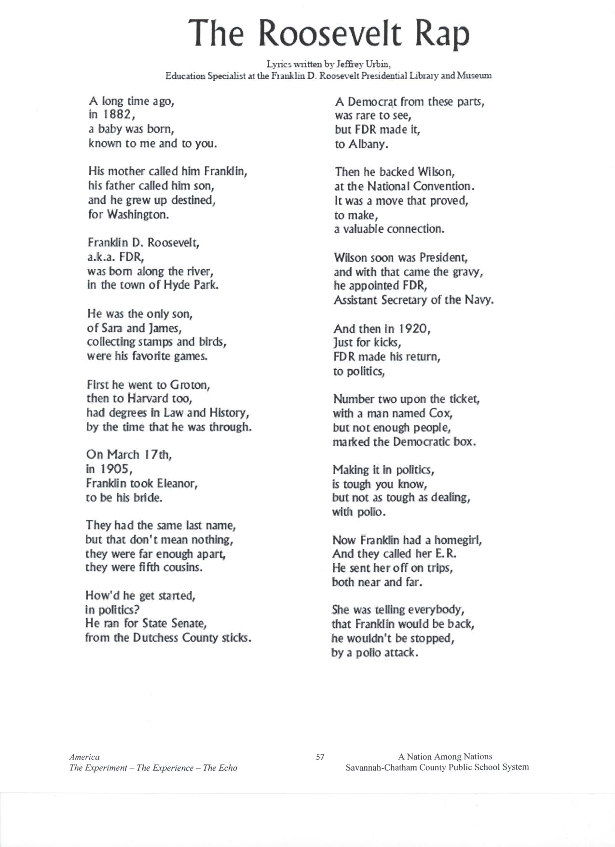
Appendix A

Adapted from: Savannah Chatham County Public School System. (2007). Jazz and World War II: A Rally to Resistance, A Catalyst for Victory. Teaching American History. Savannah, Georgia: Author.
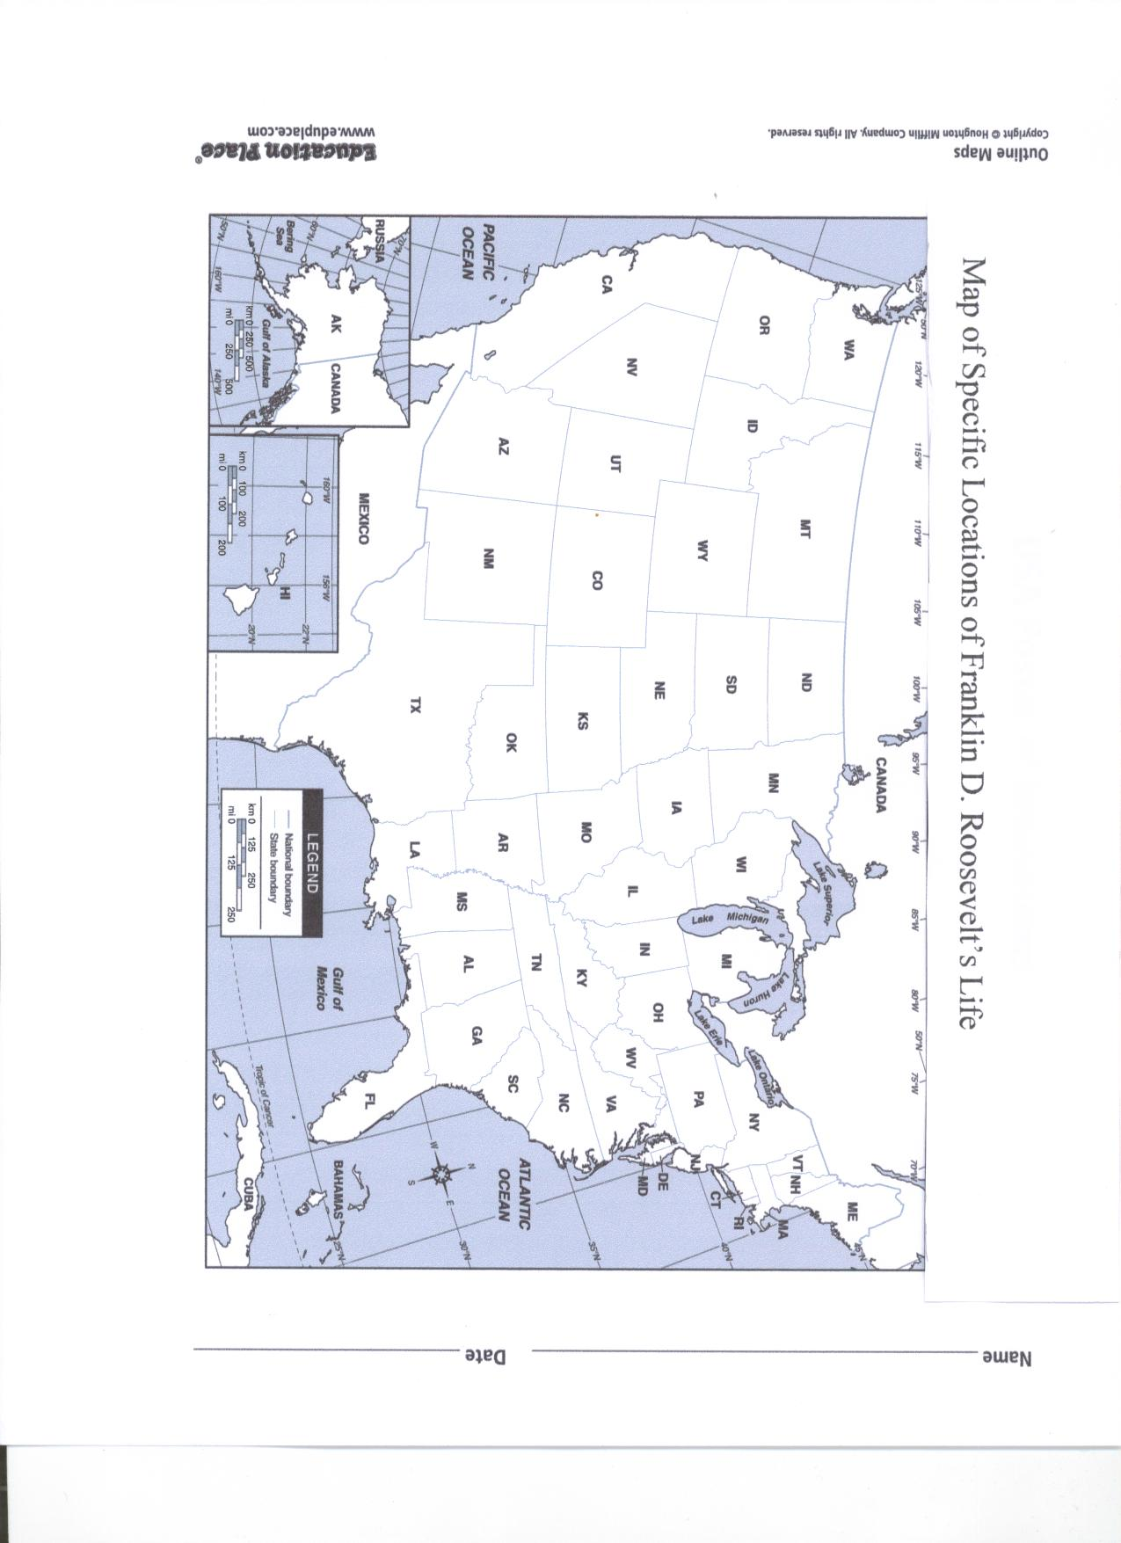
Appendix B

Adapted from: Education Place. (n.d.) Outline maps: USA Postal Abbreviations.
Retrieved July 13, 2009, http://www.eduplace.com/ss/maps/pdf/uspostal.pdf.

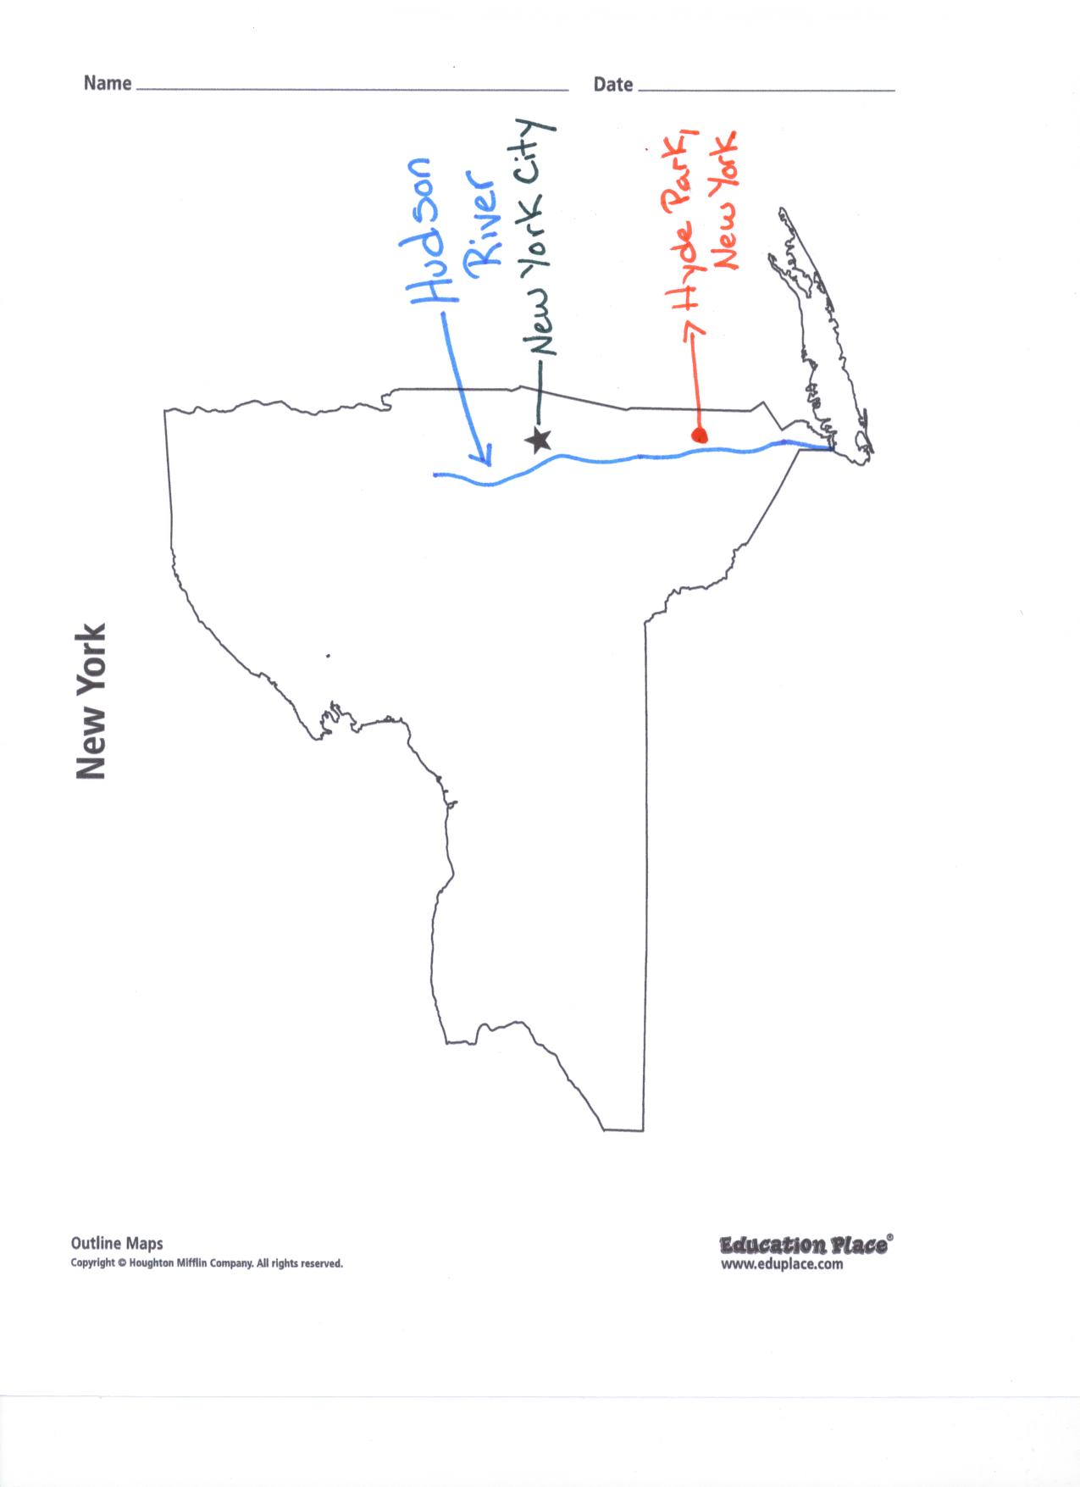
Appendix C

Adapted from: Education Place. (n.d.) Outline maps: State Maps, New York. Retrieved
July 13, 2009, from http://www.eduplace.com/state/ny/pdf/ny_map.pdf.

Appendix D
Rubric for Franklin D. Roosevelt’s Timeline

 | Exceeds Expectations 3points | Meets Expectations 2 points | Does Not Meet Expectations 1 point
Accuracy | All dates match events | Less than 2 dates do not match event | More than 2 dates do not match with event
Dates | All dates & events are included:  1882-Born in Hyde Park, New York; 1900- began doing public service; 1905-Franklin and Eleanor marry in; 1910- Roosevelt enters politics as New York State Senate; 1921- diagnosed with polio; 1924 first visit to Warm Springs; 1928- becomes governor of New York; 1929 The Great Depression; 1933- Roosevelt became President and he put the New Deal in place; 1936- Roosevelt was reelected as President; 1940-Roosevelt was reelected for a third time; 1941- Pearl Harbor was attacked; 1944- Roosevelt was reelected for the fourth time; 1945- Roosevelt helped from the United Nations, World War II ended, and Roosevelt died | Only missing 1 date or event | Missing more than 1 date or event
Readability & spelling | No problems reading timeline and no spelling mistakes | Less than 2 events are not readable and less than 3 spelling errors | More than 2 events are not readable and/or more than 3 spelling errors

Appendix E
Warm it up with Franklin Booklet Rubric
Total Points  _______/45 Points |  | Exceeds Expectations  3points | Meets Expectations  2 points | Does Not Meet Expectations  1 point
Organization |  | Have all assignments and in order: Definition of heroism, What makes a hero?, Who are your heroes?, timeline, map, public service page, diligence and courage page, flowchart of heat, warm it up with Franklin worksheet, FDR’s ABC, Job/Advertisement, Scrapbook page, and letter | Have all assignments | Missing an assignment
Definition of heroism |  | Wrote the definition the class agreed upon and titled it | Wrote the definition the class agreed upon | Did not write the class’s definition
What makes a hero? |  | Answered all questions & opinion of a hero reflects answers | Answered all questions | Did answer all questions
Who are your heroes? |  | Answered all questions and wrote more than 1 sentence | Answered all questions and wrote 1 sentence | Did answer all questions
Timeline |  | Timeline is completed & is titled Timeline | Timeline is completed | Not completed
Map of specific locations of Franklin Roosevelt’s life |  | All three locations are correctly located & labeled and explanations of each city being important to FDR are correct | All three locations are correctly located and explanations of each city being important to FDR are correct | All three locations are not correctly located and/or explanations of why each city was important to FDR are not correct
Public Service page |  | Includes definition of public service and gives more than 1 example of public service | Includes definition of public service and gives 1 example of public service | Does not include definition of public service and/or example does not refer to definition
Diligence/Courage Page |  | Includes both definitions of diligence and courage and has more than 1 example of each and they relate to the definition | Includes both definitions of diligence and courage and has 1 example of each and they relate to the definition | Does not include definition of both words and/or examples of each do relate to the definition
Flowchart of heat |  | Flowchart is completed and titled “Warming up with Franklin” | Flow chart is completed | Not completed
Warm it up with Franklin worksheet |  | Filled out worksheet and answered questions correctly, included degrees symbol and Fahrenheit after temperature | Filled out worksheet and answered questions correctly | Not completed
Appendix E, p.2
Continued: Warm it up with Franklin Booklet Rubric
FDR’s ABC | Has all 8 names for abbreviations correct: CCC- Civilian Conservation Corps; WPA-Works Progress Administration; SSA- Social Security Act; SEC-Securities and Exchange Commission; AAA- Agricultural Adjustment Act; REA- Rural Electrification Administration; TVA- Tennessee Valley Authority; PWA- Public Works Administration |  | Missing no more than 2 names for abbreviations and the ones listed are correct | Has less than 6 names for abbreviations and/or more than 2 names are incorrect
Job/Advertisement | Has the name of the job, a description of why the job is needed, and an advertisement to represent the job. Advertisement is colorful. |  | Has the name of the job, a description of why the job is needed, and an advertisement to represent the job | Missing either the name of the job, a description of why the job is needed, and/or an advertisement to represent the job
Scrapbook Page | Completed page and includes a job represented in World War II, a description of why he/she choose this job, and has a paragraph on why it was important to stop the leader of Germany from taking over other countries and how FDR showed leadership |  | Completed page but missing one of the following: job represented in World War II, a description of why he/she choose this job, or a paragraph on why it was important to stop the leader of Germany from taking over other countries and how FDR showed leadership | Not completed
Thank you Letter | Includes an example of how FDR showed the following characteristic traits: heroism, diligence, courage, leadership, and cooperation. Includes thanking FDR for creating jobs through the New Deal and during World War II and how he lead us to victory in World War II by fighting for liberty. |  | Missing less than 2 examples of how FDR showed the following characteristic traits: heroism, diligence, courage, leadership, and cooperation. Includes thanking FDR for at least 1 of the following: creating jobs through the New Deal and during World War II or how he lead us to victory in World War II by fighting for liberty | Missing more than 2 examples of how FDR showed the following characteristic traits: heroism, diligence, courage, leadership, and cooperation. And/or missing both of the following: thanking FDR for creating jobs through the New Deal and during World War II or how he lead us to victory in World War II by fighting for liberty
Neatness | Cover page has Warm it up with Franklin on it, all pages are bound with ribbon, cover page is decorated |  | Cover page has Warm it up with Franklin on it, all pages are bound with ribbon | Cover page does not have Warm it up with Franklin on it and/or all pages are not bound with ribbon,

Lesson Three: Warm Springs
Time: 115 minutes
Academic Standards:
Historical Understanding
SS3H2 The student will discuss the lives of Americans who expanded people’s rights and freedoms in a democracy.
a. Franklin D. Roosevelt (New Deal and World War II)
b. Explain social barriers, restrictions, and obstacles that these historical figures had to overcome and describe how they overcame them

SS3G2 The student will describe the cultural and geographic systems associated with the historical figures in SS3H2a.
a. Identify on a political map specific locations significant to the life and times of these historical figures.
b. Describe how place (physical and human characteristics) had an impact on the lives of these historical figures.
c. Describe how each of these historical figures adapted to and was influenced by his/her environment.
d. Trace examples of travel and movement of these historical figures and their ideas across time.

SS3CG2 The student will discuss the character of different historical figures in SS3H2a.
a. Describe how the different historical figures in SS3H2a display positive character traits of cooperation, diligence, courage, and leadership.
b. Explain how the historical figures in SS3H2a used positive character traits to support their beliefs in liberty, justice, tolerance, and freedom of conscience and expression.

Physical Science

S3P1. Students will investigate how heat is produced and the effects of heating and cooling, and will understand a change in temperature indicates a change in heat.
c. Investigate the transfer of heat energy from the sun to various materials.
d. Use thermometers to measure the changes in temperatures of water samples (hot, warm, cold) over time.

Objective
The student will:
- Compare the characteristic traits FDR possessed, including diligence and courage, to a time the student possessed these same traits.
- Create a flow map to show the transfer of heat energy from the sun to the water to FDR and tell how it helped him strengthen his legs.
- Conduct an experiment trying to get water in a measuring cup to reach 88 degrees Fahrenheit. Students will use thermometers to measure the water.
- Locate on a map and explain how Warm Springs, Georgia was an important place in FDR’s life accurately.
- Create a timeline of important events in Franklin Roosevelt’s life

Prerequisites
Students should have prior knowledge on heat, temperature, radiation, conductor, conduction, solar energy, and thermal energy. Students should also know how to read a thermometer.

Essential Vocabulary
- Polio- contagious virus disease that damages the central nervous system, causing paralysis, loss of muscle tissue, and often death
- Disabled- having a condition that makes it difficult to do something
- Campaign- time before an election when people running for office try to convince voters to vote for them
- Diligently- with hard work and effort over a long time
- Heat- is the flow of thermal energy from warmer objects to cooler objects
- Temperature- the measure of how hot or cold something is
- Radiation- the movement of energy by waves
- Conduction-the movement of heat within a solid or from one solid to another
- Conductor- any material that allows heat to move through it easily
- Solar energy- energy from the sun
- Therapy- Treatment of illness or disability
- Thermal energy-the energy of moving particles in matter
- Courage- The state or quality of mind or spirit that enables one to face danger or fear

Materials and Resources
- Katzin, Nathan Asher. (2006). American heroes: Franklin Delano Roosevelt. Boston,
Massachusetts: Houghton Mifflin Company.
- 21 sets, American heroes: Franklin Delano Roosevelt
- Learning Resources, Inc. (2009). Boiling point thermometers. Illinois: Learning Resources.
- 20 boiling point thermometers
- Potts, S. (1996). Franklin D. Roosevelt. Mankato, Minnesota: Capstone Press.
- 10 liquid measuring cups, 1 cup mark
- Disabled person, preferably someone who has been diagnosed with polio
- 20 sheets of 8 ½ x 11” paper, white
- Markers, 20 sets of 8
- Access to water
- Microwave
- 10 digital timers
- Appendix A:Warm it up with Franklin worksheet, 20 copies
- Appendix B: Timeline Rubric
- Appendix C: Rubric for Warming it up with Franklin (flowchart)
- Appendix D: Rubric for Warming it up with Franklin booklet, 2 pages
- 20 sheets of 8 ½ x 11” paper, wide-ruled
- 20 sheets of paper towels
- K-W-L chart, made in lesson one
- Roosevelt Warm Springs Institute for Rehabilitation. (n.d.). History. Retrieved June 26, 2009, from http://www.rooseveltrehab.org/history.php.
- Cable News Network. (2009). CNN Heroes: Ordinary people extraordinary impact. Retrieved July 2, 2009, from http://www.cnn.com/SPECIALS/cnn.heroes/
Note to Teacher: This is an opportunity for students to interact with someone who is disabled and ask questions. If a person who has been diagnosed with polio is unavailable, having a disabled person in a wheelchair will be most appropriate. This unit is based on the book, American heroes: Franklin Delano Roosevelt. The materials state for 21 copies, based on 20 students and 1 teacher. Please adjust accordingly. Materials are based on 20 students. If you have more or less than 20 students, adjust materials as needed. Students will create a “Warm it up with Franklin” booklet, and it will be an ongoing process throughout the unit. On the last day of the unit, students will bind their booklet with ribbon. The black folder will be used to store all information to be placed in their booklets. All construction paper and final documents to be placed in the booklet need to be hole punched. The hero bulletin board will be an ongoing event throughout the unit as well. Students will write on the sticky note describing how they were a ‘hero’ to someone else or how someone showed heroism. Students will then use a thumb tack to attach to the bulletin board. Students will be allowed to submit their hero online through CNN as ongoing project, http://www.cnn.com/SPECIALS/cnn.heroes/. (Click on nominate and fill in information and then hit submit. Students may need teacher assistance.)

Procedures
Introduction (10minutes)
- Review K-W-L chart.

- “How many of you have broken a bone and felt like you were unable to do what you would normally do? How many of you thought this would be a great time to not have to do anything?” Note to teacher: Inform students they will read about a time Franklin Roosevelt had a difficult time walking, and he worked diligently to get better.

Instructional Activities (90 minutes)
- Whole group reading, American heroes: Franklin Delano Roosevelt, on chapter 2. Note to teacher: Teacher will guide students in “popcorn.” The teacher will call on one student to read first. When the student is done reading a paragraph, he/she says popcorn and calls on another student who has not read yet. This chapter discusses the disease Roosevelt caught, polio, and how he worked diligently to strengthen his legs. It begins by talking about Roosevelt running for the New York State Senate in 1910. He sometimes made up to ten speeches a day, and people were impressed with how hard he worked. He won the election. In 1921, he was diagnosed with polio, and there was no cure for it at that time. He was unable to walk and needed a lot of help doing things. Eleanor encouraged Roosevelt to continue working in politics because he loved what he did. Eleanor went to his meetings and made speeches for him while he was trying to get better. He visited Warm Springs, GA in 1924 because people believed the warm water helped people with polio. His legs did get better, but he was unable to get around without using a wheelchair. He met many people there and gave them hope they could get better. He bought a home there and visited it many times. He ran for governor of New York in 1928 and won. The next year, 1929, the Great Depression began. Many people lost their jobs and homes. Roosevelt helped the people of New York by creating programs to give people jobs, food, clothing, and housing to those who needed it.

- Teacher will read pages 10-13 in Franklin D. Roosevelt to give more details on Franklin D. Roosevelt and polio. Note to teacher: This part of the book is discusses how Roosevelt begins to follow Teddy Roosevelt’s path to Washington, D.C. He became the assistant secretary of the navy, just like Teddy had been. Roosevelt wanted to quit his job in 1917 and fight in World War I. However, his boss would not let him because they needed him at his job. In 1920, FDR ran as vice president with James M. Cox for president. They lost, but it helped Roosevelt make a name for himself. There was not a cure for polio until the 1950’s. Polio paralyzed people and many times killed them. Roosevelt contracted polio in August of 1921 at his vacation home on Campobello Island in Canada. He was paralyzed from waist down but was determined to survive. He went to Warm Springs, GA to help him feel better. He spent four years in Warm Springs, and then returned to politics. He had to wear leg braces and use a cane. Most of the time he used a wheel chair to get around.

- Review vocabulary words: polio, campaign, diligently, and disabled

- Students will add Warm Springs to their map of specific locations of Franklin D. Roosevelt’s life. Use page 11 for reference from the reading, American heroes: Franklin Delano Roosevelt. On the back, write a sentence about why Warm Springs was an important place in Roosevelt’s life and how it affected him. Note to teacher: Students may have to finish this during closing activities. Make sure students leave a space for one more sentence on the back.

- Students will add to their timeline of Franklin D. Roosevelt’s life. (1910- Roosevelt enters politics as New York State Senate, 1921- diagnosed with polio, 1924 first visit to Warm Springs, 1928- becomes governor of New York, and 1929 The Great Depression). See Appendix B for the rubric.

- Review vocabulary words:
Heat, Temperature, Radiation, Solar energy, Thermal energy, Conduction, Conductor, Therapy

- “Who can remember what kind of energy is used to heat the springs Franklin D. Roosevelt swam in to strengthen his legs? Right, solar energy. Who can remember how solar energy is moved from the sun to objects on the earth? Right, radiation. When the heat from the springs moves to his body, what is this called? Conduction is correct. Can anybody guess what the conductor is? Yes, Franklin D. Roosevelt himself. What kind of energy has this solar energy turned into? Thermal energy, excellent!” Note to teacher: Students will draw a flow map showing this process. The drawing should include the sun with an arrow pointing to the water and then an arrow pointing from the water to Franklin D. Roosevelt. Next to the sun should be written solar energy, the arrow pointing from the sun to the springs should have radiation written next to it, the arrow pointing from the springs to Franklin Roosevelt should say convection and thermal energy. Conductor can be listed next to Franklin Roosevelt. This can be titled “Warming it up with Franklin.” See appendix C

- “Can anyone guess what the temperature was of the springs he used for therapy? It was 88 degrees. Does anyone know what water feels like at 88 degrees? We are going to do an experiment and find out.” Partner students heterogeneously. Students will fill measuring cup up with 1 cup of water. Students will have 1 opportunity to place their cup of water into the microwave, guessing how long they should put it in there. (teacher should guide this) Students will then place the thermometer into the water to measure the temperature. Students will record how long they placed the water into the microwave and the temperature the water was when it came out of the microwave. If water is not between 85 and 90 degrees Fahrenheit, students can let the water sit and measure the temperature every minute for five minutes. When students have their water measuring anywhere from 85 and 90 degrees, allow them to place two fingers inside to see what it feels like. Take a poll to see if anyone got their water to reach 88 degrees, if not, find out who was the closest. If students’ water never reaches 85 degrees, it is at the teacher’s discretion on how many times the child is allowed to put the water in the microwave. Each student will record their information on “Warm it up with Franklin” worksheet (see appendix A). This will be placed in the “Warm it up with Franklin” booklet. Note to teacher: Some students may never get their cup of water between 85-90 degrees; it is a good idea to be prepared to do this experiment as well to ensure all students will feel the water at 88 degrees.

- “Why do you think the warm springs helped Roosevelt strengthen his legs? Did you know this type of therapy has been used since the 1700’s and possibly even earlier than that? Why do you think this helped him feel better and strengthen his legs? Heat can help relieve pain. Many people use heating pads to help relieve pain. How many of you have ever used a heating pad? The heat helps you relax and relieve joint or muscle pain. The type of therapy Roosevelt was receiving while swimming in the springs is called Hydrotherapy. Hydrotherapy is the conduction of heat to or from the body by water. How many of you like to sit in a Jacuzzi? How many of you like to take a hot bath or shower? Do you feel better after taking a hot shower or bath? This is due to the heat helping you relax, besides the fact of feeling clean.”

- Have disabled person come in and speak to the children about his/her life, specifically on how diligently he/she had to work at overcoming hardships and what type of courage he/she had to have to overcome tough times. Allow students to ask the guest questions. Students will write the definition of diligence and courage. Next, they will write about a time he/she worked diligently and a time he/she had to show courage. (This will be placed in the “Warm it up with Franklin” booklet.)
Closing Activities (15 minutes)
- Randomly call on students to answer:
  - “What is the name of the disease Roosevelt had?” Polio
  - “What did it do to him?’Paralyzed him from his waist down; unable to walk and how to use a wheelchair
  - “What characteristic trait did Roosevelt show to overcome his disability?”diligence and courage
  - “How does the time you were diligent and/or showed courage like the way President Roosevelt showed diligence and courage?” Answers will vary.
  - “How did heat help Roosevelt?”It helps relax him and relieves muscle and joint pain.
  - “How did Roosevelt respect authority?” He did what his boss told him to. He wanted to join the army to fight in World War I, but his boss said they needed him there.
  - “Explain the process of how the heat flowed from the sun to Roosevelt’s body.” The sun gives off heat which is called solar energy, the water absorbs the energy by radiation, FDR absorbs the heat from the water through conduction. This is now called thermal energy. FDR is considered the conductor.
  - “How do various materials affect the transfer of heat energy from the sun?”They either absorb or reflect solar energy through radiation and the solar energy becomes thermal energy.
  - “What is the difference between heat and temperature?” Heat is the flow of thermal energy from warmer objects to cooler objects. It is what we feel when something is hot or cold. Temperature is the measure of how hot or cold something is. It tells us the degree of an object like water.

- “After what you read today, do you feel President Roosevelt showed heroism?” answers will vary among students, but should be yes. He refused to allow anything to stop him from doing what he loved, politics and helping others.

- If any students have something to add to the hero board, allow them to place it up there and share with the class.

- If any student would like to submit their hero on http://www.cnn.com/SPECIALS/cnn.heroes/, allow them.

- Add to the “L” on the K-W-L chart.

Student Assessment
-Teacher will informally evaluate students based on their answers to the review.
-Teacher will assess timeline using the timeline rubric.
-Refer to creating a flowchart of warming it up with Franklin rubric to assess the flowchart students created.
-Students will locate on a map and explain how Warm Springs, Georgia was an important place in FDR’s life accurately. Teacher will refer to warm it up with Franklin rubric.
- Student will compare the characteristic traits FDR possessed, including diligence and courage, to a time the student possessed these same traits by writing examples.
-Students will fill out the Warm it up with Franklin worksheet while conducting the experiment, hoping to get the water to reach 88 degrees Fahrenheit.
-Refer to warm it up with Franklin booklet rubric for additional assessments.

Accommodations Activities
Teacher will walk around to assist students as needed. Teacher can help students with an estimated time to put the water in the microwave.
Enrichment Activities
Students may visit http://www.rooseveltrehab.org/ to learn more about the Roosevelt Warm Springs Institute for Rehabilitation.

Appendix
Appendix A: Warm it up with Franklin
Appendix B: Timeline Rubric
Appendix C: Rubric for warming it up with Franklin (flowchart)
Appendix D: Rubric for warming it up with Franklin booklet

Appendix A
Warm it up with Franklin
Name _________________ Date__________

Time | Temperature
Right after coming out of the microwave
1st minute
2nd minute
3rd minute
4th minute
5th minute

Did you reach 88 degrees? ________________

How did the water feel?

Have you ever used heat to help you feel better? _________

If yes, what did you use and did it work?____________________________________________________
_________________________________________________________

Appendix B
Rubric for Franklin D. Roosevelt’s Timeline

 | Exceeds Expectations 3points | Meets Expectations 2 points | Does Not Meet Expectations 1 point
Accuracy | All dates match events | Less than 2 dates do not match event | More than 2 dates do not match with event
Dates | All dates & events are included:  1882-Born in Hyde Park, New York; 1900- began doing public service; 1905-Franklin and Eleanor marry in; 1910- Roosevelt enters politics as New York State Senate; 1921- diagnosed with polio; 1924 first visit to Warm Springs; 1928- becomes governor of New York; 1929 The Great Depression; 1933- Roosevelt became President and he put the New Deal in place; 1936- Roosevelt was reelected as President; 1940-Roosevelt was reelected for a third time; 1941- Pearl Harbor was attacked; 1944- Roosevelt was reelected for the fourth time; 1945- Roosevelt helped from the United Nations, World War II ended, and Roosevelt died | Only missing 1 date or event | missing more than 1 date or event
Readability & spelling | No problems reading timeline and no spelling mistakes | Less than 2 events are not readable and less than 3 spelling errors | More than 2 events are not readable and/or more than 3 spelling errors

Appendix C
Rubric for flowchart of Warming it up with Franklin
Total Points _______/6 | Exceeds Expectations 3points | Meets Expectations 2 points | Does Not Meet Expectations 1 point
Drawing | Has all objects drawn in the correct places: sun, springs, FDR. Objects are labeled, and colored picture | Has all objects drawn in the correct places: sun, springs, FDR. Objects are labeled. | Does not have all objects drawn in the correct places: sun, springs, FDR. Objects are not labeled
Description | Shows process of the flow of heat: arrow from sun to springs, arrow from springs to FDR. Next to the sun is labeled solar energy, arrow from sun to springs is labeled radiation, arrow from springs is labeled thermal energy and conduction, FDR is labeled conductor | Missing less than 2 arrows or descriptions | Missing more than 2 arrows or descriptions

Appendix D
Warm it up with Franklin Booklet Rubric
Total Points  _______/45 Points |  | Exceeds Expectations  3points | Meets Expectations  2 points | Does Not Meet Expectations  1 point
Organization |  | Have all assignments and in order: Definition of heroism, What makes a hero?, Who are your heroes?, timeline, map, public service page, diligence and courage page, flowchart of heat, warm it up with Franklin worksheet, FDR’s ABC, Job/Advertisement, Scrapbook page, and letter | Have all assignments | Missing an assignment
Definition of heroism |  | Wrote the definition the class agreed upon and titled it | Wrote the definition the class agreed upon | Did not write the class’s definition
What makes a hero? |  | Answered all questions & opinion of a hero reflects answers | Answered all questions | Did answer all questions
Who are your heroes? |  | Answered all questions and wrote more than 1 sentence | Answered all questions and wrote 1 sentence | Did answer all questions
Timeline |  | Timeline is completed & is titled Timeline | Timeline is completed | Not completed
Map of specific locations of Franklin Roosevelt’s life |  | All three locations are correctly located & labeled and explanations of each city being important to FDR are correct | All three locations are correctly located and explanations of each city being important to FDR are correct | All three locations are not correctly located and/or explanations of why each city was important to FDR are not correct
Public Service page |  | Includes definition of public service and gives more than 1 example of public service | Includes definition of public service and gives 1 example of public service | Does not include definition of public service and/or example does not refer to definition
Diligence/Courage Page |  | Includes both definitions of diligence and courage and has more than 1 example of each and they relate to the definition | Includes both definitions of diligence and courage and has 1 example of each and they relate to the definition | Does not include definition of both words and/or examples of each do relate to the definition
Flowchart of heat |  | Flowchart is completed and titled “Warming up with Franklin” | Flow chart is completed | Not completed
Warm it up with Franklin worksheet |  | Filled out worksheet and answered questions correctly, included degrees symbol and Fahrenheit after temperature | Filled out worksheet and answered questions correctly | Not completed
Appendix D, p. 2
Continued: Warm it up with Franklin Booklet Rubric
FDR’s ABC | Has all 8 names for abbreviations correct: CCC- Civilian Conservation Corps; WPA-Works Progress Administration; SSA- Social Security Act; SEC-Securities and Exchange Commission; AAA- Agricultural Adjustment Act; REA- Rural Electrification Administration; TVA- Tennessee Valley Authority; PWA- Public Works Administration |  | Missing no more than 2 names for abbreviations and the ones listed are correct | Has less than 6 names for abbreviations and/or more than 2 names are incorrect
Job/Advertisement | Has the name of the job, a description of why the job is needed, and an advertisement to represent the job. Advertisement is colorful. |  | Has the name of the job, a description of why the job is needed, and an advertisement to represent the job | Missing either the name of the job, a description of why the job is needed, and/or an advertisement to represent the job
Scrapbook Page | Completed page and includes a job represented in World War II, a description of why he/she choose this job, and has a paragraph on why it was important to stop the leader of Germany from taking over other countries and how FDR showed leadership |  | Completed page but missing one of the following: job represented in World War II, a description of why he/she choose this job, or a paragraph on why it was important to stop the leader of Germany from taking over other countries and how FDR showed leadership | Not completed
Thank you Letter | Includes an example of how FDR showed the following characteristic traits: heroism, diligence, courage, leadership, and cooperation. Includes thanking FDR for creating jobs through the New Deal and during World War II and how he lead us to victory in World War II by fighting for liberty. |  | Missing less than 2 examples of how FDR showed the following characteristic traits: heroism, diligence, courage, leadership, and cooperation. Includes thanking FDR for at least 1 of the following: creating jobs through the New Deal and during World War II or how he lead us to victory in World War II by fighting for liberty | Missing more than 2 examples of how FDR showed the following characteristic traits: heroism, diligence, courage, leadership, and cooperation. And/or missing both of the following: thanking FDR for creating jobs through the New Deal and during World War II or how he lead us to victory in World War II by fighting for liberty
Neatness | Cover page has Warm it up with Franklin on it, all pages are bound with ribbon, cover page is decorated |  | Cover page has Warm it up with Franklin on it, all pages are bound with ribbon | Cover page does not have Warm it up with Franklin on it and/or all pages are not bound with ribbon,

Lesson four: New Deal
Time: 145 minutes
Academic Standards:
SS3H2 The student will discuss the lives of Americans who expanded people’s rights and freedoms in a democracy.
a. Franklin D. Roosevelt (New Deal and World War II)
b. Explain social barriers, restrictions, and obstacles that these historical figures had to overcome and describe how they overcame them

SS3G2 The student will describe the cultural and geographic systems associated with the historical figures in SS3H2a.
a. Identify on a political map specific locations significant to the life and times of these historical figures.
b. Describe how place (physical and human characteristics) had an impact on the lives of these historical figures.
c. Describe how each of these historical figures adapted to and was influenced by his/her environment.
d. Trace examples of travel and movement of these historical figures and their ideas across time.

SS3CG2 The student will discuss the character of different historical figures in SS3H2a.
a. Describe how the different historical figures in SS3H2a display positive character traits of cooperation, diligence, courage, and leadership.
b. Explain how the historical figures in SS3H2a used positive character traits to support their beliefs in liberty, justice, tolerance, and freedom of conscience and expression.
c. Explain how the historical figures in SS3H2a chose when to respect and accept authority.

Objective
The student will:
- Describe how the New Deal helped Americans.
- Locate on a map and explain how Washington, D.C was an important place in FDR’s life.
- Describe the characteristic traits FDR possessed, including cooperation and diligence.
- Create a timeline of important events in Franklin Roosevelt’s life.

Essential Vocabulary
- Cooperate- work together with someone
- The New Deal- the government started programs that gave people jobs and hope
- Fireside Chats- radio speeches given by Franklin D. Roosevelt

Materials and Resources
- Katzin, Nathan Asher. (2006). American heroes: Franklin Delano Roosevelt. Boston,
Massachusetts: Houghton Mifflin Company.
- 21 sets, American heroes: Franklin Delano Roosevelt
- 20 sheets of 8 ½ x 11” paper, wide-ruled
- Markers, 20 sets of 8
- Kaser, V. C. (2002). Franklin Roosevelt‘s New Deal. In P.A. Sibbing (Ed.), The complete book of United States history (pp. 275-278).Columbus, Ohio: McGraw-Hill Children’s Publishing.
- 20 copies of pp. 275-278, Franklin Roosevelt ‘s New Deal
- Appendix A: FDR’s ABC, 20 copies
- 20 pencils
- Computer
- Internet accesss
- K-W-L chart, made in lesson one
- 20 sheets of 8 ½ x 11” paper, white
- National Archives and Records Administration. (NARA). (n.d.). Franklin D. Roosevelt Presidential Library and Museum. Retrieved June 25, 2009, from http://www.fdrlibrary.marist.edu/index.html.
- Cable News Network. (2009). CNN Heroes: Ordinary people extraordinary impact. Retrieved July 2, 2009, from http://www.cnn.com/SPECIALS/cnn.heroes/
- Appendix B: Creating a job and advertisement rubric
- Appendix C: Timeline Rubric
- Appendix D: Warm it up with Franklin booklet rubric, 2 pages
- Savannah Chatham County Public School System. (2007). Poetry and song. Teaching American History. Savannah, Georgia: Author.
- Feldmeth, G. (1998). New Deal Programs. U.S History Resources. Retrieved July 17, 2009, from http://home.earthlink.net/~gfeldmeth/chart.newdeal.html.

Note to teacher: This unit is based on the book, American heroes: Franklin Delano Roosevelt. The materials state for 21 copies, based on 20 students and 1 teacher. Please adjust accordingly. Materials are based on 20 students. If you have more or less than 20 students, adjust materials as needed. Students will create a “Warm it up with Franklin” booklet, and it will be an ongoing process throughout the unit. On the last day of the unit, students will bind their booklet with ribbon. The black folder will be used to store all information to be placed in their booklets. All construction paper and final documents to be placed in the booklet need to be hole punched. The hero bulletin board will be an ongoing event throughout the unit as well. Teacher will title bulletin board with the letters “HERO BOARD.” Students will write on the sticky note describing how they were a ‘hero’ to someone else or how someone showed heroism. Students will then use a thumb tack to attach to the bulletin board. Students will be allowed to submit their hero online through CNN as ongoing project, http://www.cnn.com/SPECIALS/cnn.heroes/. (Click on nominate and fill in information and then hit submit. Students may need teacher assistance.)

Procedure
Introduction (10 minutes)
- Review over K-W-L chart.

- “How many of you have heard we are in an economic crisis? How many of you know someone who has lost their job recently? How many of you know someone who has lost their home? All of these things that are happening here are happening all over the United States, and that is why it is called an economic crisis. We are not alone. Many people say the United States is going through a depression because so many people have lost their jobs and homes. This is not the first time the U.S. has gone through a depression. There was one that was much worse than now called The Great Depression. We are going to read how Franklin D. Roosevelt helped many Americans during this time.” Note to teacher: The goal here is to relate the Great Depression to what is going on now, 2009, in the United States.

Instructional (85 minutes)
- Whole group reading, American heroes: Franklin Delano Roosevelt, on chapter 3. Note to teacher: Teacher will guide students in “popcorn.” The teacher will call on one student to read first. When the student is done reading a paragraph, he/she says popcorn and calls on another student who has not read yet. Make students aware of the advertisement for WPA on page 17. The New Deal chapter begins with Roosevelt running for President of the United States in 1932. People knew he had created many jobs for people in New York, and he continued to have a smile during these rough times. People believed he looked confident and hopeful so he was elected President. In 1933, he became President and immediately tried giving people courage. He wanted people not to be afraid to try things to help solve their problems and said “The only thing we have to fear is fear itself.” He gave radio speeches to explain how the government was going to help people get through the Depression. These speeches were called “fireside chats,” and they helped give people hope. Roosevelt followed through with his “New Deal.” The New Deal gave people jobs and hope by putting people to work. The CCC, Civilian Conservation Corps, put people to work in national parks, forests, beaches, and campgrounds. The WPA, Works Progress Administration, had workers build buildings, roads, parks, and airports. Through the WPA people sewed clothes or watched children. It also gave artists jobs by making paintings for buildings. Writers were able to write about their state’s history. Musicians even had jobs to write and play music. They were all paid for these jobs. Franklin and Eleanor cooperated together to help the country during this time. She traveled around the U.S. to talk to people about the problems they were facing and tried to find ways to help them. She became known as the President’s “eyes and ears.” Roosevelt was loved for the success of the New Deal, and this helped him get reelected as President in 1936.

- Review vocabulary words: cooperate, the New Deal, and fireside chats. Note to teacher: Be sure to explain Roosevelt used the radio to announce his speeches because most Americans had one radio in their home, and they generally would listen to it all day long. This was Roosevelt’s way to speak to the nation and to inspire hope among the people.

- Whole group reading, Franklin Roosevelt‘s New Deal. Note to teacher: Teacher will guide students in “popcorn.” The teacher will call on one student to read first. When the student is done reading a paragraph, he/she says popcorn and calls on another student who has not read yet. This chapter of the book starts with Roosevelt being elected as the President of the United States of America because the people believed in his promise to end the depression by creating a New Deal. Right after he took his oath to be president, he gave a speech. In his speech, he spoke of hope for the nation and the nation would “revive” (come back to life) and prosper. The first part of the New Deal he organized was setting up new agencies. The WPA built and repaired bridges, public buildings, writing guidebooks, and creating murals. The CCC put young, unmarried men, to work by planting trees, building forest trails and other things that conserved the natural environment. The NYA, National Youth Administration, offered part-time work to students. He also passed laws to help the citizens of the U.S. The Agricultural Adjustment Act set prices on some farm products. The Home Owners Loan Act helped people pay their mortgages. The Social Security Act of 1935 was to help the elderly with retirement income, as well as, giving money to the states to help the homeless, visually handicapped, and other needy Americans. Many of these agencies and laws were known by their initials which helped President Roosevelt to be known as FDR or the alphabet President..

- As a class, read aloud FDR’s ABC (see appendix A). On the back of this sheet, students will write the “ABC’s” of the different programs and find what they stand for using the readings or the website below. Partner students heterogeneously to do this assignment. Note to teacher: Be sure to mention this is when Franklin D. Roosevelt became known as the “Alphabet President” and people began to call him FDR. This will go in the “Warm it up with Franklin” booklet. CCC-Civilian Conservation Corps, WPA- Works Progress Administration, SSA- Social Security Act, SEC- Securities and Exchange Commission, AAA-Agriculture Adjustment Administration, REA-Rural Electrification Administration, TVA- Tennessee Valley Authority, PWA-Public Works Association. Students will need to use this website to find the programs not listed in the readings. http://home.earthlink.net/~gfeldmeth/chart.newdeal.html

- “Now that we have learned how Roosevelt helped many Americans by creating jobs for them, you are going to create a job for your school”. Using the 8 ½ x 11” white paper, students will design an advertisement for the job they have created. Note to teacher: This should be a colorful, creative advertisement. The title of the job should be on the advertisement. Teacher should make a point that the New Deal created a ton of jobs for Americans, and we are going to pretend we are creating a new deal for our school. Students will need to write why they choose this job and describe how the New Deal helped Americans. This can be done individually or with partners, it is the student’s choice, however, each student needs their own job advertisement. This will go in the “Warm it up with Franklin” booklet. See appendix B for rubric.

- Students will share with the class their advertisement and why they believe the school needs this position.

Closing Activities (30 minutes)

- Randomly call among students to answer these questions:
  - “How did Franklin Delano Roosevelt help Americans when many people lost most of their money and their jobs during The Great Depression?” He created the New Deal which provided people with jobs.
  - “What character traits did President Roosevelt possess in order to help so many Americans during a hard time? “Diligence and Cooperation
  - “How did Roosevelt show the characteristic traits diligence and cooperation?” He worked very hard to find programs to give people jobs. He worked with his wife Eleanor to reach out to Americans and help them.
  - “What is Franklin D. Roosevelt’s nickname?” FDR
  - “What happened in 1933?” Roosevelt became President of the United States
  - “What are “fireside chats?” Roosevelt’s radio speeches
  - “How is the Great Depression similar to what is going on now?” People are losing their jobs and homes just like the Great Depression.
  - “Why did the Americans reelect President Roosevelt again in 1936?” They reelected him because they loved the New Deal and how much it helped them.

- Did President Roosevelt show heroism today? yes, by helping people in a time of need. Students should refer to the definition of heroism.

- Students will add Washington, D.C to their map of specific locations of Franklin D. Roosevelt’s life. Write a sentence on how Washington, D.C. affected his life and why it was important to him. Note to teacher: Students may need to add to this sentence after lesson five.

- Students will add the following to their timeline: 1933- Roosevelt became President and he put the New Deal in place, 1936- Roosevelt was reelected as President. See appendix C for rubric.

- If any students have something to add to the hero board, allow them to place it up there and share with the class.

- If any student would like to submit their hero on http://www.cnn.com/SPECIALS/cnn.heroes/, allow them.

- Add to the “L” on the K-W-L chart.

Student Assessment
-Informally, the teacher will evaluate the students’ understanding by the responses to the review questions.
-Students will create a job advertisement like the New Deal. A description on why the student chose this job and how the New Deal helped Americans must be written on the front or back of the advertisement. See creating a job and advertisement rubric.
-Students will research the name of the abbreviations of the different programs listed in “FDR’s ABC” and write the name of the abbreviations: CCC, WPA, SSA, SEC, AAA, REA, TVA, and PWA.
- Teacher will refer to the timeline rubric to assess the timeline students create of Roosevelt’s life.
-Teacher will refer to the warm it up with Franklin rubric to assess the students locating Washington, D.C. and explaining why it is important place in FDR’s life.

Accommodation Activities
Teacher will walk around and assist students as needed. Students will work with heterogeneous partners.

Enrichment Activities
Students can take the famous quote Roosevelt said and draw a picture of what they think it means: “The only thing we have to fear is fear itself.” Students can also listen to some of Roosevelt’s fireside chats and read the words to them online. http://www.fdrlibrary.marist.edu/index.html (Click on this link, click on search, type in fireside chats, click on the first link “Franklin D. Roosevelt’s fireside chats. Students can then click on which ever chat they would like to listen to.)

Appendix
Appendix A: FDR’s ABC
Appendix B: Creating a job and advertisement rubric
Appendix C: Timeline Rubric
Appendix D: Warm it up with Franklin booklet rubric, 2 pages

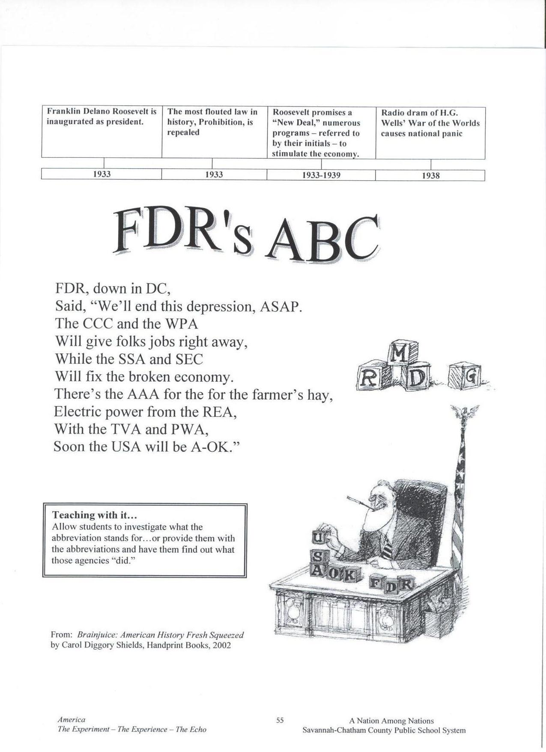
Appendix A
Adapted from: Savannah Chatham County Public School System. (2007). Poetry and song. Teaching American History. Savannah, Georgia: Author.

Appendix B
Creating a Job and Advertisement Rubric
Name _____________________ Date______________

Total Points ________/12 | Exceeds Expectations 3points | Meets Expectations 2 points | Does Not Meet Expectations 1 point
Job | Creates a job for the school and gives a description of why it is needed and gives an example | Creates a job for the school and gives a description for why it is needed | Does not create a job for the school or give description for why the job is needed
Advertisement | Advertisement is creative and appealing. Includes the name of the new creation. Illustration reflects the name of the new creation. | Advertisement includes the name of the new job. Illustration reflects the name of the new job. | Advertisement does or does not include the name of the new job. Illustration does not reflect the new job.
New Deal | Student wrote how the New Deal created by FDR helped Americans and gave examples | Student wrote a sentence on how the New Deal created by FDR helped Americans | Did not write a sentence on how the New Deal created by FDR helped Americans
Spelling & Grammar | Correct grammar and fewer than 3 misspelled words. | 1-2 Grammar mistakes and fewer than 3 misspelled words. | More than 2 grammar mistakes and/or 3 or more misspelled words.

Appendix C
Rubric for Franklin D. Roosevelt’s Timeline
Total Points _______/9 | Exceeds Expectations 3points | Meets Expectations 2 points | Does Not Meet Expectations 1 point
Accuracy | All dates match events | Less than 2 dates do not match event | More than 2 dates do not match with event
Dates | All dates & events are included:  1882-Born in Hyde Park, New York; 1900- began doing public service; 1905-Franklin and Eleanor marry in; 1910- Roosevelt enters politics as New York State Senate; 1921- diagnosed with polio; 1924 first visit to Warm Springs; 1928- becomes governor of New York; 1929 The Great Depression; 1933- Roosevelt became President and he put the New Deal in place; 1936- Roosevelt was reelected as President; 1940-Roosevelt was reelected for a third time; 1941- Pearl Harbor was attacked; 1944- Roosevelt was reelected for the fourth time; 1945- Roosevelt helped from the United Nations, World War II ended, and Roosevelt died | Only missing 1 date or event | missing more than 1 date or event
Readability & spelling | No problems reading timeline and no spelling mistakes | Less than 2 events are not readable and less than 3 spelling errors | More than 2 events are not readable and/or more than 3 spelling errors

Appendix D
Warm it up with Franklin Booklet Rubric
Total Points  _______/45 Points |  | Exceeds Expectations  3points | Meets Expectations  2 points | Does Not Meet Expectations  1 point
Organization |  | Have all assignments and in order: Definition of heroism, What makes a hero?, Who are your heroes?, timeline, map, public service page, diligence and courage page, flowchart of heat, warm it up with Franklin worksheet, FDR’s ABC, Job/Advertisement, Scrapbook page, and letter | Have all assignments | Missing an assignment
Definition of heroism |  | Wrote the definition the class agreed upon and titled it | Wrote the definition the class agreed upon | Did not write the class’s definition
What makes a hero? |  | Answered all questions & opinion of a hero reflects answers | Answered all questions | Did answer all questions
Who are your heroes? |  | Answered all questions and wrote more than 1 sentence | Answered all questions and wrote 1 sentence | Did answer all questions
Timeline |  | Timeline is completed & is titled Timeline | Timeline is completed | Not completed
Map of specific locations of Franklin Roosevelt’s life |  | All three locations are correctly located & labeled and explanations of each city being important to FDR are correct | All three locations are correctly located and explanations of each city being important to FDR are correct | All three locations are not correctly located and/or explanations of why each city was important to FDR are not correct
Public Service page |  | Includes definition of public service and gives more than 1 example of public service | Includes definition of public service and gives 1 example of public service | Does not include definition of public service and/or example does not refer to definition
Diligence/Courage Page |  | Includes both definitions of diligence and courage and has more than 1 example of each and they relate to the definition | Includes both definitions of diligence and courage and has 1 example of each and they relate to the definition | Does not include definition of both words and/or examples of each do relate to the definition
Flowchart of heat |  | Flowchart is completed and titled “Warming up with Franklin” | Flow chart is completed | Not completed
Warm it up with Franklin worksheet |  | Filled out worksheet and answered questions correctly, included degrees symbol and Fahrenheit after temperature | Filled out worksheet and answered questions correctly | Not completed
Appendix D, p. 2

Continued: Warm it up with Franklin Booklet Rubric
FDR’s ABC | Has all 8 names for abbreviations correct: CCC- Civilian Conservation Corps; WPA-Works Progress Administration; SSA- Social Security Act; SEC-Securities and Exchange Commission; AAA- Agricultural Adjustment Act; REA- Rural Electrification Administration; TVA- Tennessee Valley Authority; PWA- Public Works Administration |  | Missing no more than 2 names for abbreviations and the ones listed are correct | Has less than 6 names for abbreviations and/or more than 2 names are incorrect
Job/Advertisement | Has the name of the job, a description of why the job is needed, and an advertisement to represent the job. Advertisement is colorful. |  | Has the name of the job, a description of why the job is needed, and an advertisement to represent the job | Missing either the name of the job, a description of why the job is needed, and/or an advertisement to represent the job
Scrapbook Page | Completed page and includes a job represented in World War II, a description of why he/she choose this job, and has a paragraph on why it was important to stop the leader of Germany from taking over other countries and how FDR showed leadership |  | Completed page but missing one of the following: job represented in World War II, a description of why he/she choose this job, or a paragraph on why it was important to stop the leader of Germany from taking over other countries and how FDR showed leadership | Not completed
Thank you Letter | Includes an example of how FDR showed the following characteristic traits: heroism, diligence, courage, leadership, and cooperation. Includes thanking FDR for creating jobs through the New Deal and during World War II and how he lead us to victory in World War II by fighting for liberty. |  | Missing less than 2 examples of how FDR showed the following characteristic traits: heroism, diligence, courage, leadership, and cooperation. Includes thanking FDR for at least 1 of the following: creating jobs through the New Deal and during World War II or how he lead us to victory in World War II by fighting for liberty | Missing more than 2 examples of how FDR showed the following characteristic traits: heroism, diligence, courage, leadership, and cooperation. And/or missing both of the following: thanking FDR for creating jobs through the New Deal and during World War II or how he lead us to victory in World War II by fighting for liberty
Neatness | Cover page has Warm it up with Franklin on it, all pages are bound with ribbon, cover page is decorated |  | Cover page has Warm it up with Franklin on it, all pages are bound with ribbon | Cover page does not have Warm it up with Franklin on it and/or all pages are not bound with ribbon,

Lesson Five: World War II

Time: 140 minutes

Academic Standards:

SS3H2 The student will discuss the lives of Americans who expanded people’s rights and freedoms in a democracy.
a. Franklin D. Roosevelt (New Deal and World War II)
b. Explain social barriers, restrictions, and obstacles that these historical figures had to overcome and describe how they overcame them

SS3G2 The student will describe the cultural and geographic systems associated with the historical figures in SS3H2a.
a. Identify on a political map specific locations significant to the life and times of these historical figures.
b. Describe how place (physical and human characteristics) had an impact on the lives of these historical figures.
c. Describe how each of these historical figures adapted to and was influenced by his/her environment.
d. Trace examples of travel and movement of these historical figures and their ideas across time.

SS3CG2 The student will discuss the character of different historical figures in SS3H2a.
a. Describe how the different historical figures in SS3H2a display positive character traits of cooperation, diligence, courage, and leadership.
b. Explain how the historical figures in SS3H2a used positive character traits to support their beliefs in liberty, justice, tolerance, and freedom of conscience and expression.
c. Explain how the historical figures in SS3H2a chose when to respect and accept authority.

Objective
The students will:
- Explain how World War II created jobs for Americans.
- Analyze why President Roosevelt believed it was important to stop the leader of Germany from taking over other countries and write their reason on the back of the scrapbook page.
- Describe the characteristic trait FDR possessed, including courage; diligence; leadership.

Essential Vocabulary
- Liberty- freedom from being controlled by someone else
- World War II- Germany, Italy, and Japan were trying to take over Europe. Great Britain, France, United States, and the Soviet Union were trying to stop them and fight for democracy. Many jobs were created and filled in the United States due to the war.
- Democracy-a government in which the people have the power to make political decisions
- Leadership- Guidance; direction

Materials and Resources
- Katzin, Nathan Asher. (2006). American heroes: Franklin Delano Roosevelt. Boston,
Massachusetts: Houghton Mifflin Company.
- 21 sets, American heroes: Franklin Delano Roosevelt
- Kaser, V. C. (2002). Women at war. In P.A. Sibbing (Ed.), The complete book of United States history (pp. 294-297).Columbus, Ohio: McGraw-Hill Children’s Publishing.
- 20 copies of Women at war
- 21 sheets of 8 ½ x 11” paper, white
- Markers, 20 sets of 8
- Water color paint, 20 sets of 8
- Paintbrushes, 20
- Small plastic cups, 20
- 20 paper towels
- 20 pencils
- The Library of Congress. (1998). America from the Great Depression to World War II: Color photographs from the FSA-OWI, 1939-1945. Retrieved July 1, 2009, from http://memory.loc.gov/ammem/fsachtml/fsacSubjects08.html#bottom.
- Appendix A: What do you see?
- Transparency of Appendix A
- Appendix B: Questions for What do you see?
- Overhead projector
- Internet access
- Appendix C: Timeline rubric
- Appendix D: Rubric for Scrapbook page
- Computer
- K-W-L chart, made in lesson 1
- 20 sheets of 8 ½ x 11” paper, wide-ruled
- 6 Transparency marker, different colors
- National Archives and Records Administration. (NARA). (n.d.). Birthday Balls: Franklin D. Roosevelt and the March of Dimes. Retrieved July 15, 2009, from http://www.fdrlibrary.marist.edu/bdayb1.html.
- The U.S. Mint. (1999). Coin Curricula: Roosevelt Dime. Retrieved July 5, 2009, from http://www.usmint.gov/kids/index.cfm?fileContents=teachers/coinCurricula/10ce ntCoin. cfm.
- Printer
- LCD projector
- Cable News Network. (2009). CNN Heroes: Ordinary people extraordinary impact. Retrieved July 2, 2009, from http://www.cnn.com/SPECIALS/cnn.heroes/

Note to teacher: This unit is based on the book, American heroes: Franklin Delano Roosevelt. The materials state for 21 copies, based on 20 students and 1 teacher. Please adjust accordingly. Materials are based on 20 students. If you have more or less than 20 students, adjust materials as needed. Students will create a “Warm it up with Franklin” booklet, and it will be an ongoing process throughout the unit. On the last day of the unit, students will bind their booklet with ribbon. The black folder will be used to store all information to be placed in their booklets. All construction paper and final documents to be placed in the booklet need to be hole punched. The hero bulletin board will be an ongoing event throughout the unit as well. Students will write on the sticky note describing how they were a ‘hero’ to someone else or how someone showed heroism. Students will then use a thumb tack to attach to the bulletin board. Students will be allowed to submit their hero online through CNN as ongoing project, http://www.cnn.com/SPECIALS/cnn.heroes/. (Click on nominate and fill in information and then hit submit. Students may need teacher assistance.)

Procedures

Introduction (10 minutes)
- Review over K-W-L chart

- Discuss the different obstacles President Roosevelt has had to overcome so far: polio and the Great Depression.

- “What characteristic traits did President Roosevelt have to have to be successful so far?” (diligence, courage, & cooperation)

- “The next chapter we are going to read is titled” World War II.” What do you predict President Roosevelt would have done to show heroism during this time?”

Instructional (115 minutes)
- Partner students heterogeneously to read chapter 4 in American heroes: Franklin Delano Roosevelt. Note to teacher: In 1939, Great Britain and France went to war with Germany and Italy because their dictators were trying to take over Europe. In 1940, Roosevelt became President for a third time. He was the first President to be elected three times. Roosevelt did not want to enter the war, but he wanted to help Great Britain and France fight for democracy. Japan joined Germany and Italy, and bombed Pearl Harbor in Hawaii on December 7, 1941. The U.S. now joined the war. Roosevelt told men and women they had to cooperate with each other to be successful. Men and women joined the armed forces. Women also took over many factory jobs usually done by men. The war changed the way of life for Americans. Supplies were short, and it was hard to buy meat, sugar, gasoline, and even shoes! People grew food on their farms, called War Gardens, to send the food to soldiers. Children helped by collecting scrap metal and it was turned into equipment for fighting the war. Through his radio speeches, Roosevelt explained the U.S. would win the war by working hard and cooperating with each other. He reminded them they were fighting for liberty. President Roosevelt was reelected for a fourth term as President in 1944. In 1945, Roosevelt met with other world leaders to plan ways to prevent future wars. This was called the United Nations which is still in place today. The United States won the war, but Roosevelt died just before victory happened.

- Review vocabulary words: Liberty, Leadership, World War II, & Democracy

- As a whole group, have students discuss their thoughts on this chapter. Focus on how President Roosevelt showed leadership when leading his country to victory.

- From the reading, ask students why they think President Roosevelt believed it was important to stop the leader of Germany from taking over other countries. Note to teacher: Be sure to discuss liberty again here. Relate this subject to students by having them think about getting something stolen they really care about. Have them think about how they felt when this happened and was it right. Then discuss how the students would feel if another country came and tried to take over the U.S. “They would be “stealing our country.” We would then have to do what that country wanted us to do, and it could be a very bad situation. We could be slaves and not have any freedom to go to school or church. This is why President Roosevelt decided to join the war and stop the leader of Germany. Japan was on Germany’s side and they attacked Pearl Harbor and killed thousands of people there.” Ask students what would have happened if we didn’t declare war and would we be here right now.

- Students will answer questions to What do you see (see appendix B). Place transparency of What do you see, on the overhead (see appendix A). Note to teacher: Cover up sections two and three on the transparency using an 8 ½ x 11” white sheet of paper. Allow students 5 minutes to answer the questions to section one. Review answers in class by calling on students randomly. Repeat steps for sections two and three. Make sure the other two sections are covered while discussing one section. Afterwards, show the entire picture. Read the title of the picture to the students. Ask students why they think the women are making small gun parts.

- As a whole group, students will read Women at war. Teacher will call on students randomly to read aloud. Note to teacher: Be sure to focus on the pictures throughout the reading. Ask students why it was strange to have women working in the factories. (Most women did not work at this, they were housewives. Women were seen as incapable of doing a man’s job until the war.) Over 15 million American men went to fight in the war and their old jobs needed new workers. Women filled these jobs which were working in government offices and businesses and working in factories. By the end of the war, over 360, 000 women were putting together airplanes for the nation. Two out of five workers were women who were making ammunition. When women entered the military, they were not allowed to go into combat. They became car mechanics and truck drivers. They also did jobs like a typist, clerk, decoder, cooks, and hundreds of other supporting jobs. By the end of the war, over 330,000 women served in the armed forces. After the reading and discussion, do the activity on page 277. Draw the graph onto the overhead. Using the different color transparency markers, together as a class, fill in the chart of the number of women working during World War II. (1940: 11, 970, 1941: 13,000, 1942: 15,170, 1943: 18,200, 1944: 18,850, 1945: 18,610) Ask students what they can conclude from the graph.

- Show the first five pictures of this website. http://memory.loc.gov/ammem/fsachtml/fsacSubjects08.html#bottom. Note to teacher: Click on the website, then click on women-employment, then click on Women war workers, click on the picture to make it bigger, read the title of the picture. This is to reinforce how the war created so many jobs and the type of work women had to do to help with the war. Allow students to ask questions and encourage students to give their thoughts on the photos.

- Students will make a scrapbook page. Students will fold the 8 ½ x 11” white paper hamburger style (like a book). The front cover will be titled “World War II, 1939-1945”. On the inside of the paper, students will draw or paint a picture of what job they would have chosen to do if they lived during World War II. The choices are: building machinery, fighting in the war, growing war gardens, or picking up scraps of metal. This should take up both sides of the paper and the title of the job should be written somewhere on the drawing, as well as, a sentence describing why they chose this particular job. On the back page students will write a paragraph to describe why Franklin D. Roosevelt felt it was important to stop the leader of Germany from taking over other countries and how he showed leadership, diligence, and courage during this war. Note to teacher: This will be added to the “Warm it up with Franklin” booklet. Hole punch this in the center of the fold with only one punch, not three. See appendix D for the rubric.

Closing Activities (15 minutes)
- Student will add the following events to their timeline: 1940-Roosevelt was reelected for a third time, 1941- Pearl Harbor was attacked, 1944- Roosevelt was reelected for the fourth time, 1945- Roosevelt helped from the United Nations, World War II ended, and Roosevelt died. (Roosevelt’s death will be focused on the next lesson) See appendix C for rubric.

- Review questions with class by calling on random students:
  - “What was the name of the war discussed today?” World War II
  - “How did WWII help provide jobs to Americans?” It gave men, women, and children jobs by having to provide for the war.
  - “Why did President Roosevelt think it was important to stop the leader of Germany from trying to take over other countries?” Because it was like stealing. These countries did not belong to him, each country deserves liberty.
  - “How do you think women who worked during World War II affected how many work today?” It opened the eyes of Americans, especially men, that women are capable of doing more than being a housewife. Answers will vary.
  - “Were your predictions right on how President Roosevelt would show heroism during World War II?”Answers will vary.
  - What character traits did President Roosevelt possess in order to help so many Americans during a hard time? Diligence, cooperation, courage, heroism, and leadership

- If any students have something to add to the hero board, allow them to place it up there and share with the class.

- If any student would like to submit their hero on http://www.cnn.com/SPECIALS/cnn.heroes/, allow them.

- Add to the “L” on the K-W-L chart.

Student Evaluation
-Teacher will informally evaluate students based on their answers to the review questions.
-Students will create a scrapbook page which will include a job the student would have chosen to do during World War II and either draw or paint a picture of it. Students will include a description of why he/she chose this job. On the back, students will write a paragraph to describe why Franklin D. Roosevelt felt it was important to stop the leader of Germany from taking over other countries and how he showed leadership, diligence, and courage during this war. Refer to rubric for scrapbook page.
- Teacher will refer to the timeline rubric to assess the timeline students create of Roosevelt’s life

Accommodation Activities
Teacher will walk around and assist students as needed. Students will work in heterogeneous partners for reading and may do so for any other activities.

Enrichment Activities
Students will read online, Birthday Balls: Franklin D. Roosevelt and the March of Dimes. http://www.fdrlibrary.marist.edu/bdayb1.html. Then students will go to http://www.usmint.gov/kids/index.cfm?fileContents=teachers/coinCurricula/10centCoin. cfm. Students will then click on the front of the dime and print it and the back of the dime and print it. Students can color the dime and write on the back it why President Roosevelt’s face was chosen to be on the dime. (Hint, the answer is on the last page of Birthday Balls: Franklin D. Roosevelt and the March of Dimes).

Appendices
Appendix A: What do you see? picture
Appendix B: What do you see? Questions
Appendix C: Timeline rubric
Appendix D: Rubric for Scrapbook page

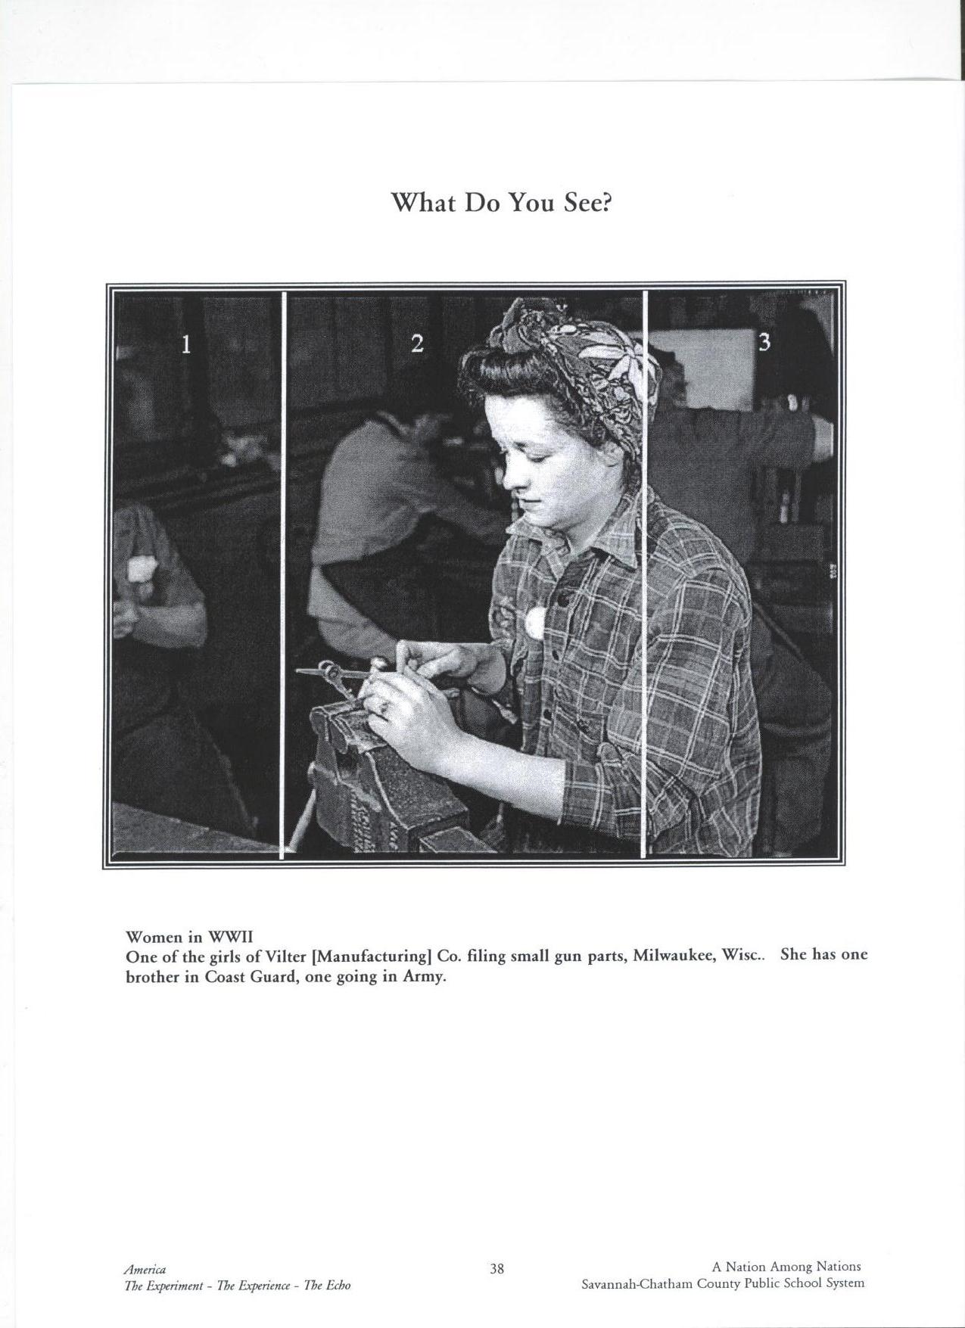
Appendix A

Adapted from: Savannah Chatham County Public School System. (2007). What do you see? Teaching American History. Savannah, Georgia: Author.
Appendix B
What do you see in this picture?

Name____________________ Date_________________

Section 1
- Can you tell if this person is male or female?________________
- Do you think this person is a male or female?_________________
- Is there anything else in the photo you can identify? ____________
- What do you think these items are used for?__________________________________________________
- What evidence in this picture helped you decide on your answers?
______________________________________________________

______________________________________________________

Section 2
- How many people do you see in this picture?_________________
- Are they male or female? ________________________________
- What do you think these people are doing?__________________
_____________________________________________________
- What evidence did you use to come up with your answers?______
_____________________________________________________
- How are they dressed? Is this unusual?______________________
_____________________________________________________

Section 3
- Can you tell if this person is male or female? _________________
- Based on the other sections, do you think this person is male or female? _______________________________________________
- From what you can see, what would your decision be on what the worker is doing?________________________________________
______________________________________________________
Adapted from: Savannah Chatham County Public School System. (2007). What do you see? Teaching American History. Savannah, Georgia: Author.
Appendix C

Rubric for Franklin D. Roosevelt’s Timeline
Total Points  ____/9 | Exceeds Expectations 3points | Meets Expectations 2 points | Does Not Meet Expectations 1 point
Accuracy | All dates match events | Less than 2 dates do not match event | More than 2 dates do not match with event
Dates | All dates & events are included:  1882-Born in Hyde Park, New York; 1900- began doing public service; 1905-Franklin and Eleanor marry in; 1910- Roosevelt enters politics as New York State Senate; 1921- diagnosed with polio; 1924 first visit to Warm Springs; 1928- becomes governor of New York; 1929 The Great Depression; 1933- Roosevelt became President and he put the New Deal in place; 1936- Roosevelt was reelected as President; 1940-Roosevelt was reelected for a third time; 1941- Pearl Harbor was attacked; 1944- Roosevelt was reelected for the fourth time; 1945- Roosevelt helped from the United Nations, World War II ended, and Roosevelt died | Only missing 1 date or event | missing more than 1 date or event
Readability & spelling | No problems reading timeline and no spelling mistakes | Less than 2 events are not readable and less than 3 spelling errors | More than 2 events are not readable and/or more than 3 spelling errors

Appendix D
Rubric for Scrapbook Page
Total Points ______/9 | Exceeds Expectations 3points | Meets Expectations 2 points | Does Not Meet Expectations 1 point
Job drawing | Job chosen represents a job during World War II (building machinery, fighting in the war, growing war gardens, or picking up scraps of metal) and the drawing reflects the job. Drawing or painting is easy to understand what it is being represented. Includes title on the front page: World War II, 1939-1945 | Job chosen represents a job during World War II and the drawing reflects the job | Job is not one of the choices and/or drawing does reflect job chosen
Description of job | Has a description of why he/she choose this job and gives examples. | Has a description of why he/she choose this job. | Does not have a job description.
Back of page | Paragraph includes why it was important to stop the leader of Germany from taking over other countries and how FDR showed leadership, courage, and diligence. Gives plenty of details and includes liberty in the description. | Paragraph includes why it was important to stop the leader of Germany from taking over other countries and how FDR showed leadership, courage, and diligence | Paragraph does not include why it was important to stop the leader of Germany from taking over other countries and/or how FDR showed leadership, courage, and diligence

Lesson six: His Legacy

Time: 165 minutes

Academic Standards:

SS3H2 The student will discuss the lives of Americans who expanded people’s rights and freedoms in a democracy.
a. Franklin D. Roosevelt (New Deal and World War II)
b. Explain social barriers, restrictions, and obstacles that these historical figures had to overcome and describe how they overcame them

SS3G2 The student will describe the cultural and geographic systems associated with the historical figures in SS3H2a.
a. Identify on a political map specific locations significant to the life and times of these historical figures.
b. Describe how place (physical and human characteristics) had an impact on the lives of these historical figures.
c. Describe how each of these historical figures adapted to and was influenced by his/her environment.
d. Trace examples of travel and movement of these historical figures and their ideas across time.

SS3CG2 The student will discuss the character of different historical figures in SS3H2a.
a. Describe how the different historical figures in SS3H2a display positive character traits of cooperation, diligence, courage, and leadership.
b. Explain how the historical figures in SS3H2a used positive character traits to support their beliefs in liberty, justice, tolerance, and freedom of conscience and expression.
c. Explain how the historical figures in SS3H2a chose when to respect and accept authority.

Objectives
The student will:
- Describe the characteristic traits FDR possessed, including cooperation, diligence, courage, and leadership.
- Describe how the New Deal helped Americans.
- Explain how World War II created jobs for Americans
Essential Vocabulary
- Heroism- students will determine this definition
- Courage- The state or quality of mind or spirit that enables one to face danger or fear
- Diligently- with hard work and effort over a long time
- Cooperate- work together with someone

Materials and Resources
- Appendix A: Warm it up with Franklin rubric, 2 pages, 20 copies
- Savannah Chatham County Public School System. (2007). Franklin Delano Roosevelt: The man who never gave up. Teaching American History. Savannah, Georgia: Author.
- Appendix B: Franklin Delano Roosevelt The Man Who Never Gave Up, 6 pages, 21 copies
- 20 sheets of stationary, American-like decorated
- 20 pencils
- Scissors, 20 pair of student scissors
- 1 roll of ribbon, any
- Appendix B: Warm it up with Franklin booklet rubric, 20 copies
- Katzin, Nathan Asher. (2006). American heroes: Franklin Delano Roosevelt. Boston,
Massachusetts: Houghton Mifflin Company.
- 21 sets, American heroes: Franklin Delano Roosevelt
- Potts, S. (1996). Franklin D. Roosevelt. Mankato, Minnesota: Capstone Press.
- K-W-L chart made in first lesson
- Computer
- Microsoft Word
- Printer
- http://jeopardylabs.com/play/franklin-d-roosevelt
- Johnson, M. (n.d.) Jeopardy Labs. Retrieved July 2, 2009, from http://jeopardylabs.com/
- Cable News Network. (2009). CNN Heroes: Ordinary people extraordinary impact. Retrieved July 2, 2009, from http://www.cnn.com/SPECIALS/cnn.heroes/

Note to teacher: This unit is based on the book, American heroes: Franklin Delano Roosevelt. The materials state for 21 copies, based on 20 students and 1 teacher. Please adjust accordingly. Materials are based on 20 students. If you have more or less than 20 students, adjust materials as needed. Students will finish their “Warm it up with Franklin” booklet. Students will bind their booklet with ribbon. The black folder will have all information to be placed in their booklets. All construction paper (front and back cover) and final documents to be placed in the booklet need to be hole punched. The hero bulletin board can be continued on all year if teacher wishes. Students will write on the sticky note describing how they were a ‘hero’ to someone else or how someone showed heroism. Students will then use a thumb tack to attach to the bulletin board. Students will be allowed to submit their hero online through CNN as ongoing project, http://www.cnn.com/SPECIALS/cnn.heroes/. (Click on nominate and fill in information and then hit submit. Students may need teacher assistance.) Props can be used for the play. Students will adapt to any props/costumes provided.

Procedures

Introduction Activities (10 minutes)
- Review K-W-L chart

- “What did we find out that happened right before the end of World War II?” Roosevelt died.

- “How many of you heard about Michael Jackson dying? What did he leave behind when he passed away?” His music. Well, we are going to read about what President Roosevelt left behind when he passed away.”

Instructional Activities (140 minutes)
- Divide students into groups of 4 heterogeneously. Students will read pgs. 23-28. (Chapter 5, Franklin Delano Roosevelt and the New Deal, and Understanding Character Traits).Students will take turns reading a paragraph going clockwise. Note to teacher: Chapter 5 begins with saying many people believe Franklin Roosevelt was one of our greatest Presidents. Some of the programs he started are still helping people today. The Tennessee Valley Authority, TVA, gave electricity to farms and homes in the South (refer to map on page 23). It also created dams to prevent floods, and trees were planted by the TVA to keep soil from washing away. This is just one that is still in place; Social Security Act and FDIC are two others. Roosevelt is not just a hero for what he did as President, but also for not letting his disability stop him from achieving his goals. The Roosevelt Memorial in Washington, D.C. is the first Presidential memorial with no steps. This was done for those who are in wheelchairs so they can easily visit the memorial. Roosevelt never gave up and worked diligently. He had courage and believed in himself to lead our country. He made people think everything would get better, regardless of the situation. During World War II, President Roosevelt led the world to fight for freedom and liberty. He cooperated with other world leaders and brought the best out in people. He helped people understand they had to work together when things were tough. The New Deal programs helped people during the Depression. The projects were paid by the national government and created jobs in every state. It put millions of people to work who had lost their jobs. These projects did not just give workers jobs, but also built things that made life better for Americans. People still benefit from these projects today. (View map on page 27)
*Franklin Roosevelt and his wife, Eleanor, cooperated together to help people. *Roosevelt worked diligently trying to regain his strength after he was unable to walk.*Liberty is when people live free from unfair laws and government control. President Roosevelt led the United States in a war against dictators who took away freedom.

- As a whole group, teacher will read page 21 of Franklin D. Roosevelt. Note to teacher: It was near the end of World War II, and the American troops were crushing the German army and bombing Japan. Fighting this war took a lot of energy and created a lot of stress for President Roosevelt. It began to affect his health. FDR was at his home in Warm Springs, GA on April 12, 1945. On this day an artist was painting a picture of him sitting in the garden. When he shook FDR’s hand, FDR looked pale. Later when FDR was signing papers, he became slumped over in his chair and died hours later. Many people were shaken up by his death. He had been president for 12 years. People depended on him to give them hope, and he was someone who cared for them deeply. His funeral train was going north to his home in Hyde Park when thousands of people came to the railroad track and said goodbye to the president. He was one of our greatest presidents. He was going home for the last time.

- Call on students randomly to answer questions:
  - “What character traits did President Roosevelt possess in order to help so many Americans during a hard time?” Heroism, courage, leadership, diligence, and cooperation
  - “How do you think people felt when he died?” Sad, upset, angry, thankful to have such a great president.
  - “What did President Roosevelt do for the Americans for them to call him a hero?” He provided them jobs through the New Deal that helped them get through the Great Depression, He led us to victory in World War II as he fought for our liberty, he gave people hope when they had none, he created programs that are still in effect today, he always wanted to help other people.
  - “What did President Roosevelt teach you about heroism?” Answers will vary. You have to work diligently, be a leader, need cooperation, believe in yourself and do not give up, you need to courage to fight for what is right.
  - “What did Roosevelt leave behind for us when he died?” Programs for the New Deal made the U.S. a powerful country after leading us and other countries to victory in World War II, to have hope, and how working cooperatively during hard times can lead us to success.

- Students will write a letter to President Roosevelt thanking him for his heroism. This will be done on the American-like decorated stationary. Note to teacher: Students must include the characteristic traits in their letter: heroism, courage, leadership, diligence, and cooperation. Students need to write about the jobs created during the New Deal and World War II and the victory of winning liberty during World War II. This will go into the “Warm it up with Franklin” booklet. See Appendix B for rubric.

- Students will perform a play. See Appendix A, 6 pages. Note to teacher: There are 4 different acts in this play, and a total of 11 characters. Teacher can switch out students in each act or have the same students play the same part throughout. Students may need their words during the play. It is at the teacher’s discretion as to how long students can have to learn their part. It is advised students will need a minimum of 30 minutes.

- Review “Warm it up with Franklin” rubric with students. As students put their booklets together, they will have a copy of the rubric. Note to teacher: Students may need help tying and cutting ribbon for their booklet. This will serve as part of the post-assessment.

Closing Activities (15 minutes)
- Finish K-W-L chart. Note to teacher: The “l” section is the other part of the post-assessment.

- Ask students if they will change their ways towards heroism.
- Answer any questions students may have on FDR.

- Ask students’ opinion on the “Warm it up with Franklin” unit.

- If any students have something to add to the hero board, allow them to place it up there and share with the class.

- If any student would like to submit their hero on http://www.cnn.com/SPECIALS/cnn.heroes/, allow them.

Student Assessment
-Students will write a letter thanking President Roosevelt for being a person of heroism. In the letter, students will discuss the characteristic traits he possessed, including leadership, courage, cooperation, and diligence. Students will also thank him for leading us to victory, by fighting for our liberty, in World War II, as well as, creating jobs through the New Deal and during World War II. Refer to warm it up with Franklin rubric.
Accommodation Activities
Teacher will walk around to help students as needed. Students may use Microsoft Word if needed to write their letter. If a student needs to type their letter, make sure it is printed out. Peer tutoring is allowed.

Enrichment Activities
Students can play a game of jeopardy on Franklin D. Roosevelt. http://jeopardylabs.com/play/franklin-d-roosevelt . The teacher can divide students into heterogeneous groups to play this as a class too.

Appendices
Appendix A: Warm it up with Franklin rubric, 2 pages
Appendix B: Franklin Delano Roosevelt The Man Who Never Gave Up, 6 pages

Appendix A
Warm it up with Franklin Booklet Rubric
Total Points  _______/45 Points |  | Exceeds Expectations  3points | Meets Expectations  2 points | Does Not Meet Expectations  1 point
Organization |  | Have all assignments and in order: Definition of heroism, What makes a hero?, Who are your heroes?, timeline, map, public service page, diligence and courage page, flowchart of heat, warm it up with Franklin worksheet, FDR’s ABC, Job/Advertisement, Scrapbook page, and letter | Have all assignments | Missing an assignment
Definition of heroism |  | Wrote the definition the class agreed upon and titled it | Wrote the definition the class agreed upon | Did not write the class’s definition
What makes a hero? |  | Answered all questions & opinion of a hero reflects answers | Answered all questions | Did answer all questions
Who are your heroes? |  | Answered all questions and wrote more than 1 sentence | Answered all questions and wrote 1 sentence | Did answer all questions
Timeline |  | Timeline is completed & is titled Timeline | Timeline is completed | Not completed
Map of specific locations of Franklin Roosevelt’s life |  | All three locations are correctly located & labeled and explanations of each city being important to FDR are correct | All three locations are correctly located and explanations of each city being important to FDR are correct | All three locations are not correctly located and/or explanations of why each city was important to FDR are not correct
Public Service page |  | Includes definition of public service and gives more than 1 example of public service | Includes definition of public service and gives 1 example of public service | Does not include definition of public service and/or example does not refer to definition
Diligence/Courage Page |  | Includes both definitions of diligence and courage and has more than 1 example of each and they relate to the definition | Includes both definitions of diligence and courage and has 1 example of each and they relate to the definition | Does not include definition of both words and/or examples of each do relate to the definition
Flowchart of heat |  | Flowchart is completed and titled “Warming up with Franklin” | Flow chart is completed | Not completed
Warm it up with Franklin worksheet |  | Filled out worksheet and answered questions correctly, included degrees symbol and Fahrenheit after temperature | Filled out worksheet and answered questions correctly | Not completed
Appendix A, p. 2
Continued: Warm it up with Franklin Booklet Rubric
FDR’s ABC | Has all 8 names for abbreviations correct: CCC- Civilian Conservation Corps; WPA-Works Progress Administration; SSA- Social Security Act; SEC-Securities and Exchange Commission; AAA- Agricultural Adjustment Act; REA- Rural Electrification Administration; TVA- Tennessee Valley Authority; PWA- Public Works Administration |  | Missing no more than 2 names for abbreviations and the ones listed are correct |  | Has less than 6 names for abbreviations and/or more than 2 names are incorrect
Job/Advertisement | Has the name of the job, a description of why the job is needed, and an advertisement to represent the job. Advertisement is colorful. |  | Has the name of the job, a description of why the job is needed, and an advertisement to represent the job |  | Missing either the name of the job, a description of why the job is needed, and/or an advertisement to represent the job
Scrapbook Page | Completed page and includes a job represented in World War II, a description of why he/she choose this job, and has a paragraph on why it was important to stop the leader of Germany from taking over other countries and how FDR showed leadership |  | Completed page but missing one of the following: job represented in World War II, a description of why he/she choose this job, or a paragraph on why it was important to stop the leader of Germany from taking over other countries and how FDR showed leadership |  | Not completed
Thank you Letter | Includes an example of how FDR showed the following characteristic traits: heroism, diligence, courage, leadership, and cooperation. Includes thanking FDR for creating jobs through the New Deal and during World War II and how he lead us to victory in World War II by fighting for liberty. |  | Missing less than 2 examples of how FDR showed the following characteristic traits: heroism, diligence, courage, leadership, and cooperation. Includes thanking FDR for at least 1 of the following: creating jobs through the New Deal and during World War II or how he lead us to victory in World War II by fighting for liberty |  | Missing more than 2 examples of how FDR showed the following characteristic traits: heroism, diligence, courage, leadership, and cooperation. And/or missing both of the following: thanking FDR for creating jobs through the New Deal and during World War II or how he lead us to victory in World War II by fighting for liberty
Neatness | Cover page has Warm it up with Franklin on it, all pages are bound with ribbon, cover page is decorated |  | Cover page has Warm it up with Franklin on it, all pages are bound with ribbon |  | Cover page does not have Warm it up with Franklin on it and/or all pages are not bound with ribbon,

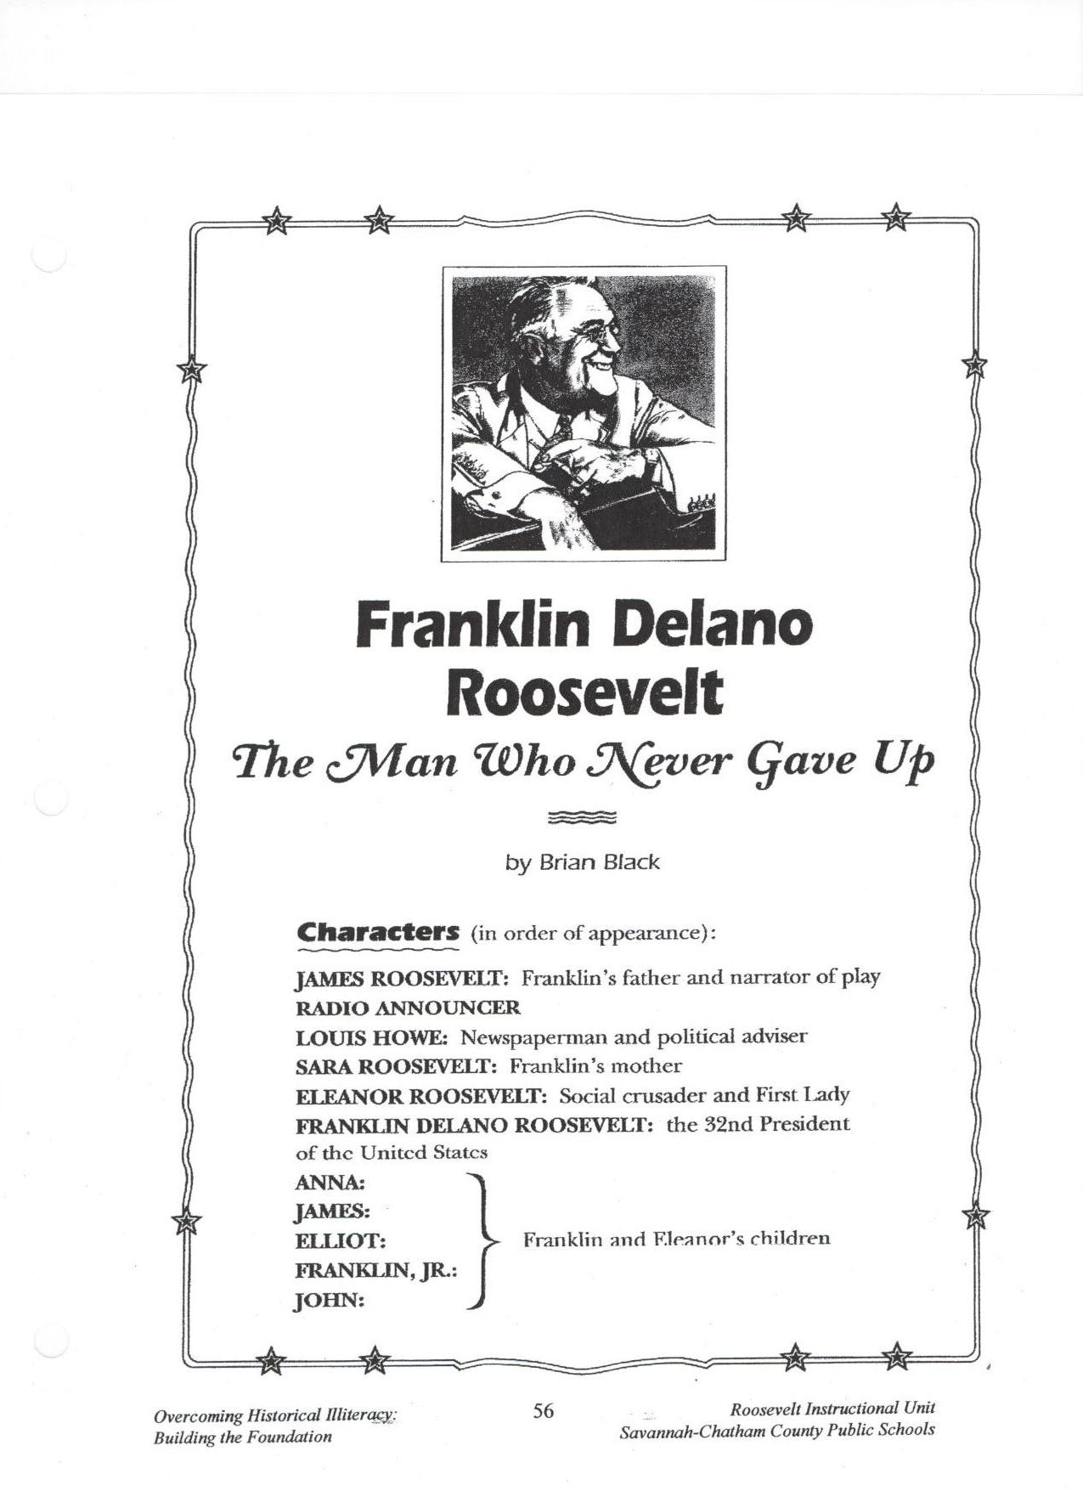
Appendix B

Adapted from: Savannah Chatham County Public School System. (2007). Franklin Delano Roosevelt: The man who never gave up. Teaching American History. Savannah, Georgia: Author

Appendix B, p. 2

Adapted from: Savannah Chatham County Public School System. (2007). Franklin Delano Roosevelt: The man who never gave up. Teaching American History. Savannah, Georgia: Author
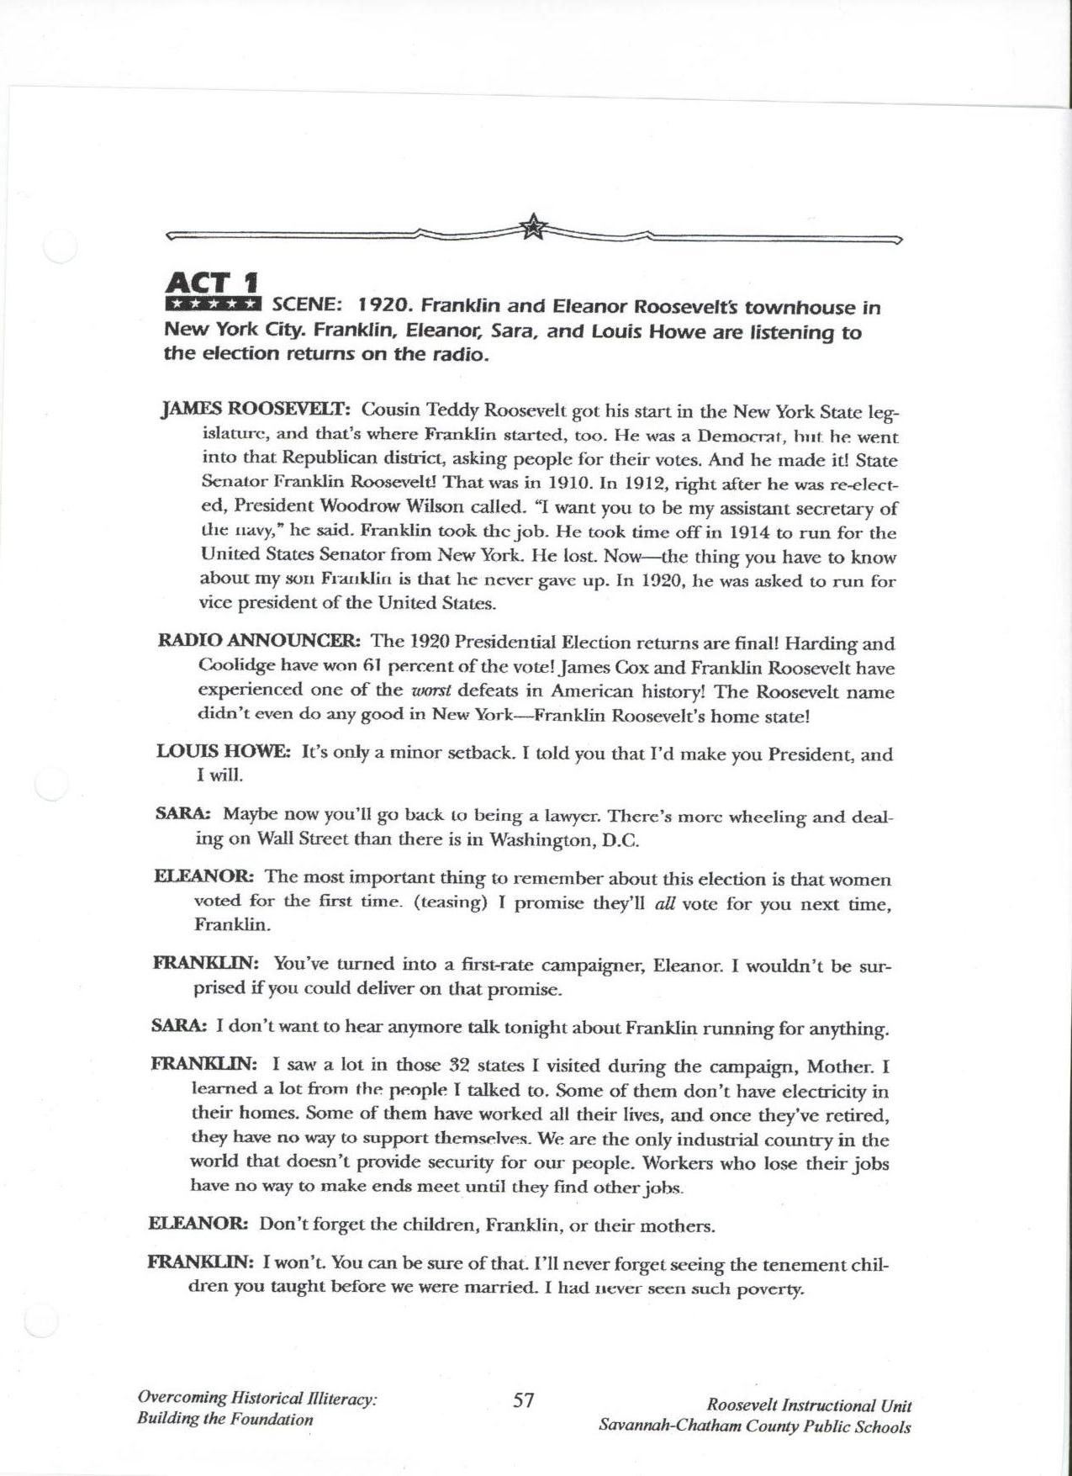
.

Appendix B, p. 3

Adapted from: Savannah Chatham County Public School System. (2007). Franklin Delano Roosevelt: The man who never gave up. Teaching American History. Savannah, Georgia: Author
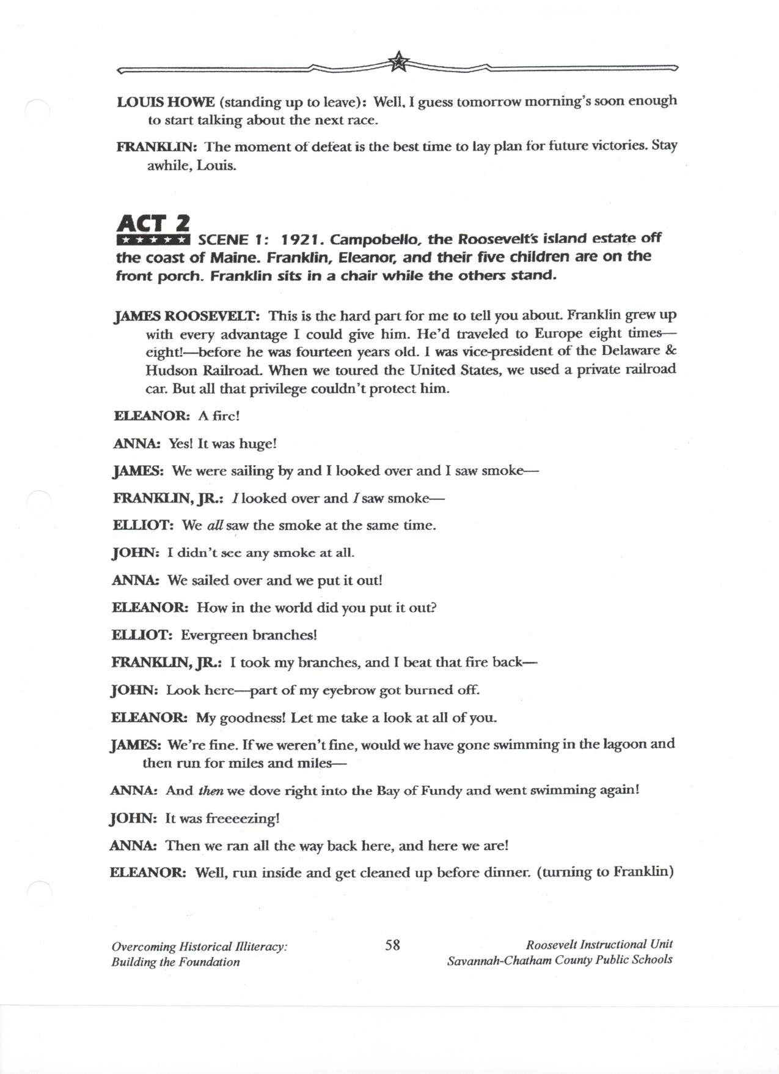
Appendix B, p. 4

Adapted from: Savannah Chatham County Public School System. (2007). Franklin Delano Roosevelt: The man who never gave up. Teaching American History. Savannah, Georgia: Author
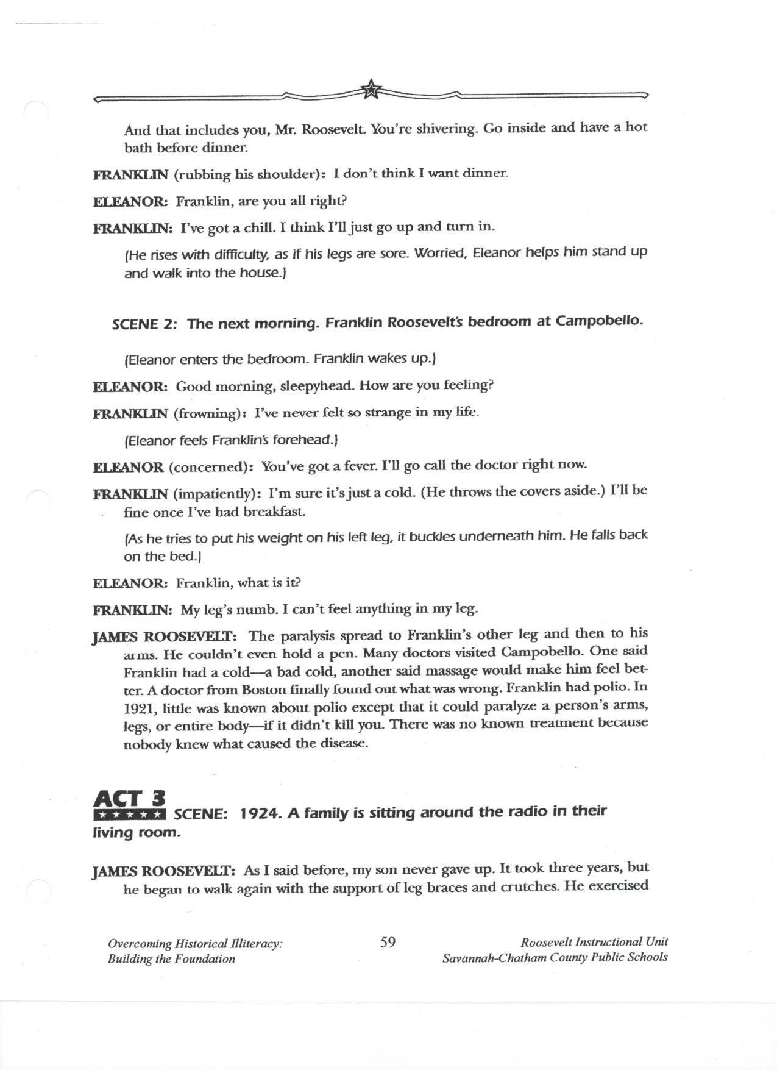
Appendix B, p. 5

Adapted from: Savannah Chatham County Public School System. (2007). Franklin Delano Roosevelt: The man who never gave up. Teaching American History. Savannah, Georgia: Author
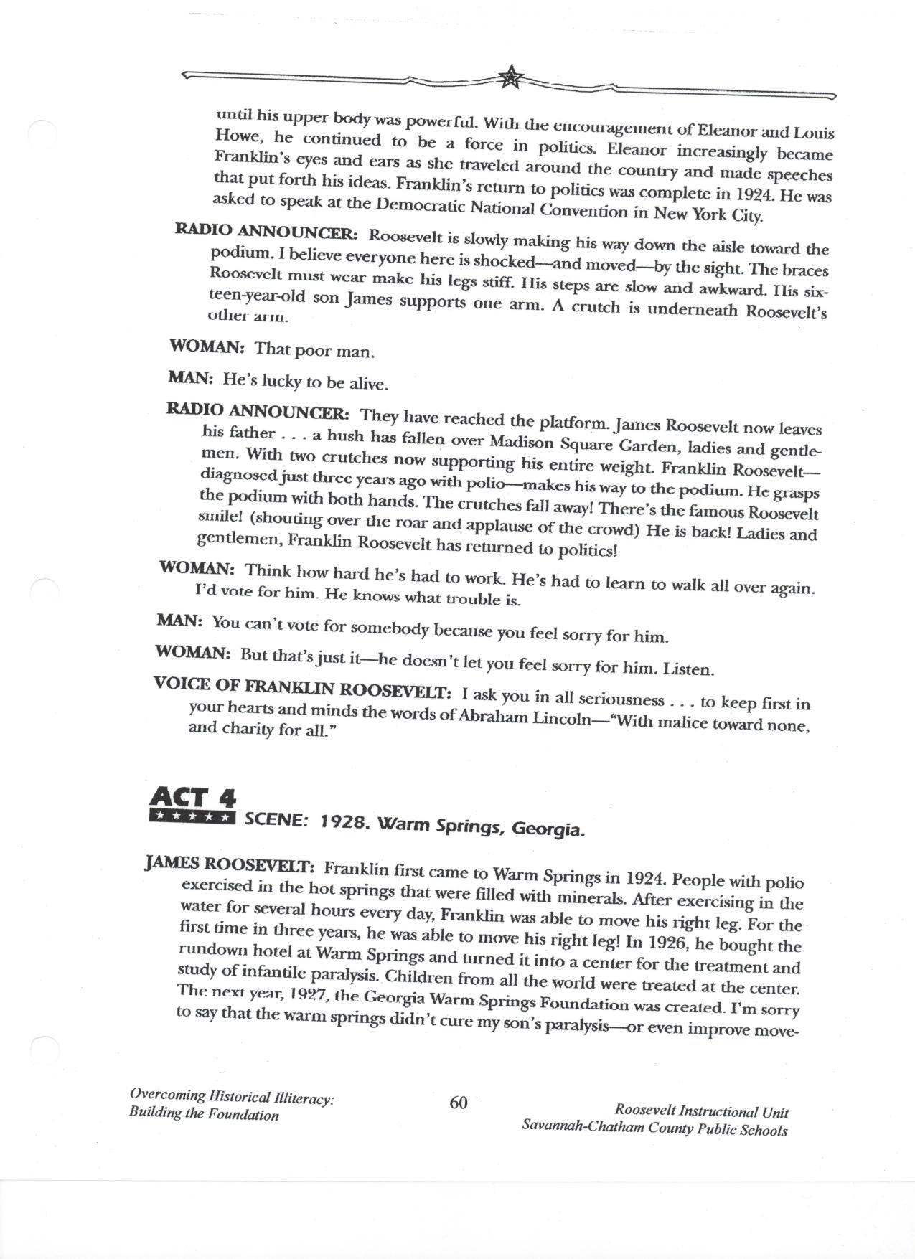
Appendix B, p. 6

Adapted from: Savannah Chatham County Public School System. (2007). Franklin Delano Roosevelt: The man who never gave up. Teaching American History. Savannah, Georgia: Author
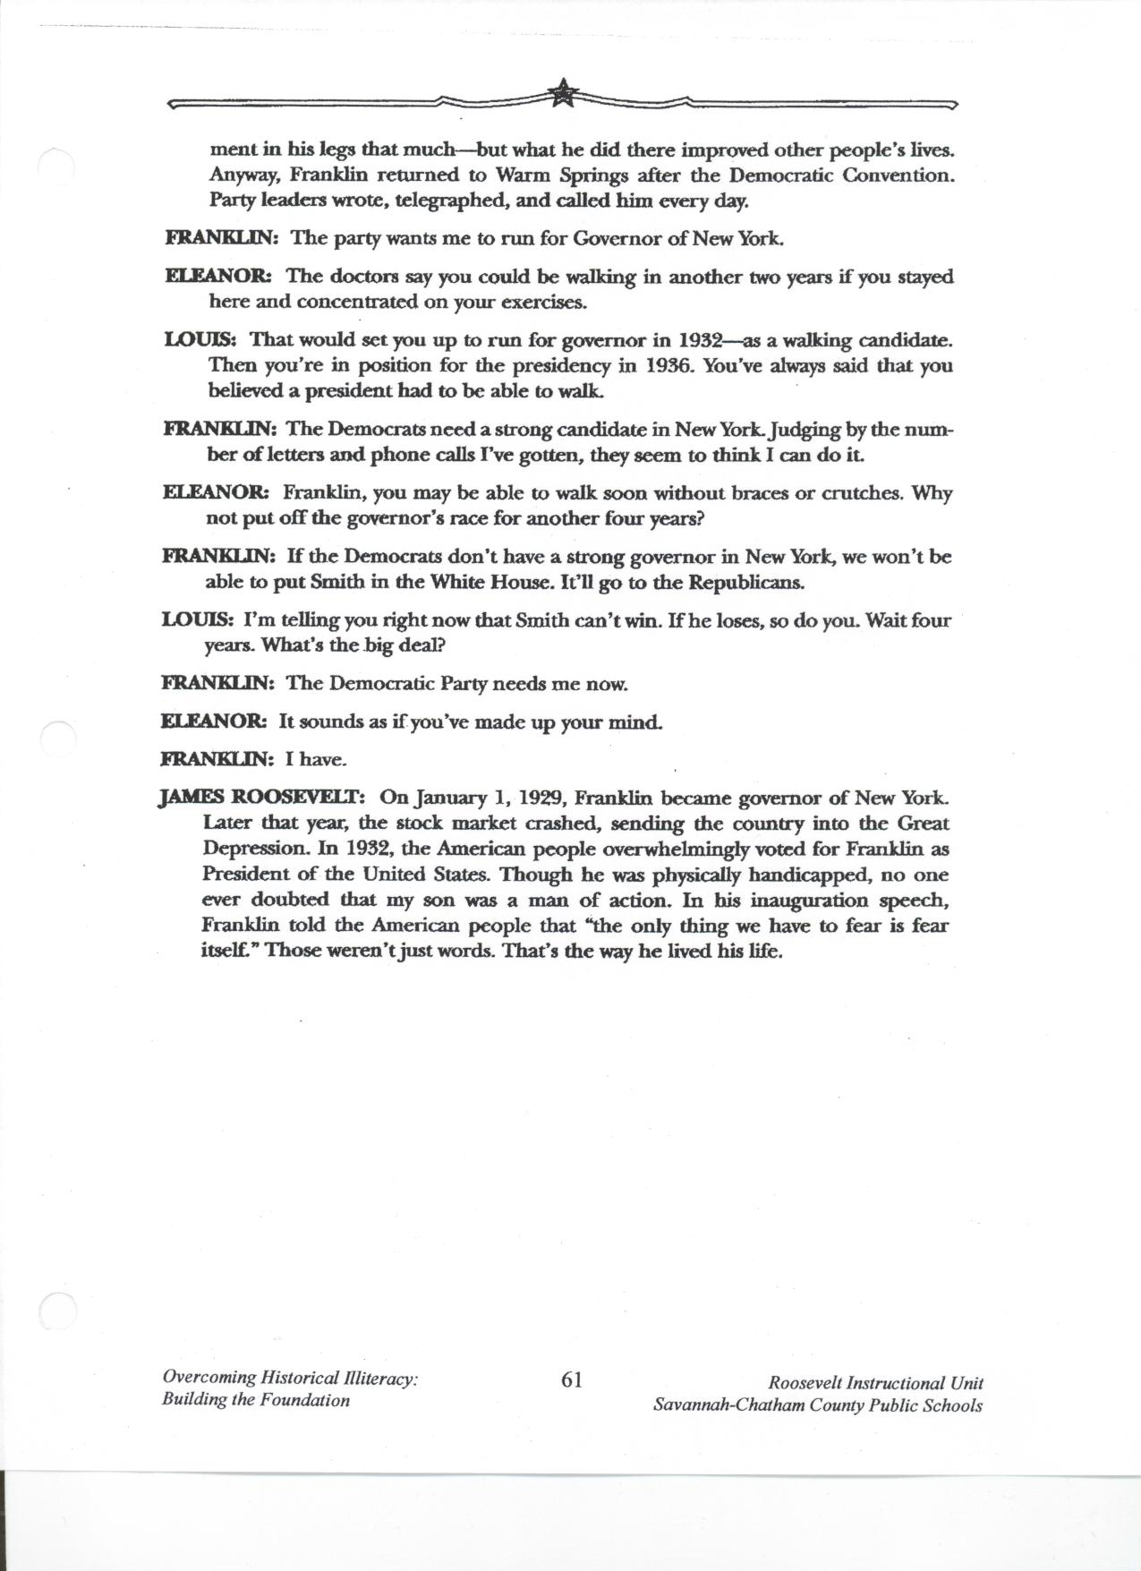
Bibliography

Cable News Network. (2009). CNN Heroes: Ordinary people extraordinary impact. Retrieved July 2, 2009, from http://www.cnn.com/SPECIALS/cnn.heroes/

Education Place. (n.d.) Outline maps: State Maps, New York. Retrieved July 13, 2009,
From http://www.eduplace.com/state/ny/pdf/ny_map.pdf.

Education Place. (n.d.) Outline maps: USA Postal Abbreviations. Retrieved July 13,
2009, from http://www.eduplace.com/ss/maps/pdf/uspostal.pdf.

Education World. (2000). What makes a hero? Retrieved July 12, 2009, from http://www.education-world.com/a_lesson/TM/WS_lp218_2282.shtml.

Education World. (2000). Who is your hero? Retrieved July 12, 2009, from http://www.educationworld.com/a_lesson/TM/WS_lp218_2283.shtml.

Feldmeth, G. (1998). New Deal Programs. U.S History Resources. Retrieved July 17, 2009, from http://home.earthlink.net/~gfeldmeth/chart.newdeal.html.

Johnson, M. (n.d.) Jeopardy Labs. Retrieved July 2, 2009, from http://jeopardylabs.com/
Kaser, V. C. (2002). Franklin Roosevelt‘s New Deal. In P.A. Sibbing (Ed.), The complete book of United States history (pp. 275-278).Columbus, Ohio: McGraw-Hill Children’s Publishing.
Kaser, V. C. (2002). Women at war. In P.A. Sibbing (Ed.), The complete book of United States history (pp. 294-297).Columbus, Ohio: McGraw-Hill Children’s Publishing.
Katzin, N. A. (2006). American heroes: Franklin Delano Roosevelt. Boston,
Massachusetts: Houghton Mifflin Company.

Learning Resources, Inc. (2009). Boiling point thermometers. Illinois: Learning Resources

National Archives and Records Administration. (NARA). (n.d.). Birthday Balls: Franklin D. Roosevelt and the March of Dimes. Retrieved July 15, 2009, from http://www.fdrlibrary.marist.edu/bdayb1.html.

National Archives and Records Administration. (NARA). (n.d.). Franklin D. Roosevelt Presidential Library and Museum. Retrieved June 25, 2009, from http://www.fdrlibrary.marist.edu/index.html.

Potts, S. (1996). Franklin D. Roosevelt. Mankato, Minnesota: Capstone Press.

Savannah Chatham County Public School System. (2007). Franklin Delano Roosevelt: The man who never gave up. Teaching American History. Savannah, Georgia: Author.
Bibliography, continued

Savannah Chatham County Public School System. (2007). Jazz and World War II: A Rally to
Resistance, A Catalyst for Victory. Teaching American History. Savannah, Georgia:
Author.

Savannah Chatham County Public School System. (2007). Poetry and song. Teaching American History. Savannah, Georgia: Author.

The Library of Congress. (1998). America from the Great Depression to World War II: Color photographs from the FSA-OWI, 1939-1945. Retrieved July 1, 2009, from http://memory.loc.gov/ammem/fsachtml/fsacSubjects08.html#bottom.

The U.S. Mint. (1999). Coin Curricula: Roosevelt Dime. Retrieved July 5, 2009, from http://www.usmint.gov/kids/index.cfm?fileContents=teachers/coinCurricula/10ce ntCoin. cfm.

You Tube. (2008). Roosevelt Rap. Retrieved July 5, 2009, from
http://www.youtube.com/watch?v=2sfftlJx9Vk

