INQUIRY BASED LESSON PLANS
Teacher: Fitzgerald/Dukes  North Harlem Elementary | Expected length of lesson:  5-7 Days | Lesson Topic:  The Dust Bowl | Unit:

 | Standards-Based Instructional Focus | Targeted Content Standards/  Element:  (Include the entire standard) | SS5H5 The student will explain how the Great Depression and New Deal affected the lives of millions of Americans.  a. Discuss the Stock Market Crash of 1929, Herbert Hoover, Franklin Roosevelt, the Dust Bowl, and soup kitchens.  b. Analyze the main features of the New Deal; include the significance of the Civilian Conservation Corps, the Works Progress Administration, and the Tennessee Valley Authority.  c. Discuss important cultural elements of the 1930s; include Duke Ellington, Margaret Mitchell, and Jesse Owens.
 |  | Targeted Literacy Skills or Standards: (include as many as your lesson incorporates) | - using context clues to understand the meaning of unfamiliar words  - main idea and supporting details  - revising sentences  - synonyms  - text structure (cause and effect, problem and solution)  - using visual elements to enhance understanding
 |  | Targeted SS Matrices: (include as many as your lesson incorporates) | -cardinal directions  -intermediate directions  -use a map to explain impact of geography on historical and current events
 |  | Inquiry Question (or what you would like the students answer)?  (*Teachers may present the question or require students to develop questions and narrow down to this one). | How did the Dust Bowl escalate the Great Depression?
 |  | Key Vocabulary:  Words important for understanding content and skills (ex: Tier 2 and 3 words) | Agricultural  Influence  Drought | Abandoned  Modifications  Destructive | Desolation  Controversial
 | Learning Targets  (I-Can Statements)  ***At the end of the week, what will students know and what will students be able to do? |  | Foundational:  I can define Dust Bowl.  I can define migrant.  I can define the Great Depression.  Mastery:  I can explain the causes of the Dust Bowl.  I can describe the effects that Dust Bowl had on migrants.  I can explain how the Dust Bowl affected the lives of Americans during the Great Depression.  Extension:
 | ENGAGE  Describe how the teacher will capture students’ interest.  What kind of questions should the students ask themselves after the engagement? |  | The students will “observe” the photograph on the cover of the article “The Grapes of Wrath and the Dust Bowl.” After reading the caption, they will use the visual to decode unfamiliar words from the caption. Bring their attention to the date in the caption and begin discussing dates of the Great Depression (point out the date on photo 8 of the gallery walk) to help lead them into the inquiry question.
 | EXPLORE  Describe what hands-on/minds-on activities students will be doing.  List “big idea” conceptual questions the teacher will use to encourage and/or focus students’ exploration |  | Day1 and 2- Great Depression Gallery Walk (included with plans) These can be blown up and posted on anchor charts around the room OR done in small groups on the worksheets.  Day 3- Quotation Mingle: Sentence strips from “The Grapes of Wrath” Excerpt will be distributed and the students walk around the room reading them to others. They try to piece the information together to gather the main idea. The excerpt is included with the plans. I usually only use the second and third paragraph as indicated by the arrow.  ***Quotation Mingle Instructions Included with resources.
 | EXPLAIN  Student explanations should precede introduction of terms or explanations by the teacher. What questions, resources, or strategies will the teacher use to help students connect their exploration to the concept under examination?  List higher order thinking questions which teachers will use to solicit student explanations and help them to justify their explanations.  Describe how the teacher will clarify the content or skill. |  | Day 1 and 2- Road-map the article “The Grapes of Wrath and the Dust Bowl.”  Focus on cause and effect and theme. Road-mapping procedure and sample included in the plans.  Day 3 and 4- Students will list ideas and objects from the quotation mingle to prepare them to read the excerpt. Read the excerpt and identify literacy elements. There is a PowerPoint included with a template used to organize this information.
 | ELABORATE  Describe how students will develop a more sophisticated understanding of the concept.  What vocabulary will be introduced and how will it connect to students’ observations?  How will students make real-life connections? |  | Day 1 and 2- Create synonyms for words in the article. Revise sentences that could use more detail.  Example in paragraph 7: “same time”- simultaneously, concurrently  Students will analyze a political cartoon depicting the Dust Bowl. They will connect the controversial and long term issues from the article to the cartoon. Students can use this guide to analyze the political cartoon: https://www.archives.gov/files/education/lessons/worksheets/cartoon_analysis_worksheet.pdf  Day 3 and 4- Analyze the excerpt and discuss symbolism, language, and issues faced by the migrants.
 | EVALUATE  How will students be evaluated THROUGHOUT the lesson?  How will students demonstrate that they have mastered the learning target(s)? |  | Day 5 - Use learned vocabulary in a written “illustration” of a migrant farmer leaving Oklahoma and moving to California (incorporate symbolism and language as seen in the excerpt). There are two student samples on last pages.  Reading skills and Dust Bowl assessment on the back of article is given on the last day (Day 6-7)
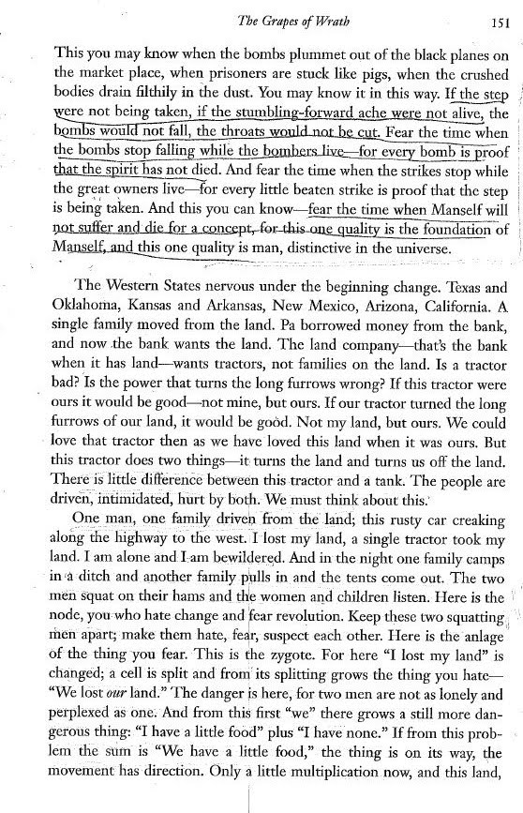
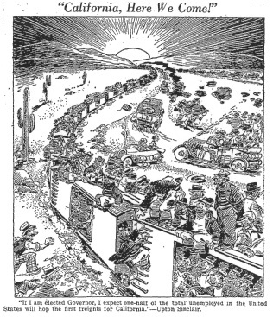

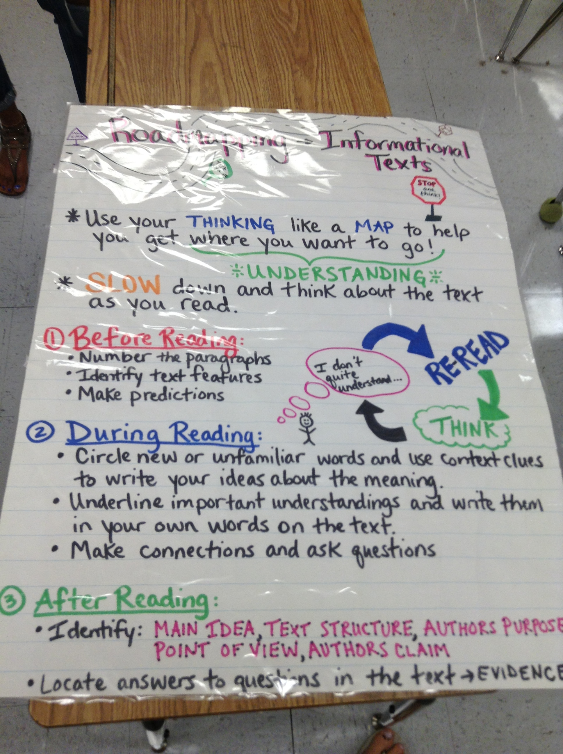

Road-mapping credits to Marisa Forney- NHE teacher

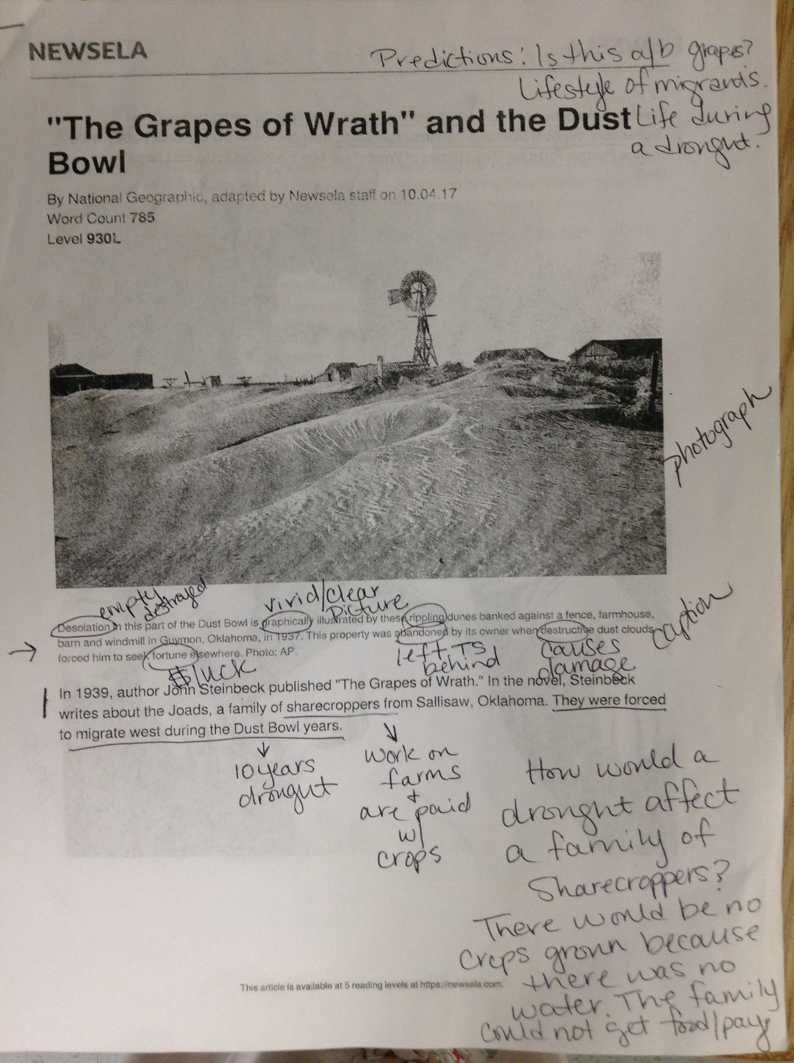

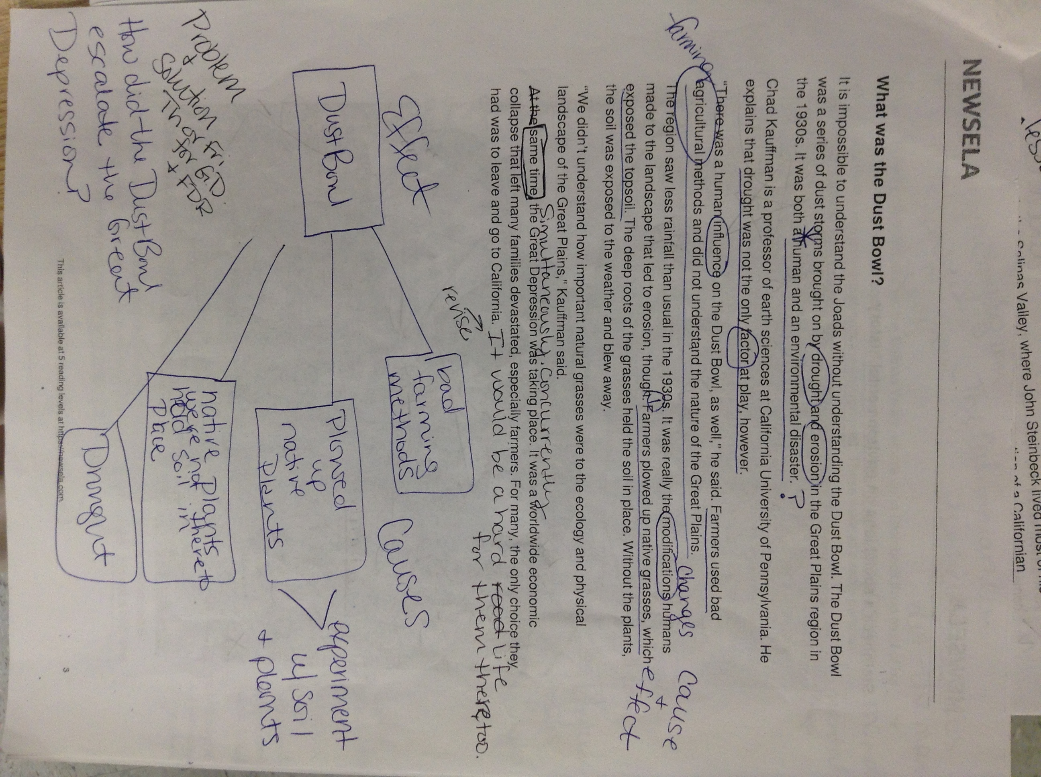

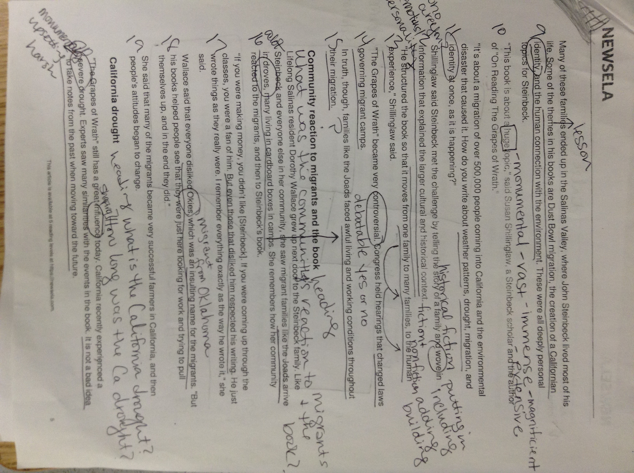

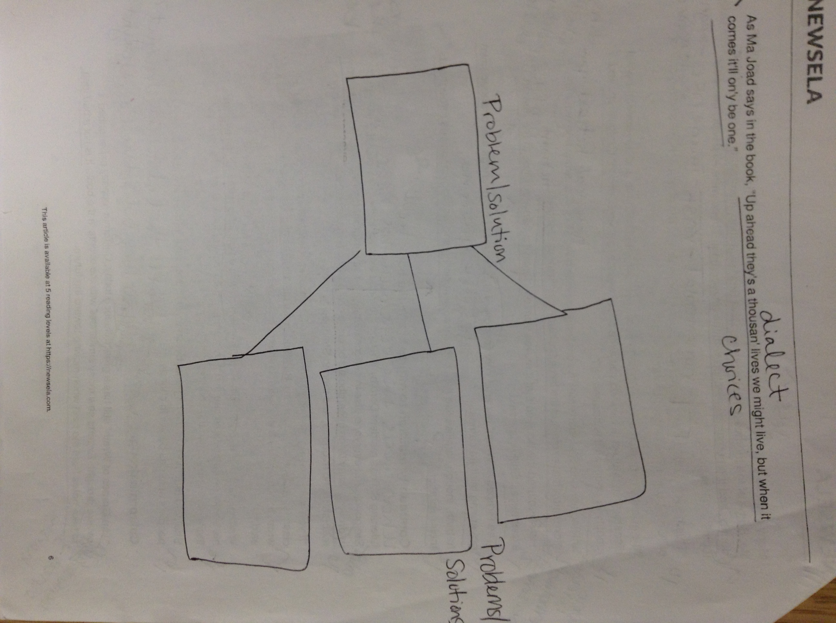

Student Samples

The Window

The window is my love, my drive, and the will to live. At one point they were beautiful, but now they are dull and dry. The window, the one I long for every night and every day, were stripped away from me and are now buried in a merciless coffin of sand. Because of this, the sand has forced us to trudge through broken dreams and glass from my window. My window my life, our window our life. Where did it begin Where will it end? When there are is So many doors to choose, but only one will be the decision, you make it makes you mourn for our window the one that we are. Where is the seed that was sown the seed that started the confusion and intimidation? What was the animal that drove us far from our farm where the tree that blocked our path? This is not only the seed’s fault but also a factor was at play that has not been done before. What did the window do but be our guide and our future.? It has also driven us away I have driven us away we have driven ourselves away. The migration has forced us to go west. The sand the seed has made us, forced us to go to a land of supposed opportunity. A place where our window is forgotten. A place where (we) are unwanted unloved unwelcome. A place where we have to work harder where our window is unaccepted and forgotten. We will still live on some will be successful others will fade to the sand but in the end we are each other.

Symbols: window- identity / sand- change, fear

The Wheelbarrow of Despair
The wheelbarrow is the carrier of all people. It is the life, the future, and the past. It is now a fracture, from what all that was left in the mystical air. Simultaneously, the work turned to hard work. Was it meant to? Did anyone know it was coming? There was suspicion, hatred, intimidation, and anxiety. These feelings were all trapped and hidden in a jar, and never to be seen, in the country of forbidden worlds. After all destruction, the movement became the plane that left Oklahoma that has been over took by wreckage. Any consideration? Was this determined to happen? In the middle of the eye, life has become destructive, UN useful, we are now independent, unforgiving and broken hearted. We no longer have anywhere to rest our heads in despair. Do we run? Do we leave? Do we stay? Our hearts are determined, but our feet are wounded. Too tired to walk. And nowhere to go, for the wrapping of our hearts are at home leaving the ones that need them most. Lonely, desperate, how much more can they be forsaken in their dead, broken dreams that still remain in the jar of forbidden worlds. This is all that is left in the life of the wheelbarrow.

Symbols: wheelbarrow- identity / jar- change, fear

THE GREAT DEPRESSION GALLERY WALK
Name: ________________________________

Directions: Walk around to each photo on the wall. Fill in the chart below WITH COMPLETE SENTENCES! The answer “I don’t know” or “It doesn’t make me feel anything” is not a good answer and will cost you points!

Photo | Describe the photo. What is happening in the photo? (1) | What can you learn about the Great Depression from this photo? (1) | How does this photo make you feel? Why? (1)
Photo #1
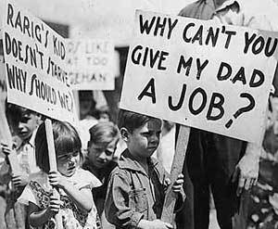
Photo #2
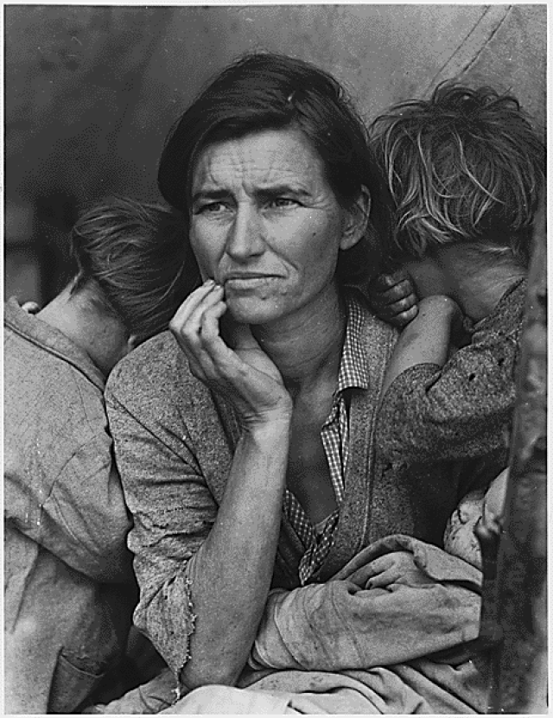
Photo #3
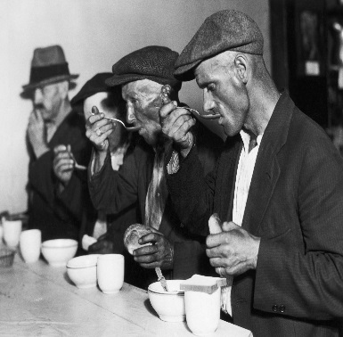

Photo | Describe the photo. What is happening in the photo? (1) | What can you learn about the Great Depression from this photo? (1) | How does this photo make you feel? Why? (1)
Photo #4
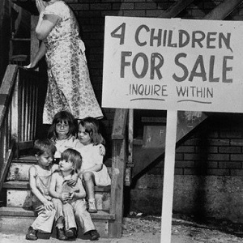
Photo #5
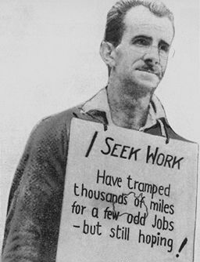
Photo #6
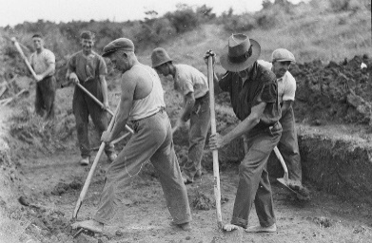
Photo #7
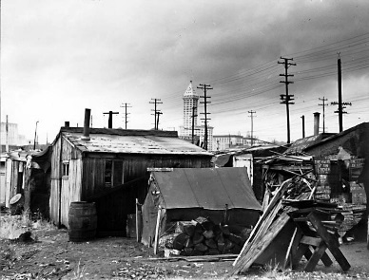
Photo #8
