All biographies are from Ducksters.com in their section Biographies for Kids

These are used for educational purposes only and are not being sold or used for profit in any way.

Wright Brothers
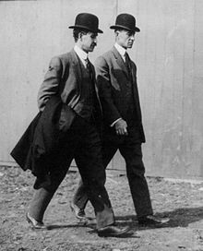
Back to Biographies
Orville and Wilbur Wright are credited with inventing the airplane. They were the first to make a successful human flight with a craft that was powered by an engine and was heavier than air. This was quite a milestone and impacted transportation throughout the world. It took some time to perfect, but in later years people could travel large distances at much less time. Today, trips that previously would have taken months by boat and train, can now be traveled by plane in a few hours.
Where did the Wright Brothers Grow Up?
Wilbur was the older brother by about 4 years. He was born in Millville, Indiana on April 16, 1867. Orville was born in Dayton, Ohio on August 19, 1871. They grew up in Indiana and Ohio, moving back and forth a few times with their family. They had 5 other siblings.
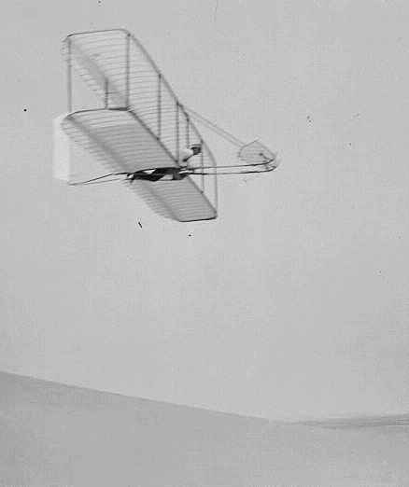
The boys grew up loving to invent things. They got interested in flying when their dad gave them a toy helicopter than flew with the help of rubber bands. They experimented with making their own helicopters and Orville liked to build kites.
Who flew the first flight?
Orville made the famous first flight. The flight took place at Kitty Hawk North Carolina on December 14, 1903. They chose Kitty Hawk because it had a hill, good breezes, and was sandy which would help soften the landings in case of a crash. The first flight lasted 12 seconds and they flew for 120 feet. Each brother made additional flights that day that were slightly longer.
This wasn't a simple or easy task they had completed. They had worked and experimented for years with gliders perfecting the wing design and controls. Then they had to learn how to make efficient propellers and a lightweight engine for the powered flight. There was a lot of technology, know how, and courage involved in making that first flight.
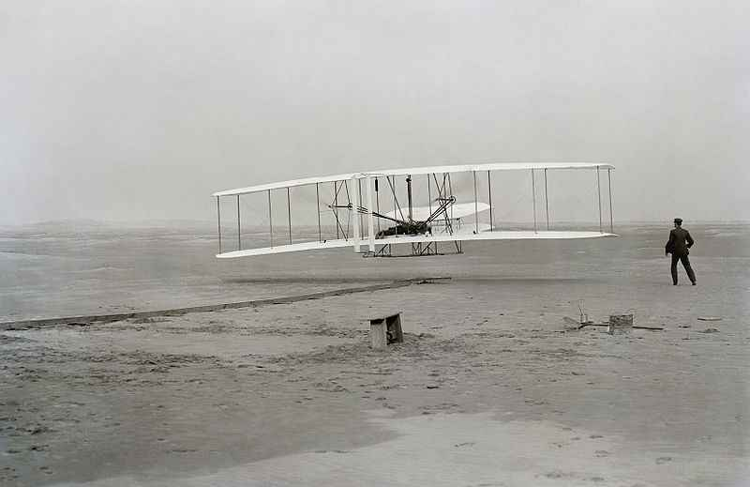
The Wright Brothers didn't stop with this first flight. They continued to perfect their craft. Around a year later, in November 1904, Wilbur took their newly designed airplane, the Flyer II, to the air for the first flight lasting over 5 minutes.
Did the Wright Brothers invent anything else?
The Wright Brother's were primarily pioneers in the area of flight. They did a lot of work on aerodynamics, propellers, and wing design. Prior to working on flight they ran a printing press business and then later a successful bicycle shop.
Fun Facts about the Wright Brothers
- For safety concerns, the brother's father asked them not to fly together.
- August 19th, Orville Wright's birthday, is also National Aviation Day.
- They studied how birds flew and used their wings to help design the wings for their gliders and planes.
- Both North Carolina and Ohio take credit for the Wright Brothers. Ohio because the Wright Brothers lived and did much of their design while living in Ohio. North Carolina because that is where the first flight took place.
- The original Wright Flyer plane from Kitty Hawk can be seen at the Smithsonian Air and Space Museum.

Alexander Graham Bell
Biographies for Kids
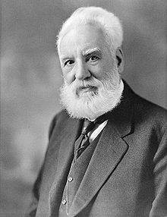
- Occupation: Inventor
- Born: March 3, 1847 in Edinburgh, Scotland
- Died: August 2, 1922 in Nova Scotia, Canada
- Best known for: Inventing the telephone
Biography:
Alexander Graham Bell is most famous for his invention of the telephone. He first became interested in the science of sound because both his mother and wife were deaf. His experiments in sound eventually let him to want to send voice signals down a telegraph wire. He was able to get some funding and hire his famous assistant Thomas Watson and together they were able to come up with the telephone. The first words spoken over the telephone were by Alex on March 10, 1876. They were "Mr. Watson, come here, I want to see you".
It turns out that other scientists had similar ideas. Bell had to race to the patent office in order to get his patent in first. He was first and, as a result, Bell and his investors had a valuable patent that would change the world. They formed the Bell Telephone Company in 1877. There have been many mergers and name changes over the years, but this company is known today as AT&T.
Where did Alexander Graham Bell grow up?
Bell was born on March 3, 1847 in Edinburgh, Scotland. He grew up in Scotland and was initially homeschooled by his father who was a professor. He later would attend high school as well as the University of Edinburgh.
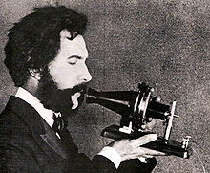
Did Alexander Graham Bell only invent the telephone?
Bell actually had many inventions and did experimentation in many areas of science. Some of these include:
- The Metal Detector - Bell invented the first metal detector which was used to try and find a bullet inside of President James Garfield.
- Audiometer - A device used to detect hearing problems.
- He did experimental work on aeronautics and hydrofoils.
- He invented techniques which helped in teaching speech to deaf persons.
- He made a device to help find icebergs.
Fun Facts about Alexander Graham Bell
- Bell made the first transcontinental telephone call on January 15, 1915. He called Thomas Watson from New York City. Watson was in San Francisco.
- He helped form the National Geographic Society.
- Bell did not like to have a telephone in his study as he found it intrusive!
- He did not get the middle name Graham until he was 10 years old, when he asked his father to give him a middle name like his brothers.
- At his wife's request, Bell went by the nickname Alec.
- Upon his death, every phone in North America was silenced for a short period to honor him.

George Washington Carver
Biography
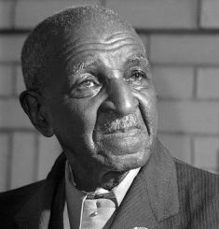
- Occupation: Scientist and educator
- Born: January 1864 in Diamond Grove, Missouri
- Died: January 5, 1943 in Tuskegee, Alabama
- Best known for: Discovering many ways to use the peanut
Biography:
Where did George grow up?
George was born in 1864 on a small farm in Diamond Grove, Missouri. His mother Mary was a slave owned by Moses and Susan Carver. One night slave raiders came and stole George and Mary from the Carvers. Moses Carver went searching for them, but only found George left by the side of the road.
George was raised by the Carvers. Slavery had been abolished by the 13th amendment and the Carvers had no children of their own. They took care of George and his brother James like their own children teaching them to read and write.
Growing up George liked to learn about things. He was especially interested in animals and plants. He also liked to read the Bible.
Going to School
George wanted to go to school and learn more. However, there weren't any schools for black children close enough to home for him to attend. George ended up traveling around the midwest in order to go to school. He eventually graduated from high school in Minneapolis, Kansas.
George enjoyed science and art. He initially thought he may want to be an artist. He took some art classes at Simpson College in Iowa where he really enjoyed drawing plants. A teacher of his suggested he combine his love for science, art, and plants and study to become a botanist. A botanist is a scientist that studies plants.
George enrolled in Iowa State to study botany. He was the first African-American student at Iowa State. After earning a bachelor's degree in science, he continued on and earned his master's degree as well. George became known as an expert in botany from the research he conducted at the school.
Professor Carver
After getting his masters, George began to teach as a professor at Iowa State. He was the first African-American professor at the college. However, in 1896 George was contacted by Booker T. Washington. Booker had opened an all-black college in Tuskegee, Alabama. He wanted George to come teach at his school. George agreed and moved to Tuskegee to head up the agricultural department. He would teach there for the rest of his life.
Crop Rotation
One of the main crops in the south was cotton. However, growing cotton year after year can remove nutrients from the soil. Eventually, the cotton crop will grow weak. Carver taught his students to use crop rotation. One year they would grow cotton, followed by other crops such as sweet potatoes and soybeans. By rotating the crops the soil stayed enriched.
Carver's research and education into crop rotation helped the farmers of the south be more successful. It also helped to diversify the products that they produced.
The Peanut
Another problem for farmers was the boll weevil. This insect would eat cotton and destroy their crops. Carver discovered that boll weevils don't like peanuts. However, farmers weren't so sure that they could make a good living off of peanuts. Carver began to come up with products that could be made from peanuts. He introduced hundreds of new peanut products including cooking oil, dyes for clothing, plastics, fuel for cars, and peanut butter.
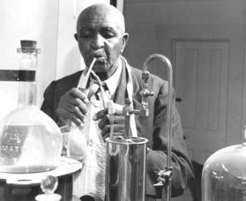
George working in his lab
In addition to his work with peanuts, Carver invented products that could be made from other important crops such as the soybean and sweet potato. By making these crops more profitable, farmers could rotate their crops and get more production from their land.
An Expert on Agriculture
Carver became known around the world as an expert on agriculture. He advised President Theodore Roosevelt and the U.S. Congress on matters of agriculture. He even worked with Indian leader Mahatma Gandhi to help with growing crops in India.
Legacy
George Washington Carver was known throughout the south as the "farmer's best friend". His work on crop rotation and innovative products helped many farmers to survive and make a good living. His interest was in science and helping others, not in getting rich. He didn't even patent most of his work because he considered his ideas as gifts from God. He thought they should be free to others.
George died on January 5, 1943 after falling down the stairs at his home. Later, congress would name January 5th as George Washington Carver Day in his honor.
Interesting Facts about George Washington Carver
- Growing up George had been known as Carver's George. When he started school he went by George Carver. He later added the W in the middle telling his friends it stood for Washington.
- People in the south at the time called peanuts "goobers".
- Carver would sometimes take his classes out to the farms and teach farmers directly what they could do to improve their crops.
- His nickname later in life was the "Wizard of Tuskegee".
- He wrote up a pamphlet called "Help for Hard Times" that instructed farmers on what they could do to improve their crops.
- It takes over 500 peanuts to make one 12-ounce jar of peanut butter.
Thomas Edison
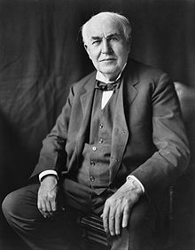
Back to Biographies
Thomas Edison may be the greatest inventor in history. He has over 1000 patents in his name. Many of his inventions still have a major affect on our lives today. He was also a business entrepreneur. Many of his inventions were group efforts in his large invention laboratory where he had many people working for him to help develop, build, and test his inventions. He also started many companies included General Electric, which is still one of the biggest corporations in the world today.
Where did Edison grow up?
Thomas Edison was born in Milan, Ohio on February 11, 1847. His family soon moved to Port Huron, Michigan where he spent most of his childhood. Surprisingly, he did not do well in school and ended up being home schooled by his mother. Thomas was an enterprising young man, selling vegetables, candy and newspapers on trains. One day he saved a child from a runaway train. The child's father repaid Edison by training him as a telegraph operator. As a telegraph operator, Thomas became interested in communications, which would be the focus of many of his inventions.
What was Menlo Park?
Menlo Park, New Jersey is where Thomas Edison built his research labs. This was the first business or institution with the sole purpose of inventing. They would do research and science and then apply it to practical applications that could be manufactured and built on a large scale. There were a lot of employees working for Edison at Menlo Park. These workers were inventors, too, and did a lot of work on Edison's ideas to help turn them into inventions.
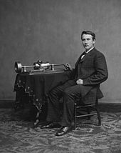

What are Thomas Edison's most famous inventions?
Thomas Edison has the patents and credits for many inventions. Three of his most famous include:
The Phonograph - this was the first major invention by Edison and made him famous. It was the first machine that was able to record and playback sound.
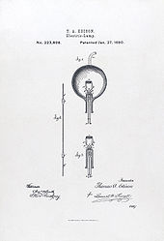
Light Bulb - although he did not invent the first electric light, Edison made the first practical electric light bulb that could be manufactured and used in the home. He also invented a lot of other items that were needed to along with the light bulb including safety fuses and off/off switches for light sockets.
The Motion Picture - Edison did a lot of work in creating the motion picture camera and helping move forward the progress of practical movies.
Fun Facts About Thomas Edison
- His middle name was Alva and his family called him Al.
- His first two kids had the nicknames Dot and Dash.
- He set up his first lab in his parent's basement at the age of 10.
- He was partially deaf.
- His first invention was an electric vote recorder.
- His 1093 patents are the most on record.
- He said the words to "Mary had a little lamb" as the first recorded voice on the phonograph.

