Design Your Own PC
AP Computer Science Principles Name______________________

Design your own custom computer using the PCPartPicker website. PCPartPicker is very helpful as it won't let you choose incompatible parts. The following components will be required for your build:
- CPU
- Motherboard
- Memory
- Storage
- Case
- Power Supply
- Operating System
You are welcome to add any additional components to your build. When you are finished with your build, add copy the permalink under the current part list to the space below and submit your finished worksheet.

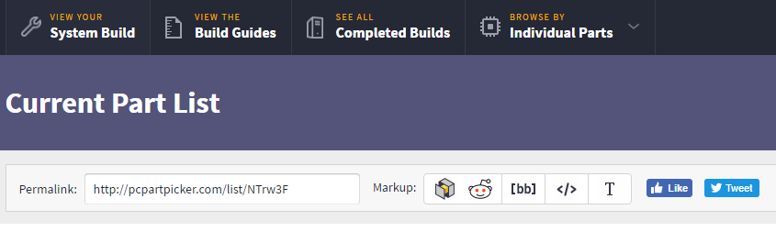

Permalink:

