Picasso
Purpose: To expose children to the creation of a Picasso-like piece of artwork which will aid in the development of cognitive, social, and motor skills.
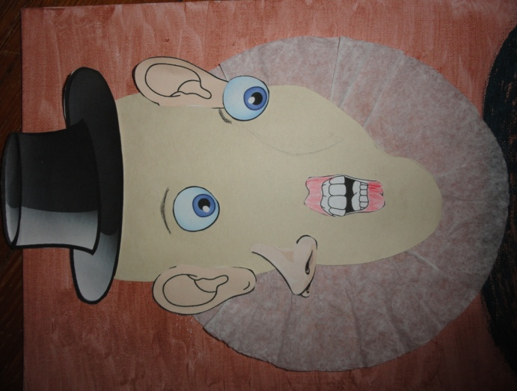
Materials:
- Scissors
- Glue
- Paint
- Poster Board
- Coffee Filter
- Paper Body Parts/Hats
- Colored Pencils/Markers

Procedures:
- Collect materials listed above.
- Paint background color of choice.
- Cut out face parts and hats to be used.
- Create an asymmetrical shaped face and cut it out.
- Cut top of coffee filter, flatten, and glue in place.
- Place face cut out on top of coffee filter and glue in place.
- Glue on facial parts and hat (cut out in step 3 above).
- Draw on eyebrows or eye glasses (if desired).
- Color or paint on the shoulder portion below the collar.
- Color lips or any other facial parts as desired.

Dr. Seuss
Purpose: To expose children to the creation of a Dr. Seuss piece of puzzle artwork which will aid in the development of cognitive, social, and motor skills.
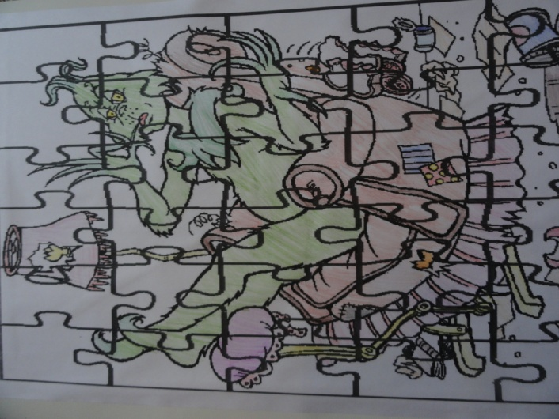
Materials:
- Scissors
- Glue
- Poster Board
- Colored Pencils/Markers/Crayons
- Individual Puzzle Pieces of a Dr. Seuss Illustration
- Plastic Individual Baggies

Procedures:
- Collect materials listed above.
- Obtain a Dr. Seuss on-line image.
- Obtain an on-line Puzzle Pieces Background.
- Transpose the Dr. Seuss image over the Puzzle Pieces Background to create a Puzzle Worksheet.
- Bring Dr. Seuss Puzzle Worksheet to a place to enlarge to the preferred size.
- Cut out the individual puzzle pieces.
- Place the puzzle pieces per worksheet into individual plastic baggie.
- Construct the puzzle pieces on a piece of Poster Board
- Glue individual puzzle pieces in place on the Poster Board.
- Color with choice of markers, colored pencils or crayons.

Art Portfolio
Purpose: To expose children to the creation of an Art Portfolio which will aid in the development of cognitive, social, and motor skills.
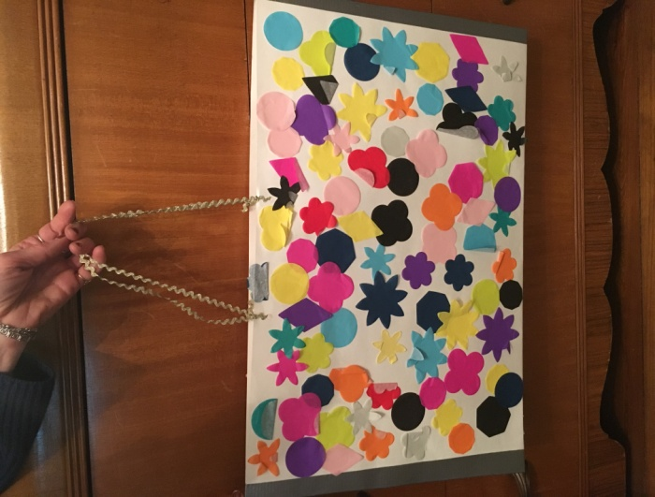
Materials:
- Scissors
- Ribbon
- Glue
- Hole Punch
- Poster Board (Largest Size)
- Colored Pencils/Markers/Crayons
- Construction Paper or Pre-Cut Tissue Shapes
- Masking Tape (Plain or Decorative)

Procedures:
- Collect materials listed above.
- Fold Poster Board in half.
- Cut masking tape to size and tape the front and back of the poster board along both sides.
- Punch holes at the top (into both pieces of poster board) and repeat about six to eight inches from the first holes.
- Cut two pieces of ribbon about 14 inches long.
- Thread first piece of ribbon into front hole and knot.
- Thread first piece of ribbon into the second front hole and knot.
- Repeat steps 6. and 7. with the second piece of ribbon for the back holes.
- Cut out paper shapes (or use pre cut shapes).
- Glue shapes to the poster board front and back.
- Alternatively, color with pencils/markers/crayons.

Henri Matisse
Purpose: To expose children to the creation of a Henri Matisse-like piece of artwork which will aid in the development of cognitive, social, and motor skills.
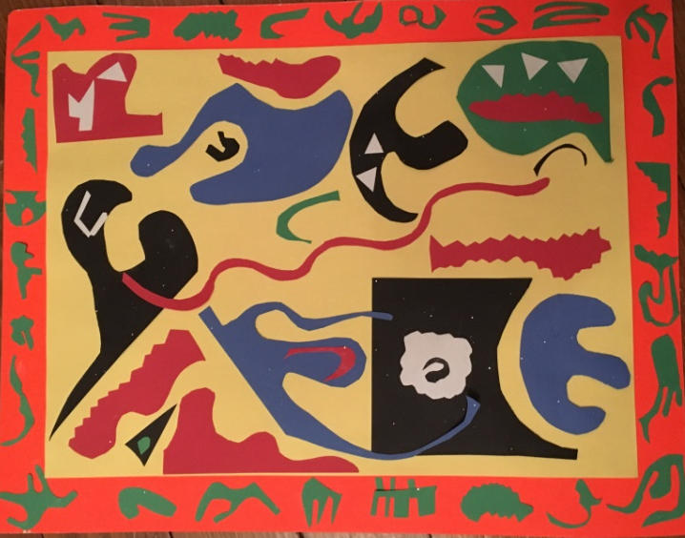
Materials:
- Scissors
- Glue
- Colored Poster Board-2 sizes
- Colored Construction Paper

Procedures:
- Collect materials listed above.
- Glue smaller poster board onto larger poster board.
- Cut various shapes using one color of construction paper and glue around the entire perimeter.
- Cut various shapes using at least 3 to 4 other colors of construction paper.
- Glue shapes of the other colors of construction paper onto the smaller poster board making sure to overlap and layer pieces.

Georgia O’Keeffe
Purpose: To expose children to the creation of a Georgia O’Keeffe-like piece of artwork which will aid in the development of cognitive, social, and motor skills.
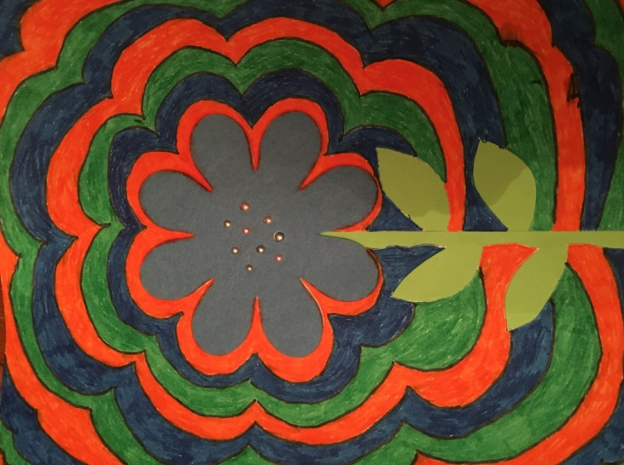
Materials:
- Scissors
- Glue
- Poster Board
- Colored Pencils/Markers/ or Crayons
- Felt or Construction Paper
- Green Construction Paper
- Beads
- Pencil

Procedures:
- Collect materials listed above.
- Make a flower petal from a piece of felt or a piece of construction paper/any color.
- Glue the petal onto the Poster Board in the middle.
- Use the green construction paper to create a stem and leaves.
- Glue the stem and leaves onto the Poster Board beneath the petal.
- Select three markers/crayons /colored pencils.
- Use a pencil with eraser to outline the entire flower in the pattern of the flower from the inside to outside.
- Color first ring of the pattern with the first color selected.
- Color second ring of the pattern with the second color selected.
- Color third ring of the pattern with the third color selected.
- Repeat the three colors moving from the inside to the outside.
- Glue beads onto felt or construction paper petal.

Marc Chagall
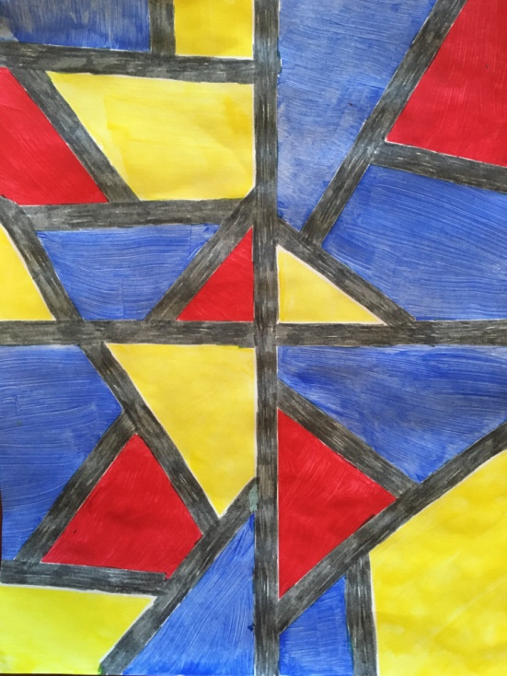
Purpose: To expose children to the creation of a Marc Chagall-like stained glass piece of artwork which will aid in the development of cognitive, social, and motor skills.
Materials:
- Scissors
- Poster Board
- Colored Pencils/Markers/ Crayons/or Paint
- Surgical Tape

Procedures:
- Collect materials listed above.
- Cut a piece of surgical tape and place vertically from top to bottom in the center of the poster board.
- Cut a piece of surgical tape and place horizontally from left to right in the center of the poster board.
- In each of the four quadrants, cut and place pieces of surgical tape on different angles creating various shapes and sizes.
- Color each shape in the four quadrants.
- Peel off surgical tape.
- Color white areas left by the tape silver or gray or leave uncolored if desired.

Vincent van Gogh
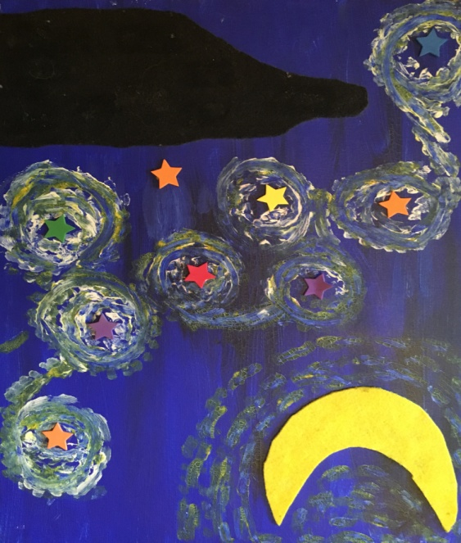
Purpose: To expose children to the creation of a Vincent van Gogh-like “Starry Night” piece of artwork which will aid in the development of cognitive, social, and motor skills.
Materials:
- Scissors
- Glue
- Poster Board
- Dark Blue Colored Pencil/Marker/ Crayon or Paint
- Yellow Colored Pencil/Marker/Crayon or Paint
- Yellow Felt or Construction Paper
- Green Felt or Construction Paper
- Black Felt or Construction Paper
- White Yarn or White Paint
- Package of Stars
- Pencil
- Paint brushes if using paint

Procedures:
- Collect materials listed above.
- Paint entire poster board dark blue.
- Using the pencil, trace a crescent moon onto the yellow felt/paper.
- Cut out the crescent moon and glue it on the upper right hand corner.
- Color around the moon with the yellow marker/pencil or paint.
- Using the pencil, trace an odd shaped building onto the black felt/paper.
- Cut out the odd building shape and glue it on the lower left hand corner.
- Cut out green squares or rectangles and glue onto the black building.
- Place stars throughout the painting between the building and the moon.
- Cut several pieces of white yarn 8-12 inches if using.
- Glue individual pieces of yarn around each star in a swirl-like pattern.
- If not using yarn, paint or color white swirl-like pattern around each individual star.

Claude Monet
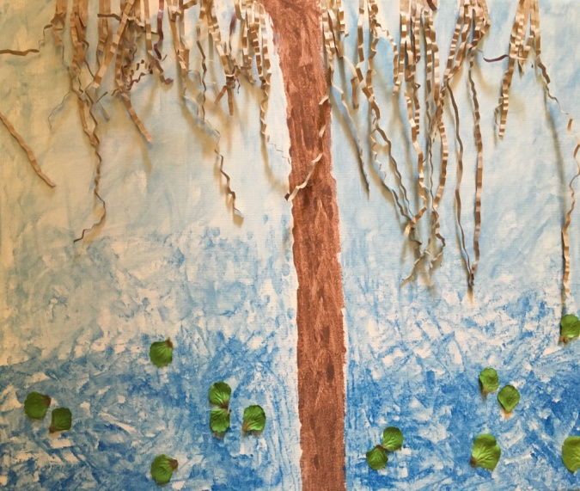
Purpose: To expose children to the creation of a Monet-like piece of artwork which will aid in the development of cognitive, social, and motor skills.
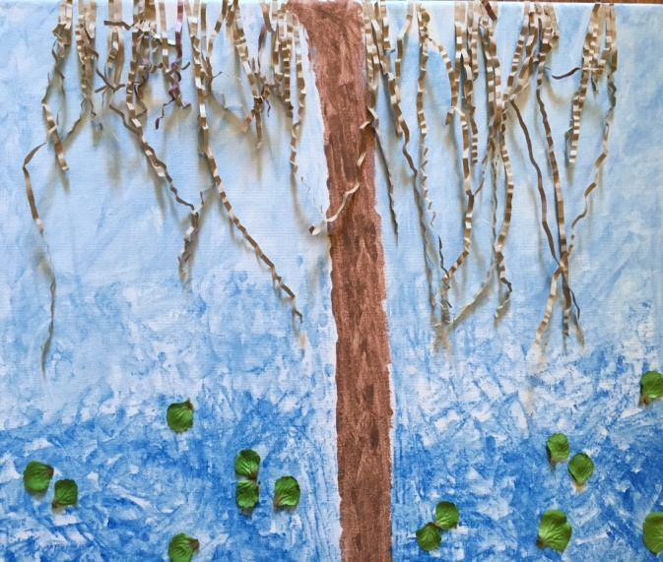
Materials:
- Scissors
- Glue
- Poster Board
- Brown Pencil/Marker/ Crayon or Paint
- Blue Colored Pencil/Marker/Crayon or Paint
- Green Felt or Construction Paper
- Package of Paper Shreds
- Paint brushes if using paint

Procedures:
- Collect materials listed above.
- Draw or paint brown bark of tree in center of poster board.
- Cut individual paper shreds into various lengths and glue along top.
- Draw or paint blue (water) on either side of the tree bark (dotting technique) darker towards bottom and gradually getting lighter moving to the top .
- Cut out green round-like shapes (lily pads) and glue along the bottom.

Jackson Pollock
Purpose: To expose children to the creation of a Pollock-like piece of artwork which will aid in the development of cognitive, social, and motor skills.
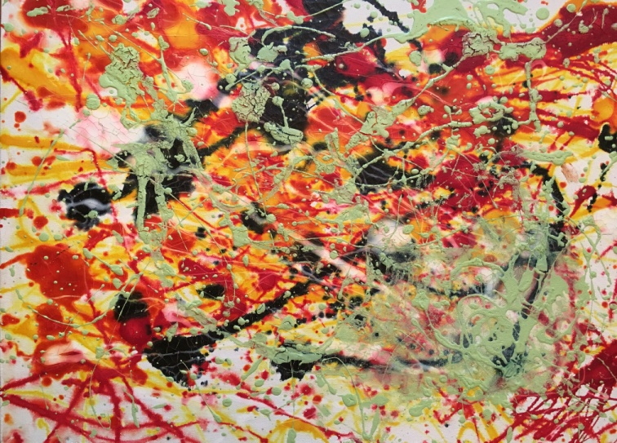
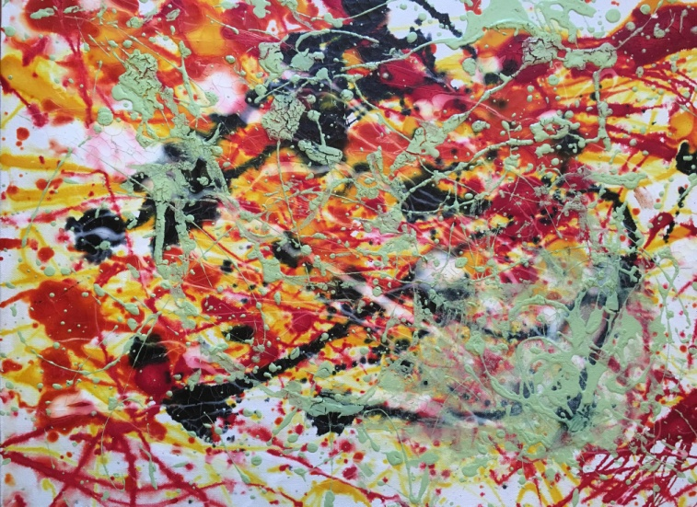
Materials:
- Red Paint
- Black Paint
- Green Paint
- Yellow Paint
- Poster Board
- Straws for splattering, dripping, spreading paint
- Paper cups for filling paint

Procedures:
- Collect materials listed above.
- Using a paint brush or straw, drip and splatter the first color paint onto the poster board.
- Repeat these techniques with the other three color paints.
- Use the straw or brush to smear paint as desired.

Andy Warhol
Purpose: To expose children to the creation of Andy Warhol-like piece of artwork which will aid in the development of cognitive, social, and motor skills.
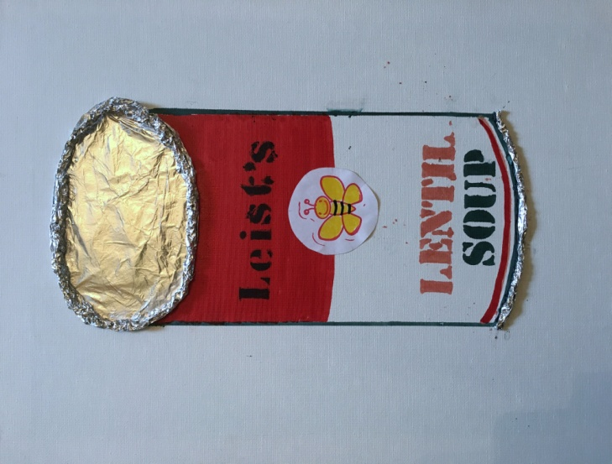
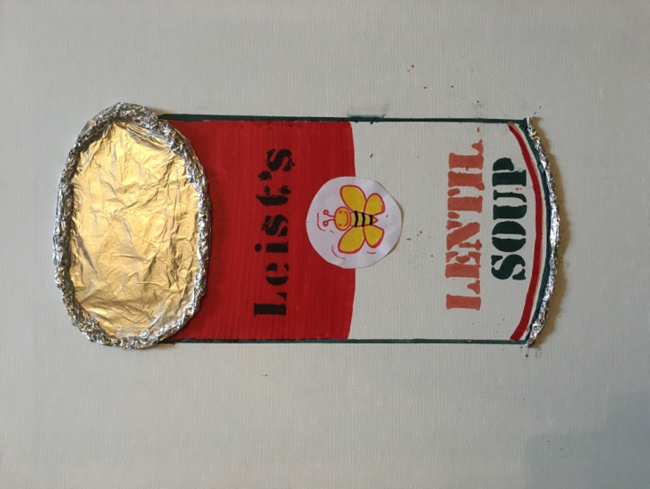
Materials:
- Scissors
- Glue
- Poster Board
- Aluminum Foil
- Black and Red Markers
- White Construction Paper
- Stamp and Ink for Logo Design
- Ruler
- Stencil letters
- Colored pencils or markers

Procedures:
- Collect materials listed above.
- Cut out an oval shape from the aluminum foil and glue at top of poster board.
- Cut a thin strip of aluminum foil and pinch edges until it is a thin, long shape.
- Cut a second strip of aluminum foil and repeat step 2.
- Attach two strips together by twisting ends and glue around the oval shape until reaching the end of the oval to create the rim. Cut off extra length.
- With the ruler and black marker, draw a straight line down from oval to desired length.
- Repeat 6. On the opposite side.
- With the black marker, connect the bottom two black lines by drawing an arc.
- With the red marker, make a red arc above the black arc in 8.
- In the center of the can, draw a red line from one side to the other and color the entire top half with the red marker.
- Using the stencil letters, stencil in red the name of the type of soup desired.
- Using the stencil letters, stencil in black directly below 11, the word SOUP.
- Cut a round circle from the white construction paper and glue in the center.
- Using a stamp/ink, stamp the design onto the round circle in 13. for the desired logo.
- Color the design in 14. with colored pencils or markers.
- In the middle of the red top half, use stencil letters to create brand name of soup.
Edgar Degas
Purpose: To expose children to the creation of a Degas-like piece of artwork which will aid in the development of cognitive, social, and motor skills.
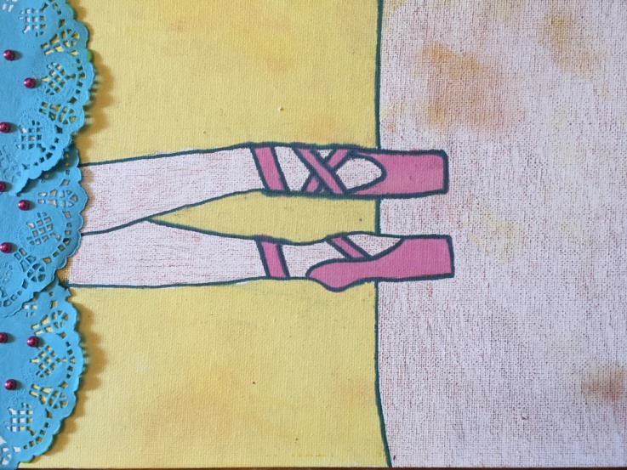
Materials:
- Scissors
- Glue
- Poster Board
- Colored Pencils/Markers/ Crayons/or Paint
- Doilies (in desired colors)
- Beads (Optional)
- Pencil

Procedures:
- Collect materials listed above.
- Cut two doilies in half.
- Glue three of the doily halves along the top of the poster board to create the dress hem.
- If using decorative beads, glue onto doilies. l
- Draw the left ballerina leg and shoe erasing until it is the desired scale and shape.
- Draw the right ballerina leg and shoe erasing until it is the desired scale and shape.
- Color the legs with desired color.
- Color the shoes with desired color.
- Using a black marker/ pencil, draw a horizontal line across the poster board 2/3 down.
- Color below the black horizontal line with the desired color.
- Color above the black horizontal line with the desired color.
- Outline the legs and shoes with black marker to give definition.

