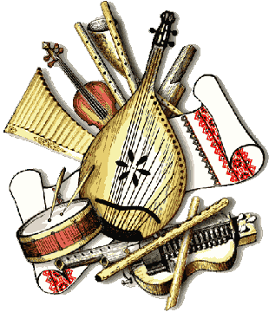 Questions to think about:
World Cultures and Music
What instruments do you associate with different cultures?
What different kinds of instruments are played around the world? How are they different? How are they similar?
Do you know how any cultures use music to reflect their traditions?

Objectives:
1. Identify name and type (classify) of at least 3 instruments from around the world.
2. Explain at least 2 aspects of a culture's music.
3. Explain at least 1 way in which the music of a culture reflects that culture's traditions.

Guided Practice:
Answer these six (6) questions for each culture you learn about.
1. Culture/Country: _____________
2. Instrument(s) Associated: ________________________________________
3. Classify each instrument above (string, woodwinds, etc.): _______________________
_______________________________________________________________________
4. What kind of music does this culture play? __________________________________
_______________________________________________________________________
5. What does the culture’s music sound like? Use musical terms you have learned in class already. Why do you think it sounds this way? _________________________________ _______________________________________________________________________
6. How or when is music used in this culture? __________________________________
_______________________________________________________________________

Project:
Choose an instrument and culture that interests you.
For this project, you may work independently or in a group with up to 3 people that are interested in the same culture.

Research the culture you have chosen, as well as the instrument(s) associated with it. To research, they may: go to the library, go online, use the books and textbooks provided in the classroom. Answer these questions in your research:
1. What is the culture, the area in which it is found, and the instrument(s) used?
2. What are 2 aspects of the culture's music?
3. What is 1 way in which the music of the culture reflects that culture's traditions?

For this project, you will present what you have researched in one of the following ways:
- Make a presentation using any of the following: Prezi, PowerPoint, Video, or Glogster, or Good Old Fashioned Posterboard.
- Perform a work from the culture and explain it, covering all aspects of the rubric.

The project must be 4-7 minutes long.
Checkpoint: Be sure to check in with your teacher about your project before the end of class!

Rubric:
 | 4 Exemplary | 3 Good | 2 Fair | 1 Poor
Content | All of the questions are answered and all are accurate. | Most of the questions are answered and all are accurate. | Some of the questions are answered and some are accurate. | Some of the questions are answered and most is not accurate.
Presentation | Clear, creative, and interesting. | Clear, but lacking in creativity or interest. | Somewhat clear, but no creativity or interest. | Not clear and no creativity or interest.
Preparedness | Very prepared and all presenters speak. | Mostly prepared and/or not all presenters speak. | A little prepared and not all presenters speak. | Not prepared to present.
Time | Within the time limit. |  |  | Not within the time limit.

