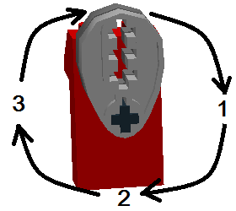
Data Table Tip: Set motor speed slow (and keep same). Watch the cams spin while you count.
left cams
right cams
Cam Arrangement |  | Observations (sound and motion) |  |  |  | (re-start count)
Left Cams  (under left arm) | Right Cams  (under right arm) | 1st Count | 2nd Count | 3rd Count | 4th Count | 1st Count
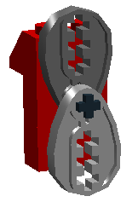  A  (one cam up, one down) | 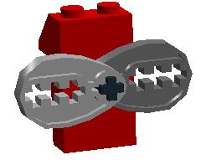  (one cam forward,  one back) | (Example:)  LEFT beat  (fast rhythm) (each arm moves opposite the other) | RIGHT beat | LEFT beat | RIGHT beat | LEFT beat
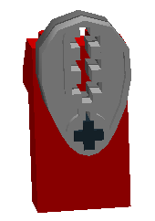  B  (both cams up) | 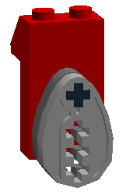  (both cams down)
C  (both cams up) | 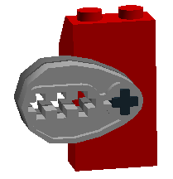  (both cams back)
D  (both cams up) | (one cam forward,  one back)
Key Question: What is the relationship between the cams and the rhythms?

Challenge: Make your own rhythms.
Cam Arrangements |  | Observations (sound and motion) |  |  |  | (re-start count)
Left Cams | Right Cams | 1st Count | 2nd Count | 3rd Count | 4th Count | 1st Count
E
F

G
H

